Generate GOES-16 True Color Imagery without a Green Band
K. Bah¹, M. M. Gunshor¹, T. J. Schmit², S. D. Miller³ and D. T. Lindsey⁴
¹ Cooperative Institute for Meteorological Satellite Studies (CIMSS), 1225 West Dayton Street, Madison, University of Wisconsin-Madison, Wisconsin, USA
² NOAA/NESDIS Center for Satellite Applications and Research, Advanced Satellite Products Branch (ASPB), Wisconsin, USA
³ Cooperative Institute for Research in the Atmosphere (CIRA), 1375 Campus Delivery, Colorado State University, Ft. Collins, Colorado, USA
⁴ NOAA/NESDIS Center for Satellite Applications and Research, Regional and Mesoscale Meteorology Branch (RAMMB), Fort Collins, Colorado, USA
Kaba Bah: (kbah@ssec.wisc.edu)

Key Points:
- The Advanced Baseline Imager (ABI) is the next generation imager Geostationary Operational Environmental Satellite (GOES) operated by the U.S. The ABI is improved in many ways over preceding instruments.
- There are a number of approaches to generating true color images from the ABI, all GOES-16 ABI approaches need to build the visible “green” spectral band.
- Comparisons are shown between different methods for generating true color images and those from the EPIC (Earth Polychromatic Imaging Camera) on DSCVR (Deep Space Climate Observatory).

Abstract
A number of approaches have been developed to generate true color images from the Advanced Baseline Imager (ABI) on the Geostationary Operational Environmental Satellite (GOES)-16. GOES-16 is the first of a series of 4 spacecraft with the ABI onboard. These approaches are complicated since the ABI does not have a “green” (0.55 µm) spectral band. Despite this limitation, representative true color images can be built. A methodology for generating color images from the ABI is discussed, along with corresponding examples from the EPIC (Earth Polychromatic Imaging Camera) on DSCVR (Deep Space Climate Observatory).

1 Introduction

1.1 Evolution from ATS to GOES-16

Geostationary imagers have greatly evolved since the experimental ATS (Applications Technology Satellite) series in the mid to late 1960s (Suomi and Parent, 1968). ATS-1 had one visible band, with an approximate spatial resolution of 4 km at the satellite sub-point. This can be compared to two visible bands (with a spatial resolution as fine as 0.5 km), 4 near-infrared (NIR) and 10 IR bands on the Geostationary Operational Environmental Satellite (GOES)-R/16 Advanced Baseline Imager (ABI) (Schmit et al., 2017; Greenwald et al., 2016; Kalluri et al., 2015). The spatial resolution of the ABI IR bands is 2 km at the sub-point. The main ABI scan mode includes a full disk image every 15 minutes; along with a Contiguous U.S. (CONUS) image every 5 minutes, and two mesoscale images every minute. GOES-16 is the first of a series of four spacecraft. To better prepare for the meso-scale modes of the ABI, GOES-14 was operated during parts of 2012-2016 in a Super Rapid Scan 1-minute imagery mode (Schmit et al., 2015). GOES-R was launched and became GOES-16 in November of 2016. The information from the ABI on the GOES-16/S/T/U series can be used for many applications including severe weather, tropical cyclones and hurricanes, aviation, natural hazards, the atmosphere, oceans, and the cryosphere.

There are other advanced geostationary imagers around the globe, either recently launched or planned. These include Japan’s two AHI (Advanced Himawari Imager), currently in-orbit on Himawari-8 and -9, China’s Advanced Geosynchronous Radiation Imager (AGRI), Korea’s AMI (Advanced Meteorological Imager) and Europe’s Flexible Combined Imager (FCI) to fly on MTG (METEOSAT Third Generation) (Bessho et al., 2016; Yang et al., 2017; Stuhlmann et al., 2005). These imagers have at least two visible bands. These are the first geostationary imagers to provide true color imagery since the experimental ATS-3 in 1967 (Suomi and Parent, 1968). India and Russia also operate geostationary imagers. Most recently, the AHI, having red, green and blue sensitive spectral bands, has allowed for true color imaging after an adjustment to its 0.51 µm green band (Miller et al., 2016).

As these advanced imagers begin to include more spectral bands, there are an increasingly number of ways to combine the spectral information. One effective way to communicate multi-spectral information is via Red-Green-Blue (RGB) composite imagery. RGB images fall into two broad categories: false color or “true” color. False color composites may highlight various features in arbitrary colors, so training is needed to understand what each color means. One such example is the EUMETSAT “Dust RGB” (Lensky and Rosenfeld, 2008). In contrast to false color RGBs, true color RGB approximates normal human color vision and thus requires far less special training to interpret. There are sub classes of true color RGB, based on level of sophistication in post-processing. For example, images from the EPIC (Earth Polychromatic Imaging Camera) on DSCVR (Deep Space Climate Observatory, which view the Earth from Langrangian Point 1 (L1) orbit) are provided in both a “natural” and “enhanced color” options. The “natural” color aims to mimic what the human eye would see if one were looking at earth from a distance. The “enhanced” version aims to boost contrast within the lower end of the signal, which generally correlates to surface futures. (https://epic.gsfc.nasa.gov/).

1.2 GOES-16 ABI spectral bands

Unlike previous-generation GOES series imagers, which had only one visible channel, GOES-16 ABI has 16 spectral bands, two of which are within the visible range and four in the NIR ranges. The two visible bands are known as the Red (0.64 µm) and Blue (0.47 µm) bands. Fig.1 shows GOES-16 ABI spectral response functions for the Red (0.64 µm), Blue (0.47 µm) and NIR (0.86 µm) bands along with their reflectance spectra for asphalt, dirt, grass and snow (Baldridge et al. 2009). It is the differences between these individual channels and how they respond to different surface features that makes it possible to combine them in such a way as to make true color RGB images.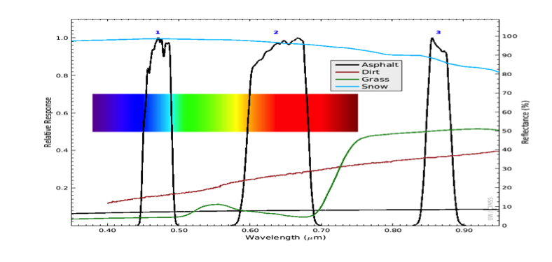
Figure 1. The GOES-16 ABI spectral response functions for bands 1 through 3, along with the visible rainbow spectrum for reference. This plot includes four reflectance (%) spectra from the ASTER spectral library of measured from "construction asphalt," "reddish brown fine sandy loam," "grass," and "medium granular snow." These spectra, plotted along with ABI spectral response functions, provide some indication of how different colored surface types are measured by different spectral bands.

1.3 Construction of true color imagery

Generally, one requires the Red (0.64 µm), Green (0.55 µm), and Blue (0.47 µm) bands to generate true color RGB images, but with GOES-16 and the next three GOES-series satellites (S/T/U), the Green (0.55 µm) band is not included. However, GOES-16 does have the vegetation band (0.86 µm) which, when proportionally combined with the existing Red (0.64 µm) and Blue (0.47 µm) bands, can generate a “Green like” band as first order approximation and hence allows for making “enhanced” or “natural” true color RGB images entirely based on the existing GOES-16 bands as shown in Fig. 2, or with the help of a green band Look Up Table (LUT) derived from similar instruments (e.g., Miller et al., 2012). The methodology for generating a green band on the fly to combine with the Red and Blue bands for making GOES-16 true color RGB images is outlined in Section 2.

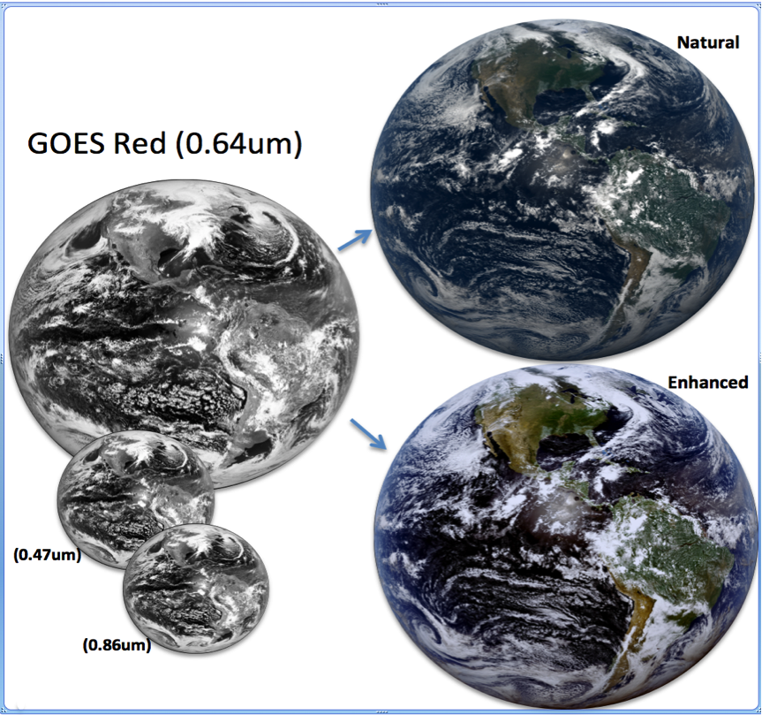

Figure 2. The three GOES-16 bands (0.47 µm, 0.64 µm and 0.86 µm) needed to make true color RGB images shown in black and white on the left along with the generated true color RGB images for the natural (upper right) and enhanced (lower right).

If correctly enhanced and combined for visualization and analysis purposes, these true color RGB images can capture most if not all the information found within the individual channels that were used to generate them. Due to the nature of the human eye cone’s sensitivity to visible light centered around these wavelengths, far less training is needed to interpret “natural’ or “enhanced” true color RGB images.

As satellite instruments get more advanced and the number of spectral bands increase, it becomes increasingly important to find simple ways of synthesizing information from multiple bands for simultaneous visualization and rapid analysis purposes instead of parsing through myriad individual bands.

2 Making ‘natural’ or ‘enhanced’ true color GOES-16 RGB images

2.1 Overview

For GOES-16 ABI, combining the blue (0.47 µm), red (0.64 µm) and NIR (0.86 µm) bands, true color RGB (natural /enhanced) is a reasonable choice for daytime imagery. This allows for both condensing critical information from three bands into a single image with the added benefit of easily communicating such information. Hence this can be very helpful for both forecasters and the general public.

Making GOES-16 ABI “natural” or “enhanced” true color ABI RGB images generally requires at least two steps. The first step is to generate a green band, and the second is to choose and apply enhancements as required to achieve the desired RGB output. There are multiple ways to approach both steps, with varying degrees of efficacy. In this paper we outline three independent ways of generating a green band, with a principal focus on a straightforward (linear) and readily replicable version. In addition, we describe four enhancement options than can be used either individually or in series with these bands to make GOES-16 true color RGB images (natural or enhanced).

2.2 Generating a GOES-16 “green like” ABI band

2.2.1. Fractional combination: The simplest approach to estimating the missing green like band (0.55 µm) for GOES-16 ABI is via fractional combination of the existing GOES-16 red (0.64 µm), blue (0.47 µm) and NIR (0.86 µm). Generally, the spectral response functions for the 0.64 µm, 0.55 µm and 0.47 µm behave similar when remotely sensing bright and dark surfaces such as snow and asphalt or water (Baldridge et al. 2009). Compared to the 0.64 µm and the 0.47 µm bands, the 0.55 µm is more sensitive to vegetation, but the 0.86 µm is even more sensitive to vegetation than the 0.55 µm. Hence by combining fractions of the measured radiances from these three bands, one can construct a “green like” band that can be used in combination with the already existing red (0.64 µm) and blue (0.47 µm) bands to make a simple GOES-16 RGB image. Through experimentation, the proportion that consistently produced reasonable results was: Green = 0.45*Red + 0.10*NIR + 0.45*Blue. Note, this approach is a first-order approximation; it does not replace the information content of the missing green band. However, when enhanced using simple mathematical functions, it can produce very reasonable GOES-16 true color RGB images for both “natural” and “enhanced”.

2.2.2. Weighted Nudging with Hybrid Green Adjustment: A second method of generating a green band is by using the weighted nudge approach. This approach requires basic preexisting knowledge of the density distribution for the red, green and blue bands. The logic behind this approach is that independent of time, it is often observed that the data density distribution functions of the red, green and blue band correlate in such a way that the green band is located between the red and blue bands. By using an instrument such as the AHI, which already has a green band, one can establish a reference correlation between the density distributions for the red (0.64 µm), green (0.51 µm) and blue (0.47 µm) bands. Next, weighted nudge the red and blue to align with the expected location of the green band, using the normalized distance between the red and green wavelengths to nudge the red, and the normalized distance between the blue and green to nudge the blue. Then average the nudged blue with the nudged red to get a first order approximation of the green like band. The first order approximated green (green0) is then modified using the vegetation band to capture the chlorophyll reflectance response at the first order approximated green (green0) and make a new green (green1) band similar to 0.55 µm. Without AHI, one can linearly approximate the normalized distance that the red and blue bands need to be nudged to align with the green band.

2.2.3. Look Up Table (LUT) with Hybrid Green Adjustment: A third method of generating a green band, accounting for the more realistic non-linear relationship between green (0.51 µm) and the blue (0.47 µm), red (0.64 µm), and NIR (0.86 µm) information, is to use a LUT approach (e.g., Miller et. al, 2012). This non-linear function is derived from measurements of an existing instrument that has all four bands, and producing a three-dimensional LUT generated at 0.5% reflectance granularity. Each cell of this LUT contains an average of all green values encountered in the training data for that specific blue/red/NIR combination. The LUT is further stratified in terms of surface type (land, shallow water, and deep water) as a way of capturing scene-dependent non-linear relationships between the bands. In practice, the pre-generated LUT is interrogated by currently observed pixel values of red, blue and NIR, then the associated green reflectance value from the LUT is used in combination with native red and blue bands to produce the RGB true color image. This approach has been tested successfully using AHI-8 as a proxy for GOES-16 ABI and has shown very promising results.

Each of the above-mentioned options for generating a green band with the suggested enhancements for making natural and enhanced true color GOES-16 RGB images will be further explained in details under section 4.2.3

2.3 Choosing the right enhancements for GOES-16 RGB images

While making a “green like” band is the first step towards generating a true color RGB for GOES-16, the choices of enhancements needed to apply to those bands are a close second and do have a very significant visual effect on the final image. The choices of enhancements generally depend on the desired RGB features one is looking to enhance. For a simple, general purpose, natural or enhanced true color RGB, one or two options for enhancements applied in series is all that is required to make true color RGB images similar to those shown in Fig. 2 above, but for more detailed and higher quality RGB images, further enhancements and sometimes further corrections might be needed to acquire the desired output. In this paper we will cover four basic but common enhancement examples, namely: (I) the square root, (II) Equalized histogram, (III) Gamma and (IV) Inverse hyperbolic sine function.

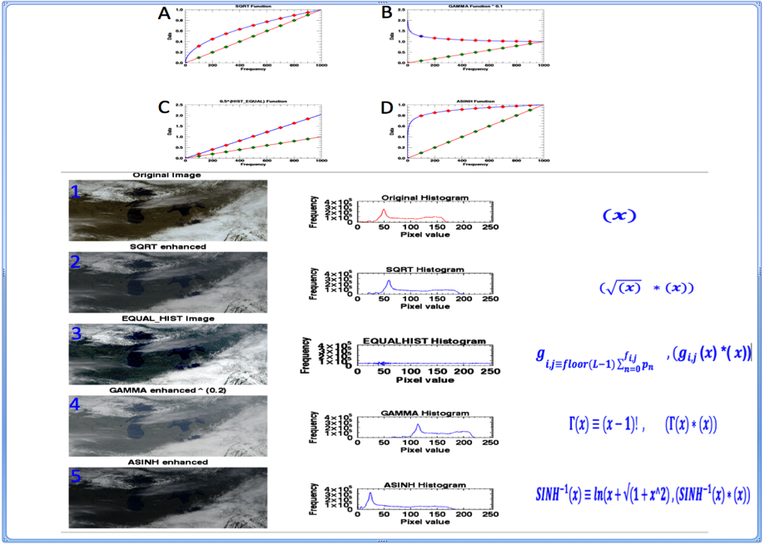
Figure 3. Shows the general effect of applying SQRT, HIST_EQUAL, GAMMA, and ASHINH to a sample dataset ranging between 0 and 1. The orange lines with green dots represents the input data. Blue lines with red dots shows the effect of applying the enhancement to the data. (1) shows a sample RGB image with no enhancement and its associated histogram on its right. (2,3,4,5) shows the effect of applying SQRT, HIST_EQUAL, GAMMA, and ASHINH enhancements to 1 and their associated histograms.
    - Square root enhancement: The square root enhancement is probably the most commonly used enhancement on GOES visible images. It is so common that some software systems such as the Man-computer Interactive Data Access System (McIDAS)-X automatically apply it to the past and current GOES series visible band (0.64 µm) when displaying images. An alternative way of accomplishing the same effect without directly interacting with the data is to apply a square root enhanced color bar to the data when displaying it. Generally, a single visible reflectance image when displayed with a linear gray scale color enhancement tends to be very dark on the lower end. Applying a simple square root function to the reflectance’s helps to boost the overall signal values but more on the lower end than on the upper end as show in Fig. 3A. This normally has the desired effect of brightening up the image, particularly the lower end values, which tend to be more towards the surface. For RGB, when applying an enhancement such as a square root, we tend to apply it to all three bands equally weighted by the input data from each channel. However, there is room to independently adjust them to enhance specific futures if desired.
    - Equalized Histogram: When applied to data for enhancement purposes, equalized histogram tends to do an excellent job enhancing an image, particularly the darker end of the image as shown in Fig 3C. However, care must be taken not to saturate the already bright parts of the image or unintentionally enhancing some noise within the image.
    - Gamma enhancement: The gamma is a highly sensitive function that can be used both for general enhancement and contrast adjustment within an image as shown in Fig 3B. When correctly applied to the individual bands, the gamma function can also help alleviate some of the haziness in an image such as those caused by Rayleigh scattering. However, it also has a great tendency to saturate the already bright pixels.
    - Inverse Hyperbolic Sine (ASINH) enhancement: The inverse hyperbolic sine enhancements generally tend to enhance the darker pixels of an image and slightly dampen the brighter pixels as shown in Fig 3D. This enhancement tends to maintain the overall nature of the data distribution but is often not enough to provide very vivid true color RGB images. It generally tends to do a great job for natural color when combined with an additional contrast enhancements

3 Flow diagram to make a GOES-16 true color RGB using the fractionally combining approach
3.1 The steps shown below are mainly meant to make simple natural or enhanced true color RGB images. If you want to make the final image more vivid, further enhancements might be required. For the natural color RGB, the images generally tend to be a little hazy with less contrast, so applying a contrast enhancement or a gamma function can help to further enhance the image. The histogram equalized on the other end tends to over enhance thereby making the clouds look saturated. To reduce saturation one can linearly dampen the entire image by taking ~ 80% of each channel or apply some other preferred enhancement that will reduce the over saturation.

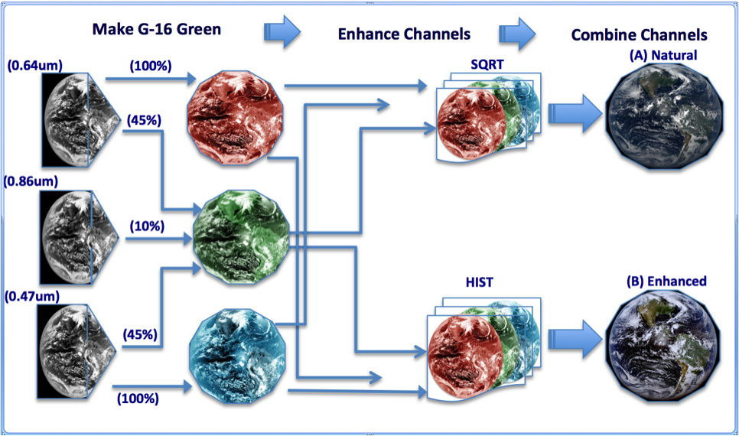
Figure 4. Flow diagram for making GOES-16 true color RGB using the fractionally combining approach for making the green band with a square root or histogram equalized enhancements for making a natural or enhanced color respectively

The steps to make a 16 bits per pixel true color RGB images following the fractionally combined approach as shown in the Fig. 4, flow diagram:
- Read in the Red (0.64 µm), Blue (0.47 µm), NIR (0.86 µm), and Scale each band to 16 bits. (Data can be scaled back to 8 bits before making RGB image if desired)
- Fractionally combine the Red, Blue and NIR to make a “green like” band.
- Check for out-of-range values then set the lower range to the minimum and upper ends to the maximum possible values.
- For natural color, make a square root enhancement for each channel (R, G, B) and apply to the enhancement to the associated data ($(\sqrt{(x)} *(x))$. Where “x” is the R, G or B input data.
- For enhanced color, make a histogram equalized enhancement for each channel similar to step (IV) above and apply to input data.
- Combine the new output (R, G, B) to make a Natural or enhanced RGB image.

4 Results of using GOES-16 data to make natural and enhance true color RGB images

4.1 The Earth Polychromatic Imaging Camera (EPIC) on board the Deep Space Climate Observatory (DSCOVR), is a ten channel spectroradiometer orbiting approximately 1 million miles away from earth at the Lagrangian 1 (L1) point. The EPIC team has had success in using three of these channels centered at Red (680 nm), Green (551 nm) and Blue (443 nm) to make Natural and Enhanced Color RGB images as shown at: https://epic.gsfc.nasa.gov/about.
  - CIMSS GOES-16 and the EPIC true color RGB for natural and enhanced

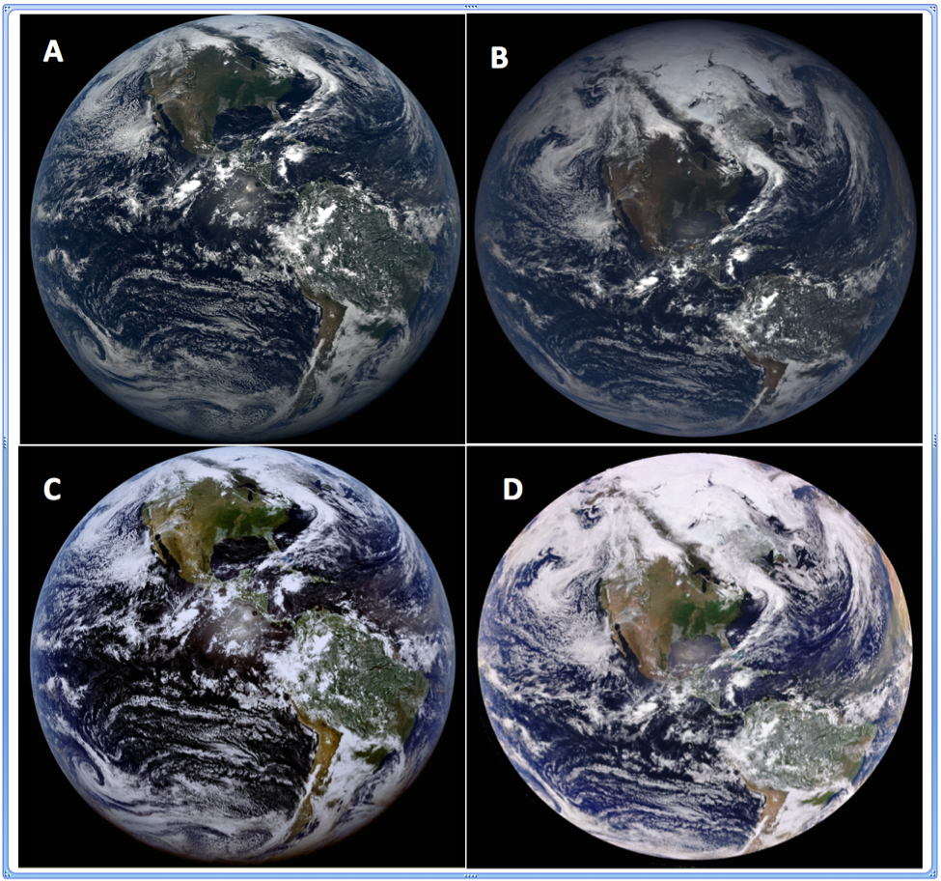
Figure 5. Comparing GOES-16 ABI true color RGB for (May 14th, 2017, 18:00 UTC) using the fractional combination approach to make the green as compared to EPIC (May 14TH, 2017, 18:03 UTC). (A) CIMSS natural color (with square root enhancement). (B) EPIC natural color. (C) CIMSS enhanced (with equalized histogram). (D) EPIC enhanced color.

As shown in Fig. 5, using the fractional combination approach for making a “green like” GOES-16 band along with the right enhancements can lead to very reasonable comparisons to other known natural and enhanced true color RGB images such as EPIC (which has a green band). While GOES-16 and EPIC are comparatively different in both orbital positions and resolutions (spatial, spectral and temporal), in addition to the missing green (0.55 µm) band on GOES-16, the comparisons are shown to be similar. Note that both images remain in their native projections. This is all in addition to using different mathematical functions for enhancement techniques. The GOES-16 green band for these comparisons was created using the Fractional combined approach discussed in section 2 .2.1. The main enhancements used in the GOES-16 RGB are the square root (natural color) and histogram equalized (enhanced color). For details on EPIC enhancements, visit the epic website: https://epic.gsfc.nasa.gov/about
  - Weighted Nudging approach to make GOES-16 natural true color RGB

This alternative way of making the green band can also be used to generate both natural and enhanced true color RGB images similar to the fractional combination approach. For this method, we found that applying an inverse hyperbolic sine function enhancement leads to a better natural color image compared to a simple square root as shown in Fig. 6.

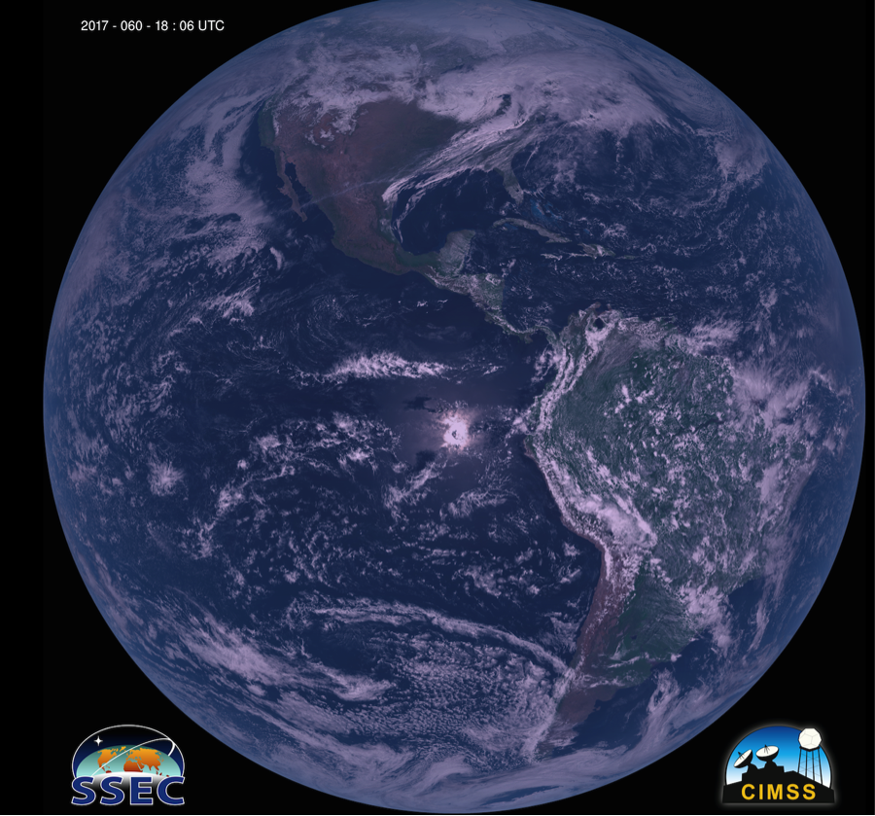
Figure 6. GOES-16 True color (natural) RGB image for February 29th, 2017, at 18:06 UTC. The green band in this case was generated using the weighted nudging approach with an inverse hyperbolic sine function enhancement applied.

  - Look Up Table (LUT) green with Rayleigh correction

The look-up table approach to determining a green band is detailed by Miller et al. (2012). This approach attempts to capture the non-linear relationships between green reflectance and the available blue, red, and near-infrared reflectance information. As a pre-processing step used to eliminate sun/sensor geometric dependencies (atmospheric signal variations), a correction for Rayleigh scatter is first applied. Scattering by the molecular atmosphere is most prominent in the blue band and falls off rapidly toward the near infrared, owing to the λ⁻⁴ dependency of Rayleigh optical depth. The correction provides a ‘cleaner’ view of the scene with more vivid coloration of surface features, having suppressed contributions from the clear-sky atmosphere. Special accommodations for deep convection and high sun/sensor geometry where the assumptions of the Rayleigh correction are violated or amplify uncertainties. As described in Section 2.1, this method in also enlists the hybrid adjustment—in this case applied to the synthetic green band. As such, the approach is termed the Synthetic Hybrid Atmospheric Correction (or SHAC) approach. An example of SHAC is shown in Fig. 7. Note the ability of SHAC to reveal the presence of Saharan dust over the Atlantic on the eastern limb, thanks in part to the Rayleigh corrections. Given the value of true color in readily distinguishing lofted mineral dust, SHAC will be evaluated by National Hurricane Center (NHC) forecasters during the Atlantic tropical season.

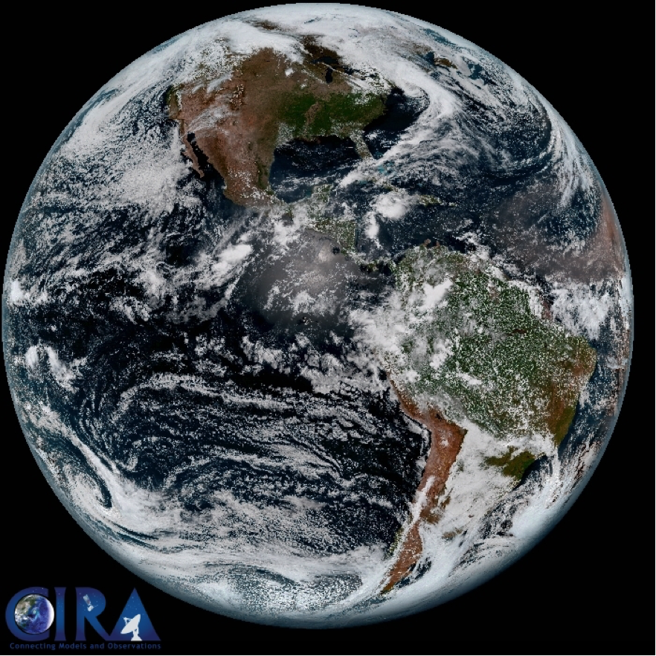

Figure 7. Example of Synthetic Hybrid Atmospherically Corrected (SHAC) true color imagery for the same full disk scene shown in Fig. 5

  - Natural features that are easily depicted in “enhanced” or “natural” color RGB images

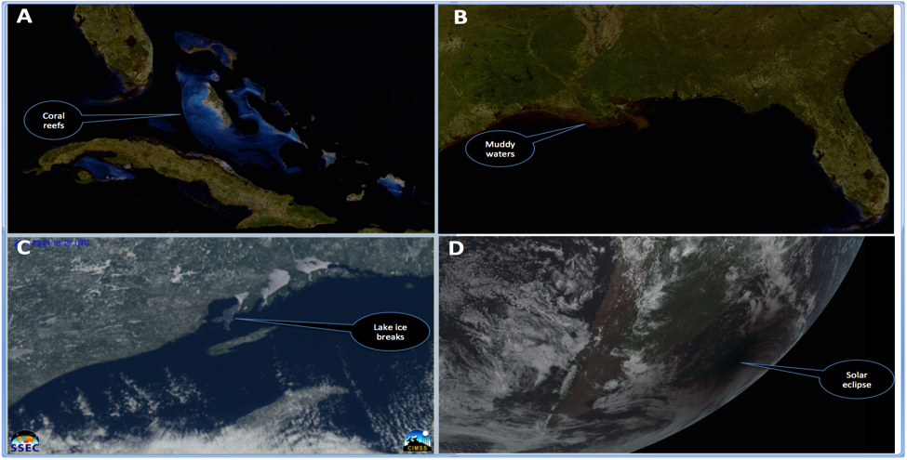

Figure 8. Samples natural features that are easily depicted in true color RGB images without any further required enhancements. (A) Coral reefs over the Caribbean Islands. (B) Muddy shallow waters off the coast of Louisiana. (C) Lake ice breaking in the Great Lakes. (D) Solar eclipse over the Atlantic Ocean. (A) and (B) above uses a CIMSS in house built GOES-16 cloud filter algorithm.

One major advantage of enhanced and natural color RGB images over individual visible channels is that of the features within the image becomes naturally easier to decipher without special training. Fig. 8A shows coral reefs in the Caribbean. Such features are almost impossible to identify in a visible channel, especially with a standard enhancement. Fig 8B shows muddy shallow waters off the Louisiana coast. Similar to Fig 8A, such features clearly stands out is the RGB images but nearly impossible to identify even in a series of visible channels, again using the standard enhancement. Fig 8C shows lake ice breaking over Lake Superior that clearly stood out in the GOES-16 natural color RGB. A loop of this can be found in the following link: http://data.ssec.wisc.edu/abi/true_color_imagery_paper_baetal_2017/ice3x.mp4. Fig 4D shows the February 26th, 2017 solar eclipse over South America. Though this was also seen the visible channels, it stands out much better in the RGB images. To see a sample loop of this event, visit the following link: http://cimss.ssec.wisc.edu/goes/blog/wp-content/uploads/2017/02/2017_SH_solar_eclipse_shadow_truecolor_anim.gif

4.6 Limitations

While true color RGB images offers great advantages over gray scale visible images, it also has some limitations that often requires non trivial efforts to correct for visualization effects some of which are shown in Fig 9.

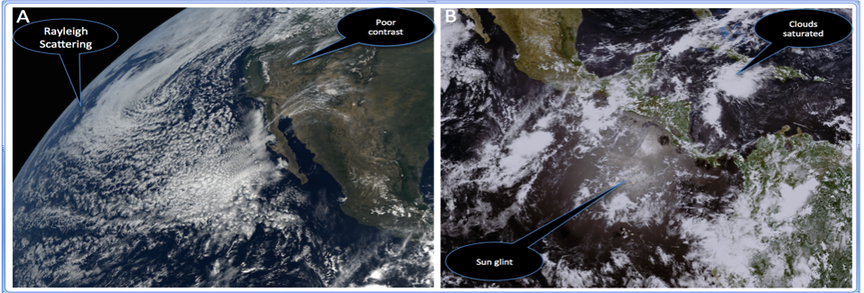
Figure 9. Sample of natural and true color GOES-16 RGB images highlighting some of the limitations that would require further enhancement for corrections. (A) Natural color showing Rayleigh scattering around edges over ocean and poor vegetation contrast over land. (B) Enhanced color showing sun glint effect over ocean and saturated high clouds due to their high reflectance components.

Fig 9A shows a GOES-16 natural true color RGB image without Rayleigh scattering corrections. In such images, it is common to see a general haziness over the image particularly over ocean towards the limb of the satellite-viewing angle. To correct for these, a Rayleigh scattering correction algorithm will be needed which requires information about the particular satellite viewing angles for each image. Fig 10B shows a GOES-16 enhanced true color RGB image showing the effect of sun glint over ocean. Similar to Fig 9A, if it is desired to visually eliminate such effects, further efforts will be needed to correct for it besides just making RGB images. This can be tricky and often requires bringing in more data but if done well, can greatly improve the overall visual effect of the final image.

5 Conclusions
A number of approaches have been documented to generate true color images from the ABI on the GOES-16. These approaches are complicated since the ABI does not have a “green” (0.55 µm) spectral band. Even with this limitation, fairly representative true color RGB images can be built. The method for generating color images is discussed, along with corresponding examples from the EPIC. Following guidelines highlighted in this paper, algorithms for generating GOES-16 true color RGB images on the fly was successfully developed and evaluated at the National Weather Service (NWS) Operations proving Ground (OPG). This makes it possible for Advanced Weather Interactive Processing System (AWIPS-II) users to automatically generate GOES-16 true color RGB images relying entirely on already existing goes-16 data within their local environment.

Acknowledgments

The authors of this paper would like to thank the additional UW-Madison CIMSS imagery team members (James P. Nelson, III, Joleen Feltz, Hong Zhang) and the SSEC Data Center for all the support and help they have provided to make this publication possible. All are thanked that helped with the research, testing, coding, integrating, transporting, launching and check-out of the GOES-16 ABI. To experiment with combining ABI bands to build color composite imagery, see: http://cimss.ssec.wisc.edu/goes/webapps/satrgb/satrgb_ABI_fd_realtime.html or http://cimss.ssec.wisc.edu/goes/webapps/satrgb/satrgb_ABI_2017_14May_18utc_fd.html. Data supporting the analysis and conclusions in this paper can be accessed through the NOAA CLASS (Comprehensive Large Array-data stewardship System): https://www.class.ncdc.noaa.gov. At the time of writing, NOAA’s GOES-16 satellite was non operational and all data were preliminary. Views, opinions, and findings contained in this report are those of the authors and should not be construed as an official National Oceanic and Atmospheric Administration or U.S. Government position, policy, or decision. This work was supported, in part, via NOAA grant number NA15NES4320001.

References

Baldridge, A. M., S.J. Hook, C.I. Grove and G. Rivera, 2009. The ASTER Spectral Library Version 2.0. Remote Sensing of Environment, vol 113, pp. 711-715.

Bessho, K., and Coauthors, 2016: An introduction to Himawari-8/9—Japan’s new-generation geostationary meteorological satellites. J. Meteor. Soc. Japan, 94, 151–183, doi:10.2151/jmsj.2016-009.

Greenwald, T., and Coauthors, 2016: Real-time simulation of the GOES-R ABI for user readiness and product evaluation. Bull. Amer. Meteor. Soc., 97, 245–261, doi:10.1175/BAMS-D-14-00007.1.

Kalluri, S., J. Gundy, B. Haman, A. Paullin, P. Van Rompay, D. Vititoe, and A. Weiner, 2015: A high performance remote sensing product generation system based on a service oriented architecture for the next generation of Geostationary Operational Environmental Satellites. Remote Sens., 7, 10 385–10 399, doi:10.3390/rs70810385.

Lensky, I.M. and Rosenfeld, D., 2008: Clouds-aerosols-precipitation satellite analysis tool (CAPSAT). Atmospheric Chemistry and Physics, 8(22), pp.6739-6753.

Miller, S. D., C. C. Schmidt, T. J. Schmit, and D. W. Hillger, 2012: A case for natural colour imagery from geostationary satellites, and an approximation for the GOES-R ABI. Int. J. Remote Sens., 33, 3999–4028, doi:10.1080/01431161.2011.637529.

Miller, S. D., T. J. Schmit, C. Seaman, D. T. Lindsey, M. M. Gunshor, R. A. Kohrs, Y. Sumida, and D Hillger, 2016: A sight for sore eyes—The return of true color to geostationary satellites. Bull. Amer. Meteor. Soc., 97, 1803–1816, doi:10.1175/BAMS-D-15-00154.1.

Schmit, T.J., and Coauthors, 2015: Rapid Refresh information of significant events: Preparing users for the next generation of geostationary operational satellites. Bull. Amer. Meteor. Soc., 96, 561–576, doi:10.1175/BAMS-D-13-00210.1.

Schmit, T. J., P. Griffith, M. M. Gunshor, J. M. Daniels, S. J. Goodman, and W. J. Lebair, 2017: A closer look at the ABI on the GOES-R series. Bull. Amer. Meteor. Soc., 98, 681-698, doi:10.1175/BAMS-D-15-00230.1.

Stuhlmann, R., A. Rodriguez, S. Tjemkes, J. Grandell, A. Arriaga, J.-L. Bézy, D. minou, and P. Bensi, 2005: Plans for EUMETSAT’s Third Generation Meteosat (MTG) Geostationary Satellite Program. Adv. Space Res., 36, 975–981.

Suomi, V. E., and R. Parent, 1968: A color view of Planet Earth. Bull. Amer. Meteor. Soc., 49, 74–75.

Yang, J., Z. Zhang, C. Wei, F. Lu, and Q. Guo, 2017: Introducing the new generation of Chinese geostationary weather satellites - FengYun 4 (FY-4). Bull. Amer. Meteor. Soc. doi:10.1175/BAMS-D-16-0065.1, in press.

