

NOAA NESDIS
Center for Satellite Applications and Research

GOES-R Advanced Baseline Imager (ABI) Algorithm Theoretical Basis Document
For
Cloud and Moisture Imagery (CMIP)

Tim Schmit, NOAA/NESDIS/STAR
Wenhui Wang, IMSG Inc.
Gang Fu, PSGS

Version 3.0
September 25, 2009

TABLE OF CONTENTS
TABLE OF CONTENTS 2
LIST OF FIGURES 4
LIST OF TABLES 4
ACRONYMS 5
ABSTRACT 6
1 INTRODUCTION 6
1.1 Purpose of This Document 6
1.2 Who Should Use This Document 6
1.3 Inside Each Section 7
1.4 Related Documents 7
1.5 Revision History 7
2 PRODUCT OVERVIEW 9
2.1 Products Generated 9
2.2 Instrument Characteristics 9
2.3 Product Requirement Description 10
3 ALGORITHM DESCRIPTION 13
3.1 Algorithm Overview 13
3.2 Processing Outline 14
3.3 Algorithm Input 14
3.4 Theoretical Description 15
3.4.1 Radiometric Calibration 15
3.4.1.1 Converting Scaled Reflectance to TOA Reflectance (bands 1-6) 15
3.4.1.2 Converting Scaled Radiance to Spectral Radiance (bands 7-16) 16
3.4.1.3 Converting Spectral Radiance to BT (bands 7-16) 16
3.4.2 Mapping Reflectance and Brightness Temperature to BV 18
3.4.2.1 Bi-Linear Stretch 19
3.4.2.2 Square Root Stretch 19
3.5 Algorithm Output 20
4 TEST DATA SETS AND OUTPUTS 22
4.1 GOES-R Simulated Input Data Sets 22
4.2 Output from Simulated ABI Data Sets 28
4.2.1 Imagery Generated from Simulated ABI Data 28
4.2.2 Precisions and Accuracy Estimation 35
4.2.3 Error Budget 37
5 PRACTICAL CONSIDERATIONS 37
5.1 Numerical Computation Considerations 37
5.2 Programming and Procedural Considerations 38
5.3 Quality Assessment and Diagnostics 38
5.4 Exception Handling 39
5.5 Algorithm Validation 39
6 ASSUMPTIONS AND LIMITATIONS 40
6.1 Assumed Sensor Performance 40
6.2 Pre-Planned Product Improvements 40
6.2.2 Quality Control Indicators 40
7 REFERENCES 41
ACKNOWLEDGEMENTS 42

LIST OF FIGURES
Figure 1 High level flowchart for generating CMIP 13
Figure 2 ABI Band 2 stored as a McIDAS AREA displayed in McIDAS-X 23
Figure 3. ABI Band 14 stored as a McIDAS AREA displayed in McIDAS-X 23
Figure 4. ABI Band 1 stored as a NetCDF displayed in McIDAS-V 24
Figure 5. ABI Band 7 stored as a NetCDF displayed in McIDAS-V 25
Figure 6. ABI Bands 1-6 converted to an AWIPS-ready NetCDF and displayed in AWIPS 26
Figure 7. ABI Bands 9-16 converted to an AWIPS-ready NetCDF and displayed in AWIPS 26
Figure 8. Reflectance of ABI Band 1 at 22:00 UTC on 05 June 2005 displayed in McIDAS 27
Figure 9. Brightness Values of ABI Band 1 at 22:00 UTC on 04 June 2005 displayed in McIDAS 28
Figure 10. Radiance of ABI Band 7 at 22:00 UTC on 04 June 2005 displayed in McIDAS 29
Figure 11. Brightness Temperature of ABI Band 7 at 22:00 UTC on 04 June 2005 displayed in McIDAS 30
Figure 12. Brightness Value derived from simulated ABI Band 7 data at 22:00 UTC on 04 June 2005 displayed in McIDAS 31
Figure 13. ABI band 4 (1.38 um) simulation of hurricane Katrina at 22 UTC on September 28, 2005. 35
Figure 14. ABI band 15 (12.3 um) simulation of the Pacific at 137 West longitude at 20 UTC on June 26, 2008. 36
Figure 15. The ‘stepped-edge’ approach of the ABI FD scan 39

LIST OF TABLES
Table 1. GOES-R ABI instrument characteristics (the spatial resolution reflects the sub-point value). 9
Table 2. CMIP Requirements 10
Table 3. Slope and intercept (TBV, the Min/Max Values are given in radiance units of mW/(m2•sr•cm⁻¹)) 13
Table 4. Table of Planck Coefficients (TBV) 15
Table 5. Table of Planck Coefficients. These values are based on the Gaussian-Hybrid version of the ABI mock SRF (ftp://ftp.ssec.wisc.edu/ABI/SRF/) 15
Table 6 Fields in CMIP single-band imagery products (the band center frequency information is the area under the curve weighted value and could be stored in a header) 19
Table 7. Fields in CMIP multi-band imagery products (the band center frequency information is the area under the curve weighted value and could be stored in a header) 19
Table 8. Comparison results of generated Imagery products and validation data serving as GOES-R ABI proxy data for the GOES-R CMIP 30

ACRONYMS
ABI – Advanced Baseline Imager
AIT – Algorithm Integration Team
ATBD – Algorithm Theoretical Basis Document
AWG – Algorithm Working Group
AWIPS – Advanced Weather Interactive Processing System
BT – Brightness Temperature
BV – Brightness Values
CMIP – Cloud and Moisture Imagery Product
CONUS – Continental United States
DC – Digital Count
FD – Full Disk
GRB – GOES ReBroadcast
GVAR – GOES Variable
IR – InfraRed
KPP – Key Performance Parameter
McIDAS – Man computer Interactive Data Access System
MTF – Modulation Transfer Function
SNR – Signal-to-Noise Ratio
SRF – Spectral Response Function
TBD – To Be Determined
TBV – To Be Verified
TOA – Top Of Atmosphere
VAGL - Vendor-Allocated Ground Latency

ABSTRACT

This document provides a theoretical description of the algorithms used by the Cloud and Moisture Imagery Product (CMIP) from the Advanced Baseline Imager (ABI) onboard the GOES-R series. The topics covered in this document include requirements for CMIP algorithms and software system, description of CMIP key algorithms, test data sets and outputs, practical considerations and assumptions and limitations.

The GOES-R ABI is designed to observe the Western hemisphere in various intervals and at 0.5, 1, 2 km spatial resolutions in visible, near-IR, and IR wavelengths, respectively. The ABI has two main scan modes, the most likely will allow full disk imagery every 15 minutes, along with the CONUS every 5 minutes and a meso-scale as often as every 30 sec. CMIP is the ABI tier 1A and key performance parameter (KPP) product, including 16 ABI single-band images for 3 coverage areas plus 3 multi-band spectral products in NetCDF and McIDAS formats, which will be used as input data by various other algorithms.

GOES-R ABI CMIP algorithms have been tested on ABI simulated data covering the CONUS area. The generated image files have been compared with the validation data generated by the research code, and the images are numerically identical.

1 INTRODUCTION

Purpose of This Document
The primary purpose of this algorithm theoretical basis document (ATBD) is to provide a theoretical description (scientific and mathematical) of the algorithms used by the Cloud and Moisture Imagery Product (CMIP) from the Advanced Baseline Imager (ABI) onboard the GOES-R series of NOAA geostationary meteorological/environmental satellites. CMIP is the ABI tier 1A and Key Performance Parameter (KPP) product.
Cloud and Moisture Imagery algorithms produce digital maps of clouds, moisture, and atmospheric windows, through which land and water are observed, by reporting reflectance and radiance measurements for visible, near-IR and IR bands, respectively. For visible bands, the reflectance (or reflectance factor) can be converted to digital counts, ranging from 0-255. Information will also be provided on the conversion to radiance values. For IR bands, the radiances can be converted first to brightness temperature and then digital counts, again ranging from 0-255. Cloud and Moisture Imagery provides input to other algorithms producing other environmental products (same as CONUS product except this version provides mesoscale coverage).

Who Should Use This Document
The intended users of this document include algorithm reviewers, who would understand the theoretical basis of CMIP, product users, who would use the product in an operational task, scientific programmers, who would develop new algorithms, and system administrator, who would maintain the software.

Inside Each Section
This document consists of following main sections:
- Product Overview: provides relevant details of the ABI and a brief description of the products generated by the algorithm.

- Product Requirement Description: provides the detailed requirements for the CMIP key algorithms and software system.

- Algorithm Description: provides the details for CMIP processing outline, input/output parameters and key algorithms.

- Test Data Sets, and Output: provides a description of the test data sets used to characterize the performance of the algorithms and quality of the data products. It also describes the results of using test data sets.

- Practical Considerations: provides a description of the issues involving CMIP software system programming, quality assessment, diagnostics, and exception handling.

- Assumptions and Limitations: provides an overview of the current assumption and limitations of the approach and a plan for overcoming these limitations with further algorithm development.

Related Documents
GOES-R Ground Segment (GS) Functional and Performance Specification (F&PS).

GOES-R Series Ground Segment Project Notional Transition from GVAR to GRB Operations Plan

GOES-R Mission Requirements Document

Revision History
Version 0.1 was created by Wenhui Wang of NOAA/NESDIS/STAR and I. M. System Groups to accompany the delivery of the version 0.1 algorithm to the GOES-R AWG Algorithm Integration Team (AIT). T. Schmit added several sections.

Version 1.0 of this document was the official adaptation of Version 0.1.

Version 2.0 was developed by Gang Fu of NOAA/NESDIS/STAR and PSGS based on the GOESR Imagery CDR and TRR to meet 80% ATBD requirement. This version was reviewed by many, including T. Schmit of NOAA/NESDIS/STAR.

Version 3.0 was completed by T. Schmit (and others), leveraging the many comments from the IV&V reviewer.

2 PRODUCT OVERVIEW
This section describes the CMIP and the requirements it places on the system.

2.1 Products Generated
The CMIP is responsible for ABI clouds and moisture imagery, and will produce 54 total end-products, including:
- 16 ABI single-band products (TOA reflectance in bands 1-6 and radiance in bands 7-16) for 3 coverage areas
- Multi-band spectral products (16 bands at 2 km resolution) for 3 coverage areas in NetCDF4 format
- Multi-band spectral products (16 bands at 2 km resolution) for 3 coverage areas in McIDAS format
Additionally, the CMIP end-products will include the information about the methods of converting TOA reflectance to radiance and BV (Brightness Value) for bands 1-6, and converting radiance to brightness temperature (BT) and then to BV for bands 7-16. The BV is a low-precision brightness value for a pixel on a display.

2.2 Instrument Characteristics
The ABI on GOES-R has 16 spectral bands. The selection of each was covers a variety of environmental applications. ABI Infrared (IR) bands have been chosen to coincide either with spectral absorption features (including those of water vapor bands or CO₂ bands) or with regions having little absorption (atmospheric windows) that permit observations of the surface. Visible and near-IR bands have been chosen in windows in order to sense lower tropospheric cloud cover (including fog) and the Earth’s surface (NOAA/NESDIS 2007).
Table 1. GOES-R ABI instrument characteristics. summarizes the instrument (nominal) central wavelength, spatial resolution (at the sub-point), and bit-depth characteristics of the ABI. The instrument has two basic modes of operation:
- Every 15 minutes, ABI will scan the full disk (FD) once, plus the continental United States (CONUS) three times (every 5 minutes). A selectable 1000 km × 1000 km mesoscale area will be scanned every 30 seconds. This has been referred to as mode 3 (or ‘flex’ mode).
- The ABI can be programmed to scan the FD iteratively. The FD image can be acquired in approximately 5 minutes (Schmit et al. 2005). The mode as been referred to as mode 4 (or the Continuous Full Disk (CFD)).

Band Number | Central Wavelength (μm) | Spatial Resolution  (km) | Bit-Depth  (Expected) | Used in Cloudy and Moisture Imagery
1 | 0.47 | 1 | 14 | X
2 | 0.64 | 0.5 | 12 | X
3 | 0.865 | 1 | 14 | X
4 | 1.378 | 2 | 14 | X
5 | 1.61 | 1 | 14 | X
6 | 2.25 | 2 | 14 | X
7 | 3.90 | 2 | 14 | X
8 | 6.19 | 2 | 14 | X
9 | 6.95 | 2 | 14 | X
10 | 7.34 | 2 | 14 | X
11 | 8.5 | 2 | 14 | X
12 | 9.61 | 2 | 14 | X
13 | 10.35 | 2 | 14 | X
14 | 11.2 | 2 | 14 | X
15 | 12.3 | 2 | 14 | X
16 | 13.3 | 2 | 14 | X
Table 1. GOES-R ABI instrument characteristics.

The CMIP will be produced using all 16 bands in three coverage areas: FD, CONUS, and mesoscale. Bands 1-6 are “visible bands” (and include near-IR) and bands 7-16 are considered as “IR bands.” The performance of the CMIP is sensitive to any imagery artifacts or instrument noise, calibration accuracy, and geolocation accuracy.

2.3 Product Requirement Description
The CMIP performance requirements are derived from the GOES-R Series Ground Segment (GS) Functional and Performance Specification (F&PS) (NOAA/NASA 2008). The software system that generates routine CMIP shall meet the following requirements:
- The system should be able to convert ABI scaled reflectance obtained from the GOES ReBroadcast (GRB) data stream (L1B) into reflectance factor for bands 1-6 and convert GRB scaled radiance (L1B) to spectral radiance for bands 7-16.

- The system should define the process for converting radiance to brightness temperature (BT) for IR bands.

- The system should define the process for converting TOA reflectance to BV for bands 1-6 and converting radiance to brightness temperature and then BV for bands 7-16. BV would be at least 8-bit, but it could support higher bit depths.

- The conversion methods and the associated parameters should be embedded in CMIP end-products. Besides, users can still employ their own enhancements to the data values.

- The CMIP end-products should be produced in NetCDF (version 4) and McIDAS formats. The system should ensure that these end-products could be converted into other formats, such as HDF (TBV). The NetCDF format will be Climate and Forecasts (CF) conventions compliant. More information can be found at: http://cf-pcmdi.llnl.gov

- The CMIP should contain the geolocation information extracted from the input data stream (TBV).

- The CMIP shall include metadata.

- The system shall implement an interface to access input data and to store the generated products.

- The GOES-R system shall produce CMIP in accordance with the requirements listed in Table 2. CMIP Requirements:

 | Threshold
Geographic Coverage/Conditions | CONUS | FD |  | Mesoscale
Vertical Resolution | N/A | N/A |  | N/A
Horizontal Resolution | 2 km, with finer daytime resolution
Mapping Accuracy | 1 km | 1 km |  | 1 km
Measurement Range | N/A | N/A |  | N/A
Refresh Rate/  Coverage Time (Mode 3) | 5 min | 15 min |  | 30 sec
Refresh Rate/  Coverage Time (Mode 4) | 5 min | 15 min
VAGL | 50 sec | 50 sec |  | 23 sec
Product Measurement Precision | N/A | N/A |  | N/A
Temporal Coverage Qualifier | Day and Night
Product Extent Qualifier | Quantitative out to at least 60 degrees LZA (Threshold) and qualitative at larger LZA
Cloud Cover Conditions Qualifier | In presence of clear air and clouds | In presence of clear air and clouds |  | In presence of clear air and clouds
Product Statistics Qualifier | Over specified geographic area
Primary Instrument | ABI
Prioritization | 1A
Table 2. CMIP Requirements

3 ALGORITHM DESCRIPTION
This section describes the CMIP software system processing outline, input/output parameters, and key algorithms at their current level of maturity (will be improved with each revision).

3.1 Algorithm Overview
The CMIP algorithms consist of radiometric calibration and mapping TOA reflectance and BT to BV. The BV are used as indices either to customized color tables or to the red/green/blue color guns of a composite image, resulting in enhanced imagery intending to highlight environmental features of interest. The GOES-R ABI CMIP radiometric algorithms are based on GOES 8-13 algorithms (Weinreb et al. 1997; Schmit et al 1991). Algorithms for mapping TOA reflectance and BT to BV are based on examples from the literature (Acharya and Ray 2005; Russ 2002), commercial remote sensing data visualization tools (e.g., ENVI and PCI), and open source tools (e.g. McIDAS-X/V and IDV). Some display systems may be capable of displaying more that 8-bit (or 256 levels). The bit-depth of the end-products for CMIP is TBD.
Given the proper amount of ancillary data, the reflectance data can be converted, if needed into radiance units. This is generated using what is called the ‘kappa factor’ to convert from reflectance to radiances (W / (m2 ster µm)). Inputs needed are the inband solar irradiance at 1 AU (E_sun) for each of the first six ABI bands, a correction for the mean earth-sun distance and the value of pi. The relationship is the reflectance (factor) times the E_sun, divided by pi and the distance correction squared.
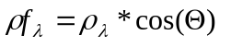 (3-1)
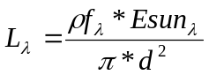 (3-2)

Radiometric calibration and mapping algorithms are responsible for:
- Converting the scaled reflectance from the input data stream to an unscaled reflectance (bands 1-6)
- Converting unscaled TOA reflectance to BV (bands 1-6)
- Re-sampling bands 1, 2, 3, and 5 from 1 km to 2 km for multi-band product
- Converting scaled radiance from the input data stream to an unscaled spectral radiance (bands 7-16)
- Converting the unscaled spectral radiance to equivalent BT (bands 7-16)
- Converting BT to BV (bands 7-16)

3.2 Processing Outline
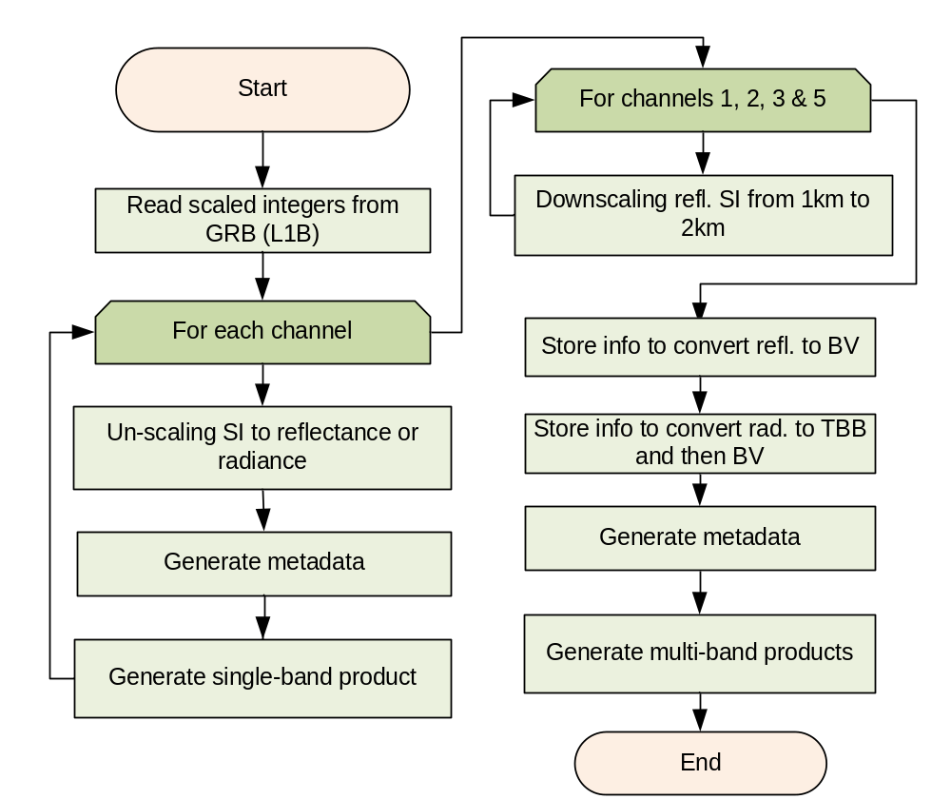
Figure 1 High level flowchart for generating CMIP

3.3 Algorithm Input
The input data to the CMIP algorithm is the scaled GRB data (level 1b; provided as digital counts), scaling coefficients and calibration coefficients (also available from the GRB data stream). The scaling coefficients are used to convert scaled GRB data to unscaled TOA reflectance (factor) for bands 1-6 and to radiance for bands 7-16, respectively. The calibration coefficients are related to the Planck conversion to brightness temperatures.
The details regarding the actual format and data structures of the GRB will be determined by the Harris Ground System implementation and hence are not covered in detail in this document.
Table 3. Slope and intercept (TBV, the Min/Max Values are given in radiance units of mW/(m2•sr•cm-1)) shows the slope and intercept using in conversion to (and from) Scaled Integers values based on work by Hillger and Schmit (2004). The slope and intercept are chosen from a trade-off of two competing interests: 1) accommodate all realistic values of scene radiance for a given band, and 2) use the full dynamic range to maximize the radiometric resolution of the data (Schmit et al 1991). In CMIP, scale coefficients (slopes and intercepts in Table 3) are also used to convert scaled data to un-scaled quantities.

Band Number | Central Wavelength (μm) | Min Value | Max Value | Slope | Intercept
1 | 0.47 | -0.05 | 1.15 | 0.0000733 | -0.0500733
2 | 0.64 | -0.05 | 1.15 | 0.0002931 | -0.0502931
3 | 0.86 | -0.05 | 1.15 | 0.0000733 | -0.0500733
4 | 1.38 | -0.05 | 1.15 | 0.0000733 | -0.0500733
5 | 1.61 | -0.05 | 1.15 | 0.0000733 | -0.0500733
6 | 2.26 | -0.05 | 1.15 | 0.0000733 | -0.0500733
7 | 3.9 | -0.02 | 25.0 | 0.0015273 | -0.0215273
8 | 6.15 | -0.25 | 28.1 | 0.0017306 | -0.2517306
9 | 7.0 | -0.45 | 45.3 | 0.0027927 | -0.4527927
10 | 7.4 | -0.50 | 80.2 | 0.0049261 | -0.5049261
11 | 8.5 | -0.65 | 135.4 | 0.0083048 | -0.6583048
12 | 9.7 | -0.80 | 109.2 | 0.0067147 | -0.8067147
13 | 10.35 | -0.85 | 184.4 | 0.0113081 | -0.8613081
14 | 11.2 | -0.85 | 200.0 | 0.0122604 | -0.8622604
15 | 12.3 | -0.85 | 213.2 | 0.0130662 | -0.8630662
16 | 13.3 | -2.65 | 171.7 | 0.0106428 | -2.6606428
Table 3. Slope and intercept (TBV, the Min/Max Values are given in radiance units of mW/(m2•sr•cm⁻¹))
Coefficients for converting data to TOA reflectance or radiance/BT are also input parameters for CMIP. They may be obtained from GRB data stream (TBV).
The fixed grid coordinates and QC flags are also extracted from the GRB data stream.

3.4 Theoretical Description

3.4.1 Radiometric Calibration

3.4.1.1 Converting Scaled Reflectance to TOA Reflectance (bands 1-6)
The TOA reflectance factor is derived from the SI value. A linear conversion is required:
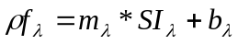 (3-3)
where 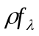 is TOA reflectance; 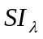is digital counts of the scaled reflectance; 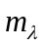 and 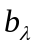 are scaling coefficients obtained from the GRB data stream.

3.4.1.2 Converting Scaled Radiance to Spectral Radiance (bands 7-16)
To obtain BT, the scaled radiance from the input data stream will first be converted to spectral radiance:
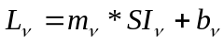 (3-4)
where  is spectral radiance (mW/(m2 ster cm-1)) for an ABI band characterized by central wavenumber ν, 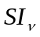is digital counts of the scaled radiance, and  and  are calibration coefficients obtained from the GRB data stream.

3.4.1.3 Converting Spectral Radiance to BT (bands 7-16)
Spectral radiance will be converted to BT using two steps (Weinreb et al. 1997). The first step is to convert spectral radiance to effective temperature using inverse Planck Function:
 (3-5)
where  is the effective temperature,  and are two constants ( = 1.191066 x 10⁻⁵ [mW/(m²-sr-cm⁻⁴)]; = 1.438833 (K/cm⁻¹)), is spectral radiance, and  is the central wavenumber of the channel.

The second step converts effective temperature to BT (K):
 (3-6)
where and depend on band and detector (TBV) and are summarized in Table 4.
Band Number | Central Wavelength (μm) | Central Wavenumber
1 | 0.47 |  | N/A | N/A
2 | 0.64 |  | N/A | N/A
3 | 0.86 |  | N/A | N/A
4 | 1.38 |  | N/A | N/A
5 | 1.61 |  | N/A | N/A
6 | 2.26 |  | N/A | N/A
7 | 3.9 | 2564
8 | 6.15 | 1617
9 | 7.0 | 1439
10 | 7.4 | 1362
11 | 8.5 | 1176
12 | 9.7 | 1041
13 | 10.35 | 966
14 | 11.2 | 893
15 | 12.3 | 813
16 | 13.3 | 752
Table 4. Table of Planck Coefficients (TBV)

A parallel method of Planck Function constants has been used to make the conversion between radiance (mW/(m²-sr-cm⁻¹) and BT or vice versa. To convert from radiance to temperature (kelvins):
T = [ fk2 / (alog((fk1 / ) + 1)) - bc1 ] / bc2 (3-7)
To convert from temperature (K) back to radiance (mW/(m²-sr-cm⁻¹):
= fk1 / [ exp (fk2 / (bc1 + (bc2 * T))) - 1 ] (3-8)
The two methods are needed given they both have expansive user bases with the current GOES system. The parameters in the two methods are listed in Table 5. Note that these values will need to be updated with the flight SRF.
Band Number | Central Wavelength (μm) | Central Wavenumber (μm⁻¹) | fk1 | fk2 | bc1 | bc2
7 | 3.9 | 2564 | 2.00800E+05 | 3.68920E+03 | 0.51139 | 0.99928
8 | 6.15 | 1617 | 5.03710E+04 | 2.32670E+03 | 2.11916 | 0.99543
9 | 7.0 | 1439 | 3.55010E+04 | 2.07060E+03 | 0.33222 | 0.99921
10 | 7.4 | 1362 | 3.00990E+04 | 1.95980E+03 | 0.07096 | 0.99982
11 | 8.5 | 1176 | 1.93780E+04 | 1.69220E+03 | 0.17913 | 0.99949
12 | 9.7 | 1041 | 1.34420E+04 | 1.49800E+03 | 0.10525 | 0.99967
13 | 10.35 | 966 | 1.07400E+04 | 1.39000E+03 | 0.13202 | 0.99956
14 | 11.2 | 893 | 8.48600E+03 | 1.28500E+03 | 0.24744 | 0.99912
15 | 12.3 | 813 | 6.40380E+03 | 1.16990E+03 | 0.26205 | 0.99898
16 | 13.3 | 752 | 5.06800E+03 | 1.08220E+03 | 0.07139 | 0.99970
Table 5. Table of Planck Coefficients. These values are based on the Gaussian-Hybrid version of the ABI mock SRF (ftp://ftp.ssec.wisc.edu/ABI/SRF/).

The relationship between the two approaches is:
fk1 =  (3-9)
fk2 =  (3-10)
bc1 = -α/β (3-11)
bc2 = 1/β (3-12)

Finally, another method uses the fk1 and fk2, along with the central wavelength to derive the bc1 and bc2 internally. It is this methodology that has been coded for the GOES-R AWG usage.

fk1 = C1 * WaveNumber ** 3 (3-13)
fk2 = C2 * WaveNumber (3-14)

Var_Tmpy = log(1.0 + fk1 / Radiance) (3-15)
Var_Tmpy = fk2 / Var_Tmpy (3-16)

Brt_Temp = ( Var_Tmpy - bc1) / bc2 (3-17)

3.4.2 Mapping Reflectance and Brightness Temperature to BV
The TOA reflectance and BT calculated from spectral radiance are floating point numbers. The method for mapping TOA reflectance and BT to integer BV (8-bit or more, TBV) are described in this section.

The Square-Root stretch method is recommended to be used for converting TOA reflectance to BV for the visible bands. The advantages and disadvantages of this method are summarized as follows:
- Advantages:
  - Covers more temperature range than a 1K/1Count stretch
  - Heritage
  - Efficient
  - Algorithm is mature
- Disadvantages:
  - Not as straight forward as a linear stretch

The Bi-Linear stretch method is recommended to be used for converting brightness temperature to BV for IR bands. The advantages and disadvantages of this method are summarized as follows:
- Advantages:
  - Highlights important features that would have been too dark
  - Heritage
  - Low risks
  - Efficient
  - Algorithm is mature
- Disadvantages:
  - Not as straight forward as a linear stretch

The square-root method (for the visible and near-IR bands) and a bi-linear method (for the IR bands) are recommended, because there is a long history in both McIDAS and AWIPS of employing a bi-linear approach for the IR bands and a square-root function for the reflective bands.

Alternatively, user can employ other methods, similar to methods used in image enhancement, to convert TOA reflectance and BT to 8-bit (or other bit-depth) scaled BV.

3.4.2.1 Bi-Linear Stretch
The linear scaling method provides a linear amplitude transformation of input reflectance or radiance/BTs to output BV.
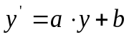 (3-18)
where 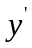is the new brightness value,is the original value (TOA reflectance or radiance/BT).

Often, a bi-linear equation is applied. This allows for two slopes at either side of a break point. For example, if the BT is less then 242 K, then = 418 – T; while for value equal or great than 242 K, then = 660 – (2 * T).

3.4.2.2 Square Root Stretch
Power law stretch is a nonlinear algorithm that changes image brightness according to:
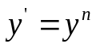 (3-19)
where is the new brightness value, is the original value, and n is the power scaling coefficient. If n > 1, high values are enhanced disproportionately with respect to low values. If n < 1, low BV are enhanced disproportionately with respect to high values.

Square enhancement is a special case of the power law stretching (n=2). It compresses the brighter end of spectrum and stretches the darker end. The image gray levels are shifted towards the higher end so the image appears brighter in comparison to the linearly scaled result.

Square root enhancement is another special case of the power law stretch (n=1/2). It compresses the upper end of spectrum and stretches the lower end. This method has been used for decades when displaying GOES visible data (and for many years for AWIPS displays). Reflectance factors darker than 0 would be mapped to a 0 BV, while values greater than 1 will be mapped to 255 (in an 8-bit system).

(3-20)

Where NINT (or IDINT) is the “nearest integer” and SQRT is the Square-root function.

3.4.3 Re-sampling Algorithm

To produce CMIP multi-band end-products, it is necessary to re-sample the scaled reflectance from 1km to 2 km for visual bands (1, 3 & 5), since the spatial resolution of the data in multi-band products is 2 km while the resolution of scaled reflectance of bands 1, 3 and 5 is 1 km originally.

The re-sampling algorithm is applied to downscale the data and it is described as follows:

, (3-21)
where  is the re-sampled data and  is the original data. The current algorithm simply sub-samples.

The ABI band 2 spatial resolution is 0.5 km nominally, so more ‘down-scaling’ is needed for the multi-band files.

The advantages of using this algorithm include:
- Quicker
- Traceable, less “blurry”
- Doesn’t create artificial values
  - If the scene has a bi-modal distribution
- Straight forward (due to resolutions nested in one another)
In addition, uses that need the full resolution data could still access the full resolution files (e.g., not the multi-band files).

An advantage of spatially averaging is that it can improve the signal-to-noise ratio and it may more closely match the 2 km IR bands with respect to implicit ‘area averaging’. The final methodology may need to consider the expected instrument performance. This is also dependent on the nature of the kernel used when ABI data are remapped from detector to pixel space.

3.5 Algorithm Output
The primary output of this algorithm is the information to generate enhanced cloud and moisture images. In total, 54 end-products are produced: 16 ABI channels for the 3 coverage areas (CONUS, FD, and mesoscale) in NetCDF format, 1 multi-banded image (all 16 bands) at the spatial resolution of the IR bands (2 km) for each of the 3 coverage areas in NetCDF format, and 1 multi-banded image (all 16 bands) at 2 km resolution for each of the 3 coverage areas in McIDAS format. The supported formats will be in NetCDF (version 4) format and McIDAS format. Output should be able to be converted from NetCDF or McIDAS format to other formats.
Table 7. Fields in CMIP multi-band imagery products (the band center frequency information is the area under the curve weighted value and could be stored in a header) summarizes the fields in the single-band imagery products:
Field | Name | Description | Dimension
1 | Reflectance Factor (or Radiance) Data | Reflectance Factor for channels 1-6, Radiance for channels 7-16 at full spatial resolution | grid (xsize, ysize)
2 | Day | Julian Date | array (zsize)
3 | Times | Nominal and swath start/end | array (zsize)
4 | Fixed Grid Coordinates | Definition of earth in GRS80 | array (lsize)
5 | Sub-point (nominal) | Sub point latitude and longitude nominal | array (2)
6 | Sub-point (actual) | Sub point latitude and longitude actual | array (2)
7 | Un-scaling coefficients | Coefficients to unscale to reflectance factor/radiance | array (2, 6)
8 | Band Center wavenumbers | Band Center wavenumbers | array (10)
9 | Radiance to Brightness Temperature conversion coeffs | Plank Coefficients | array (2, 10)
10 | Reflectance Factor to Radiance Coefficients | Coefficients to convert from reflectance factor to radiances for reflective bands | array (jsize)
11 | Quality Flags (by band) | Quality Flags by band per swath | Array (numofswaths, 16)
12 | Sat. id | Satellite ID | array (1)
Table 6. Fields in CMIP single-band imagery products (the band center frequency information is the area under the curve weighted value and could be stored in a header)
Table 7. Fields in CMIP multi-band imagery products (the band center frequency information is the area under the curve weighted value and could be stored in a header) summarizes the fields in the multi-band imagery products:
Field | Name | Description | Dimension
1 | Chs. 1 – 6 scaled integers | Scaled Int. Band 1-6 reflectance factor at 2 km | grid (xsize, ysize, 6)
2 | Chs. 7 – 16 scaled integers | Scaled Int. Band 7-16 radiance at 2 km | grid (xsize, ysize, 10)
3 | Day/Time | Nominal and swath start/end | array (zsize)
4 | Fixed Grid Coordinates | Definition of earth in GRS80 | array (lsize)
5 | Sub-point (nominal) | Sub point latitude and longitude nominal | array (2)
6 | Sub-point (actual) | Sub point latitude and longitude actual | array (2)
7 | Un-scaling coefficients | Coefficients to unscale to reflectance factor/radiance | array (2, 6)
8 | Band Center wavenumbers | Band Center wavenumbers | array (10)
9 | Radiance to Brightness Temperature conversion coeffs | Plank Coefficients | array (2, 10)
10 | Reflectance Factor to Radiance Coefficients | Coefficients to convert from reflectance factor to radiances for reflective bands | array (jsize)
11 | Quality Flags (by band) | Quality Flags by band per swath | array (numofswaths, 16)
12 | Sat. id | Satellite ID | array (1)
Table 7. Fields in CMIP multi-band imagery products (the band center frequency information is the area under the curve weighted value and could be stored in a header)

An open question is what unit(s) should be stored. In general the more ‘native’ format should be used, so information is not lost. For example, for the IR bands, the BTs could also be stored, but not at the expense of the more native radiance information. For the reflective bands, it is thought that reflectance should be stored, both to be consistent with GOES heritage and the on-board diffuser of the ABI.

The output also includes metadata and geolocation information (TBV). Metadata examples might be the actual satellite sub-point, or the scaling methods and corresponding coefficients that are used to generate “n”-bit BV. It is assumed that “n” will be 8 at current stage. Users can use these scaling coefficients to convert BV back to TOA reflectance or BT. Another example of needed metadata is the angles describing the earth/sun/satellite geometry.

Latitude and Longitude information for each pixel would not have to be stored if enough information is stored to describe the location of the data. For example, current AWIPS NetCDF do not store the latitude/longitude information, given the data is first remapped to a known projection/location. Once more information is known about the ABI fixed grid format details, that coordinate system could be employed.

4 TEST DATA SETS AND OUTPUTS

4.1 GOES-R Simulated Input Data Sets
Simulated GOES-R ABI data has been used in the pre-launch phase to develop, test, and validate the ABI CMIP products. The data is derived from use of a radiative transfer model, where the atmospheric and earth surface representations are provided by a high resolution numerical weather prediction forecast model. The GOES-R Algorithm Working Group Proxy Data Team is responsible for the generation of the proxy and simulated instrument data sets.

Much work has been done to generate high-quality simulated ABI images based on output from the high resolution Weather Research and Forecasting (WRF) numerical model. The forward radiative transfer models used to transform from model (environmental parameter) space to measurement (radiances and BTs) space cover from the visible, to the IR spectral regions (Otkin and Greenwald 2008). High quality forward model simulations have been made of each of the ABI 16 bands.

The GOES-R AWG Proxy Data team has created several ABI simulations. This section details the work on a CONUS simulation which mimics one of the proposed scan segments on the future ABI (Otkin et. al 2007). Two flexible scanning scenarios are currently under review for the ABI. The first mode allows the ABI to scan the full disk (FD) every 15 minutes, 3 CONUS scenes, and scan a 1000 km x 1000 km selectable area every 30 seconds. A second mode would program the ABI to scan the FD every 5 minutes (Schmit et al. 2005).

The synthetic GOES-R ABI imagery begins as a high resolution Weather Research and Forecasting (WRF) model simulation. The CONUS simulation was performed at the National Center for Supercomputing Applications (NCSA) at the University of Illinois at Urbana-Champaign by the GOES-R AWG proxy data team. Simulated atmospheric fields were generated using version 2.2 of the WRF model (ARW core). The simulation was initialized at 23:55 UTC on 04 June 2005 with 1° GFS data and then run for 30 hours using a triple-nested domain configuration. The outermost domain covers the entire GOES-R viewing area with a 6-km horizontal resolution while the inner domains cover the CONUS and mesoscale regions with 2-km and 0.667-km horizontal resolution, respectively.

WRF model output, including the surface skin temperature, atmospheric temperature, water vapor mixing ratio, and the mixing ratio and effective particle diameters for each hydrometeor species, were ingested into the Successive Order of Interaction (SOI) forward radiative transfer model in order to generate simulated top of atmosphere (TOA) radiances. Gas optical depths were calculated for each ABI infrared band using the Community Radiative Transfer Model (CRTM). Ice cloud absorption and scattering properties were obtained from Baum et al. (2005), whereas the liquid cloud properties were based on Lorenz-Mie calculations.

Figures 2-7 show an example of simulated ABI imagery images over the CONUS. The simulated data captures the general features and locations well. Some differences can be observed in the cloud structures.


Figure 2 ABI Band 2 stored as a McIDAS AREA displayed in McIDAS-X


Figure 3. ABI Band 14 stored as a McIDAS AREA displayed in McIDAS-X

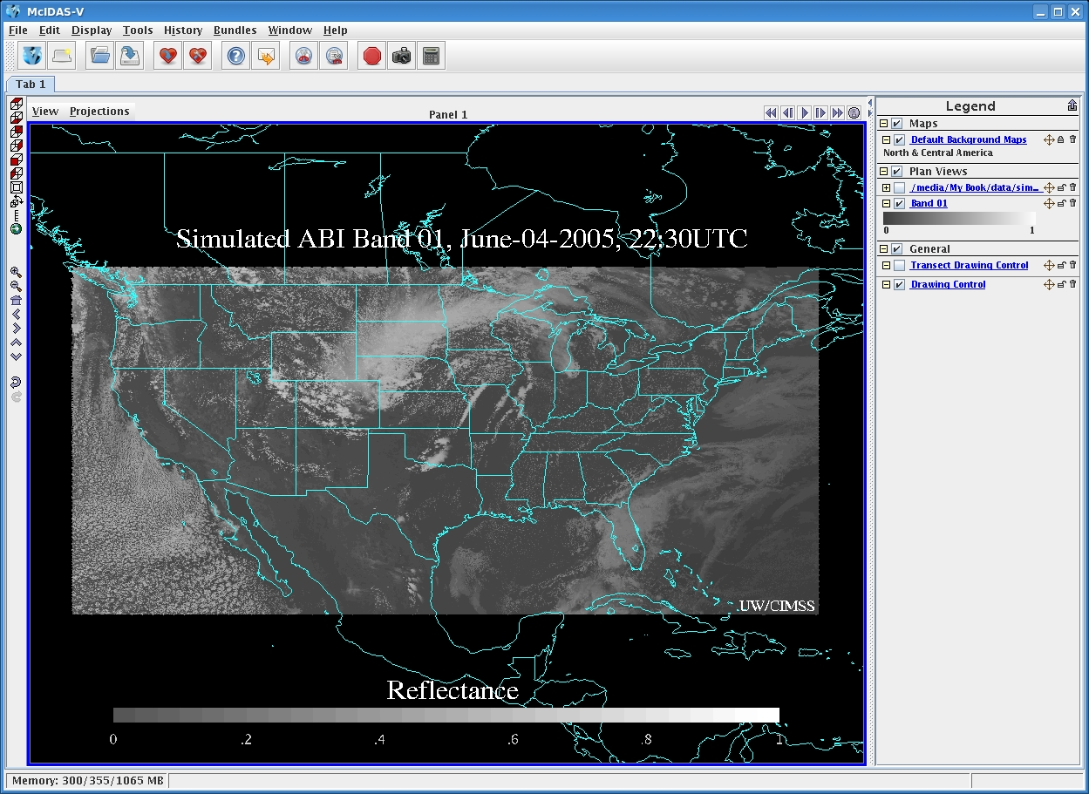
Figure 4. ABI Band 1 stored as a NetCDF displayed in McIDAS-V


Figure 5. ABI Band 7 stored as a NetCDF displayed in McIDAS-V

Figure 6. ABI Bands 1-6 converted to an AWIPS-ready NetCDF and displayed in AWIPS


Figure 7. ABI Bands 9-16 converted to an AWIPS-ready NetCDF and displayed in AWIPS

4.2 Output from Simulated ABI Data Sets

4.2.1 Imagery Generated from Simulated ABI Data
The Imagery products have been generated from the CONUS simulated ABI data at 23:55 UTC on 04 June, 2005. Figures 9 and 10 show examples of reflectance and brightness values products generated from simulated ABI band 1 data over the CONUS. Figures 8-12 show the examples of radiance, brightness temperature and brightness values products generated from simulated ABI band 7 data over the CONUS.


Figure 8. Reflectance of ABI Band 1 at 22:00 UTC on 05 June 2005 displayed in McIDAS

Figure 9. Brightness Values of ABI Band 1 at 22:00 UTC on 04 June 2005 displayed in McIDAS


Figure 10. Radiance of ABI Band 7 at 22:00 UTC on 04 June 2005 displayed in McIDAS


Figure 11. Brightness Temperature of ABI Band 7 at 22:00 UTC on 04 June 2005 displayed in McIDAS

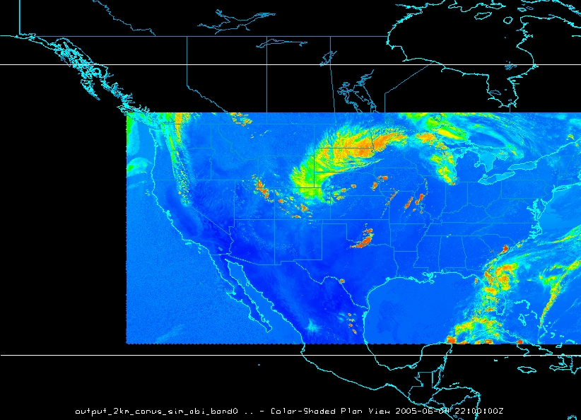
Figure 12. Brightness Value derived from simulated ABI Band 7 data at 22:00 UTC on 04 June 2005 displayed in McIDAS

Sample netCDF structure for the simulated ABI data is envisioned as follows for a visible and infrared bands:

netcdf GRB_scaled_1km_conus_sim_abi_band02_2005_0604_2200utc {
dimensions:
west-east = 5304 ;
south_north = 2438 ;
time = 1 ;
e_sun = 1 ;
variables:
float lat(south_north, west-east) ;
lat:long_name = "Latitude" ;
lat:units = "degrees_north" ;
lat:valid_range = -90.f, 90.f ;
lat:_FillValue = -999.f ;
float lon(south_north, west-east) ;
lon:long_name = "Longitude" ;
lon:units = "degrees_east" ;
lon:valid_range = -180.f, 180.f ;
lon:_FillValue = -999.f ;
short ABI_scaledint_02(time, south_north, west-east) ;
ABI_scaledint_02:long_name = "Reflectance band 2 (0.64um)" ;
ABI_scaledint_02:units = "None" ;
ABI_scaledint_02:add_offset = -0.0502931f ;
ABI_scaledint_02:coordinates = "lat lon" ;
ABI_scaledint_02:scale_factor = 0.0002931f ;
ABI_scaledint_02:valid_min = 1s ;
ABI_scaledint_02:_FillValue = 0s ;
ABI_scaledint_02:missing_value = 0s ;
float time(time) ;
time:long_name = "Image start time" ;
time:units = "seconds since 2005-06-04 22:00" ;
float E_sun(e_sun) ;
E_sun:long_name = "E_SUN" ;
E_sun:units = " W/(m^2 micrometer)" ;

// global attributes:
:TITLE = "NCSA-FCM 2-KM CONUS ABI VISIBLE DATA REMAPPED TO GOES-R 2-KM DOMAIN" ;
:INSTITUTE = "UNIVERSITY OF WISCONSIN-MADISON SSEC/CIMSS" ;
:HISTORY = "The model was simulated on a supercomputer at the National Center for Supercomputing Applications. The CIMSS forward radiative transfer modeling system was then used to compute simulated radiances for each ABI band" ;
:SOURCE = "Simulated ABI scaled integer data for this dataset were computed using output from a high-resolution Weather Research and Forecasting model coupled with the CIMSS forward radiative transfer models" ;
:REFERENCE = "Otkin, J. A., T. J. Greenwald, J. Sieglaff, and H.-L. Huang, 2009: Validation of a large-scale simulated brightness temperature dataset using SEVIRI satellite observations. [accepted for publication in/ J. Appl. Meteor. Climatol/.]" ;
:SOLAR_CONSTANT = "2000 ASTM Standard Extraterrestrial Spectrum Reference E-490-00 for a solar constant of 1366.1 W/m**2" ;
:pi = "3.14159265" ;
:Reflectance_factor = "(ABI_scaledint* scale_factor) + add_offset" ;
:Radiance = "(Reflectance_factor * E_sun ) / pi" ;
:Conventions = "CF-1.4" ;
:REMAP_AUTHOR = "JASON OTKIN" ;
:GRB_SCALED_AUTHOR = "KABA BAH" ;
:PROCESSED_DATE = "Wed Jul 8 19:18:24 2009" ;
:FM_CVS_VERSION = "Release_Sep08_A" ;
:NWP_MODEL = "OUTPUT FROM WRF V2.2 MODEL" ;
:CEN_LAT = 37.34798f ;
:CEN_LON = -96.5871f ;
:OUTPUT_TIME = "2005-06-04_22:40:00" ;
:WRF_MAP_PROJ = "Mercator" ;
:dyKm = 2.f ;
:dxKm = 2.f ;
:rotation = 0.f ;
:xMin = -0.1179891f ;
:xMax = 0.1966484f ;
:yMin = -0.8768772f ;
:yMax = -0.5622401f ;

netcdf GRB_scaled_2km_conus_sim_abi_band14_2005_0604_2200utc {
dimensions:
west-east = 2652 ;
south_north = 1219 ;
time = 1 ;
e_sun = 1 ;
variables:
float lat(south_north, west-east) ;
lat:long_name = "Latitude" ;
lat:units = "degrees_north" ;
lat:valid_range = -90.f, 90.f ;
lat:_FillValue = -999.f ;
float lon(south_north, west-east) ;
lon:long_name = "Longitude" ;
lon:units = "degrees_east" ;
lon:valid_range = -180.f, 180.f ;
lon:_FillValue = -999.f ;
short ABI_TBB_14(time, south_north, west-east) ;
ABI_TBB_14:long_name = "ABI brightness temperatures band 14 (11.2um)" ;
ABI_TBB_14:units = "K" ;
ABI_TBB_14:add_offset = -0.8622603f ;
ABI_TBB_14:coordinates = "lat lon" ;
ABI_TBB_14:scale_factor = 0.01f ;
ABI_TBB_14:valid_min = 0s ;
ABI_TBB_14:_FillValue = -32768s ;
ABI_TBB_14:missing_value = -32768s ;
short ABI_scaledint_14(time, south_north, west-east) ;
ABI_scaledint_14:long_name = "ABI radiance band 14 (11.2um)" ;
ABI_scaledint_14:units = "milliwatts/m2/steradian/cm-1" ;
ABI_scaledint_14:add_offset = -0.8622603f ;
ABI_scaledint_14:coordinates = "lat lon" ;
ABI_scaledint_14:scale_factor = 0.0122604f ;
ABI_scaledint_14:valid_min = 1s ;
ABI_scaledint_14:_FillValue = 0s ;
ABI_scaledint_14:missing_value = 0s ;
float time(time) ;
time:long_name = "Image start time" ;
time:units = "seconds since 2005-06-04 22:00" ;

// global attributes:
:TITLE = "NCSA-FCM 2-KM CONUS ABI VISIBLE DATA REMAPPED TO GOES-R 2-KM DOMAIN" ;
:INSTITUTE = "UNIVERSITY OF WISCONSIN-MADISON SSEC/CIMSS" ;
:HISTORY = "The model was simulated on a supercomputer at the National Center for Supercomputing Applications. The CIMSS forward radiative transfer modeling system was then used to compute simulated radiances for each ABI band" ;
:SOURCE = "Simulated ABI scaled integer data for this dataset were computed using output from a high-resolution Weather Research and Forecasting model coupled with the CIMSS forward radiative transfer models" ;
:REFERENCE = "Otkin, J. A., T. J. Greenwald, J. Sieglaff, and H.-L. Huang, 2009: Validation of a large-scale simulated brightness temperature dataset using SEVIRI satellite observations. [accepted for publication in/ J. Appl. Meteor. Climatol/.]" ;
:Conventions = "CF-1.4" ;
:REMAP_AUTHOR = "JASON OTKIN" ;
:GRB_SCALED_AUTHOR = "KABA BAH" ;
:PROCESSED_DATE = "Wed Jul 8 19:25:01 2009" ;
:FM_CVS_VERSION = "Release_Sep08_A" ;
:NWP_MODEL = "OUTPUT FROM WRF V2.2 MODEL" ;
:CEN_LAT = 37.34798f ;
:CEN_LON = -96.5871f ;
:OUTPUT_TIME = "2005-06-04_22:40:00" ;
:WRF_MAP_PROJ = "Mercator" ;
:dyKm = 2.f ;
:dxKm = 2.f ;
:rotation = 0.f ;
:xMin = -0.1179891f ;
:xMax = 0.1966484f ;
:yMin = -0.8768772f ;
:yMax = -0.5622401f ;
}

Two other ABI simulated datasets are also being used as part of the imagery validations.


Figure 13. ABI band 4 (1.38 um) simulation of hurricane Katrina at 22 UTC on August 28, 2005.

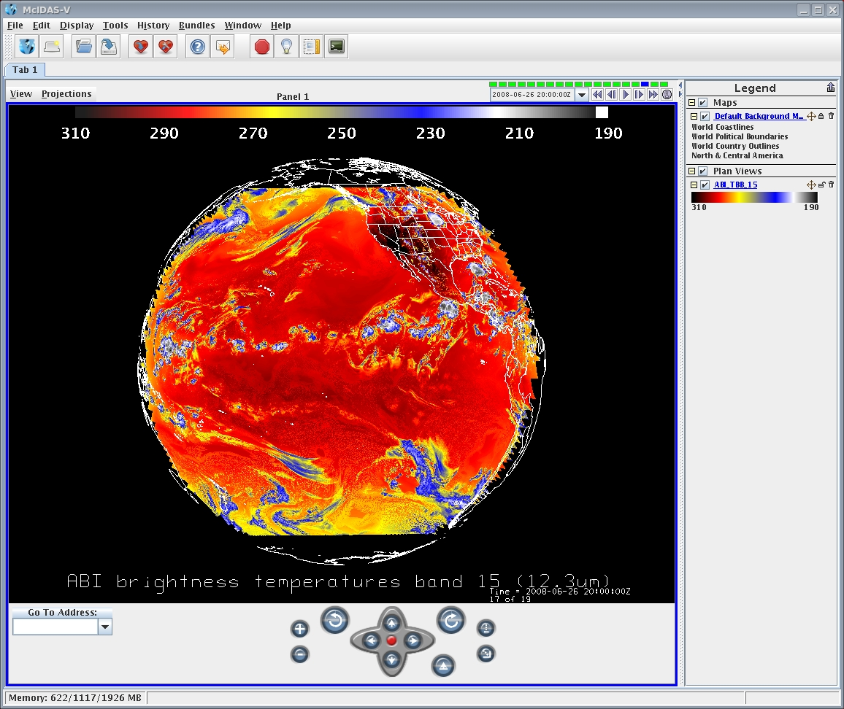
Figure 14. ABI band 15 (12.3 um) simulation of the Pacific at 137 West longitude at 20 UTC on June 26, 2008.

4.2.2 Precisions and Accuracy Estimation
This section describes the predicted performance and product quality of the CMIP relative to the CMIP specifications found within the GOES-R Functional and Performance Specification Document (F&PS). To estimate the precision and accuracy of the Imagery product requires validation files generated by the research code running offline. The reference (“truth”) data files include reflectance, radiance, brightness values and geolocation information for bands 1-6, and radiance, brightness temperature, brightness values and geolocation information for bands 7-16.

The accuracy and precision estimates for the Imagery products are determined by computing the following values: mean difference, max difference and standard deviation of difference of reflectance, radiance, brightness values for bands 1-6 and radiance, brightness temperature and brightness values for bands 7-16. The comparison results are summarized in the Table 8, in which s is the value generated by the software and t is the reference (“true”) data.

 | Reflectance |  |  | Radiance |  |  | Brightness Value
 | mean(s – t) | stdev(s – t) | max(|s - t|) | mean(s – t) | stdev(s – t) | max(|s - t|) | mean(s – t) | stdev(s – t) | max(|s - t|)
01 | -1.80270e-09 | 8.77219e-09 | 5.96046e-08 | -8.23024e-06 | 1.14099e-05 | 9.15527e-05 | 1.93469e-05 | 0.00439843 | 1.00000
02 | 5.43765e-10 | 9.10306e-09 | 5.96046e-08 | -4.51243e-06 | 7.01644e-06 | 6.10352e-05 | 0.00000 | 0.00000 | 0.00000
03 | -3.63924e-09 | 1.04284e-08 | 5.96046e-08 | -5.55586e-06 | 6.18800e-06 | 4.57764e-05 | 0.00434283 | 1.88608e-05 | 1.00000
04 | 6.02707e-10 | 1.39890e-09 | 2.98023e-08 | 1.53219e-08 | 2.71043e-07 | 7.62939e-06 | 0.00000 | 0.00000 | 0.00000
05 | 6.95558e-09 | -8.69477e-10 | 5.96046e-08 | 1.03450e-06 | -6.73960e-07 | 1.14441e-05 | 0.00000 | 0.00000 | 0.00000
06 | -4.82609e-10 | 5.72237e-09 | 2.98023e-08 | -1.45095e-07 | 2.36706e-07 | 1.90735e-06 | 0.00000 | 0.00000 | 0.00000
 | Radiance |  |  | Brightness Temperature |  |  | Brightness Value
 | mean(s – t) | stdev(s – t) | max(|s - t|) | mean(s – t) | stdev(s – t) | max(|s - t|) | mean(s – t) | stdev(s – t) | max(|s - t|)
07 | 8.07578e-09 | 2.31943e-08 | 1.19209e-07 | 7.14495e-06 | 1.57137e-05 | 6.10352e-05 | 0.00000 | 0.00000 | 0.00000
08 | -3.38373e-07 | 1.27241e-07 | 5.96046e-07 | -7.39373e-07 | 1.18933e-05 | 6.10352e-05 | 0.0000 | 0.0000 | 0.0000
09 | -4.15323e-07 | 3.61135e-07 | 9.53674e-07 | 4.15826e-06 | 1.04421e-05 | 3.05176e-05 | 0.00000 | 0.00000 | 0.00000
10 | -5.85536e-09 | 7.67321e-07 | 1.90735e-06 | 6.83676e-06 | 1.29271e-05 | 6.10352e-05 | 0.00000 | 0.00000 | 0.00000
11 | -5.51336e-07 | 2.43044e-06 | 7.62939e-06 | -7.01631e-06 | 1.64498e-05 | 6.10352e-05 | 0.00000 | 0.00000 | 0.00000
12 | -2.97309e-07 | 2.42303e-06 | 3.81470e-06 | -5.58301e-06 | 1.43563e-05 | 6.10352e-05 | 0.00000 | 0.00000 | 0.00000
13 | 2.34330e-06 | 3.65624e-06 | 1.52588e-05 | 2.67977e-06 | 1.58865e-05 | 6.10352e-05 | 0.00000 | 0.00000 | 0.00000
14 | 1.27602e-06 | 2.86722e-06 | 1.52588e-05 | 4.47034e-06 | 1.55042e-05 | 6.10352e-05 | 0.00000 | 0.00000 | 0.00000
15 | -1.57553e-06 | 3.15149e-06 | 1.52588e-05 | -5.84233e-06 | 1.57901e-05 | 6.10352e-05 | 0.00000 | 0.00000 | 0.00000
16 | 5.44584e-06 | 3.28566e-06 | 7.62939e-06 | 4.06769e-06 | 1.72088e-05 | 6.10352e-05 | 0.00037225 | 0.0192876 | 1.00000
Table 8. Comparison results of generated Imagery products and validation data serving as GOES-R ABI proxy data for the GOES-R CMIP. This is for data from the June 2005 case.

4.2.3 Error Budget
This section will be removed.

5 PRACTICAL CONSIDERATIONS

5.1 Numerical Computation Considerations
Handling of the large ABI image datasets is one of the major challenges to the CMIP. There will be a 4 to 16-fold data increase for the ABI compared with the current GOES imager in individual channels. The 0.5 km visible band has a data volume larger than all ten of the IR bands combined. Moreover, for the full disk scans, the temporal resolution will be improved to 5 minutes, compared to 25 minutes for current GOES instruments.

The system shall design and implement appropriate algorithm(s) to address issues related to handling the large dimension and volume of data from the ABI. The related issues include, but are not limited to:

- Memory limitation versus large image dimension
- Fulfill the product latency requirements

The ‘stepped-edge’ approach of the ABI FD scan certainly improves the efficiency of this operation. At the same time, it complicates the image generation step, given that ‘swaths’ can be varying width. The “corners” of the stepped-earth edge image should be considered to allow for easy user amalgamation of swath data. One solution may be to ‘null fill’ the ‘corners’ to form a rectangular data array.


Figure 15. The ‘stepped-edge’ approach of the ABI FD scan

5.2 Programming and Procedural Considerations
Striping or banding is systematic noise in an image that results from variation in the response of the individual detectors used for a particular band. This usually happens when a detector goes out of adjustment and produces readings that are consistently much higher or lower than the other detectors for the same band.
Many methods have been developed to correct for striping, such as histogram matching, the empirical distribution function (EDF) matching (Weinreb et al. 1989), and the moment matching (Gurka and Dittberner 2001). Appropriate methods should be developed or to address the potential striping issue.

Due to the nature of the ABI data being remapped prior to distribution, any needed de-striping will need to be conducted before data distribution.

5.3 Quality Assessment and Diagnostics
To be completed. This section describes how the quality of the output products is assessed, documented, and any anomalies diagnosed. In general, any quality control information that is included in the GRB will be passed on. This includes information related to the calibration and navigation attributes.

5.4 Exception Handling
The CMIP includes checking the validity of each band before applying radiometric calibration procedures. The CMIP also expects the Level 1b processing to flag any pixels with missing geolocation information.

Exception handling is required for the development of robust and efficient numerical software. Requirements set forth by the AIT also stress the importance of exception handling. While the main modules of the CMIP program are using the AIT-provided subroutine for error messaging, its use is limited. More extensive error checking will be added to future versions of the CMIP.

For the most part, the CMIP assumes that all necessary image, forecast and ancillary data are available through the processing framework. The only data that the algorithm explicitly checks for is the temporal brightness temperature data, which is necessary for the tracking portion of the algorithm. If the temporal data is unavailable, the algorithm outputs an error message and control is returned to the processing framework.

As part of the target selection process, the CMIP checks for missing or unrealistic values within both the target and search regions. If either condition is met, the algorithm will flag the scene as bad and proceed to the next adjacent scene.

5.5 Algorithm Validation
Validation of the Imagery products requires comparing to reference (“truth”) data for the CONUS and other scan sectors. From these validation data, comparison metrics can be calculated that characterize the agreement between the satellite-derived CMIP and the reference values.

During the pre-launch phase of the GOES-R program, the product validation activities are aimed at characterizing the performance and uncertainties of the CMIP products resulting from parameterizations and algorithmic implementation artifacts. During this phase, there is total reliance on the use of GOES-R ABI simulated dataset as described in Section 4.1. Post-launch validation will apply lessons learned to inter-comparisons of actual CMIP products generated from real ABI measurements and reference (“ground-truth”) wind observations. Validation methodologies and tools developed and tested during the pre-launch phase will be automated and applied. More specific details on CMIP product validation activities can be found in the Product Validation Document for the CMIP product.

6 ASSUMPTIONS AND LIMITATIONS
This section describes the current assumptions and limitations in the current version of the CMIP.

6.1 Assumed Sensor Performance
We assume the sensor will meet its current specifications. However, the CMIP will be dependent on the following instrumental characteristics. In addition, it is assumed that the supplied SRF will be normalized and provided in historically consistent units.
- Any needed information to ‘combine’ ABI swaths will be supplied.
- The quality of the CMIP will depend on the amount of striping in the data.
- The quality of the CMIP will depend on the overall quality of the data. This includes (but is not limited to), the cross-talk, the modulation transfer function (MTF), the signal-to-noise ratio (SNR), similarity of detector responses, etc.
- GRB will include Quality indicators with respect to calibration and navigation.
- Only one SRF per band
- The minimum and maximum radiance value for the GRB scaling does not need to change from instrument to instrument.
- GRB will include various version numbers (say of the Planck coefficients, instrument number, SRF version, etc.)
- Errors in navigation from input GRB data stream will affect the quality of CMIP.
- Unknown spectral shifts in some bands will affect the quality of CMIP.
- A zero (GRB) count is a ‘missing’ value. Data counts begin with one.
- That there will be ‘space’ data around the edge of full disk sectors.
- That ‘system-level’ tests will be conducted to test the algorithm sensitivity on any satellite transmission-induced noise.

6.2 Pre-Planned Product Improvements

6.2.2 Quality Control Indicators

The relevant quality control flags, obtained from the GRB signal, will be passed along.

7 REFERENCES
Acharya, T., and A. K. Ray. 2005. Image processing: principles and applications: Wiley-Interscience.
Baum, Bryan , P. Yang, Yang, Ping; Heymsfield, Andrew J.; Platnick, Steven; King, Michael D.; Hu, Y.-X., and Bedka, Sarah T., 2005: Bulk scattering properties for the remote sensing of ice clouds, part II: Narrowband models. Journal of Applied Meteorology, Volume 44, Issue 12, pp.1896-1911.
Gurka, J. J., and G. J. Dittberner. 2001. The next generation GOES instruments: Status and potential impact. Paper read at Fifth Symp. on Integrated Observing Systems, at Albuquerque, NM.
Hillger, D. W., and T. Schmit. 2004. Quantization noise for GOES-R ABI bands. Paper read at Proceedings of the 13th Conference on Satellite Meteorology and Oceanography, Sep., 2004, at Norfolk, VA.
NOAA/NASA. 2008. GOES-R Ground Segment (GS) Functional and Performance Specification (F&PS): GOES-R/Code 417.

NOAA/NESDIS. 2007. GOES-R Series Mission Requirements Document (MRD, version 3.1): GOES-R Program/Code 417.
Otkin, J. A., D. J. Posselt, E. R. Olson, H.-L. Huang, J. E. Davies, J. Li, and C. S. Velden, 2007: Mesoscale numerical weather prediction models used in support of infrared hyperspectral measurements simulation and product algorithm development. J. Atmospheric and Oceanic Tech., 24, 585-601.
Otkin, J. A., and T. J. Greenwald. 2008. Comparison of WRF model-simulated and MODIS-derived cloud data. Mon. Wea. Rev. 136:1957-1970.
Russ, J. C. 2002. The Image Processing Handbook, Fourth Edition CRC Press.
Schmit, T. J., M. M. Gunshor, W. P. Menzel, J. Li, S. Bachmeier, and J. J. Gurka. 2005. Introducing the next-generation Advanced Baseline Imager (ABI) on GOES-R. Bull. Amer. Meteor. Soc. 8:1079-1096.
Schmit, T. J., M. P. Weinreb, and W. P. Menzel. 1991. GVAR IR scale factor coefficients: NOAA.
Weinreb, M. P., M. Jamison, N. Fulton, Y. Chen, J. X. Johnson, J. Bremer, C. Smith, and J. Baucom. 1997. Operational calibration of Geostationary Operational Environmental Satellite-8 and -9 imagers and sounders. Appl. Opt. 36:6895-6904.
Weinreb, M. P., J. X. Johnson, J. H. Lienesch, and D. S. Crosby. 1989. Destriping GOES images by matching empirical distribution functions. Rem. Sens. Environ 29 (185-195).

ACKNOWLEDGEMENTS

The entire Imagery and Visualization team is thanked for their input to these critical products. This includes: Mat Gunshor, Kaba Bah and Tom Rink of CIMSS. Also thanked for a review of the document are Steve Miller and Don Hillger. Steve Wanzong, CIMSS, is thanked for the McIDAS-X images, while Kaba Bah, CIMSS, is thanked for the McIDAS-V images.

