

NOAA NESDIS
Center for Satellite Applications and Research

GOES-R Advanced Baseline Imager (ABI) Algorithm Theoretical Basis Document
For
Cloud and Moisture Imagery (CMIP)

Tim Schmit, NOAA/NESDIS/STAR
Mat Gunshor, CIMSS
Gang Fu, PSGS
Frank Padula, Integrity Application Incorporated
Tom Rink, CIMSS
Kaba Bah, CIMSS

Version 2.3
10 September 2010

TABLE OF CONTENTS
TABLE OF CONTENTS 2
LIST OF FIGURES 4
LIST OF TABLES 5
ACRONYMS 6
ABSTRACT 7
1 INTRODUCTION 7
Purpose of This Document 7
Who Should Use This Document 8
Inside Each Section 8
Related Documents 8
Revision History 9
2 PRODUCT OVERVIEW 10
2.1 Products Generated 10
2.2 Instrument Characteristics 10
2.3 Product Requirement Description 12
3 ALGORITHM DESCRIPTION 15
3.1 Algorithm Overview 15
3.2 Processing Outline 17
3.3.1 Primary Sensor Data 18
3.3.2 Ancillary Data 20
3.3.3 Derived Data 20
3.4 Theoretical Description 20
3.4.1 Radiometric Calibration 20
3.4.1.1 Un-scaling Scaled Radiance to Spectral Radiance (bands 1-16) 20
3.4.1.2 Converting Spectral Radiance to Reflectance Factor (bands 1-6) 21
3.4.1.3 Converting Spectral Radiance to BT (bands 7-16) 21
3.4.1.4 Converting ABI noise values between temperature and radiance space (bands 7-16) 23
3.4.2 Mapping Reflectance and Brightness Temperature to BV 24
3.4.2.1 Bi-Linear Stretch 25
3.4.2.2 Square Root Stretch 26
3.5 Algorithm Output 33
4 TEST DATA SETS AND OUTPUTS 37
4.1 GOES-R Simulated Input Data Sets 37
4.2 Output from Simulated ABI Data Sets 41
4.2.1 Imagery Generated from Simulated ABI Data 41
4.2.2 Precisions and Accuracy Estimation 52
4.2.3 Error Budget 54
5 PRACTICAL CONSIDERATIONS 54
5.1 Numerical Computation Considerations 54
5.2 Programming and Procedural Considerations 55
5.3 Quality Assessment and Diagnostics 55
5.4 Exception Handling 56
5.5 Algorithm Validation 56
6 ASSUMPTIONS AND LIMITATIONS 57
6.1 Assumed Sensor Performance 57
6.2 Pre-Planned Product Improvements 57
6.2.2 Quality Control Indicators 57
7 REFERENCES 58
ACKNOWLEDGEMENTS 59
Appendix A. Converting Spectral Radiance to BT via Historical Method 60
Appendix B. A note on fundamental constants 61

LIST OF FIGURES
Figure 1 High level flowchart for generating CMIP 17
Figure 2. Re-sampling points for the ABI FGF for the 0.5, 1 and 2 km. The magenta points represent the center of a 0.5 km pixel, the green points the center of a 1 km pixel and the black points the center of a 2 km pixel. The "lower-left dot" is the satellite sub-point, i.e., there is no pixel centered on the sub-point. 27
Figure 3. Re-sampling points for the ABI FGF for the 1 km data. Note the sub-sampling method ‘re-projects’ to the 2 km FGF domain. 29
Figure 4. Averaging points for the ABI FGF for the 1 km data. 30
Figure 5. Simulated ABI 1 km data shown in the FGF. 31
Figure 6. Simulated ABI sub-sampled and re-projected to 2 km shown in the FGF. 31
Figure 7. Simulated ABI averaged to 2 km and re-projected on the 2 km FGF. 32
Figure 8a (top panel) ABI Band 2 stored as a McIDAS AREA displayed in McIDAS-X. 8b (bottom panel) ABI Band 14 stored as a McIDAS AREA displayed in McIDAS-X. 38
Figure 9. ABI Band 7 stored as a NetCDF displayed in McIDAS-V 39
Figure 10. ABI Bands 1-6 converted to an AWIPS-ready NetCDF and displayed in AWIPS 40
Figure 11. ABI Bands 9-16 converted to an AWIPS-ready NetCDF and displayed in AWIPS 40
Figure 12. Reflectance of ABI Band 1 at 2200 UTC on 04 June 2005 displayed in McIDAS-V 41
Figure 13. Brightness Values of ABI Band 1 at 2200 UTC on 04 June 2005 displayed in McIDAS-V 42
Figure 14. Radiance of ABI Band 7 at 2200 UTC on 04 June 2005 displayed in McIDAS-V 43
Figure 15. Brightness Temperature of ABI Band 7 at 2200 UTC on 04 June 2005 displayed in McIDAS-V 44
Figure 16. Brightness Value derived from simulated ABI Band 10 data displayed in McIDAS-V. The sub-point is 75°W. 45
Figure 17. ABI band 4 (1.38 µm) simulation of hurricane Katrina at 2200 UTC on 28 August 2005. 49
Figure 18. ABI band 10 (7.34 µm) simulation of the Pacific at 137°W at 2000 UTC on 26 June 2008. 50
Figure 19. ABI band Fixed Grid Format (FGF) coverage sample from 75°W. The point is that latitudes and longitude would not have to be carried, given the grid format. 51
Figure 20. ABI band Fixed Grid Format (FGF) coverage sample from 137°W. 52
Figure 21. The ‘stepped-edge’ approach of the ABI FD scan. 55

LIST OF TABLES
Table 1. GOES-R ABI instrument characteristics. 11
Table 2. CMIP Requirements 14
Table 3. Slope and intercept to convert from the calibrated radiance data to SR counts in GRB (TBV, the Min/Max Values are given in terms of radiance units (mW/(m2•sr•cm-1))) 19
Table 4. Slope and intercept to convert from the GRB SR to radiance values (TBV, the Min/Max Values are given in radiance units (mW/(m2•sr•cm-1))) 19
Table 5. Min/Max Values are given in radiance units (mW/(m2•sr•cm-1)). A factor of three was used for the IR band spec noise. 20
Table 6. E_{sun} values. (TBV). These are from the UW Mock SRF. Again, these need to be revised with the flight SRF. 21
Table 8. Planck Coefficients. (TBV). These values are based on the Gaussian-Hybrid version of the ABI mock SRF (ftp://ftp.ssec.wisc.edu/ABI/SRF/). 22
Table 9. Noise Equivalent delta Temperature (NEdT) and Radiance (NEdN) for the infrared bands on the ABI. NEdT is given, the other values are derived from it. Note that these values were calculated using the University of Wisconsin mock spectral response functions as a basis for spec noise; the NEdT will change when flight spectral response functions are available and these are not representative of actual noise measurements from the ABI. 24
Table 10. Equivalent Widths (EQW) for the six visible and near-IR bands on the ABI. (TBV when flight SRFs are available – these are based on the University of Wisconsin simulated SRFs). 32
Table 11. Fields in CMIP single-band imagery products. (TBV) 35
Table 12. Fields in CMIP multi-band imagery products. (TBV) 36
Table 13. Comparison results of generated Imagery products and validation data serving as GOES-R ABI proxy data for the GOES-R CMIP. This is for data from the June 2005 case. 53

ACRONYMS
ABI – Advanced Baseline Imager
AIT – Algorithm Integration Team
ATBD – Algorithm Theoretical Basis Document
AU – Astronomical Unit
AWG – Algorithm Working Group
AWIPS – Advanced Weather Interactive Processing System
BT – Brightness Temperature
BV – Brightness Values
CDR – Critical Design Review
CFD – Continuous Full Disk
CMIP – Cloud and Moisture Imagery Product
CONUS – Continental United States
CRTM – Community Radiative Transfer Model
DC – Digital Count
FD – Full Disk
FGF – Fixed Grid Format
F&PS – Functional and Performance Specification
GFS – Global Forecast System
GPO – GOES-R Program Office
GRB – GOES ReBroadcast
GS – Ground System
GVAR – GOES Variable
IR – InfraRed
ITT – (no longer an acronym)
I&VT – Imagery and Visualization Team
IV&V – Independent Verification and Validation
KPP – Key Performance Parameter
McIDAS – Man computer Interactive Data Access System
MTF – Modulation Transfer Function
QC – Quality Control
SOI – Successive Order of Integration
SR – Scaled Radiance
SNR – Signal-to-Noise Ratio
SRF – Spectral Response Function
TBD – To Be Determined
TBV – To Be Verified
TOA – Top Of Atmosphere
TRR – Test Readiness Review
UTC – Universal Time Coordinated
UW – University of Wisconsin
VAGL - Vendor-Allocated Ground Latency
WRF – Weather Research and Forecasting

ABSTRACT

This document provides a theoretical description of the algorithms used by the Cloud and Moisture Imagery Product (CMIP) from the Advanced Baseline Imager (ABI) onboard the GOES-R series. The topics covered in this document include requirements for CMIP algorithms and software system, description of CMIP key algorithms, test data sets and outputs, practical considerations and assumptions and limitations.

The GOES-R ABI is designed to observe the Western hemisphere in various time intervals and at 0.5, 1, 2 km spatial resolutions in visible, near-IR, and IR wavelengths, respectively. The ABI has two main scan modes, of which the most likely mode will allow full disk imagery every 15 minutes, along with the Continental U.S. (CONUS) every 5 minutes and a meso-scale as often as every 30 seconds. CMIP is the ABI tier 1A and key performance parameter (KPP) product, including 16 ABI single-band images for 3 coverage areas plus the multi-band spectral products for each coverage area in NetCDF and McIDAS formats, which will be used as input data by various other algorithms.

GOES-R ABI CMIP algorithms have been tested on ABI simulated data covering the CONUS and nearly Full Disk areas. The generated image files have been compared with the validation data generated by the research code, and the images are effectively identical.

1 INTRODUCTION

Purpose of This Document
The primary purpose of this algorithm theoretical basis document (ATBD) is to provide a theoretical description (scientific and mathematical) of the algorithms used by the Cloud and Moisture Imagery Product (CMIP) from the Advanced Baseline Imager (ABI) onboard the GOES-R series of NOAA geostationary meteorological/environmental satellites. CMIP is the ABI tier 1A and Key Performance Parameter (KPP) product.
Cloud and Moisture Imagery algorithms produce digital maps of clouds, moisture, and atmospheric windows, through which land and water are observed, by reporting reflectance and radiance measurements for visible, near-IR and IR bands, respectively. For visible bands, the reflectance (or reflectance factor) can be converted to brightness values, ranging from 0-255 for an 8-bit system. Information will also be provided on the conversion from radiance values to reflectance factor (ABI bands 1-6) and brightness temperatures (ABI bands 7-16). These will be converted into brightness values, again ranging from 0-255 for an 8-bit system and 0-4095 for a 12-bit system. Cloud and Moisture Imagery provides input to other algorithms producing other environmental products.

Who Should Use This Document
The intended users of this document include: algorithm reviewers, who would understand the theoretical basis of CMIP; product users, who would use the product in an operational task; scientific programmers, who would develop new algorithms; and system administrators, who would maintain the software.

Inside Each Section
This document consists of the following main sections:
- Product Overview: provides relevant details of the ABI and a brief description of the products generated by the algorithm.

- Product Requirement Description: provides the detailed requirements for the CMIP key algorithms and software system.

- Algorithm Description: provides the details for CMIP processing outline, input/output parameters and key algorithms.

- Test Data Sets, and Output: provides a description of the test data sets used to characterize the performance of the algorithms and quality of the data products. It also describes the results of using test data sets.

- Practical Considerations: provides a description of the issues involving CMIP software system programming, quality assessment, diagnostics, and exception handling.

- Assumptions and Limitations: provides an overview of the current assumption and limitations of the approach and a plan for overcoming these limitations with further algorithm development.

Related Documents
GOES-R Ground Segment (GS) Functional and Performance Specification (F&PS).

GOES-R Series Ground Segment Project Notional Transition from GVAR to GRB Operations Plan

GOES-R Mission Requirements Document

Revision History
Version 0.1 was created by Wenhui Wang of NOAA/NESDIS/STAR and I. M. System Groups to accompany the delivery of the version 0.1 algorithm to the GOES-R AWG Algorithm Integration Team (AIT). T. Schmit added several sections.

Version 1.0 of this document was the official adaptation of Version 0.1.

Version 2.0 was developed by Gang Fu of NOAA/NESDIS/STAR and PSGS based on the GOES-R Imagery Critical Design Review (CDR) and Test Readiness Review (TRR) to meet 80% ATBD requirement. This version was reviewed by many, including T. Schmit of NOAA/NESDIS/STAR.

Version 2.0 was completed by T. Schmit (and others), leveraging the many comments from the IV&V reviewer.

Version 2.2 was completed by T. Schmit (and many others), reflecting the change from 14 bits per pixel for most bands and the decision to scale all bands to radiance for the GRB datastream. Don Hillger and Mike Weinreb provided many improvements.

Version 2.3 includes updates related to the down-scaling methodology.

2 PRODUCT OVERVIEW
This section describes the CMIP and the requirements it places on the system.

2.1 Products Generated
The CMIP is responsible for ABI cloud and moisture imagery, and will produce 54 total end-products, including:
- 16 ABI single-band products ([spectral] radiance in bands 1-16) for 3 coverage areas
- Multi-band spectral products (16 bands at 2 km resolution) for 3 coverage areas in NetCDF4 format
- Multi-band spectral products (16 bands at 2 km resolution) for 3 coverage areas in McIDAS format
The three coverage areas are for full disk, CONUS and meso-scales. Additionally, the CMIP end-products will include the information about the methods of converting radiance to reflectance factor and BV (Brightness Value) for bands 1-6, and converting radiance to brightness temperature (BT) and then to BV for bands 7-16. The BV is a brightness value for a pixel on a display, perhaps at lower precision. By community convention the term “radiance” is used throughout this document and actually refers to a spectral radiance; e.g., technically radiance is only at a single frequency, while spectral radiance is radiance per unit frequency (either wavelength or wavenumber). It should also be noted that the radiance is actually an average value, weighted by the sensor response for that given band.

2.2 Instrument Characteristics
The ABI on GOES-R has 16 spectral bands. The selection of each covers a variety of environmental applications. ABI Infrared (IR) bands have been chosen to coincide either with spectral absorption features (including those of water vapor bands or CO₂ bands) or with regions having little absorption (atmospheric windows) that permit observations of the surface. Visible and near-IR bands have been chosen in order to sense lower tropospheric cloud cover (including fog) and the Earth’s surface (NOAA/NESDIS 2007).
Table 1. GOES-R ABI instrument characteristics.summarizes the instrument (nominal) central wavelength, spatial resolution (at the sub-point), and bit-depth characteristics of the ABI data in the data stream transmitted to users—the GOES ReBroadcast (GRB). The instrument has two basic modes of operation:
- Every 15 minutes, ABI will scan the full disk (FD) once, plus the continental United States (CONUS) three times (every 5 minutes). A selectable 1000 km × 1000 km mesoscale area will be scanned every 30 seconds. This has been referred to as mode 3 (or ‘flex’ mode).
- The ABI can be programmed to scan the FD iteratively. The FD image can be acquired in approximately 5 minutes (Schmit et al. 2005). This mode has been referred to as mode 4 (or the Continuous Full Disk (CFD)).

Band Number | Nominal Central Wavelength (μm) | Spatial Resolution  (km) | GRB Bit-Depth  (Expected) | Used in Cloud and Moisture Imagery
1 | 0.47 | 1 | 12 | X
2 | 0.64 | 0.5 | 12 | X
3 | 0.865 | 1 | 12 | X
4 | 1.378 | 2 | 12 | X
5 | 1.61 | 1 | 12 | X
6 | 2.25 | 2 | 12 | X
7 | 3.90 | 2 | 14 | X
8 | 6.19 | 2 | 12 | X
9 | 6.95 | 2 | 12 | X
10 | 7.34 | 2 | 12 | X
11 | 8.5 | 2 | 12 | X
12 | 9.61 | 2 | 12 | X
13 | 10.35 | 2 | 12 | X
14 | 11.2 | 2 | 12 | X
15 | 12.3 | 2 | 12 | X
16 | 13.3 | 2 | 12 | X
Table 1. GOES-R ABI instrument characteristics.

The rationale for the bit-depth being 12 bits per pixel for all the bands, with the exception of 14 bits for band 7 (3.9 μm), is to balance the need to minimize the transmitted data bandwidth against the need to ensure that the quantization step will not add noise to the system.

If specified noise is used and do not prepare for improvements in actual noise performance and loss of responsivity with time in orbit are not considered, and if the noise requires 2.5 counts to be properly resolved in the GRB, then 10 GRB bits per pixel would be the requirement for all the ABI's solar bands. However, if the noise is represented by 3 counts, the requirement is (barely) 11 bits in all solar bands. If the actual noise is 1/2 the spec noise, the required bit-depth increases to 12 or 13 bits (barely).
In sum, a 12-bit GRB is recommended for each of the solar bands.

The following discussion on the rationale for increased bit depth to account for an actual instrument noise level that is lower than the specified noise, and for the likelihood that over time in orbit the responsivities of the ABI's bands will decrease, applies to all bands of the ABI, both solar and thermal IR bands.
First, it is expected that the instrument’s actual performance will be better than the specified noise levels. In the current GOES system, ITT has built Imagers whose noise levels are almost always lower than specified, and in some cases an order of magnitude lower. This means that the instrument is measuring with greater precision than planned, and if we do not want the GRB is to not lose this added precision, one bit needs to be added to the GRB for every decrease of a factor of two in the noise levels. Since the bit depth of the GRB will be fixed once and for all (and it will not change for later satellites of the series), the extra bit needs to be included in the original design.
Second, the responsivity is expected to decrease with time in orbit. In the current GOES system, the instruments' responsivities continue to fall over time, which means that as the sensors age, the instruments can see hotter and hotter, or brighter and brighter, scenes before the detectors saturate. But if the increase in maximum observable radiance exceeds the upper limit of what the GRB will carry, the GRB will saturate or roll over, and information from those observations will be lost. A good example of this occurred with the 3.9 μm band of the GOES-12 Imager, whose responsivity decreased to the point where the maximum observed scene radiances exceeded 342 K, which is the maximum temperature the GVAR can carry. In this case, the GVAR count level rolled over to zero and levels slightly above, so that very cold pixels appeared at the centers of the hottest scenes--such as fires or specularly-reflected sunlight. If a higher maximum GVAR radiance had been established, corresponding to, 350 K, for example, this would not have happened. When ITT builds an instrument to a specification for maximum observable radiance, headroom is provided in order to guarantee meeting the specification under all conditions. This means that the actual maximum will be slightly higher than the specification. This should also be taken into account in designing the bit-depth of the GRB.

In sum, a 12-bit GRB is recommended for each of the IR bands. However, the 3.9 µm band needs 14 bits, given its use both to monitor hot fires, but also cold clouds. Even with 14-bits for this band, the quantization step in brightness temperature space at 200 K will be over 10 K.

The CMIP will be produced using all 16 bands in three coverage areas: FD, CONUS, and mesoscale. Bands 1-6 are the “visible bands” (1 and 2) and “near-IR” (3-6), while bands 7-16 are considered “IR bands.” The performance of the CMIP is sensitive to any imagery artifacts or instrument noise, calibration accuracy, and geolocation accuracy.

2.3 Product Requirement Description
The CMIP performance requirements are derived from the GOES-R Series Ground Segment (GS) Functional and Performance Specification (F&PS) (NOAA/NASA 2010). The software system that generates routine CMIP shall meet the following requirements:
- The system should be able to convert ABI scaled radiance (SR) obtained from the GOES ReBroadcast (GRB) data stream (L1B) into spectral radiance for bands 1-16.

- The system should define the process for converting radiance to brightness temperature (BT) for the IR bands.

- The system should define the process for converting reflectance factor to BV for bands 1-6 and converting brightness temperature to BV for bands 7-16. BV would be at least 12 or 14-bit, but it could support higher bit depths. A BV based on the historical 8-bit could also be provided.

- The conversion methods and the associated parameters should be embedded in CMIP end-products. Users can still employ their own enhancements to the data values. For example, the users could employ a ‘square root’ function on the full bit depth BV data.

- The CMIP end-products should be produced in NetCDF (version 4) and McIDAS formats. The McIDAS convention for GOES-R is 186 for the satellite sensor. The system should ensure that these end-products could be converted into other formats, such as HDF (TBV). The NetCDF format will be Climate and Forecasts (CF) conventions compliant. More information can be found at: http://cf-pcmdi.llnl.gov

- The CMIP should contain the geolocation information with respect to the Fixed Grid Format extracted from the input data stream (TBV).

- The CMIP shall include metadata.

- The system shall implement an interface to access input data (eg, GRB) and to store the generated products.

- The GOES-R system shall produce CMIP in accordance with the requirements listed in Table 2. CMIP Requirements:

 | Threshold
Geographic Coverage/Conditions | CONUS | FD | Mesoscale
Vertical Resolution | N/A | N/A | N/A
Horizontal Resolution | 2 km, with finer daytime resolution
Mapping Accuracy | 1 km | 1 km | 1 km
Measurement Range | N/A | N/A | N/A
Refresh Rate/  Coverage Time (Mode 3—Flex Mode) | 5 min | 15 min | 30 sec
Refresh Rate/  Coverage Time (Mode 4—Continuous Full Disk mode) |  | 5 min
VAGL | 50 sec | 50 sec | 23 sec
Product Measurement Precision | N/A | N/A | N/A
Temporal Coverage Qualifier | Day and Night
Product Extent Qualifier | N/A
Cloud Cover Conditions Qualifier | N/A | N/A | N/A
Product Statistics Qualifier | N/A
Primary Instrument | ABI
Prioritization | 1A
Table 2. CMIP Requirements

3 ALGORITHM DESCRIPTION
This section describes the CMIP software system processing outline, input/output parameters, and key algorithms at their current level of maturity (will be improved with each revision).

3.1 Algorithm Overview
The CMIP algorithms consist of acquiring the radiometrically calibrated and mapped radiances and converting to BT and BV. The BV are used as indices either to customized color tables or to the red/green/blue color components of a composite image, resulting in enhanced imagery intending to highlight environmental features of interest. The GOES-R ABI CMIP radiometric algorithms are based on GOES 8-13 algorithms (Weinreb et al. 1997; Schmit et al. 1991). Algorithms for mapping TOA reflectance and BT to BV are based on examples from the literature (Acharya and Ray 2005; Russ 2002), commercial remote sensing data visualization tools (e.g., ENVI and PCI), and open source tools (e.g. McIDAS-X/V and IDV). Some display systems may be capable of displaying more that 8-bit (or 256 levels). The bit-depth of the end-products (BV) for CMIP is 12-bit for all the bands, with the exception of band 7, which is 14 bits. Hence, the enhancements would need to be applied on the user display side and not part of converted to, only 8-bits, for example. This is because the conversion to an 8-bit BV also includes a ‘compression’ such as a square-root function in the solar bands and a bi-linear stretch for the IR bands.
Given the proper amount of ancillary data, the radiance data can be converted into reflectance factor units (nominally 0-1). This is generated using what is called the ‘κ factor’ ((π·d²)/E_{sun}) to convert between reflectance factors and [spectral] radiances (mW/(m2•sr•cm-1)). “Kappa” is used to convert from radiance to reflectance factor, while the reciprocal of Kappa is used to convert from reflectance factor to radiance. Inputs needed are the in-band solar irradiance at 1 Astronomical Unit (AU), E_{sun}, for each of the first six ABI bands, a correction (e.g., ratio) for the earth-sun distance (d) ratio and the value of π. The parameter d is the ratio of the actual distance (as acquired via the GRB) to the mean earth-sun distance. The relationship is the reflectance factor (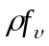) multiplied by E_{sun}, divided by π and the distance correction squared.  is the solar zenith angle. It is assumed that E_{sun} and the distance will flow as part of GRB. Equation 3-1 is the relationship between the reflectance factor (left-hand side) and the reflectance (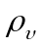).
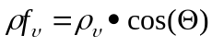 (3-1)
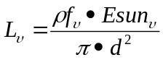 (3-2)
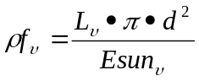 (3-3)
Equation 3.3 shows how the radiance data can be converted into reflectance factor. This is the equation that will be used. The values for E_{sun}, π and d will be provided via the GRB, another option would be for just the ‘κ factor’ (or its reciprocal) to be provided.
CMIP algorithms are responsible for:
- Converting the scaled [spectral] radiance from the input data stream (eg, GRB) to an unscaled [spectral] radiance (bands 1-16)
- Converting unscaled [spectral] radiance to reflectance factor and to BV (bands 1-6)
- Re-sampling bands 1, 3, and 5 from 1 km to 2 km for multi-band product. Re-sampling band 2 from 0.5 km to 2 km for multi-band product.
- Converting the spectral radiance to equivalent BT (bands 7-16)
- Converting BT to BV (bands 7-16)

3.2 Processing Outline
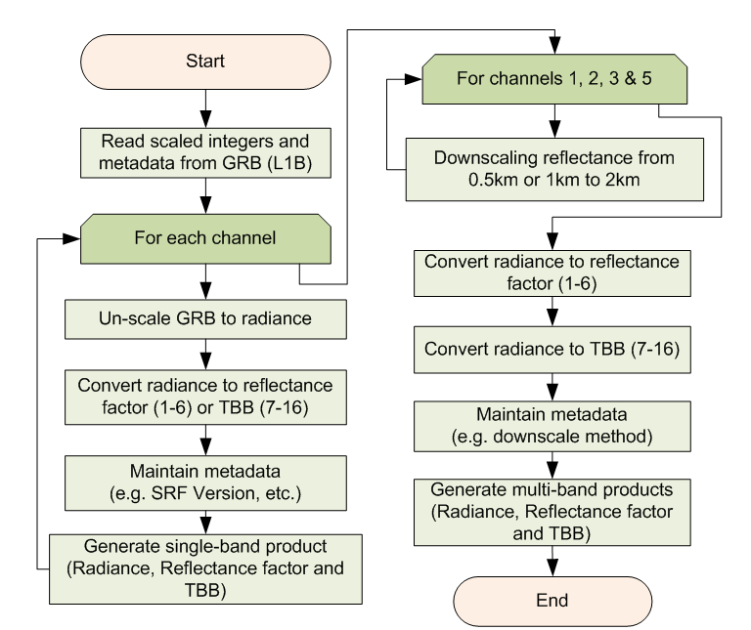
Figure 1 High level flowchart for generating CMIP

3.3 Algorithm Input

3.3.1 Primary Sensor Data
The input data to the CMIP algorithm for processing the KPP are the scaled GRB radiance data (level 1b; provided as digital counts), scaling coefficients and calibration coefficients (also available from the GRB data stream). The scaling coefficients are used to convert scaled GRB radiance data to unscaled radiance for all ABI bands. The calibration coefficients are used to convert to other units, such as reflectance factor for ABI bands 1-6 and brightness temperature for bands 7-16 (e.g., the modified Planck equation values).
The details regarding the actual format and data structures of the GRB will be determined by the Harris Ground System implementation and hence are not covered in detail in this document.
Table 3 and Table 4 show the slope and intercept used in conversion to (and from) Scaled Radiance values similar to the work by Hillger and Schmit (2004). The slope and intercept are chosen from a trade-off of two competing interests: 1) accommodate all realistic values of scene radiance for a given band, and 2) use the full dynamic range to maximize the radiometric resolution of the data (Schmit et al 1991). In CMIP, scale coefficients (slopes and intercepts in Table 4) are also used to convert scaled data to un-scaled quantities. Table 3 shows the values for converting calibrated radiance data to scaled radiance (SR) counts for GRB, while Table 4 shows the values for converting the SR counts into radiances. For Table 3, the slope is the ratio of the number of bits over the radiance range; the intercept is the slope times the negative of the minimum radiance. For Table 4, the slope is calculated as the inverse of the slope from Table 3, while the intercept is negative of the ratio of the intercept to slope from Table 3.

Band Number | Central Wavelength (μm) | Min Value | Max Value | Slope | Intercept
1 | 0.47 | -0.57338338 | 17.77488538 | 223.181819 | 127.968746
2 | 0.64 | -0.83799012 | 25.97769412 | 152.709137 | 127.968748
3 | 0.86 | -0.90205983 | 27.96385483 | 141.862818 | 127.968750
4 | 1.38 | -0.85959404 | 26.64741504 | 148.871147 | 127.968751
5 | 1.61 | -0.79255993 | 24.56935793 | 161.462553 | 127.968749
6 | 2.26 | -0.48595030 | 15.06445930 | 263.337115 | 127.968750
7 | 3.9 | -0.0114 | 24.962 | 656.028511 | 7.478725
8 | 6.15 | -0.1692 | 28.366 | 143.505961 | 24.281209
9 | 7.0 | -0.2472 | 44.998 | 90.507438 | 22.373439
10 | 7.4 | -0.2871 | 79.831 | 51.112173 | 14.674305
11 | 8.5 | -0.3909 | 134.93 | 30.261915 | 11.829383
12 | 9.7 | -0.4617 | 108.44 | 37.602788 | 17.361207
13 | 10.35 | -0.4935 | 183.62 | 22.241413 | 10.976137
14 | 11.2 | -0.5154 | 198.71 | 20.554123 | 10.593595
15 | 12.3 | -0.5262 | 212.28 | 19.242580 | 10.125446
16 | 13.3 | -1.5726 | 170.19 | 23.841254 | 37.492756
Table 3. Slope and intercept to convert from the calibrated radiance data to SR counts in GRB (TBV, the Min/Max Values are given in terms of radiance units (mW/(m2•sr•cm-1)))

Band Number | Central Wavelength (μm) | Min Value | Max Value | Slope | Intercept
1 | 0.47 | -0.57338338 | 17.77488538 | 0.004481 | -0.573383
2 | 0.64 | -0.83799012 | 25.97769412 | 0.006548 | -0.837990
3 | 0.86 | -0.90205983 | 27.96385483 | 0.007049 | -0.902060
4 | 1.38 | -0.85959404 | 26.64741504 | 0.006717 | -0.859594
5 | 1.61 | -0.79255993 | 24.56935793 | 0.006193 | -0.792560
6 | 2.26 | -0.48595030 | 15.06445930 | 0.003797 | -0.485950
7 | 3.9 | -0.0114 | 24.962 | 0.001524 | -0.011400
8 | 6.15 | -0.1692 | 28.366 | 0.006968 | -0.169200
9 | 7.0 | -0.2472 | 44.998 | 0.011049 | -0.247200
10 | 7.4 | -0.2871 | 79.831 | 0.019565 | -0.287100
11 | 8.5 | -0.3909 | 134.93 | 0.033045 | -0.390900
12 | 9.7 | -0.4617 | 108.44 | 0.026594 | -0.461700
13 | 10.35 | -0.4935 | 183.62 | 0.044961 | -0.493500
14 | 11.2 | -0.5154 | 198.71 | 0.048652 | -0.515400
15 | 12.3 | -0.5262 | 212.28 | 0.051968 | -0.526200
16 | 13.3 | -1.5726 | 170.19 | 0.041944 | -1.572600
Table 4. Slope and intercept to convert from the GRB SR to radiance values (TBV, the Min/Max Values are given in radiance units (mW/(m2•sr•cm-1)))

The values in Table 3 would be used when one is generating GRB (at a central facility). The minimum and maximum values listed in Table 3 and 4 represent the bounds of the un-scaled radiances. These values are larger than the instrument only minimum and maximum values, to limit data being ‘clipped’ on either end. Coefficients (slopes and intercepts) for converting data to radiance are also input parameters for CMIP. Even though the coefficients are not expected to change during the mission lifetime, they should be obtained from the GRB data stream. The values in Table 4 would be used to un-scale the SR by the many users. Table 5 contains the maximum values used for the generation of the maximum radiance values in Tables 3 and 4. Details about the minimum and maximum values for the solar bands can be found in Padula, 2010.

Band Number | Central Wavelength (μm) | Min Rad for Scaling | Max Rad for Scaling | Min Rad - Noise | Max Rad. + Noise
1 | 0.47 | 0 | 17.201502 | -0.57338338 | 17.77488538
2 | 0.64 | 0 | 25.139704 | -0.83799012 | 25.97769412
3 | 0.86 | 0 | 27.061795 | -0.90205983 | 27.96385483
4 | 1.38 | 0 | 25.787821 | -0.85959404 | 26.64741504
5 | 1.61 | 0 | 23.776798 | -0.79255993 | 24.56935793
6 | 2.26 | 0 | 14.578509 | -0.48595030 | 15.06445930
7 | 3.9 | 0 | 24.95 | -0.0114 | 24.962
8 | 6.15 | 0 | 28.197 | -0.1692 | 28.366
9 | 7.0 | 0 | 44.751 | -0.2472 | 44.998
10 | 7.4 | 0 | 79.544 | -0.2871 | 79.831
11 | 8.5 | 0 | 134.54 | -0.3909 | 134.93
12 | 9.7 | 0 | 107.98 | -0.4617 | 108.44
13 | 10.35 | 0 | 183.13 | -0.4935 | 183.62
14 | 11.2 | 0 | 198.2 | -0.5154 | 198.71
15 | 12.3 | 0 | 211.76 | -0.5262 | 212.28
16 | 13.3 | 0 | 168.62 | -1.5726 | 170.19
Table 5. Min/Max Values are given in radiance units (mW/(m2•sr•cm-1)). A factor of three was used for the IR band spec noise.
The fixed grid coordinates and quality control (QC) flags are also extracted from the GRB data stream.

3.3.2 Ancillary Data

Many parameters are acquired from the GRB data stream. This includes, but is not limited to: GRB counts of scaled radiances, un-scaling coefficients, conversion information to reflectance factor, modified Planck conversion coefficients, day/time stamps, etc.

3.3.3 Derived Data

There is no derived data.

3.4 Theoretical Description

3.4.1 Radiometric Calibration

3.4.1.1 Un-scaling Scaled Radiance to Spectral Radiance (bands 1-16)
The radiance is derived from the SR (Scaled Radiance) value. A linear conversion is required:
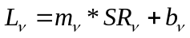 (3-4)
where 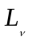 is spectral radiance (mW/(m2•sr•cm-1)) for a band characterized by central wavenumber ν, 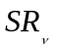is digital counts of the scaled radiance, and  and  are scaling coefficients obtained from the GRB data stream.

3.4.1.2 Converting Spectral Radiance to Reflectance Factor (bands 1-6)
(3-5)
Equation 3-5 shows how the radiance data can be converted into reflectance factor. This is the equation that will be used. The values for E_{sun} , π and d will be provided via the GRB.
Table 6 shows the values of E_{sun}. Note that the solar constant used 1366.1 W/m². The third column is what is used to convert from the GOES-R radiances units. The last column is provided only as a reference, for those that may need other units.
Band Number | Central Wavelength (μm) | E_{sun}  (mW/(m2·cm-1)) | E_{sun}  (W/(m2·µm))
1 | 0.47 | 44.1868715 | 1993.6600
2 | 0.64 | 66.3274497 | 1605.9593
3 | 0.86 | 72.6721072 | 969.7815
4 | 1.38 | 67.9143879 | 357.3011
5 | 1.61 | 63.4454241 | 244.7938
6 | 2.26 | 38.1148813 | 75.3057
Table 6. E_{sun} values. (TBV). These are from the UW Mock SRF. Again, these need to be revised with the flight SRF.

So, for ABI band 1, a radiance value of 14.06511802 mW/(m2•sr•cm-1) equates to a reflectance factor of 1.0.

3.4.1.3 Converting Spectral Radiance to BT (bands 7-16)

Planck Function constants are used for the conversion between radiance (mW/(m²·sr·cm⁻¹)) and BT or vice versa. To convert from radiance to temperature (K):
T = [ fk2 / (alog((fk1 / ) + 1)) - bc1 ] / bc2 (3-6)
To convert from temperature (K) back to radiance (mW/(m²·sr·cm⁻¹)):
= fk1 / [ exp (fk2 / (bc1 + (bc2 * T))) - 1 ] (3-7)
The two methods both have expansive user bases with the current GOES system. The coefficients for the second method are listed in Table 8. Note that these values will need to be updated with the flight SRF.
Band Number | Central Wavelength (μm) | Central Wavenumber (cm⁻¹) | fk1 | fk2 | bc1 | bc2
7 | 3.9 | 2564.05 | 2.00774e+05 | 3.68909e+03 | 0.50777 | 0.99929
8 | 6.15 | 1617.05 | 5.03614e+04 | 2.32657e+03 | 2.12504 | 0.99541
9 | 7.0 | 1439.05 | 3.54940e+04 | 2.07047e+03 | 0.33291 | 0.9992
10 | 7.4 | 1362.00 | 3.00925e+04 | 1.95961e+03 | 0.06984 | 0.99983
11 | 8.5 | 1176.05 | 1.93733e+04 | 1.69207e+03 | 0.17462 | 0.99951
12 | 9.7 | 1041.05 | 1.34382e+04 | 1.49784e+03 | 0.10861 | 0.99966
13 | 10.35 | 966.00 | 1.07364e+04 | 1.38986e+03 | 0.13445 | 0.99955
14 | 11.2 | 893.05 | 8.48310e+03 | 1.28490e+03 | 0.25361 | 0.9991
15 | 12.3 | 813.05 | 6.40146e+03 | 1.16980e+03 | 0.27049 | 0.99894
16 | 13.3 | 752.05 | 5.06603e+03 | 1.08203e+03 | 0.07574 | 0.99968
Table 7. Planck Coefficients. (TBV). These values are based on the Gaussian-Hybrid version of the ABI mock SRF (ftp://ftp.ssec.wisc.edu/ABI/SRF/).

Note that the Planck Conversion coefficients will need to be updated with the official flight ABI system-level SRF.

The Planck function is used to convert between radiance and brightness temperature There are equations that can be utilized to that take into account the spectral width. The equation that has been in use since the early 1980s for GOES (and several other satellites) is 3-6.

To calculate fk1 and fk2, use Boltzmann’s Constant, Planck’s Constant, and the velocity of light, along with the central wavenumber calculated in equation 3-6.

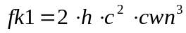 (3-8)
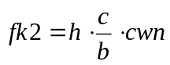 (3-9)
h = Planck Constant (6.62606896 x 10⁻²⁷ erg S)
b = Boltzmann Constant (1.3806504 x 10⁻¹⁶ erg/K)
c = Velocity of light (2.99792458 x 10¹⁰ cm/s)
cwn = Central Wavenumber (cm⁻¹)

Note that these values were considered correct as of 2006 (Mohr et al., 2007) but have been known to change. See Appendix B for further discussion.

For simplification, we have combined the first terms in the equations to calculate fk1 and fk2 as new constants, noted as C1 and C2.

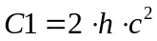 (3-10)
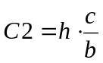 (3-11)

C1 = 1.19104276 x10⁻⁵ mW/(m2•sr•cm⁻⁴)
C2 = 1.43877516 K/cm⁻¹

The coefficients bc1 and bc2, once called ‘band correction’, are the intercept and slope from linear regression fits over equally spaced radiance values between a monochromatic Planck conversion and one that integrates over the instrument SRF. The coefficients fk1, fk2, bc1, and bc2 are constants for a given spectral band and should only change if the SRF is changed. Again, these values will need to be updated with the flight SRF.

Once the ABI flight model SRF have been determined, they will need to be made freely available. The SRFs will be needed by a number of users, included being needed to finalize the Planck coefficients reported in this ATBD.

3.4.1.4 Converting ABI noise values between temperature and radiance space (bands 7-16)
Instrument specifications for noise are given in kelvins for the IR bands. The specification is for noise at a temperature of 300 K. This is called the Noise Equivalent delta Temperature (NEdT) and NEdT is 0.1 K for all IR bands except for band 16 (the 13.3 µm band) which is 0.3 K. The Noise Equivalent delta Radiance is referred to as NEdN (mW/(m2•sr•cm-1)). There is a requirement that the quantization step be no larger than 0.5 times the NEdN. Since radiances are distributed and stored as digital counts, there can only be as many values as the bit depth allows (for instance, if data are 12-bits there are 2¹² = 4096 values that can be used). The difference in radiance units between the values stored in these counts will be uniform across the range of available counts, though it is not uniform in brightness temperature. To calculate NEdN from brightness temperature, first the radiance at 300 K, where the NEdT is defined, must be calculated. This is done using the modified Planck function which takes into account the instrument’s spectral response, so solving for radiance given a brightness temperature of 300:
(300) = fk1 / [ exp (fk2 / (bc1 + (bc2 * 300))) - 1 ] (3-12)
NEdN = (300 + NEdT) - (300) (3-13)
NEdN is a constant value across the entire temperature range of the instrument. To calculate NEdT at a temperature other than 300 K, the NEdN can be used in conjunction with the modified inverse Planck Function (equation 3-7) and the modified Planck Function (equation 3-8). For example, to calculate NEdT at 240 K, first the radiance at 240 K must be calculated the same as in equation 3-6.
(240) = fk1 / [ exp (fk2 / (bc1 + (bc2 * 240))) - 1 ] (3-14)
T⁺ = [ fk2 / (alog((fk1 / (+ NEdN) + 1)) - bc1 ] / bc2 (3-15)
NEdT(240) = T⁺ - 240 (3-16)
Equations 3-12 through 3-16 can be used to obtain the NEdT at any brightness temperature. Table 9 lists the NEdT values at 300, 240, and 200 K for the IR bands on the ABI.

Band | Central wavelength (µm) | NEdT (300 K)  K | NEdT (240 K)  K | NEdT (200 K)  K | NEdN  mW/(m2•sr•cm-1)
7 | 3.9 | 0.1 | 1.3253 | 12.2034 | 0.0038
8 | 6.19 | 0.1 | 0.4346 | 1.9664 | 0.0564
9 | 6.95 | 0.1 | 0.3576 | 1.3583 | 0.0824
10 | 7.34 | 0.1 | 0.3272 | 1.1423 | 0.0957
11 | 8.5 | 0.1 | 0.2628 | 0.7408 | 0.1303
12 | 9.61 | 0.1 | 0.2248 | 0.5421 | 0.1539
13 | 10.35 | 0.1 | 0.2062 | 0.4599 | 0.1645
14 | 11.2 | 0.1 | 0.1899 | 0.3856 | 0.1718
15 | 12.3 | 0.1 | 0.1738 | 0.3221 | 0.1754
16 | 13.3 | 0.3 | 0.4880 | 0.8421 | 0.5242

Table 8. Noise Equivalent delta Temperature (NEdT) and Radiance (NEdN) for the infrared bands on the ABI. NEdT is given, the other values are derived from it. Note that these values were calculated using the University of Wisconsin mock spectral response functions as a basis for spec noise; the NEdT will change when flight spectral response functions are available and these are not representative of actual noise measurements from the ABI.

The other approach is to simply use the derivative of the Planck function.

3.4.2 Mapping Reflectance and Brightness Temperature to BV
The TOA reflectance factor and BT calculated from spectral radiance are floating point numbers. The method for mapping TOA reflectance and BT to integer BV (12/14-bit) are described in this section. Information on 8-bits per pixel is also included here, for comparisons.

The Square-Root stretch method is recommended to be used for converting TOA reflectance to BV for the visible and near-IR bands if only 8 bits per pixel. The advantages and disadvantages of this method are summarized as follows:
- Advantages:
  - Covers more temperature range than a 1K/1Count stretch
  - Heritage
  - Efficient
  - Algorithm is mature
- Disadvantages:
  - Not as straight forward as a linear stretch

The Bi-Linear stretch method is recommended to be used for converting brightness temperature to BV for IR bands when using only 8 bits per pixel. The advantages and disadvantages of this method are summarized as follows:
- Advantages:
  - Highlights important features that would have been too dark
  - Heritage
  - Low risks
  - Efficient
  - Algorithm is mature
- Disadvantages:
  - Not as straight forward as a linear stretch

The square-root method (for the visible and near-IR bands) and a bi-linear method (for the IR bands) are recommended when the information has be to ‘compressed’ to only 8 bits, because there is a long history in both McIDAS and AWIPS of employing a bi-linear approach for the IR bands and a square-root function for the reflective bands. These methods are employed for the 8-bit brightness values.

Alternatively, users can employ other methods, similar to methods used in image enhancement, to convert TOA reflectance and BT to 8-bit (or other bit-depth) scaled BV.

3.4.2.1 Bi-Linear Stretch
Assuming 8 bits per pixels, the linear scaling method provides a linear amplitude transformation of input reflectance or radiance/BTs to output BV.
BV08= 418 – BT (for “cold” scenes, BT < 242) (3-17)
BV08= 660 – (2*BT) (3-18)
where BV08 is the new brightness value, BT is the original value BT. This allows for two slopes at either side of a break point. For example, if the BT is less then 242 K, then BV08 = 418 – T; while for value equal or great than 242 K, then BV08 = 660 – (2 * T).

Assuming the maximum bit depth (14 for band 7, 12 for other bands) is used for the IR bands, then this ‘bi-linear’ approach will not be needed, since the information would not need to be similarly ‘compressed’.

The following equations are used to generate the 12-bit (for 9 of the IR bands) and the 14-bit (for ABI band 2) brightness values:

BV12 = abs (count- 2¹² + 1) (3-19)

BV14 = abs (count- 2¹⁴ + 1) (3-20)

3.4.2.2 Square Root Stretch
Power law stretch is a nonlinear algorithm that changes image brightness according to:
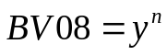 (3-21)
where BV08 is the new brightness value for an 8-bit system, is the original reflectance factor value, and n is the power scaling coefficient. If n > 1, high values are enhanced disproportionately with respect to low values. If n < 1, low BV are enhanced disproportionately with respect to high values.

The square root enhancement is a special case of the power law stretch (n=1/2). It compresses the upper end of spectrum and stretches the lower end. This method has been used for decades when displaying GOES visible data (and for many years for AWIPS displays). Reflectance factors darker than 0 would be mapped to a 0 BV, while values greater than 1 will be mapped to 255 (in an 8-bit system).

(3-22)

Where NINT (or IDINT) is the “nearest integer” and SQRT is the Square-root function.

If a system can display the full bit depth (assumed to be 12), for bands 1-6, then this square root function could be applied locally. So, the conversion is simply:
BV12 = GRB_Count (SR) (3-23)

3.4.3 Down-scaling Algorithm

To produce CMIP multi-band end-products, it is necessary to re-sample the radiance from 1 km to 2 km for ABI visible and near-IR bands (1, 3 & 5), since the spatial resolution of the data in multi-band products is nominally 2 km while the native resolution of ABI bands 1, 3 and 5 is 1 km.

There are two methods for this down-scaling. The default method is via re-sampling. The re-sampling algorithm is applied to downscale the data and it is described as follows:

, (3-24)
where  is the re-sampled data and  is the original data. The g(x,y) array then needs to be re-projected to the 2 km FGF. For the 1 km data, start with the first pixel, which then gets “shifted” to the “north-east”. That assumes the FGF for the coordinate of (0,0) being the most ‘southwest’ pixel. For example, pixels, (0,0), (0,2), (0,4), etc are selected. This is regardless of the value in any saturation or quality flag. Those corresponding flags will be carried along from the selected pixel.

The ABI band 2 spatial resolution is 0.5 km nominally, so more ‘down-scaling’ (eg, a factor of 16) is needed for the multi-band files. For the 0.5 km data to 2 km, the pixel just “southwest” of the 2 km pixel will be used. For example, (1,1), (1, 5), (1,9), etc. Assuming (0,0) is in the ‘southwest’.

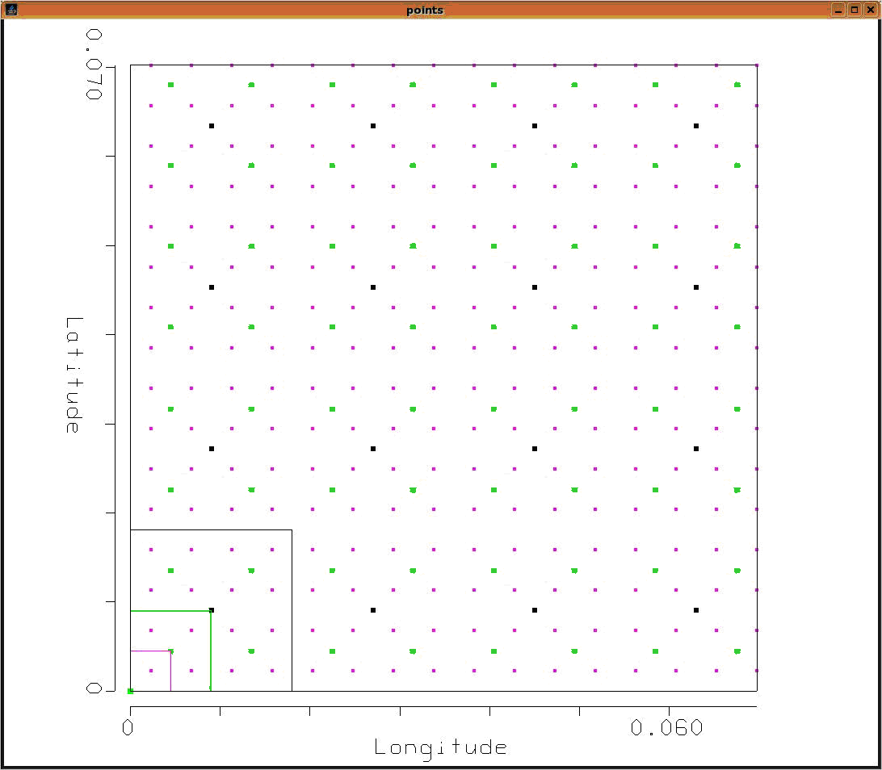
Figure 2. Re-sampling points for the ABI FGF for the 0.5, 1 and 2 km. The magenta points represent the center of a 0.5 km pixel, the green points the center of a 1 km pixel and the black points the center of a 2 km pixel. The "lower-left dot" is the satellite sub-point, i.e., there is no pixel centered on the sub-point.

Figure 2 shows how there are actually three FGF projections, each based on its spatial resolution.

The advantages of using this sampling algorithm include:
- Quicker
- Traceable, less “blurry”
  - Preserves image gradients
- Doesn’t create artificial values
  - If the scene has a bi-modal distribution
- Straight forward (due to resolutions nested in one another)
In addition, users that need the full resolution data could still access the full resolution files (e.g., not the multi-band files).

The second method is to average pixels. An advantage of spatial averaging is that it can improve the signal-to-noise ratio and it may more closely match the 2 km IR bands with respect to implicit ‘area averaging’. The final methodology to be routinely employed may need to consider the instrument performance, etc. This is also dependent on the nature of the kernel used when ABI data are remapped from detector to pixel space. The simple averaging method will give equal weight to the 4 pixels (for the 1 km to 2 km case) and the 16 pixels (for the 0.5 km to 2 km case), if all pixels are noted as having both good quality and saturation flags. In the case of non-zero quality or saturation flags, then the remaining good pixels (e.g., both quality and saturation) should be averaged and the good quality flags passed on to the 2 km grid. If all pixels are noted to be of non-zero quality or saturation flags, then all pixels are averaged and the non-zero flags passed on.

It is assumed the quality and saturation flags from GRB will each be 1-bit. It is assumed a zero value is ‘good’, while a value of one is ‘bad’.

Hence, at this time it is thought that the option for arithmetic average needs to be available, along with the default sampling option. The default down-scaling algorithm will be via sub-sampling, while the code will support the averaging option as well (along with an attribute for the method used).

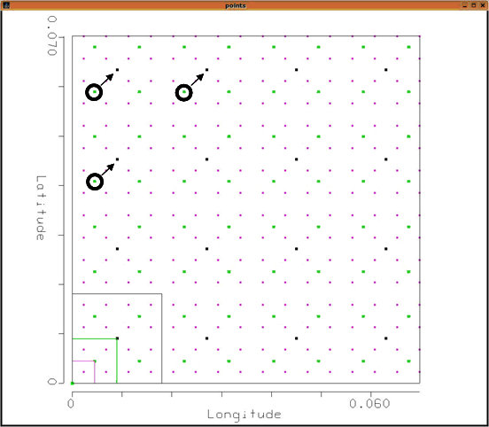
Figure 3. Re-sampling points for the ABI FGF for the 1 km data. Note the sub-sampling method ‘re-projects’ to the 2 km FGF domain.

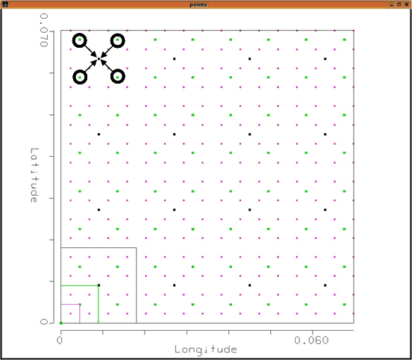
Figure 4. Averaging points for the ABI FGF for the 1 km data.

Figures 5 is a simulated 1km ABI data, while Figures 6 and 7 show the image after sub-sampling and averaging to 2 km, respectively. Note that Figures 6 and 7 are ‘grainer’ due to the coarser spatial resolution.
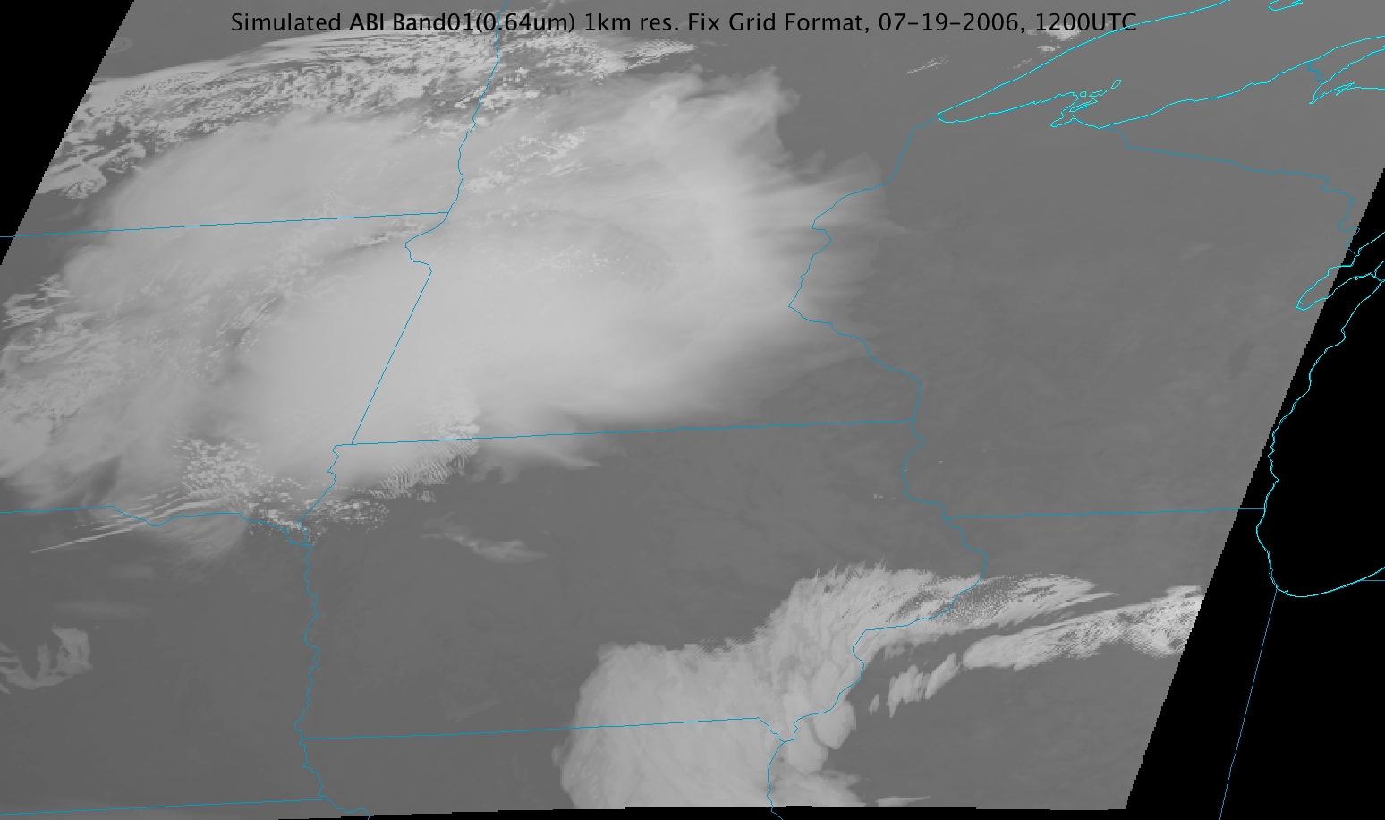
Figure 5. Simulated ABI 1 km data shown in the FGF.
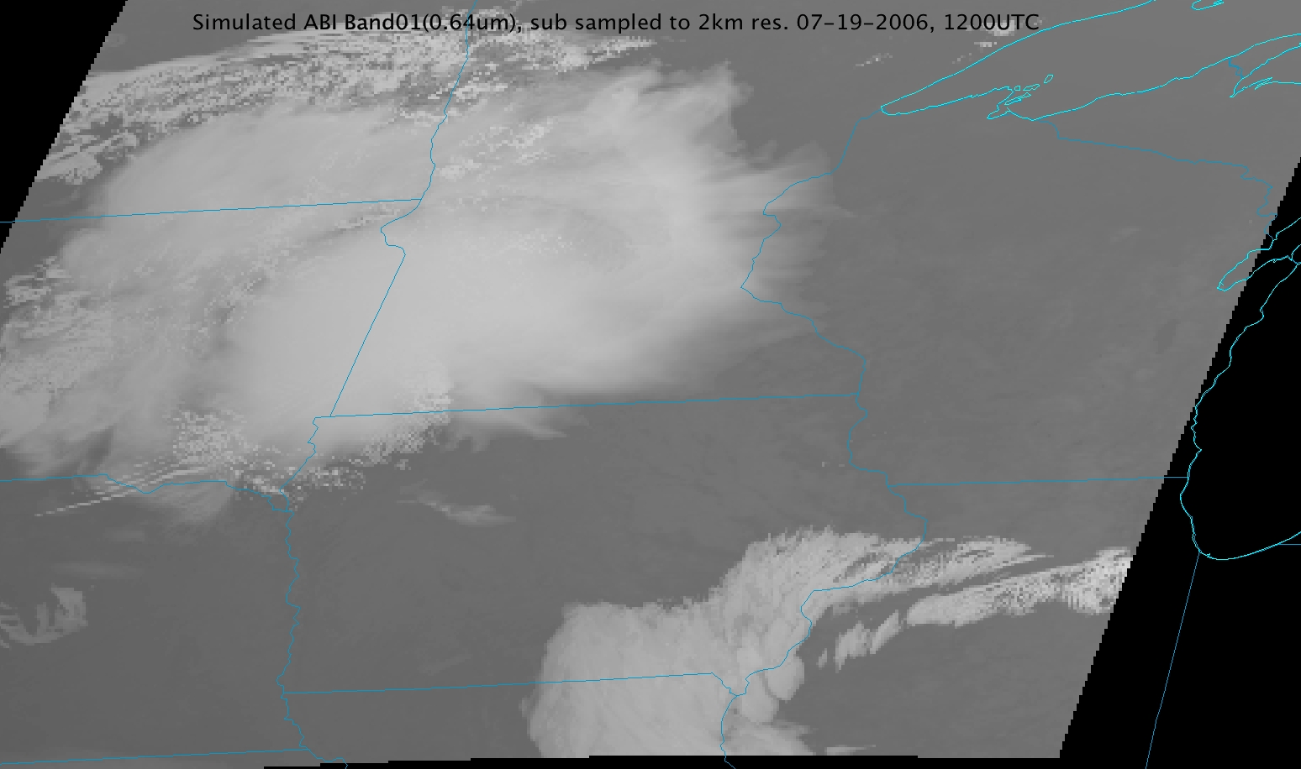
Figure 6. Simulated ABI sub-sampled and re-projected to 2 km shown in the FGF.
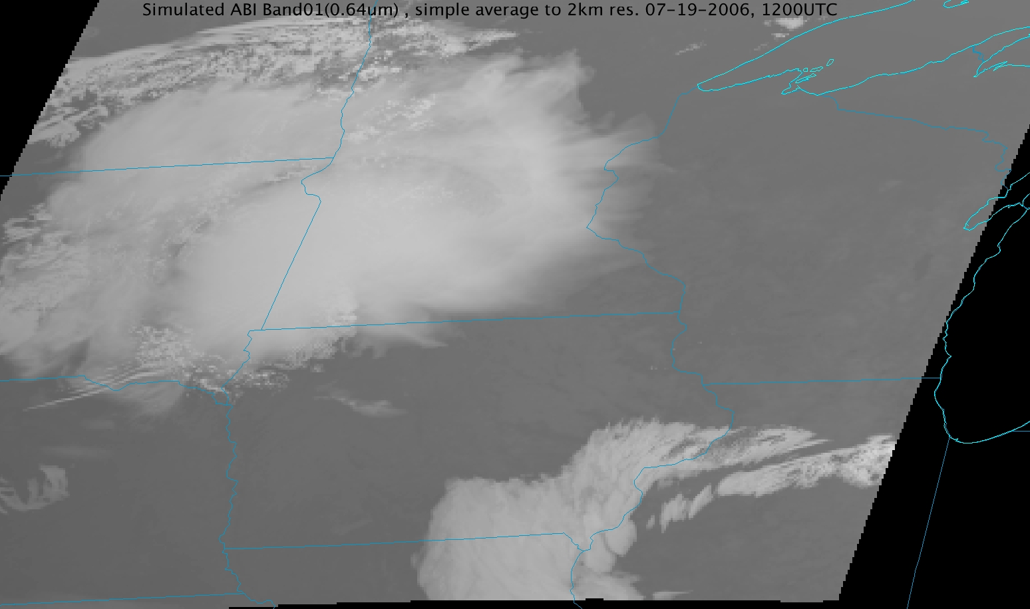
Figure 7. Simulated ABI averaged to 2 km and re-projected on the 2 km FGF.
3.4.4 Radiance Unit Conversions

The spectral radiance units will be mW/(m2•sr•cm-1), however, some users may be interested in switching to other units, such as (W/(m2•sr•µm)). Therefore, the methodology is included here based on Cao and Heidinger, 2002.

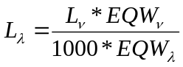, (3-21)
where L_{ν} = Radiance in wavenumber (mW/(m2•sr•cm-1))
L_{λ} = Radiance in wavelength (W/(m2•sr•µm))
1000 = convert W to mW
EQW_{λ}=Equivalent Width in wavelength (µm) space, which is the integral of the SRF in µm
EQW_{ν}=Equivalent Width in wavenumber (cm-1) space, which is the integral of the SRF in cm-1

UW SRF | Band 1 | Band 2 | Band 3 | Band 4 | Band 5 | Band 6
Band EQW [cm-1] | 1872.4315 | 2535.0581 | 537.7881 | 81.5463 | 238.4452 | 101.1587
Band EQW [µm] | 0.0415 | 0.1047 | 0.0403 | 0.0155 | 0.0618 | 0.0512
Table 9. Equivalent Widths (EQW) for the six visible and near-IR bands on the ABI. (TBV when flight SRFs are available – these are based on the University of Wisconsin simulated SRFs).
Table 10 contains the EQW values for the UW mock spectral response functions. The Equivalent Width values can be computed once the flight SRF are available.

3.5 Algorithm Output
The primary output of this algorithm is the information to generate enhanced cloud and moisture images. That said, these files are also used to generate the plethora of ABI products. For example, products can access either radiance or brightness temperatures. In total, 54 end-products are produced: 16 ABI bands for the 3 coverage areas (CONUS, FD, and mesoscale) in NetCDF format, 1 multi-banded image (all 16 bands) at the spatial resolution of the IR bands (2 km) for each of the 3 coverage areas in NetCDF format, and 1 multi-banded image (all 16 bands) at 2 km resolution for each of the 3 coverage areas in McIDAS format. The supported formats will be in NetCDF (version 4) format and McIDAS format. Output should be able to be converted from NetCDF or McIDAS format to other formats.
Table 11 summarizes the fields in the single-band imagery products:
Field | Name | Description | Dimension
1 | Radiance Data | Radiance for bands 1-16 at full spatial resolution | grid (ysizeh, xsizeh)  grid (yxsize1, xsize1)  grid (ysize2, xsize2)
2 | Reflectance Factor | Bands 1-6 [nominally 0-1] | grid (ysizeh, xsizeh)  grid (ysize1, xsize1)  grid (ysize2, xsize2)
3 | Brightness Temperature | Bands 7-16 [K] | grid (ysize2, xsize2)
4 | Brightness Values | Bands 1-16 | grid (ysizeh, xsizeh)  grid (ysize1, xsize1)  grid (ysize2, xsize2)
5 | Nominal Start Day/Time | Julian Date/Time (UTC) | array (zsize)
6 | Image Day/Times | Nominal swath start day/times | array (2,22)FD  array (2,6)CONUS  array (2,2)MESO
7 | Fixed Grid Coordinates | Definition of earth in GRS80 | array (lsize)
8 | Sub-point (nominal) | Sub point latitude and longitude nominal | array (2)
9 | Sub-point (actual) | Sub point latitude and longitude actual | array (2)
10 | Band Center wavenumbers | Band Center wavenumbers | array (16)
11 | Radiance to Brightness Temperature conversion coefficients | Plank Coefficients | array (2, 10)
12 | Radiance Coefficients to Reflectance Factor | Coefficients to convert to reflectance factor from radiances for reflective bands (Esun, pi, d, etc.) | array (jsize)
13 | Quality Flags | Quality Flags by band (quality and saturation) | grid (ysizeh, xsizeh)  grid (ysize1, xsize1)  grid (ysize2, xsize2)
14 | Sat. id | Satellite ID | array (1)
15 | Earth-Sun Distance | Earth-Sun Distance | array (1)
16 | Image Center point | Latitude/Longitude | array (2)
17 | Line array | absolute fixed grid line-coordinate | array (xsizeh)  array (xsize1)  array (xsize2)
18 | Element array | absolute fixed grid line-coordinate | array (ysizeh)  array (ysize1)  array (ysize2)
19 | Bits per pixel |  | array (1)
20 | Spare
21 | Satellite | GOES-16, -17, etc.
22 | Instrument | ABI
23 | Altitude | km | array (1)
24 | Scan type | FD, CONUS, Mesoscale, Other
25 | Product Version | Version # | array (1)
26 | Data compression | type
27 | Location of production
28 | Citations to Documents
29 | Contact Information
30 | SRF version |  | array (1)
31 | Processing day/time |  | array (2)
32 | Product Name | Cloud and Moisture Imagery
33 | Radiance Units | mW/(m2•sr•cm-1)
34 | Brightness Temperature Units | K
35 | Reflectance factor Units | N/A
36 | GRB version number |  | array (1)
37 | Central wavelength | area under the curve weighted value (µm) | array (1)
38 | Band resolution | km | array (1)
39 | C1 | mW/(m2·sr·cm-4) | array (1)
40 | C2 | K/cm-1 | array (1)
41 | Earth-Sun distance |  | array (1)
42 | Nominal Earth-Sun distance |  | array (1)
43 | Radiance stats | Min, Max, Mean and Stddev + units | array (5)
44 | Reflectance factor stats | Min, Max, Mean and Stddev + units | array (5)
44 | Brightness Temperature stats | Min, Max, Mean and Stddev + units | array (5)
45 | # good cal points | From level1b | array (1)
46 | # good nav points | From level1b | array (1)
47 | Total # of points | From level1b | array (1)
48 | Space Look times
49 | Blackbody times
Table 10. Fields in CMIP single-band imagery products. (TBV)

One viable option, to reduce individual file sizes and allow users to get files in the unit they need, would be to generate separate files with radiances, or reflectance factor, or brightness temperature or brightness values.

For a full disk 2 km image, the ysize2, xsize2 would be 5534. For a meso-scale image, ysizeh, xsizeh would be 1000. ysize1, xsize1 corresponds to the 1 km files.
Table 12 summarizes the fields in the multi-band imagery products:
Field | Name | Description | Dimension
1 | Bands 1 – 16 radiance | Band 1-16 radiance at 2 km | grid (16, ysize2, xsize2)
2 | Reflectance Factor | Bands 1-6 [nominally 0-1] | grid (6, ysize2, xsize2)
3 | Brightness Temperature | Bands 7-16 [K] | grid (10, ysize2, xsize2)
4 | Brightness Values | Bands 1-16 | grid (16, ysize2, xsize2)
5 | Nominal Start Day/Time | Julian Date/Time (UTC) | array (zsize)
6 | Image Day/Times | Nominal swath start day/times | array (2,22)FD  array (2,6)CONUS  array (2,2)MESO
7 | Fixed Grid Coordinates | Definition of earth in GRS80 | array (lsize)
8 | Sub-point (nominal) | Sub point latitude and longitude nominal | array (2)
9 | Sub-point (actual) | Sub point latitude and longitude actual | array (2)
10 | Band Center wavenumbers | Band Center wavenumbers (cm-1) | array (16)
11 | Radiance to Brightness Temperature conversion coefficients | Plank Coefficients | array (2, 10)
12 | Radiance Coefficients to Reflectance Factor | Coefficients to convert to reflectance factor from radiances for reflective bands (Esun, pi, d, etc.) | array (jsize)
13 | Quality Flags | Quality Flags by band (quality and saturation) | grid (16, ysize2, xsize2)
14 | Sat. id | Satellite ID | array (1)
15 | Earth-Sun Distance | Earth-Sun Distance | array (1)
16 | Image Center point | Latitude/Longitude | array (2)
17 | Line array | absolute fixed grid line-coordinate | array (xsize2)
18 | Element array | absolute fixed grid line-coordinate | array (ysize2)
19 | Down-scaling method | Sampling or average
20 | Bits per pixel |  | array (16)
21 | Satellite | GOES-16, -17, etc.
22 | Instrument | ABI
23 | Altitude | km | array (1)
24 | Scan type | FD, CONUS, Mesoscale, Other
25 | Product Version | Version # | array (1)
26 | Data compression | type
27 | Location of production
28 | Citations to Documents
29 | Contact Information
30 | SRF version |  | array (16)
31 | Processing day/time |  | array (2)
32 | Product Name | Cloud and Moisture Imagery
33 | Radiance Units | mW/(m2•sr•cm-1)
34 | Brightness Temperature Units | K
35 | Reflectance factor Units | N/A
36 | GRB version number |  | array (1)
37 | Central wavelength | area under the curve weighted value (µm) | array (16)
38 | Band resolution | km | array (16)
39 | C1 | mW/(m2·sr·cm-4) | array (1)
40 | C2 | K/cm-1 | array (1)
41 | Earth-Sun distance |  | array (1)
42 | Nominal Earth-Sun distance |  | array (1)
43 | Radiance stats | Min, Max, Mean and Stddev + units | array (5,16)
44 | Reflectance factor stats | Min, Max, Mean and Stddev + units | array (5,6)
44 | Brightness Temperature stats | Min, Max, Mean and Stddev + units | array (5,10)
45 | # good cal points | From level1b | array (16)
46 | # good nav points | From level1b | array (16)
47 | Total # of points | From level1b | array (16)
48 | Space Look times
49 | Blackbody times
Table 11. Fields in CMIP multi-band imagery products. (TBV)

The output also includes metadata (min, max, mean, and standard deviation, plus the metadata passed on from GRB) and geolocation information, such as the number of pixels flagged with poor calibration and/or navigation acquired from GRB (TBV). Metadata examples might be the actual satellite sub-point, or the scaling methods and corresponding coefficients that are used to generate “n”-bit BV. It is assumed that, at least initially, two versions of “n” will be generated. The first will be the maximum bits, 12 for all bands, with the exception of ABI band 7 which needs to be 14 bits. For any legacy system, 8 bits per pixel will also be available. Users can use the full-bit depth scaling coefficients to convert BV back to reflectance factor or BT.

Latitude and Longitude information for each pixel does not have to be stored when enough information is stored to describe the location of the data on the FGF. For example, current AWIPS NetCDF do not store the latitude/longitude information, given the data is first remapped to a known projection/location. CF-NetCDF has metadata constructs for describing grid to earth coordinate transforms. The projection coordinates for the array domain are stored in two 1-D arrays (one each for x and y) whose lengths match those of the data array dimension. A separate file containing the full disk latitude and longitude grids (for the three spatial resolutions) could be provided as part of the test datasets for applications which do not how, or do not want, to interpret the standardized navigation metadata and/or don’t have the FGF to (longitude, latitude) transformations algorithm available to them. In this case, the 1-D arrays of absolute grid coordinates can be used as indexes into the full disk master files for navigating full disk or sub domains.

4 TEST DATA SETS AND OUTPUTS

4.1 GOES-R Simulated Input Data Sets
Simulated GOES-R ABI data has been used in the pre-launch phase to develop, test, and validate the ABI CMIP products. The data is derived from use of a radiative transfer model, where the atmospheric and earth surface representations are provided by a high resolution numerical weather prediction forecast model. The GOES-R Algorithm Working Group Proxy Data Team is responsible for the generation of the proxy and simulated instrument data sets. Within the proxy group, the simulated images used by the imagery team were generated by CIMSS.

Much work has been done to generate high-quality simulated ABI images based on output from the high resolution Weather Research and Forecasting (WRF) numerical model. The forward radiative transfer models used to transform from model (environmental parameter) space to measurement (radiances and BTs) space cover from the visible, to the IR spectral regions (Otkin and Greenwald 2008). High quality forward model simulations have been made of each of the ABI 16 bands.

The GOES-R AWG Proxy Data team has created several ABI simulations. This section details the work on a CONUS simulation which mimics one of the proposed scan segments on the future ABI (Otkin et. al 2007). Two flexible scanning scenarios are currently under review for the ABI. The first mode allows the ABI to scan the full disk (FD) every 15 minutes, 3 CONUS scenes, and scan a 1000 km x 1000 km selectable area every 30 seconds, although it is envisioned that 2 areas will be scanned, giving a 1-minute cadence for each. A second mode would program the ABI to scan the FD every 5 minutes (Schmit et al. 2005).

The synthetic GOES-R ABI imagery begins as a high resolution WWRF model simulation. The CONUS simulation was performed at the National Center for Supercomputing Applications (NCSA) at the University of Illinois at Urbana-Champaign by the GOES-R AWG proxy data team at CIMSS. Simulated atmospheric fields were generated using version 2.2 of the WRF model (ARW core). The simulation was initialized at 2355 UTC on 04 June 2005 with 1° Global Forecast System (GFS) data and then run for 30 hours using a triple-nested domain configuration. The outermost domain covers the entire GOES-R viewing area with a 6-km horizontal resolution while the inner domains cover the CONUS and mesoscale regions with 2 km and 0.667 km horizontal resolution, respectively.

WRF model output, including the surface skin temperature, atmospheric temperature, water vapor mixing ratio, and the mixing ratio and effective particle diameters for each hydrometeor species, were ingested into the Successive Order of Interaction (SOI) forward radiative transfer model in order to generate simulated top of atmosphere (TOA) radiances. Gas optical depths were calculated for each ABI infrared band using the Community Radiative Transfer Model (CRTM). Ice cloud absorption and scattering properties were obtained from Baum et al. (2005), whereas the liquid cloud properties were based on Lorenz-Mie calculations.

Figures 8-16 show examples of simulated ABI imagery images over the CONUS and near Full Disk regions. The simulated data captures the general features and locations well. Some differences can be observed in the cloud structures.



Figure 8a (top panel) ABI Band 2 stored as a McIDAS AREA displayed in McIDAS-X. 8b (bottom panel) ABI Band 14 stored as a McIDAS AREA displayed in McIDAS-X.


Figure 9. ABI Band 7 stored as a NetCDF displayed in McIDAS-V

Figure 10. ABI Bands 1-6 converted to an AWIPS-ready NetCDF and displayed in AWIPS


Figure 11. ABI Bands 9-16 converted to an AWIPS-ready NetCDF and displayed in AWIPS

4.2 Output from Simulated ABI Data Sets

4.2.1 Imagery Generated from Simulated ABI Data
The Imagery products have been generated from the CONUS simulated ABI data at 2355 UTC on 04 June 2005. Figures 12 and 13 show examples of reflectance and brightness values products generated from simulated ABI band 1 data over the CONUS. Figures 14-15 show the examples of radiance, brightness temperature, and brightness values products generated from simulated ABI band 7 data over the CONUS.


Figure 12. Reflectance of ABI Band 1 at 2200 UTC on 04 June 2005 displayed in McIDAS-V

Figure 13. Brightness Values of ABI Band 1 at 2200 UTC on 04 June 2005 displayed in McIDAS-V


Figure 14. Radiance of ABI Band 7 at 2200 UTC on 04 June 2005 displayed in McIDAS-V


Figure 15. Brightness Temperature of ABI Band 7 at 2200 UTC on 04 June 2005 displayed in McIDAS-V

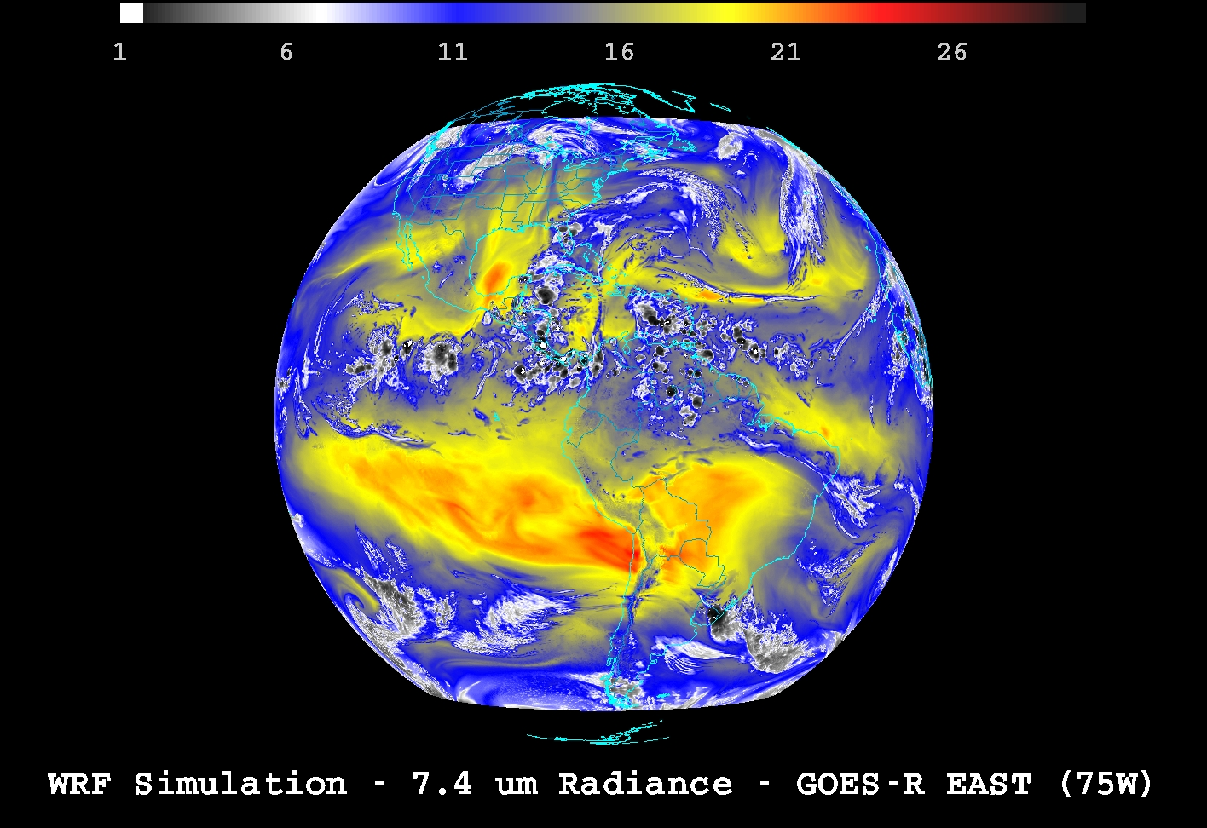
Figure 16. Brightness Value derived from simulated ABI Band 10 data displayed in McIDAS-V. The sub-point is 75°W.

Sample (TBV) single-band netCDF structure for the simulated ABI data is envisioned as follows for the visible and infrared bands.

ABI Band 1 example:

Simple_AVG_reprojected_Validation_1km_sim_abi_band01_2006_0719_1200utc {
dimensions:
y = 328 ;
x = 580 ;
line = 328 ;
element = 580 ;
time = 1 ;
e_sun = 1 ;
swath_t = 22 ;
variables:
float ABI_Rad_b01(y, x) ;
ABI_Rad_b01:long_name = "ABI radiance band01 (0.47um)" ;
ABI_Rad_b01:units = "milliwatts/m2/steradian/cm-1" ;
ABI_Rad_b01:_FillValue = -999.f ;
ABI_Rad_b01:grid_mapping = "Projection" ;
ABI_Rad_b01:coordinates = "y x" ;
float ABI_Refl_b01(y, x) ;
ABI_Refl_b01:long_name = "ABI reflectance band01(0.47um)" ;
ABI_Refl_b01:units = "none" ;
ABI_Refl_b01:_FillValue = -999.f ;
ABI_Refl_b01:grid_mapping = "Projection" ;
ABI_Refl_b01:coordinates = "y x" ;
short Brit_val_08bit_b01(y, x) ;
Brit_val_08bit_b01:long_name = "Brightness Values 8bit band01 (0.47um)" ;
Brit_val_08bit_b01:units = "None" ;
Brit_val_08bit_b01:_FillValue = 0s ;
Brit_val_08bit_b01:grid_mapping = "Projection" ;
Brit_val_08bit_b01:coordinates = "y x" ;
short Brit_val_12bit_b01(y, x) ;
Brit_val_12bit_b01:long_name = "Brightness values 12bit band01 (0.47um)" ;
Brit_val_12bit_b01:units = "None" ;
Brit_val_12bit_b01:_FillValue = 0s ;
Brit_val_12bit_b01:grid_mapping = "Projection" ;
Brit_val_12bit_b01:coordinates = "y x" ;
double x(x) ;
x:standard_name = "projection_x_coordinate" ;
short elements(x) ;
elements:long_name = "elements_x_dir" ;
double y(y) ;
y:standard_name = "projection_y_coordinate" ;
short lines(y) ;
lines:long_name = "lines_y_dir" ;
float time(time) ;
time:long_name = "Image start time" ;
time:units = "seconds since 2006-07-19 12:00" ;
short swathtimes(swath_t) ;
swathtimes:long_name = "Swath start Time " ;
swathtimes:units = "seconds since 2006-07-19 12:00" ;
char Projection ;
Projection:grid_mapping_name = "FGFProjection" ;
Projection:_CoordinateTransformType = "Projection" ;
Projection:_CorrdinateAxes = "y x" ;
Projection:subpoint_longitude_degrees = "-75." ;
Projection:delta_lamda_radians = "2.8e-05" ;

// global attributes:
:TITLE = "NCSA-FCM 2-KM CONUS ABI VISIBLE DATA REMAPPED TO GOES-R 2-KM DOMAIN" ;
:INSTITUTE = "UNIVERSITY OF WISCONSIN-MADISON SSEC/CIMSS" ;
:HISTORY = "The model was simulated on a supercomputer at the National Center for Supercomputing Applications. The CIMSS forward radiative transfer modeling system was then used to compute simulated radiances for each ABI band" ;
:SOURCE = "Simulated ABI scaled integer data for this dataset were computed using output from a high-resolution Weather Research and Forecasting model coupled with the CIMSS forward radiative transfer models" ;
:REFERENCE = "Otkin, J. A., T. J. Greenwald, J. Sieglaff, and H.-L. Huang, 2009: Validation of a large-scale simulated brightness temperature dataset using SEVIRI satellite observations. [accepted for publication in/ J. Appl. Meteor. Climatol/.]" ;
:Conventions = "CF-1.4" ;
:FM_AUTHOR = "CRTM" ;
:PROCESSED_DATE = "Tue Sep 7 18:24:59 2010" ;
:FM_CVS_VERSION = "Release_Sep08_A" ;
:NWP_MODEL = "OUTPUT FROM WRF-CHEM MODEL" ;
:CEN_LAT = 0.f ;
:CEN_LON = -75.f ;
:OUTPUT_TIME = "2006-07-19 12:00UTC" ;
:Longitude_Subpoint = -75.f ;
:dyKm = 2.f ;
:dxKm = 2.f ;
:rotation = 0.f ;
:Sampling_Method = "Simple Average" ;
}

ABI Band 10 example:

netcdf Validation_2km_fd_sim_abi_band10_2008_0626_2100utc {
dimensions:
sw1 = 22 ;
y = 5534 ;
x = 5534 ;
line = 5534 ;
element = 5534 ;
time = 1 ;
e_sun = 1 ;
swath_t = 22 ;
variables:
float ABI_Rad_b10(y, x) ;
ABI_Rad_b10:long_name = "ABI radiance band10 (7.34um)" ;
ABI_Rad_b10:units = "milliwatts/m2/steradian/cm-1" ;
ABI_Rad_b10:grid_mapping = "Projection" ;
ABI_Rad_b10:coordinates = "y x" ;
float ABI_TBB_b10(y, x) ;
ABI_TBB_b10:long_name = "ABI brightness temperature band10 (7.34um)" ;
ABI_TBB_b10:units = "Kelvin" ;
ABI_TBB_b10:grid_mapping = "Projection" ;
ABI_TBB_b10:coordinates = "y x" ;
short brit_val(y, x) ;
brit_val:long_name = "Brightness Values 08bit band 10(7.34um)" ;
brit_val:units = "None" ;
brit_val:grid_mapping = "Projection" ;
brit_val:coordinates = "y x" ;
short Brit_val_12bit_b10(y, x) ;
Brit_val_12bit_b10:long_name = "Brightness values 12bit band10 (7.34um)" ;
Brit_val_12bit_b10:units = "None" ;
Brit_val_12bit_b10:grid_mapping = "Projection" ;
Brit_val_12bit_b10:coordinates = "y x" ;
double x(x) ;
x:standard_name = "projection_x_coordinate" ;
short elements(x) ;
elements:long_name = "elements_x_dir" ;
double y(y) ;
y:standard_name = "projection_y_coordinate" ;
short lines(y) ;
lines:long_name = "lines_y_dir" ;
float time(time) ;
time:long_name = "Image start time" ;
time:units = "seconds since 2008-06-26 21:00" ;
short swathtimes(swath_t) ;
swathtimes:long_name = "Swath start Time " ;
swathtimes:units = "seconds since 2008-06-26 21:00" ;
char Projection ;
Projection:grid_mapping_name = "FGFProjection" ;
Projection:_CoordinateTransformType = "Projection" ;
Projection:_CorrdinateAxes = "y x" ;
Projection:subpoint_longitude_degrees = "-137." ;
Projection:delta_lamda_radians = "5.6e-05" ;

// global attributes:
:TITLE = "NCSA-FCM 2-KM CONUS ABI VISIBLE DATA REMAPPED TO GOES-R 2-KM DOMAIN" ;
:INSTITUTE = "UNIVERSITY OF WISCONSIN-MADISON SSEC/CIMSS" ;
:HISTORY = "The model was simulated on a supercomputer at the National Center for Supercomputing Applications. The CIMSS forward radiative transfer modeling system was then used to compute simulated radiances for each ABI band" ;
:SOURCE = "Simulated ABI scaled integer data for this dataset were computed using output from a high-resolution Weather Research and Forecasting model coupled with the CIMSS forward radiative transfer models" ;
:REFERENCE = "Otkin, J. A., T. J. Greenwald, J. Sieglaff, and H.-L. Huang, 2009: Validation of a large-scale simulated brightness temperature dataset using SEVIRI satellite observations. [accepted for publication in/ J. Appl. Meteor. Climatol/.]" ;
:Conventions = "CF-1.4" ;
:FM_AUTHOR = "CRTM" ;
:PROCESSED_DATE = "Tue Aug 24 18:15:11 2010" ;
:FM_CVS_VERSION = "Release_Sep08_A" ;
:NWP_MODEL = "OUTPUT FROM WRF-CHEM MODEL" ;
:CEN_LAT = 0.f ;
:CEN_LON = -137.f ;
:OUTPUT_TIME = "2008-06-26 21:00UTC" ;
:Longitude_Subpoint = -137.f ;
:dyKm = 2.f ;
:dxKm = 2.f ;
:rotation = 0.f ;
}

Two other ABI simulated datasets are also being used as part of the imagery validations.


Figure 17. ABI band 4 (1.38 µm) simulation of hurricane Katrina at 2200 UTC on 28 August 2005.

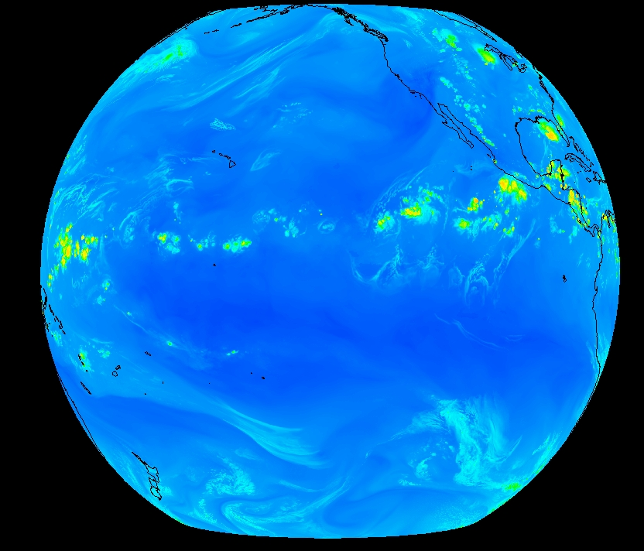
Figure 18. ABI band 10 (7.34 µm) simulation of the Pacific at 137°W at 2000 UTC on 26 June 2008.

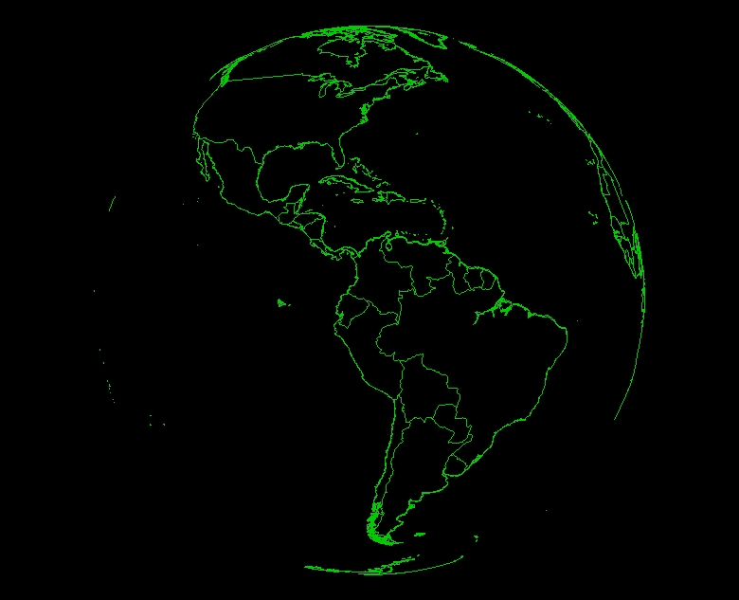
Figure 19. ABI band Fixed Grid Format (FGF) coverage sample from 75°W. The point is that latitudes and longitude would not have to be carried, given the grid format.
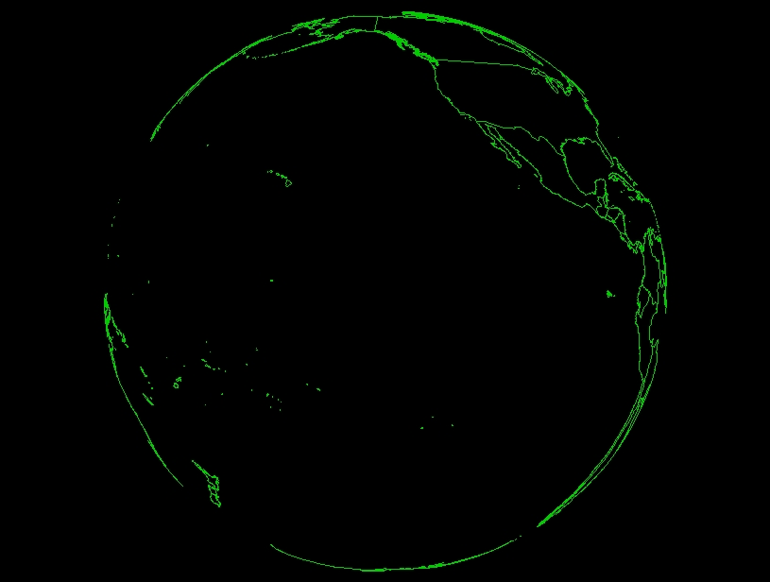
Figure 20. ABI band Fixed Grid Format (FGF) coverage sample from 137°W.

The FGF comprises a set of fixed view angles at regular intervals, and their respective intersections with the GRS80 Earth geoid, from an ideal or nominal point in space in the equatorial plane. The geometric transformations from FGF coordinate to Earth location, and visa-versa, are essentially those outlined in the CGMS defined Normalized Geostationary Projection (4.4.3.2). The complete description of the FGF is formally defined in ABIPORD13. The transform algorithms are being tested in the McIDAS-V geolocation framework, and necessary CF-compliant metadata have been added to NetCDF files to produce the above figures. Using the FGF will reduce the file size (by not needing to carry a latitude/longitude value for each pixel) and should also improve the performance of any remapping functions.

4.2.2 Precisions and Accuracy Estimation
This section describes the predicted performance and product quality of the CMIP relative to the CMIP specifications found within the GOES-R Functional and Performance Specification Document (F&PS). To estimate the precision and accuracy of the Imagery product requires validation files generated by the research code running offline. The reference (“truth”) data files include reflectance, radiance, brightness values and geolocation information for bands 1-6, and radiance, brightness temperature, brightness values and geolocation information for bands 7-16.

The accuracy and precision estimates for the Imagery products are determined by computing the following values: mean difference, max difference and standard deviation of difference of reflectance, radiance, brightness values for bands 1-6 and radiance, brightness temperature and brightness values for bands 7-16. The comparison results are summarized in the Table 13, in which s is the value generated by the software and t is the reference (“true”) data.

 | Reflectance |  |  | Radiance |  |  | Brightness Value
 | mean(s – t) | stdev(s – t) | max(|s - t|) | mean(s – t) | stdev(s – t) | max(|s - t|) | mean(s – t) | stdev(s – t) | max(|s - t|)
01 | -1.80270e-09 | 8.77219e-09 | 5.96046e-08 | -8.23024e-06 | 1.14099e-05 | 9.15527e-05 | 1.93469e-05 | 0.00439843 | 1.00000
02 | 5.43765e-10 | 9.10306e-09 | 5.96046e-08 | -4.51243e-06 | 7.01644e-06 | 6.10352e-05 | 0.00000 | 0.00000 | 0.00000
03 | -3.63924e-09 | 1.04284e-08 | 5.96046e-08 | -5.55586e-06 | 6.18800e-06 | 4.57764e-05 | 0.00434283 | 1.88608e-05 | 1.00000
04 | 6.02707e-10 | 1.39890e-09 | 2.98023e-08 | 1.53219e-08 | 2.71043e-07 | 7.62939e-06 | 0.00000 | 0.00000 | 0.00000
05 | 6.95558e-09 | -8.69477e-10 | 5.96046e-08 | 1.03450e-06 | -6.73960e-07 | 1.14441e-05 | 0.00000 | 0.00000 | 0.00000
06 | -4.82609e-10 | 5.72237e-09 | 2.98023e-08 | -1.45095e-07 | 2.36706e-07 | 1.90735e-06 | 0.00000 | 0.00000 | 0.00000
 | Radiance |  |  | Brightness Temperature |  |  | Brightness Value
 | mean(s – t) | stdev(s – t) | max(|s - t|) | mean(s – t) | stdev(s – t) | max(|s - t|) | mean(s – t) | stdev(s – t) | max(|s - t|)
07 | 8.07578e-09 | 2.31943e-08 | 1.19209e-07 | 7.14495e-06 | 1.57137e-05 | 6.10352e-05 | 0.00000 | 0.00000 | 0.00000
08 | -3.38373e-07 | 1.27241e-07 | 5.96046e-07 | -7.39373e-07 | 1.18933e-05 | 6.10352e-05 | 0.0000 | 0.0000 | 0.0000
09 | -4.15323e-07 | 3.61135e-07 | 9.53674e-07 | 4.15826e-06 | 1.04421e-05 | 3.05176e-05 | 0.00000 | 0.00000 | 0.00000
10 | -5.85536e-09 | 7.67321e-07 | 1.90735e-06 | 6.83676e-06 | 1.29271e-05 | 6.10352e-05 | 0.00000 | 0.00000 | 0.00000
11 | -5.51336e-07 | 2.43044e-06 | 7.62939e-06 | -7.01631e-06 | 1.64498e-05 | 6.10352e-05 | 0.00000 | 0.00000 | 0.00000
12 | -2.97309e-07 | 2.42303e-06 | 3.81470e-06 | -5.58301e-06 | 1.43563e-05 | 6.10352e-05 | 0.00000 | 0.00000 | 0.00000
13 | 2.34330e-06 | 3.65624e-06 | 1.52588e-05 | 2.67977e-06 | 1.58865e-05 | 6.10352e-05 | 0.00000 | 0.00000 | 0.00000
14 | 1.27602e-06 | 2.86722e-06 | 1.52588e-05 | 4.47034e-06 | 1.55042e-05 | 6.10352e-05 | 0.00000 | 0.00000 | 0.00000
15 | -1.57553e-06 | 3.15149e-06 | 1.52588e-05 | -5.84233e-06 | 1.57901e-05 | 6.10352e-05 | 0.00000 | 0.00000 | 0.00000
16 | 5.44584e-06 | 3.28566e-06 | 7.62939e-06 | 4.06769e-06 | 1.72088e-05 | 6.10352e-05 | 0.00037225 | 0.0192876 | 1.00000
Table 12. Comparison results of generated Imagery products and validation data serving as GOES-R ABI proxy data for the GOES-R CMIP. This is for data from the June 2005 case.

4.2.3 Error Budget
There is no error budget.

5 PRACTICAL CONSIDERATIONS

5.1 Numerical Computation Considerations
Handling of the large ABI image datasets is one of the major challenges to the CMIP. There will be a 4 to 16-fold data increase for the ABI compared with the current GOES imager in individual bands. The 0.5 km visible band has a data volume larger than all ten of the IR bands combined. Moreover, for the full disk scans, the temporal resolution will be improved to 5 minutes, compared to 25 minutes for current GOES instruments. File sizes become especially large with the ABI band 2 full disk image.

The system shall design and implement appropriate algorithm(s) to address issues related to handling the large dimension and volume of data from the ABI. The related issues include, but are not limited to:

- Memory limitation versus large image dimension
- Fulfill the product latency requirements

The ‘stepped-edge’ approach of the ABI FD scan certainly improves the efficiency of this operation. At the same time, it complicates the image generation step, given that ‘swaths’ can be varying width. It should be noted that ‘swaths’ are only in instrument space, before the remap step. So, the more precise term should be a ‘chunk’ of data. The “corners” of the stepped-earth edge image should be considered to allow for easy user amalgamation of swath data. One solution may be to ‘null fill’ the ‘corners’ to form a rectangular data array. Given that the definition of a full disk is 17.76 degrees (and this is larger than what the earth subtends at approximately 17.4 degrees), it is expected that there will be ‘earth edge’ atmosphere data included (to approximately 70 km).


Figure 21. The ‘stepped-edge’ approach of the ABI FD scan.

5.2 Programming and Procedural Considerations
Striping or banding is systematic noise in an image that results from variation in the response of the individual detectors used for a particular band. This usually happens when a detector goes out of adjustment and produces readings that are consistently much higher or lower than the other detectors for the same band.
Many methods have been developed to correct for striping, such as histogram matching, empirical distribution function (EDF) matching (Weinreb et al. 1989), and moment matching (Gurka and Dittberner 2001). Appropriate methods should be developed or to address the potential striping issue, although this is a calibration group issue and not one addressed by the imagery team.

Due to the irreversible nature of the ABI data being remapped prior to distribution, any needed de-striping will need to be conducted before data distribution.

5.3 Quality Assessment and Diagnostics
This section describes how the quality of the output products is assessed, documented, and any anomalies diagnosed. In general, any quality control information that is included in the GRB will be passed on. This includes information related to the calibration and navigation attributes. For example, the bit-level flags for saturation and quality.

5.4 Exception Handling
The CMIP applies radiometric calibration procedures to convert to the various units. The CMIP also expects the Level 1b processing to flag any pixels with missing geolocation information.

Exception handling is required for the development of robust and efficient numerical software. Requirements set forth by the AIT also stress the importance of exception handling. While the main modules of the CMIP program are using the AIT-provided subroutine for error messaging, its use is limited. More extensive error checking will be added to future versions of the CMIP.

For the most part, the CMIP assumes that all necessary image and ancillary data are available through the GRB datastream and processing framework.

5.5 Algorithm Validation
Validation of the Imagery products requires comparing to reference (“truth”) data for the CONUS and other scan sectors. From these validation data, comparison metrics can be calculated that characterize the agreement between the satellite-derived CMIP and the reference values.

During the pre-launch phase of the GOES-R program, the product validation activities are aimed at characterizing the performance and uncertainties of the CMIP products resulting from parameterizations and algorithmic implementation artifacts. During this phase, there is total reliance on the use of GOES-R ABI simulated dataset as described in Section 4.1. Post-launch validation will apply lessons learned to inter-comparisons of actual CMIP products generated from real ABI measurements and other observations. Validation methodologies and tools developed and tested during the pre-launch phase will be automated and applied. More specific details on CMIP product validation activities can be found in the Product Validation Document for the CMIP product.

6 ASSUMPTIONS AND LIMITATIONS
This section describes the current assumptions and limitations in the current version of the CMIP.

6.1 Assumed Sensor Performance
We assume the sensor will meet its current specifications. However, the CMIP will be dependent on the following instrumental characteristics. In addition, it is assumed that the supplied SRF will be the relative response and provided in historically consistent units (cm-1).
- Any needed information to ‘combine’ ABI “chunks” will be supplied. If a ‘chunk’ is the piece of the image that is processed and send out.
- The quality of the CMIP will depend on the amount of striping in the data.
- The quality of the CMIP will depend on the overall quality of the data. This includes (but is not limited to), the cross-talk, the modulation transfer function (MTF), the signal-to-noise ratio (SNR), similarity of detector responses, etc.
- GRB will include Quality indicators with respect to calibration and navigation.
- Only one SRF per band per instrument
- The minimum and maximum radiance value for the GRB scaling does not need to change from instrument to instrument.
- GRB will include various version numbers (such as the Planck coefficients, instrument number, SRF version, etc.)
- Errors in navigation from input GRB data stream will affect the quality of CMIP.
- Unknown spectral shifts in some bands will affect the quality of CMIP.
- That there will be ‘space’ data around the edge of full disk sectors. Calculations imply that will be at least 70 km of the atmosphere on the edge of full disk scans.
- That ‘system-level’ tests will be conducted to test the algorithm sensitivity on any satellite transmission-induced noise.
- Negative radiances will be mapped to a 0 K brightness temperature.

6.2 Pre-Planned Product Improvements
There are no planned pre-planned product improvements.

6.2.2 Quality Control Indicators

The relevant quality control flags, obtained from the GRB signal, will be passed along. These will include flag with respect to pixel-level quality and saturation flag for each band.

7 REFERENCES

ACKNOWLEDGEMENTS

The entire Imagery and Visualization Team (I&VT) is thanked for their input to these critical products. This includes: Mat Gunshor, Kaba Bah, Justin Sieglaff and Tom Rink of CIMSS and Walter Wolf of NOAA/NESDIS. Wenhui Wang of NOAA/NESDIS/STAR and I. M. System Groups is thanked for the initial version. The high quality simulated ABI data is from the GOES-R AWG proxy team at CIMSS, Jason Oktin is especially thanked. Many members of the GOES-R Calibration Working Group (CWG) also provided much needed information, especially thanked are Mike Weinreb and Changyong Cao. Also thanked for review is Steve Miller (CIRA). Don Hillger (NOAA/NESDIS/StAR) is especially thanked for a detailed review of this document. Steve Wanzong (CIMSS) is thanked for the McIDAS-X images. ADEB reviewers are also thanked for their time.

Appendix A. Converting Spectral Radiance to BT via Historical Method
Historically, spectral radiance has been converted to BT using two steps (Weinreb et al. 1997), the first step is to convert spectral radiance to effective temperature using inverse Planck Function:
 (A-1)
where  is the effective temperature,  and are two constants (; ), is spectral radiance, and  is the central wavenumber of the band.
The second step converts effective temperature to BT (K), accounting for the sensor response function:
 (A-2)
where and depend on band and detector (TBV) and are summarized in Table 7.

Band Number | Central Wavelength (μm) | Central Wavenumber  (cm-1)
7 | 3.9 | 2564.1501 | -0.51176 | 1.000721
8 | 6.15 | 1617.15 | -2.12889 | 1.004591
9 | 7.0 | 1439.15 | -0.33248 | 1.000791
10 | 7.4 | 1362.1 | -0.07097 | 1.00018
11 | 8.5 | 1176.15 | -0.17922 | 1.00051
12 | 9.7 | 1041.15 | -0.10528 | 1.00033
13 | 10.35 | 966.1 | -0.13208 | 1.00044
14 | 11.2 | 893.15 | -0.24766 | 1.000881
15 | 12.3 | 813.15 | -0.26232 | 1.001021
16 | 13.3 | 752.15 | -0.07141 | 1.0003
Table A-1. Planck Coefficients (TBV). These values are based on the Gaussian-Hybrid version of the ABI mock SRF (ftp://ftp.ssec.wisc.edu/ABI/SRF/). This table is for historic reference for users interested in maintaining their own capabilities with this method. Again, these values would need to be updated with the ABI flight SRF.

The relationship between the two approaches is:
fk1 =  (A-3)
fk2 =  (A-4)
bc1 = -α/β (A-5)
bc2 = 1/β (A-6)

Finally, the conversion methodology evoked by some has been implemented by using the central wavelength to derive the fk1 and fk2 internally. It should be noted that that the central wavenumber needs to be properly computed (significant digits, etc.) to derive the most accurate fk1 and fk2. For example, a nominal value should not be used. The central wavenumber is calculated by the integral of the relative response times the wavenumber divided by the integral of the relative response.

fk1 = C1 * WaveNumber ** 3 (A-7)
fk2 = C2 * WaveNumber (A-8)

Var_Tmp1 = log(1.0 + fk1 / Radiance) (A-9)
Var_Tmp = fk2 / Var_Tmp1 (A-10)

Brt_Temp = (Var_Tmp - bc1) / bc2 (A-11)

Appendix B. A note on fundamental constants

The Boltzmann constant is the physical constant relating energy to temperature at the particle level. It is named after the Austrian physicist Ludwig Boltzmann. The Planck Constant is a physical constant that is used to describe the sizes of quanta. It is named after Max Planck, a German physicist and the founder of quantum theory. The speed of light here is actually the speed of light in a vacuum. Without going into a great deal of physics, or quantum physics, as measurement equipment and/or techniques change and improve, these constants can change. These values are maintained at the National Institute of Standards and Technology (NIST) and the Committee on Data for Science and Technology, known as CODATA. CODATA is an international and interdisciplinary committee whose purpose is to periodically provide the international scientific and technological communities with an internationally accepted set of values of the fundamental physical constants and closely related conversion factors for use worldwide. The first such CODATA set was published in 1973, later in 1986, 1998, 2002 and the fifth in 2006. The values presented here are from what is termed the "2006 CODATA recommended values," they are generally recognized worldwide for use in all fields of science and technology.

Great take should be taken before these values are updated. One approach might be to just adopt the 2006 values for the life of the GOES-R series. This is consistent with previous NOAA/NESDIS processing.

Reference

Mohr, Peter J., Barry N. Taylor, and David B. Newell, CODATA Recommended Values of the Fundamental Physical Constants: 2006. National Institute of Standards and Technology, Gaithersburg, Maryland, USA. Dated: December 28, 2007.

