Cloud and Moisture Imagery

What Is GOES-R?

The Geostationary Operational
Environmental Satellite - R Series
(GOES-R) is the next generation of
National Oceanic and Atmospheric
Administration (NOAA) geostationary
Earth-observing systems.
Superior spacecraft and instrument
technology will support expanded
detection of environmental phenomena,
resulting in more timely and accurate
forecasts and warnings. The
Advanced Baseline Imager (ABI),
is an advanced imager on the GOES-R series. Other
advancements over current GOES capabilities include total
lightning detection (in-cloud and cloud-to-ground flashes)
from the Geostationary Lightning Mapper
(GLM), and increased dynamic range, resolution, and sensitivity
in monitoring solar X-ray flux with the Solar UV
Imager (SUVI). GOES-R is scheduled for launch in 2015.

What is the ABI?

The ABI is a sixteen channel imager with two visible channels, four near-infrared
channels, and ten infrared channels. Similar to the current GOES imager, the ABI will be used for a wide range of qualitative and quantitative weather, oceanographic, climate, and environmental applications. With 16 spectral bands the ABI will provide approximately three times more spectral information, four times the spatial resolution, and five times faster temporal coverage than the current system.

The GOES-R ABI is designed to observe the western hemisphere in various time intervals at 0.5, 1, and 2 km spatial resolutions in visible, near-IR, and IR wavelengths, respectively. The ABI has two main scan modes. The ‘flex’ mode will concurrently allow full disk imagery every 15 minutes, the continental US every 5 minutes and a meso-scale region as often as every 30 seconds. It is expected that two meso-scale regions will be scanned, resulting in a 1 minute cadence for those sectors.

What is the Cloud and Moisture Imagery?
Cloud and Moisture Imagery are the satellite images that users and the public are accustomed to viewing in weather forecast offices, on the web, and in the news. Cloud and Moisture Imagery are digital maps of clouds, atmospheric column moisture, and atmospheric windows through which land, water, and clouds are observed. Reflectance and radiance measurements for visible/near-IR and IR bands, respectively, are converted into digital information which can be displayed by a visualization system.
Cloud and moisture imagery of the 16 ABI bands in the various regions is the key performance parameter (KPP) product. The imagery will also be used as input to the various product algorithms such as cloud properties, atmospheric motion vectors, Sea Surface Temperature, etc.

What is the Cloud and Moisture Imagery used for?
The imagery from the ABI will not only be used directly, by National Weather Service and other forecasters, as part of broadcast media, and on the Internet, but also indirectly via derived products or in numerical weather prediction models to better define the initial state. The data from the ABI will have a wide-range of uses and multiple societal benefits in areas such as communications, energy, transportation, and commerce.
The ABI has 16 spectral bands. Six of the ABI bands are similar to the current GOES imager. However, the ABI will have both a 12 and 13.3 μm channel, allowing for enhanced products. Ten of the ABI bands are new to the GOES Imager, allowing new products that are currently not available. The additional bands on ABI are 0.47 μm for aerosol detection and visibility estimation; 0.865 μm for aerosol detection and estimation of vegetation health; 1.378 μm to detect very thin cirrus clouds; 1.6 μm for snow/cloud discrimination; 2.25 μm for aerosol and cloud particle size estimation, vegetation health, cloud properties/screening, hot-spot detection, moisture determination, and snow detection; 7.0 and 7.34 μm for midtropospheric water vapor detection and tracking, and upper-level sulfur dioxide (SO₂) detection; 8.5 μm for detection of volcanic dust clouds containing sulfuric acid aerosols and estimation of cloud phase; 9.6 μm for monitoring atmospheric total column ozone and upper-level dynamics; and 10.35 μm for deriving low-level moisture and cloud particle size. Each of these bands is often used in conjunction with other bands in a multi-spectral approach for product generation, such as the clear sky mask or aviation-related products.
ABI Band | Central Wavelength (μm) | “Nickname” and Type | Sample Uses
1 | 0.47 | “Blue” band. Visible | Daytime aerosol over land, visibility, insolation
2 | 0.64 | “Red” band. Visible | Daytime clouds, fog, insolation, winds
3 | 0.865 | “Veggie” band. Near-IR | Daytime vegetation/burn scar and aerosol over water, clouds, winds, snow cover
4 | 1.38 | “Cirrus” band. Near-IR | Daytime cirrus cloud
5 | 1.6 | “Snow” band. Near-IR | Daytime cloud-top phase and particle size, snow
6 | 2.25 | “Cloud-top phase” band. Near-IR | Daytime land/cloud properties, particle size, vegetation, snow
7 | 3.90 | Shortwave IR window band | Surface and cloud, fog, ash at night, fire, winds
8 | 6.2 | Upper-level tropospheric water vapor band. IR. | High-level atmospheric water vapor, winds, rainfall, atmospheric profiles
9 | 6.95 | Upper/mid-level tropospheric water vapor band. IR | Midlevel atmospheric water vapor, winds, rainfall, atmospheric profiles
10 | 7.34 | Lower mid-level water vapor band. IR | Lower-level water vapor, winds, and upper-level SO₂
11 | 8.5 | “Cloud-top phase” band. IR | Total water for stability, cloud phase, dust, upper-level SO₂ rainfall, atmospheric profiles
12 | 9.61 | “Ozone” band. IR | Total ozone, turbulence, and winds
13 | 10.35 | “Clean” IR longwave window band | Land Surface Temperature and cloud
14 | 11.2 | IR longwave window band | Hurricane strength and track analyses, SST, clouds, rainfall
15 | 12.3 | “Dirty” longwave window IR band | Total water, ash, and SST
16 | 13.3 | “CO₂” longwave IR band | Air temperature, cloud heights and amounts

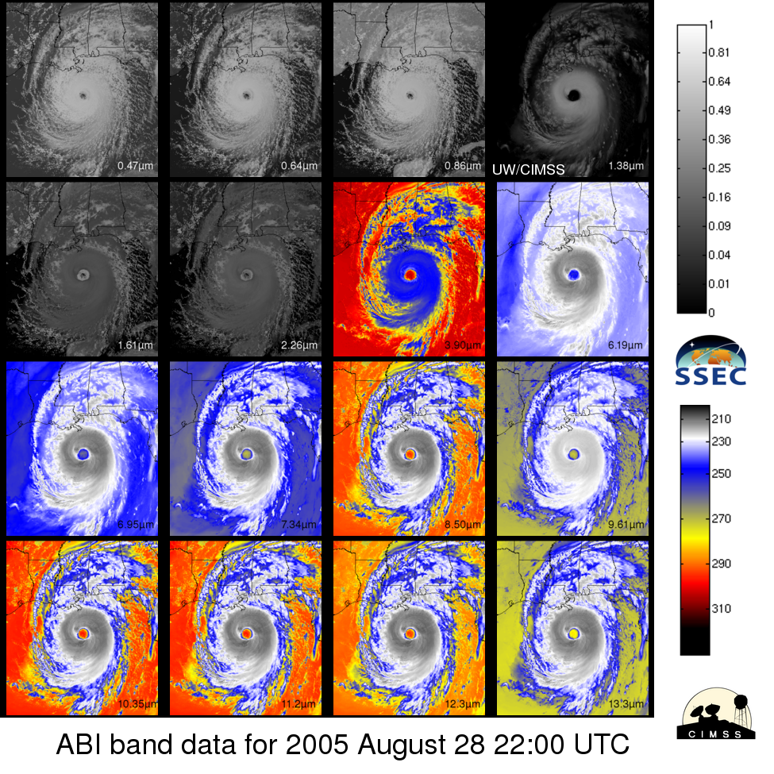
Simulated images of the 16 ABI bands for Hurricane Katrina. These images were simulated via a combination of high spatial resolution numerical model runs and advanced ‘forward’ models. Note how each band, or frequency, observes the earth/atmosphere somewhat differently.

What Are the Benefits?
The improved spectral, spatial, and temporal resolution provided by the ABI will lead to great improvements in imagery and derived products. The ABI addresses the needs of many users of geostationary data by increasing spatial resolution (to better monitor small-scale features), scanning faster (to improve temporal sampling and to scan additional regions), and adding spectral bands (to enable new and improved products for a wide range of phenomena). Every product that is being produced from the current GOES imager will be improved due to data from the ABI. In addition, several new products, such as vegetative health and atmospheric visibility, will be possible and exploit the improved spectral, temporal, and spatial resolutions. It was determined that the incremental monetary benefits of only 5 sectors (aviation, energy, irrigated agriculture, recreational boating and tropical cyclones) were estimated to be at least $4.6B over that of the current system.

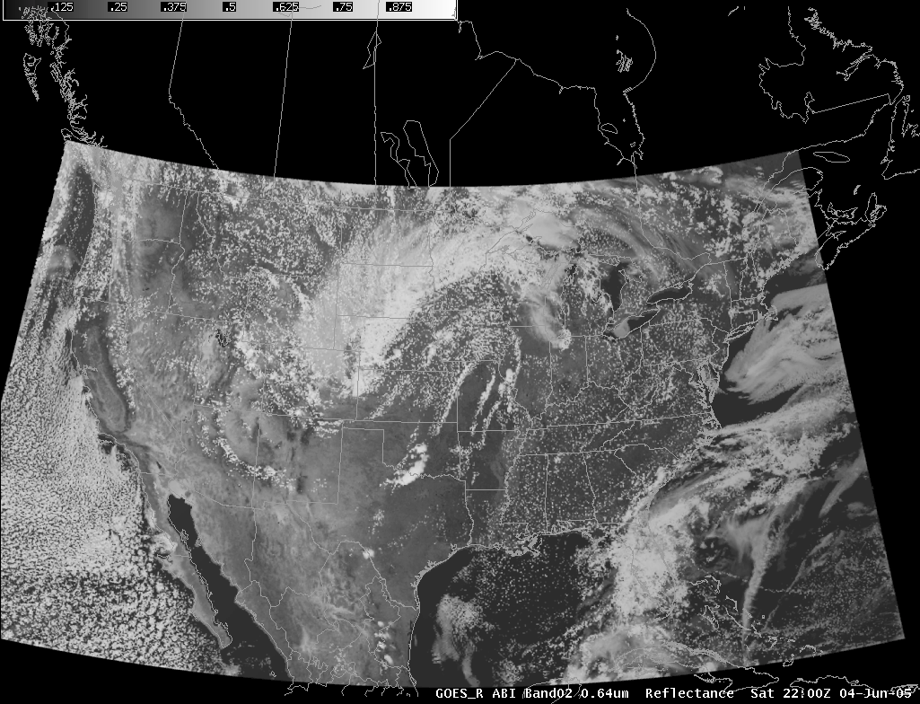
Simulated ABI band 2 (0.64 µm) for 4 June 2005 at 22:00 UTC. Displayed in AWIPS (Advanced Weather Interactive Processing System), which is used by the NWS. These simulated datasets are being used to not only pre-launch visualization, but also for product testing

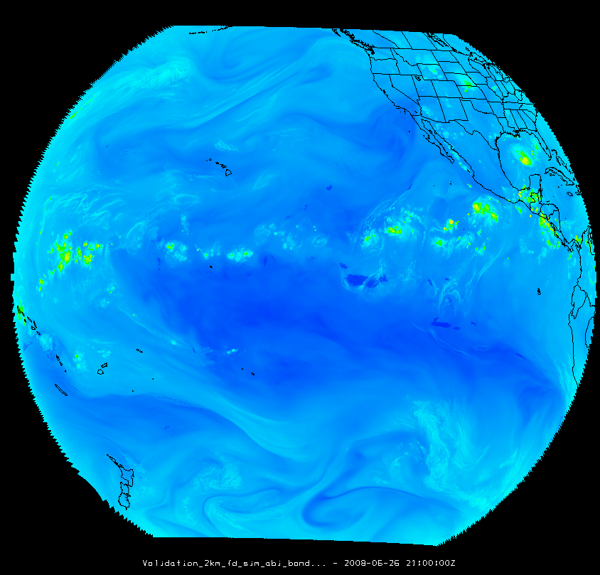
Simulated ABI band 8 (6.2 µm) for 26 June 2008 over the Pacific. The image is displayed using Man computer Interactive Data Access System (McIDAS)-V.

Contributors: Timothy J. Schmit – NOAA/NESDIS/STAR, M. Gunshor, K. Bah, J. Otkin, J. Feltz, C. Schmidt, J. Sieglaff, William Straka -- CIMSS and the Cloud and Moisture Imagery Applications Team.

Blue Box:

Research and Development Partners for Cloud and Moisture Imagery
• Cooperative Institute for Meteorological Satellite Studies (CIMSS)
at the University of Wisconsin
• NOAA National Environmental Satellite, Data, and Information Service,
Center for Satellite Applications and Research (NESDIS/STAR)
• Cooperative Institute for Research in the Atmosphere (CIRA)

On the Web
http://www.goes-r.gov
http://cimss.ssec.wisc.edu/abi/
http://cimss.ssec.wisc.edu/goes_r/proving-ground.html
http://www.economics.noaa.gov/?goal=weather&file=obs/satellite/goes&view=benefits

For More Information, Contact
GOES-R Program Office
Code 417
NASA Goddard Space Flight Center
Greenbelt, MD 20771
301-286-1355
Jim Gurka, james.gurka@noaa.gov
Steve Goodman, steve.goodman@noaa.gov

Misc. thumbnails (may be un-cropped)



