Rapid Refresh Information of Significant Events: Preparing users for the next generation of geostationary operational satellites

Timothy J. Schmit,ª Steven J. Goodman,^{b} Mathew M. Gunshor,^{c} Justin Sieglaff, ^{c} Andrew K. Heidinger,ª A. Scott Bachmeier,^{c} Scott S. Lindstrom,^{c} Amanda Terborg,^{c} Kaba Bah,^{c} Joleen Feltz,^{c}
Scott Rudlosky, ^{f} Daniel T. Lindsey, ^{d} Robert M. Rabin,^{e}

Possible additional Author (or acknowledgement section): Christopher C. Schmidt^{c}
ª NOAA Center for Satellite Applications and Research,
Advanced Satellite Products Branch (ASPB), 1225 West Dayton Street, Madison, Wisconsin, USA, (608) 263-0291
tim.j.schmit@noaa.gov
^{b} NOAA/NESDIS GOES-R Program Office,
NASA GSFC Code 417, Greenbelt, Maryland, USA
^{c} Cooperative Institute for Meteorological Satellite Studies (CIMSS), University of Wisconsin-Madison, Madison, Wisconsin, USA
^{d} NOAA Center for Satellite Applications and Research, Fort Collins, Colorado, USA
^{e} NOAA/NSSL, Norman, Oklahoma, USA
^{f} NOAA Center for Satellite Applications and Research,
College Park, MD, USA

Draft: 30-Oct-2013
Abstract
The Geostationary Operational Environmental Satellite (GOES)-14 Imager was operated by National Oceanic and Atmospheric Administration (NOAA) in an experimental rapid scan 1-minute mode during parts of the summers of 2012 and 2013. This scan mode is called Super Rapid Scan Operations for GOES-R (SRSOR) and emulates the high temporal resolution sampling of the mesoscale region scanning of the Advanced Baseline Imager (ABI) on the next generation GOES-R series. Many phenomena were observed from GOES-14, including fog, clouds, severe storms, fires and smoke (including the California Rim Fire), and several tropical cyclones. Over 6 days of SRSOR data were acquired in 2012 of Hurricane Sandy. In 2013, the first two days of SRSOR in June observed the propagation and evolution of the mid-Atlantic Derecho events. The data from August of 2013 were unique in that the GOES imager operated in nearly continuous 1-minute mode; prior to this, the 1-minute data were interrupted every 3 hours for full disk scans. These data are helping better prepare GOES users for the next generation imager which will be able to routinely take mesoscale (1,000 km x 1,000 km) images every 30 seconds (or two separate locations every minute). In addition, these experimental data were used in a number of NOAA testbeds and operational centers, including at NOAA’s Storm PrediFction Center (SPC), the Aviation Weather Center (AWC), the Ocean Prediction Center (OPC), and the National Hurricane Center (NHC). Several animations are included to showcase the rapid change of the many phenomena observed during SRSOR from the GOES-14 Imager.
Capsule
The GOES-14 Imager scanned experimental rapid scan 1-minute images. These special scans emulated the high temporal resolution sampling of the imager on the next generation GOES-R series.

SRSOR Overview
The Geostationary Operational Environmental Satellite (GOES)-14 Imager was operated by National Oceanic and Atmospheric Administration (NOAA) in an experimental rapid scan 1-minute mode during parts of 2012 and 2013 when the satellite was in normal mode for its annual north/south maneuver and performance testing. This scan mode was called Super Rapid Scan Operations for GOES-R (SRSOR). These special scans emulated the high temporal resolution sampling of the mesoscale scanning capability of the Advanced Baseline Imager (ABI) on the next generation GOES-R series (Schmit et al, 2005). The GOES-R will also carry for the first time a Geostationary Lightning Mapper (GLM) to monitor total lightning activity (Goodman et al., 2012), and which will allow for the GLM information to be used in concert with the ABI information (in regions of overlap). GOES-R is slated to launch in early 2016. Many phenomena were observed from GOES-14 during this experiment, including fog, clouds, severe storms, monsoon moisture, fires and smoke (including the California Rim Fire), and several tropical cyclones. These data are helping better prepare users for the next generation GOES-R imager which will be able to routinely take mesoscale (1,000 km x 1,000 km) images every 30 seconds (or two separate locations every minute). In addition, these experimental data were used in a number of NOAA testbeds and operational centers, including at NOAA’s Storm Prediction Center (SPC), the Aviation Weather Center (AWC), the Weather Prediction Center (WPC), the Ocean Prediction Center (OPC), and the National Hurricane Center (NHC). For example, at the SPC MetWatch desk, the SRSOR data provided enhanced situational awareness of an “outflow boundary and nearby frontal zone which was not readily apparent in the scant surface data.” Forecasters reported the 1-min imagery “helped to increase lead-time for convective development” and “more easily determine whether convection was elevated or rooted in the boundary layer.” They also stated that it “could be helpful in radar gap areas, and where there is less confidence in radar.” Several animations are included to showcase the rapid change of the many phenomena observed during SRSOR from the GOES-14 Imager.

Table 1 lists the comparison of various GOES-East schedules. These include routine, RSO (Rapid Scan Operations), SRSO (Super Rapid Scan Operations), SRSOR (Super Rapid Scan Operations for GOES-R) and that expected from the ABI on the GOES-R series. Note that there are two versions of the SRSOR schedule, one with full disk imaging every 3 hours and one without. The SRSOR data from August of 2013 ran the latter schedule. The area near the middle of the image over northwestern Illinois in Figure 1 demonstrates how much can change over only 34 minutes. . This underscores the need for the geostationary vantage point to observe rapidly changing phenomena.

The SRSOR campaign of 2012 included approximately 38 days of SRSOR data. In fact, over six days of SRSOR data were acquired in late October of Hurricane Sandy (Schmit et al., 2013; Folmer et al., 2014). Many operational uses were noted: “Examples from the SRSOR data included better determining the cyclone center early in the daylight hours by the NHC, improved monitoring of cumulus cloud fields prior to convective initiation by the SPC, utilizing the imagery animations and derived AMVs by the OPC, identifying meso-high locations associated with hurricanes to better assess the rainfall potential by WPC, monitoring smoke plumes by the Satellite Analysis Branch, and overshooting tops (OT) detection by the forecast offices” (Schmit et al, 2013). More information has been posted at: http://cimss.ssec.wisc.edu/goes/srsor/GOES-14_SRSOR.html. In 2012 the GOES-14 instrument was taking experimental images to gather data needed for the imager stray light correction, so SRSOR imagery could be acquired during the other times of the day.
In 2013, the first two days of SRSOR in June observed the mid-Atlantic Derecho events. These were days just subsequent to when GOES-14 had been the operational GOES-East, when GOES-13 had an anomaly, possibly due to a collision with a micro-meteorite (Aviation Week, 2013). The data from August of 2013 were unique in that the GOES imager operated in nearly continuous 1-minute mode. For the first time there were no 30 minute outages of the 1-minute data when full disk images had been scanned every 3 hours under the prior SRSOR schedule. The SRSOR campaign of 2013 included approximately 14 days of SRSOR data. See Table 2 for information on the schedule and center point run each day. Deciding on the daily center point included a number of factors. These included the outlooks from SPC and WPC, the regions previously scanned and other factors. On several days the location was decided in part to coincide with other observations from a NASA field experiment called SEAC4RS (Studies of Emissions and Atmospheric Composition, Clouds and Climate Coupling by Regional Surveys) and ground-based lightning mapping networks providing GLM total lightning proxy data. More information about the SRSOR schedules in 2013 has been posted at: http://cimss.ssec.wisc.edu/goes/srsor2013/GOES-14_SRSOR.html. The recent SRSOR rapid scan imagery continues the long legacy of rapid scan imagery from GOES, as stated by Davis (2007): “Rapid interval imaging has been an important component of the GOES research program since 1975. In 1979 during a project known as SESAME (Severe Environmental Storm and Mesoscale Experiment) two GOES satellites were synchronized to produce three minute interval rapid scan imagery to study storm development”. Fujita and others demonstrated the many uses of these data (Purdom, 1976).

Derecho Event of June 12 and 13, 2013
The GOES-14 satellite was placed into SRSOR mode to monitor the development of severe weather over a SPC High Risk region on 12 June 2013 (Figure 2 and Figure 3). In SRSOR mode, images were available at 1-minute intervals (compared to the routine 15-minute image interval). The development of numerous large thunderstorms can be seen on GOES-14 SRSOR 0.63 µm visible channel images. These storms produced tornadoes, large hail, and damaging winds across parts of Minnesota, Iowa, Wisconsin, and Illinois according to NOAA SPC storm reports. One item of interest revealed on the 1-minute imagery was the appearance of “inflow feeder band” clouds that were developing along the western edge of the large thunderstorm located over northeastern Iowa during the 2015 – 2058 UTC time period; without the 1-minute temporal resolution, such subtle mesoscale features would be difficult if not impossible to identify with conventional 15-minute imagery. Numerous overshooting tops could also be seen on some of the larger storms. The severe weather reports from NOAA’s SPC are over-plotted, showing the active weather associated with a Derecho. The plotted reports are the preliminary, filtered ones and follow the SPC convention of being from 12 UTC on the preceding day to 12 UTC on the given day. Tornadoes are plotted in red, hail in green and winds in blue. These figures also show the coverage possible each minute from the current GOES imager. For the infrared bands, this means 347 lines (north-south) and 608 elements (east-west); for the visible band this equates to 1,388 lines and 2,432 elements (due to the finer spatial resolution).

The Washington D.C. Lightning Mapping Array (DCLMA), one of a handful of regional multi-station total lightning mapping networks, , provides detailed 3-D lightning observations of developing severe storms that enhances forecaster situational awareness and helps to inform decision makers regarding severe weather and lightning threats. These data have been combined with GOES-14 visible SRSOR information to illustrate a potential new product that could be provided to weather forecasters and broadcast meteorologists in the GOES-R era (Figure 4). Recent studies have shown that rapidly increasing lightning flash rates (termed “lightning jumps”) often precede severe winds, hail, and tornadoes (Schultz et al., 2009; 2011). Lightning jumps are evident ~20 minutes prior to the each of the tornadoes identified herein, and frequent lightning flashes persist throughout the duration of the tornadoes. The GOES-14 and DCLMA image referenced in the text is complemented by an animation in the online supplement for this article (available at http://dx.doi.org.10.1175/BAMSD-12-00082.2).

Fog over Pennsylvania on August 20, 2013
Valley fog was clearly evident in the GOES imager visible band over Pennsylvania (Figure 5). While fog itself may not change rapidly, the finer time resolution imagery may allow for faster, more accurate detection, or a better understanding, and hence an improved forecast of its dissipation. More frequent images might also increase the product confidence by allowing the obscuring high-level clouds to advect across the scene. Of course time is of the essence in detecting fog that may affect surface transportation, such as fog in river valleys. A combination of the infrared bands (along with other data) can also be used to detect fog and low stratus at night and the improved spectral, temporal and spatial capabilities of the ABI will allow for an improved product. The GOES-14 image of low cloud and fog referenced in the text is complemented by an animation in the online supplement for this article (available at http://dx.doi.org.10.1175/BAMSD-12-00082.2).

Severe Convection over the Midwest on August 21, 2013
A cold front moving through Wisconsin triggered severe convection (NOAA SPC storm reports of wind and hail) on August 21, 2013. GOES-14 SRSOR data gave a compelling look at the convective development at 1-minute refresh intervals. The Cloud Top Cooling (CTC) product developed for GOES/GOES-R at the University of Wisconsin (UW), known as UW-CTC, provides an estimate of the cooling rate of the cloud tops, to give better ‘situational awareness’ (Dworak et al., 2013; Sieglaff et al., 2013). Figure 6 shows the GOES-14 visible band on August 21, 2013 with the UW-CTC product over-plotted in red. Because of the satellite position, the rear inflow into the convection near Rice Lake, WI, was very apparent. The figure illustrates the timing of the detection of overshooting tops with both the SRSOR and routine GOES imager operations. The GOES-14 image of UW-CTC referenced in the text is complemented by an animation in the online supplement for this article (available at http://dx.doi.org.10.1175/BAMSD-12-00082.2). GOES-13 sounder Derived Product Imagery (DPI) of the Lifted Index (LI) and Convective Available Potential Energy (CAPE), neither shown, demonstrated that the airmass that supported the convection was unstable.
The 3rd annual Summer Experiment at the Aviation Weather Testbed (AWT) in Kansas City, MO, took place from August 12-23, 2013, its purpose two-fold: (1) it provided a pre-operational environment in which to test and evaluate new GOES-R proxy products, and (2) it also aided in familiarizing forecasters with the capabilities of the next generation GOES series. The goal with the SRSOR information was to familiarize forecasters with the temporal latency expected with the GOES-R ABI in its meso-scale mode and how it will benefit operations. Participation throughout the two-week period included 14 operational forecasters from the Aviation Weather Center (AWC), as well as 44 external visitors from various types of organizations throughout the aviation community which included government, commercial entities, and aviation research interests. For example, participants came from the Federal Aviation Administration (FAA), Lockheed Martin, United Parcel Service (UPS), the Air Force Weather Agency (AFWA), the GOES-R program, Earth Networks, various research entities within the NOAA, and a number of universities. Operational forecasting desks with real-time, nowcasting responsibilities such as the Convective Significant Meteorological Information (SIGMET), CSIG, and National Aviation Meteorologist (NAM) desks, consistently used the 1-minute imagery as a situational awareness tool. These forecasters were able to identify details missed in the typical 15-minute latency of current GOES. An excellent example of this was noted in association with convective development around the area known as the Minneapolis Air Route Traffic Control Center (Figure 7). Participants used the 1-minute imagery to monitor the convective development just to the northeast of the circle in that figure. In particular, the growth of the southwestern most cell closest to Minneapolis was very obvious in the SRSOR information, especially the rapid expansion of the anvil as it began to impede the airspace above the center. Having this additional detail will provide air traffic managers and aviation forecasters a more accurate picture of the growth rate or dissipation of convection, and thus allow for more efficient and safer air traffic control. Forecasters were very pleased with the SRSOR imagery overall and look forward to seeing it in operations on a permanent basis come the launch and operation of GOES-R. (http://testbed.aviationweather.gov/page/public?name=2013_Summer_Experiment)

GOES-R ACHA time series, showing the rapidly changing cloud, maybe with a 1min sampling and 15/30 min sampling…. Figure 8

Severe Convection over Wisconsin August 26, 2013
NOAA’s SPC made operational use of the GOES-14 SRSOR on this day (as well as others), stating in a forecast discussion: “TOWERING CU ROOTED IN THE BOUNDARY LAYER IS INCREASING IN AREAL COVERAGE OVER THE PAST HR PER 1-MIN SUPER RAPID SCAN VISIBLE SATELLITE IMAGERY” (http://www.spc.noaa.gov/products/md/md1777.html). One method of combining the views of the visible and longwave window imagery is known as the ‘sandwich’ product (M. Setvák, personal communication: http://essl.org/cwg/?page_id=143). The two layers of this blended product are the full resolution visible imagery and a color-enhanced longwave window band (shown with a partial transparency) (Figure 9). Of course rapid convection is of interest for a number of reasons, but so is any rapid dissipation, as was evident on this day. The GOES-14 ‘sandwich product’ referenced in the text is complemented by an animation in the online supplement for this article (available at http://dx.doi.org.10.1175/BAMSD-12-00082.2). SRSOR data showed both rapid dissipation, but also an undular bore over southern Wisconsin on the morning of 26 August. The parallel lines of enhanced radar return suggest that the outflow from the convective complex over northern Wisconsin organized into a bore, in part because the atmosphere over Wisconsin (as sampled, for example, by the 1200 UTC Green Bay, WI sounding) included a stable layer. The wind at Madison’s Truax Airport shifted to northeast at 1453 UTC as the bore moved overhead. Winds are parallel to the bore motion and perpendicular to the linear bore feature. An abundance of cirrus obscured information from the lower cloud deck throughout the early part of the morning. The presence of two over-shooting tops (OST) at 13:00 UTC was evident (Figure 10). An OST is derived from a combination of the infrared bands (Bedka et al., 2010). However, parallel lines of low clouds marked the leading edge of the bore, later in the day (after 1600 UTC, northwest of Madison, WI). The GOES-14 animation (in the online supplement for this article (available at http://dx.doi.org.10.1175/BAMSD-12-00082.2) also shows the transformation of the atmosphere from convectively unstable, with transverse bands in the cirrus outflow suggestive of turbulence, to an atmosphere with mid-level cumuliform clouds (over northwest Wisconsin) in the wake of a departing mesoscale system. Finally, the mesoscale system exits the state as cirrus continues to erode. Low- and mid-level clouds have dissipated. As the lower atmosphere destabilizes due to diurnal heating, the bore must dissipate, as it requires a stable layer to propagate.

California Rim Fire on August 19 and 22, 2013

On August 19, 2013, the Rim Fire complex in Groveland, CA spawned a pyrocumulonimbus cloud (pyroCb) as it burned through the Stanislaus National Forest. The GOES-14 SRSOR visible imagery showed a white plume (our soon-to-be pyroCb) erupting from the fire complex in the center of the image at around 2300 UTC (Figure 11). The fire complex became enveloped by convection from the east as the evening progressed, but the path of the initial “pyroburst” can be seen throughout. As this plume drifted to the northwest, it developed into a pyroCb, casting a shadow over some lower-level clouds. The GOES-14 shortwave InfraRed (IR) imagery shows the pyroCb (lighter pixels) emanating from the fire complex (red pixels). The GOES-14 imagery referenced in the text is complemented by an animation in the online supplement for this article (available at http://dx.doi.org.10.1175/BAMSD-12-00082.2).

On August 22, 2013, a sequence of GOES-14 SRSOR 0.63 µm visible channel images showed that the initial northward motion of the smoke plume began to transition to a more northeasterly motion after about 1700 UTC (Figure 12). This was due to a shift in the winds aloft as a semi-stationary cut-off low just west of the coast of California began to move northward during the day. This shift is best seen in the GOES-14 animation in the online supplement for this article (available at http://dx.doi.org.10.1175/BAMSD-12-00082.2).Of course quantitative derived products, such as the Wildfire Automated Biomass Burning Algorithm (WFABBA) offers information on not only the fire detection, but details on characterization as well. For example, it is postulated that a hot spot that has greater temporal changes in fire radiative power may be more erratic than a hot spot with a more uniform fire radiative power. Good place to add in a WFABBI time series….
The most information about fires and smoke will result from a combination of what is sensed from polar and geostationary orbits. For example, the Suomi National Polar-orbiting Partnership (NPP) Visible Infrared Imaging Radiometer Suite (VIIRS) 3.74 µm shortwave IR and 0.7 µm Day/Night Band (DNB) data monitored signatures of the Rim Fire which had been burning since 17 August near Yosemite National Park in California (not shown). On the shortwave IR image, numerous “hot spots” revealed the location of larger, hotter fires that were burning along the periphery of the large burn scar. The Day/Night Band image, also on Suomi NPP, demonstrated (1) a bright white glow over the area of active fires, and (2) light gray signatures of the primary middle to upper altitude smoke plume that was moving northward, in addition to an area of lower altitude smoke that was moving westward toward lower elevations. Due to ample illumination from a 98% full waning gibbous Moon phase, the “visible image at night” capability of the Day/Night Band proved to be useful for identifying the location of the smoke plumes. In fact, when a pass occurs from Lansdat-8, the 30-meter resolution information can be used for a detail view and hence validations. These examples demonstrate the many potential synergies by using both geostationary and polar-orbiting information, along with other information.

Summary
The GOES-14 Imager was operated in an experimental rapid scan 1-minute mode during parts of the summer in 2012 and 2013. These special scans, called Super Rapid Scan Operations for GOES-R (SRSOR) emulated the high temporal resolution sampling of the ABI on the next generation GOES-R series. Many phenomena were observed from GOES-14, including fog, clouds, convection, severe storms, fires and smoke (including the California Rim Fire), monsoon moisture and several tropical cyclones. These data are helping users better prepare for the next generation GOES-R imager which will be able to routinely scan mesoscale images every 30 seconds (or two separate locations every minute). In addition, these experimental data were used in a number of NOAA testbeds, including at NOAA’s Storm Prediction Center (SPC), the Aviation Weather Center (AWC), the Ocean Prediction Center and others. The applications included monitoring towering cumulus, rapidly growing convection, heavy precipitation, fires, smoke, over-shooting tops, cloud-top cooling, etc. Examples included monitoring: outflow boundaries and frontal zones, earlier convection dissipation, helped to increase lead-time for convective development and better understand the nature of the convection. Forecasters stated that super rapid scan imagery could be helpful in radar gap areas. Many animations are available to showcase the rapid change of the many phenomena observed during SRSOR from the GOES-14 Imager. This manuscript provides exciting examples of real uses for the GOES-14 1-min refresh SRSOR datasets collected in the summers of 2013 and 2013 as well as demonstrating what will be possible with the ABI on the GOES-R series. All of the GOES-14 GVAR (GOES Variable) data have been archived, either by CLASS (Comprehensive Large Array-data Stewardship System), the SSEC data center, and possibly others. One challenge for the GOES-R era will be to effectively use the rapid scan imagery and derived products, along with other measurements, to best monitor the earth/atmosphere system in order to enhance the timeliness of forecasts and warnings for a wide range of environmental phenomena that impact human activities.
Acknowledgements

The authors would like to thank the many contributors to the generation of the GOES-14 SRSOR Imager data streams. The NOAA National Environmental Satellite, Data, and Information Service (NESDIS) Office of Satellite and Product Operations (OSPO) is especially thanked for the production of the GVAR data. Thanks to: Vanessa Griffin, Kevin Ludlum, GOES shift supervisors and operators, John Tsui, Tom Renkevens, Ralph Petersen, Steve Weiss, Jaime Daniels, Bill Bellon, Pete Pokrandt, Michael J. Folmer, Gregg Gallina, Jordan Gerth, William Straka, Chad Gravelle, Bill Line, Mark Ruminski, Bryan Baum, John L. Cintineo, Christopher S. Velden, Kristopher M. Bedka, Mike Hiley, and Louis Nguyen. Jim Nelson and Gary S. Wade are thanked for Figure 2 and Figure 3. Patrick Meyers is thanked for Figure 4. Martin Setvák is thanked for his work with the ‘sandwich product’. Special thanks go to Jerry Robaidek and the SSEC Data Center staff who acquired the GOES-14 data in real-time, and subsequently archived them, at the SSEC Data Center. The Man computer Interactive Data Access System (McIDAS-X or V) was used to create most of the images. The views, opinions, and findings contained in this report are those of the authors and should not be construed as an official National Oceanic and Atmospheric Administration or U.S. Government position, policy, or decision. More information on many of these cases can be found in the CIMSS Satellite blog, under the GOES-14 category: http://cimss.ssec.wisc.edu/goes/blog/archives/category/goes-14.

References

Aviation Week, GOES Control Problem Could Be Due To Micrometeroid Collision, May 30, 2013, http://www.aviationweek.com/Article.aspx?id=/article-xml/asd_05_30_2013_p03-01-583298.xml
Bedka, K. M., J. Brunner, R. Dworak, W. Feltz, J. Otkin, and T. Greenwald, 2010: Objective satellite-based overshooting top detection using infrared window channel brightness temperature gradients. J. Appl. Meteor. And Climatol., 49, 181-202.
Davis G; History of the NOAA satellite program. J. Appl. Remote Sens. 0001;1(1):012504-012504-18.
Dworak, R.; Bedka, K., Brunner, J. and F. Wayne, 2012: Comparison between GOES-12 overshooting-top detections, WSR-88D radar reflectivity, and severe storm reports. Wea. Forecasting, 27, Issue 3, 684–699.
Folmer M. J., and co-authors, 2014: Use of Satellite Tools to Monitor and Predict “Super Storm Sandy 2012” – Current and Emerging Products, to be submitted to the National Weather Association Digest.
Goodman, Steven J., and Coauthors, 2012: The GOES-R Proving Ground: Accelerating User Readiness for the Next-Generation Geostationary Environmental Satellite System. Bull. Amer. Meteor. Soc., 93, 1029–1040. doi: http://dx.doi.org/10.1175/BAMS-D-11-00175.1
Purdom, J. F. W., 1976: Some uses of high-resolution GOES imagery in the mesoscale forecasting of convection and its behavior. Mon. Wea. Rev., 104, 1474–1483.
Schmit, T. J., M. M. Gunshor, W. P. Menzel, J. Li, S. Bachmeier, and J. J. Gurka, 2005: “Introducing the Next-generation Advanced Baseline Imager (ABI) on GOES-R”, Bull. Amer. Meteor. Soc., 8, August, pp. 1079-1096.
Schmit, T. J., and co-authors, 2013: GOES-14 Super Rapid Scan Operations to Prepare for GOES-R, Conditionally accepted to J. Applied Remote Sensing.
Schultz, Christopher J., Walter A. Petersen, and Lawrence D. Carey, 2009: Preliminary Development and Evaluation of Lightning Jump Algorithms for the Real-Time Detection of Severe Weather. J. Appl. Meteor. Climatol., 48, 2543–2563. doi: http://dx.doi.org/10.1175/2009JAMC2237.1
Schultz, Christopher J., Walter A. Petersen, Lawrence D. Carey, 2011: Lightning and Severe Weather: A Comparison between Total and Cloud-to-Ground Lightning Trends. Wea. Forecasting, 26, 744–755.
Sieglaff, Justin M.; Hartung, Daniel C.; Feltz, Wayne F.; Cronce, Lee M. and Lakshmanan, Valliappa, 2013: A satellite-based convective cloud object tracking and multipurpose data fusion tool with application to developing convection. Journal of Atmospheric and Oceanic Technology, Volume 30, Issue 3, 510–525.

Tables
Table 1. Comparison of GOES-East Imager schedules, including routine, RSO, SRSO, SRSOR and GOES-R ABI. The approximate number of images over three hours is also listed. FD is a Full Disk, NHE is Northern Hemisphere Extended, NH is Northern Hemisphere, CONUS is Continental U.S., SHEMI is a Southern Hemisphere, SA is South America scans and meso is a meso-scale sized image.
Table 2. Starting day (with ordinal day number), schedules, start times, and location with SRSOR from GOES-14 during 2013.

 | Routine | RSO | SRSO | SRSOR | SRSOR  (No FD) | GOES-R ABI
# of images  (in 3 hours) | 16 | 26 | 56 | 129 | 157 | ~400
# of images covering part of CONUS  (in 3 hours) | 11 | 21 | 56 | 129 | 157 | ~400
Finest refresh time (min) | 15 | 5 | 1 | 1 | 1 | 0.5
2nd slowest refresh rate (min) | 15 | 10 | 10 | 4 | 4 | 5
Slowest refresh rate (min) | 30 | 30 | 30 | 30 | 15 | 15
Sectors Scanned (listed by size) | FD, NHE,CONUS, SHEMI | FD, NH, CONUS, SA | FD, NH, CONUS, MESO | FD, MESO | FD, MESO | FD, CONUS, MESO
Table 1. Comparison of GOES-East Imager schedules, including routine, RSO, SRSO, SRSOR and GOES-R ABI. The approximate number of images over three hours is also listed. FD is a Full Disk, NHE is Northern Hemisphere Extended, NH is Northern Hemisphere, CONUS is Continental U.S., SHEMI is a Southern Hemisphere, SA is South America scans and meso is a meso-scale sized image.

Starting Date | Schedule | Starting Time | Center Point | Comments
June 12 [163] | SRSOR | 16:14:30 UTC - 164/ 11:44:30 UTC | 37N 85W | Moderate Risk over IL, IN, OH
June 13 [164] | SRSOR | 11:44:30 UTC - 165/ 12:14:30 UTC | 36N 84W | Moderate Risk over MD, DE, etc.
August 13 [225] | SRSOR (no FD) | 11:14:30 UTC - 226/ 11:14:00 UTC | 39N 115W | Pacific NW fires, etc.
August 14 [226] | SRSOR (no FD) | 11:14:30 UTC - 227/ 11:14:00 UTC | 37N 85W | SE. GOES-14 E/W maneuver approx. 1220-1230 UTC
August 15 [227] | SRSOR (no FD) | 11:14:30 UTC - 228/ 11:14:00 UTC | 32N 85W | Global Hawk ferry flight + Gulf of Mexico Convection
August 19 [231] | SRSOR (No FD) | 11:14:30 UTC - 232/ 11:14:00 UTC | 39N 115W | West Coast, NW Fires, etc.
August 20 [232] | SRSOR (No FD) | 11:14:30 UTC - 233/ 11:14:00 UTC | 37N 84W | US SE, GH take-off, AWC support, etc.
August 21 [233] | SRSOR (No FD) | 11:14:30 UTC - 234/ 11:14:00 UTC | 39N 93W | Slight Risk over MN
August 22 [234] | SRSOR (No FD) | 11:14:30 UTC - 235/ 11:14:00 UTC | 39N 115W | Western US, Fires, etc.
August 23 [235] | SRSOR (No FD) | 11:14:30 UTC - 236/ 11:14:00 UTC | 35N 91W | SEAC4RS field experiment
August 24 [236] | SRSOR (No FD) | 11:14:30 UTC - 237/ 11:14:00 UTC | 39N 98W | Northern Plains, slight risk
August 25 [237] | SRSOR (No FD) | 11:14:30 UTC - 238/ 11:14:00 UTC | 37N 113W | Monsoon convection over SW
August 26 [238] | SRSOR (No FD) | 11:14:30 UTC - 239/ 11:14:00 UTC | 40N 96W | Convection over Upper Midwest
August 27 [239] | SRSOR (No FD) | 11:14:30 UTC - 240/ 11:14:00 UTC | 39N 115W | West Coast: Monsoon, SEAC4RS flights, etc.
August 28 [240] | Optimized schedule tests | 11:14:30 UTC - 240/ 14:14:00 UTC | 39N 115W | Optimized Super Rapid Scan
August 28 [240] | Optimized schedule tests | 14:14:30 UTC - 241/ 17:00:00 UTC | N/A | Optimized Rapid Scan
Table 2. Starting day (with ordinal day number), schedules, start times, and location with SRSOR from GOES-14 during 2013.

List of Figure Captions
Figure 1. GOES-14 visible image on June 12, 2013 showing rapid convective development forming over approximately 30 minutes in northwest Illinois.
Figure 2. A demonstration of the GOES-14 SRSOR areal coverage (June 12, 2013) in one minute mode, with the days severe weather reports plotted (the colors indicate the type). The satellite image is of the 10.7 μm longwave window (GOES Imager band 4).
Figure 3. GOES-14 SRSOR coverage area in one minute mode, with the days severe weather reports, for June 13, 2013. The satellite image is of the 10.7 μm longwave window.
Figure 4. Visible GOES-14 imagery and Washington D.C. Lightning Mapping Array (DCLMA) observations (white highlights) on June 13, 2013.
Figure 5. GOES-14 Visible image of fog and low stratus on August 20, 2013 at 1300 UTC.
Figure 6. GOES-14 visible band on August 21, 2013 with University of Wisconsin-Cloud Top Cooling (UW-CTC) for the SRSOR timing (left panel) and the timing of routine GOES operations (right panel). The SRSOR shows the cooling well before that from routine operations.
Figure 7. One minute visible imagery and Aircraft Situation Display to Industry (ASDI) flight routes over the Minneapolis Air Traffic Control Center on August 21, 2013 at 2100 UTC.
Figure 8. Time Series of the Cloud Height on August 21, 2013.
Figure 9. Combined visible and infrared 'sandwich' product from August 26, 2013 at 13:01 UTC.
Figure 10. GOES-14 visible image and derived Over-shooting Tops (along with radar information?) from August 26, 2013 at 13:00 UTC.
Figure 11. GOES-14 Visible (left panels) and shortwave infrared window (right panels) from the California Rim fire for August 19, 2013. Note that warm temperatures have been color-coded to be dark, with the hottest pixels red.
Figure 12. GOES-14 visible image enhanced to better visual the smoke from the California Rim fire on August 22, 2013.

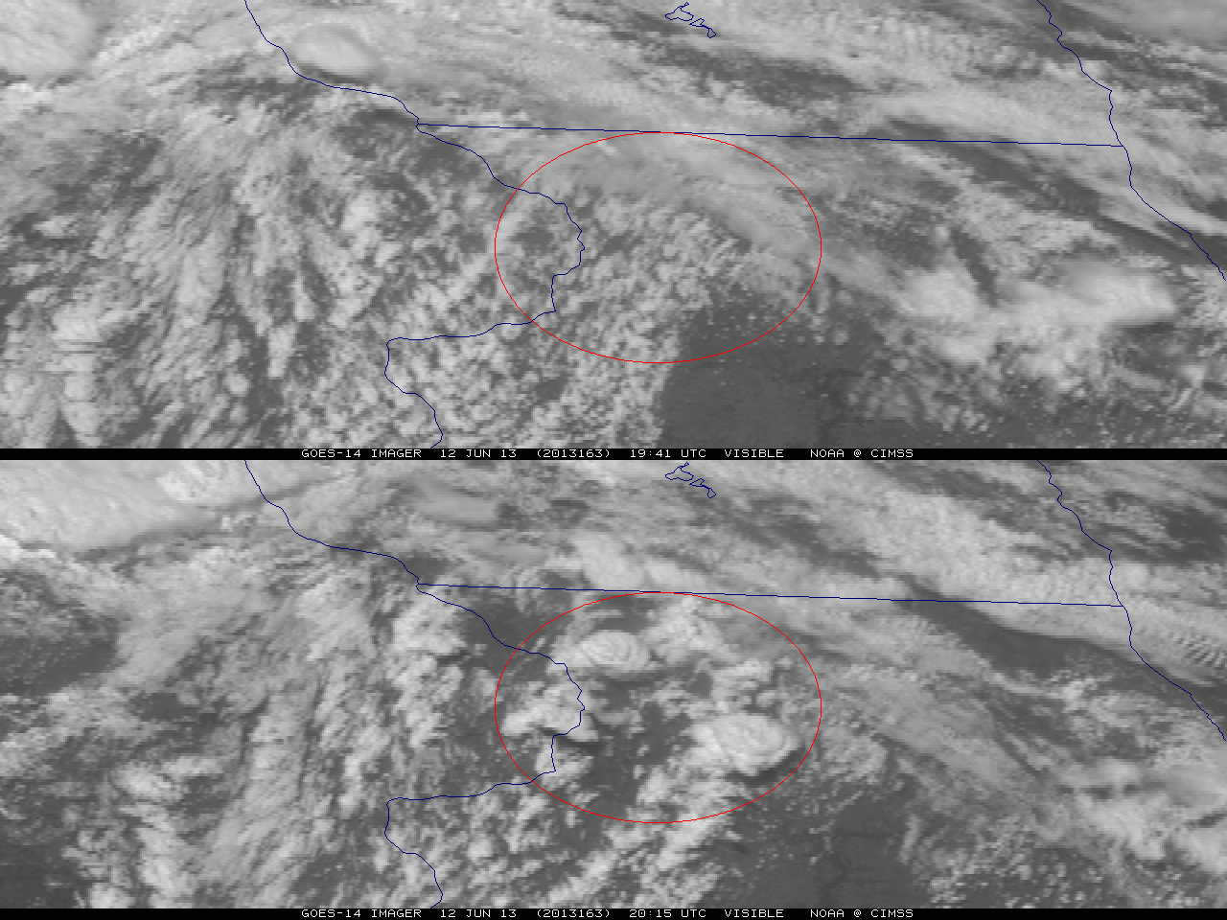
Figure 1. GOES-14 visible image on June 12, 2013 showing rapid convective development forming over approximately 30 minutes in northwest Illinois.

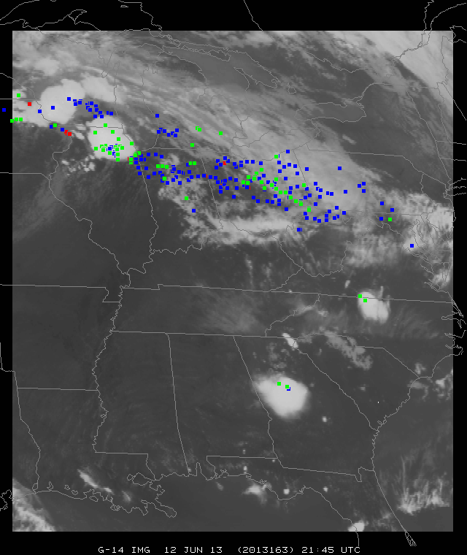
Figure 2. A demonstration of the GOES-14 SRSOR areal coverage (June 12, 2013) in one minute mode, with the days severe weather reports plotted (the colors indicate the type). The satellite image is of the 10.7 μm longwave window (GOES Imager band 4).
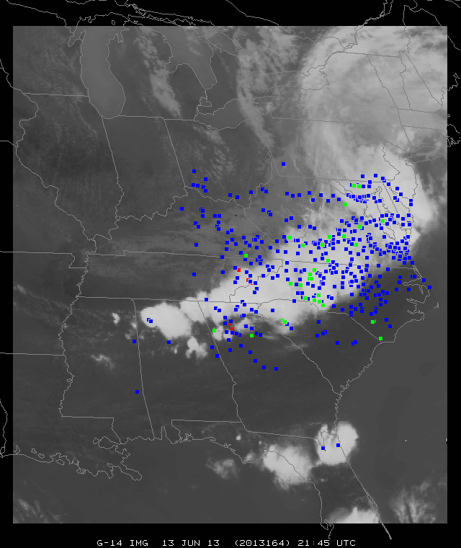
Figure 3. GOES-14 SRSOR coverage area in one minute mode, with the days severe weather reports, for June 13, 2013. The satellite image is of the 10.7 μm longwave window.

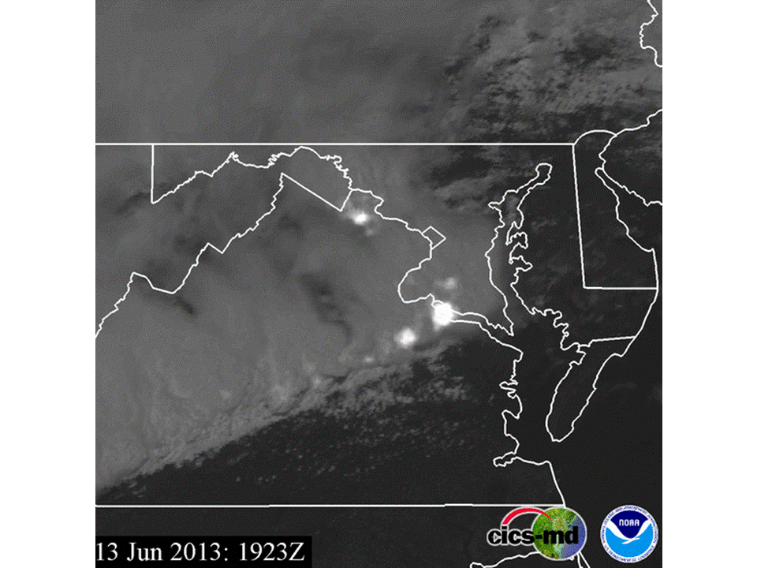
Figure 4. Visible GOES-14 imagery and Washington D.C. Lightning Mapping Array (DCLMA) observations (white highlights) on June 13, 2013.
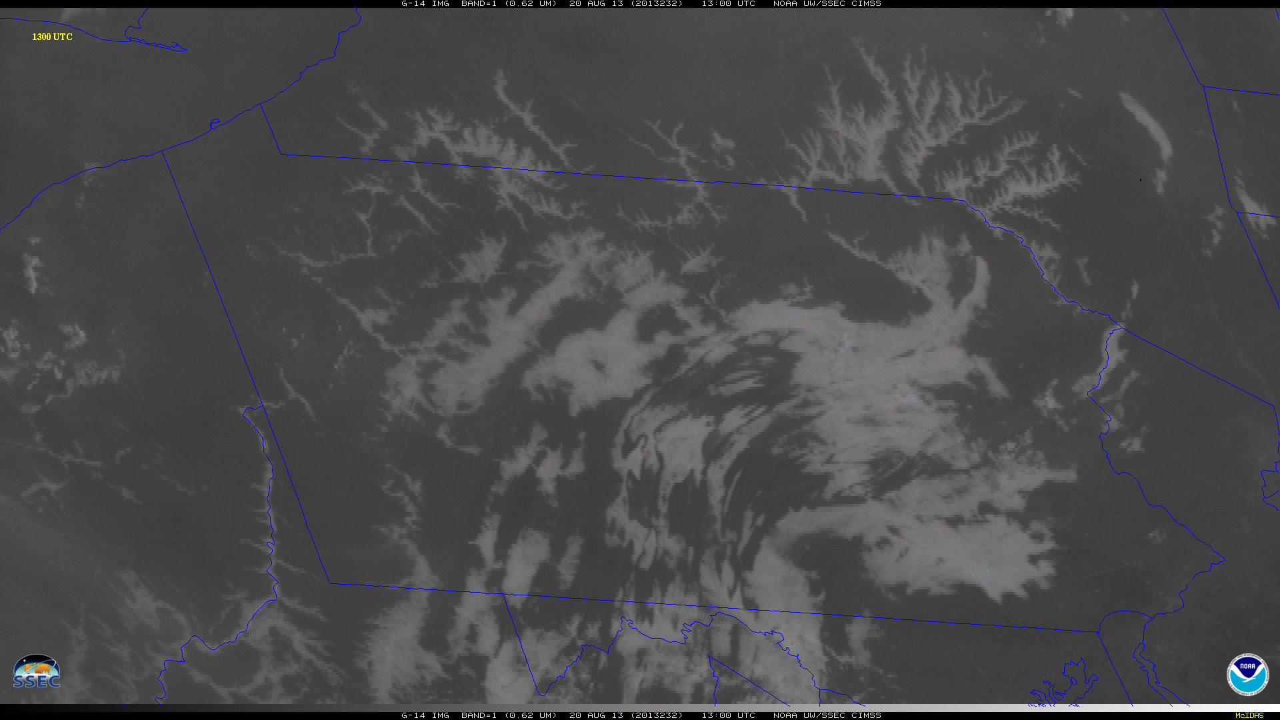
Figure 5. GOES-14 Visible image of fog and low stratus on August 20, 2013 at 1300 UTC.

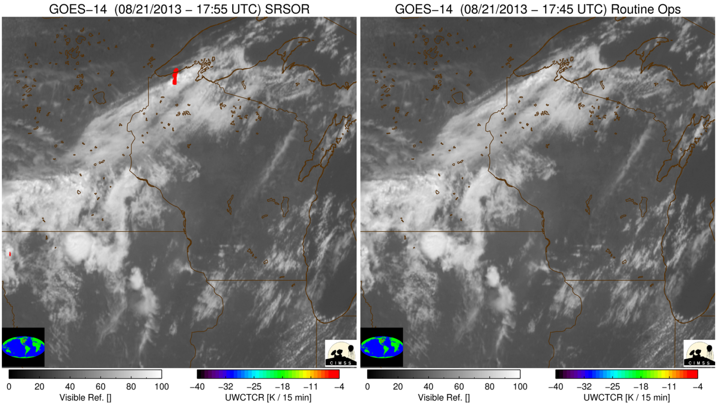
Figure 6. GOES-14 visible band on August 21, 2013 with University of Wisconsin-Cloud Top Cooling (UW-CTC) for the SRSOR timing (left panel) and the timing of routine GOES operations (right panel). The SRSOR shows the cooling well before that from routine operations.

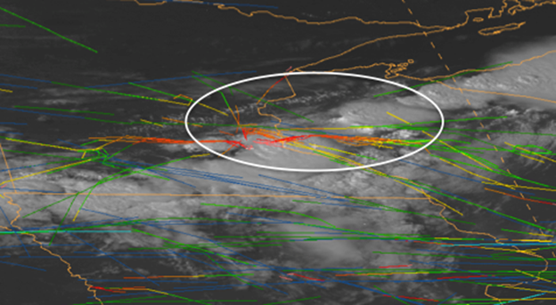
Figure 7. One minute visible imagery and Aircraft Situation Display to Industry (ASDI) flight routes over the Minneapolis Air Traffic Control Center on August 21, 2013 at 2100 UTC.
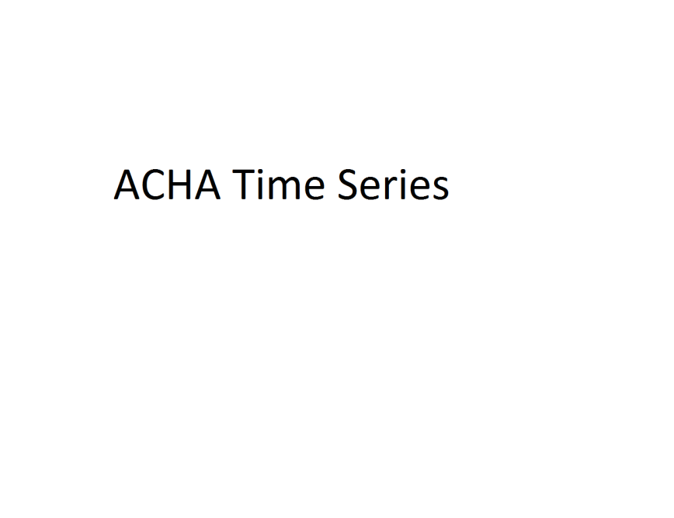
Figure 8. Time Series of the Cloud Height on August 21, 2013.
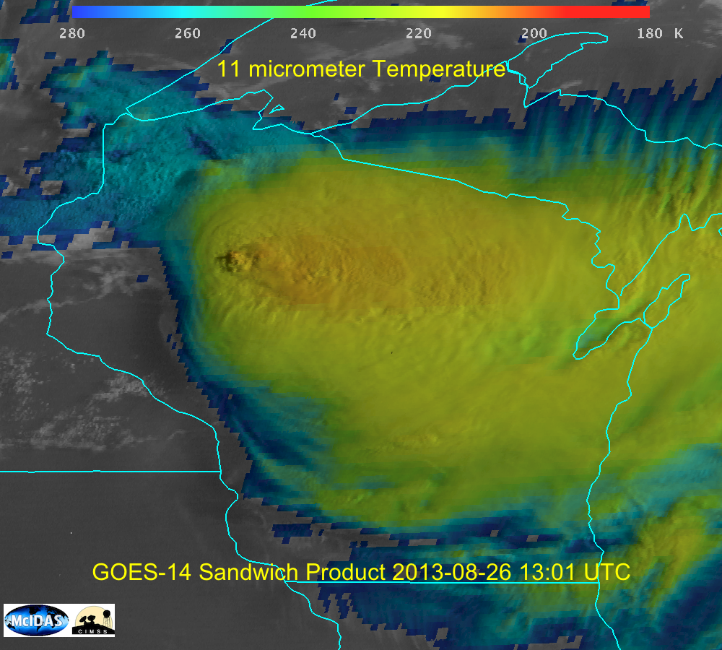
Figure 9. Combined visible and infrared 'sandwich' product from August 26, 2013 at 13:01 UTC.
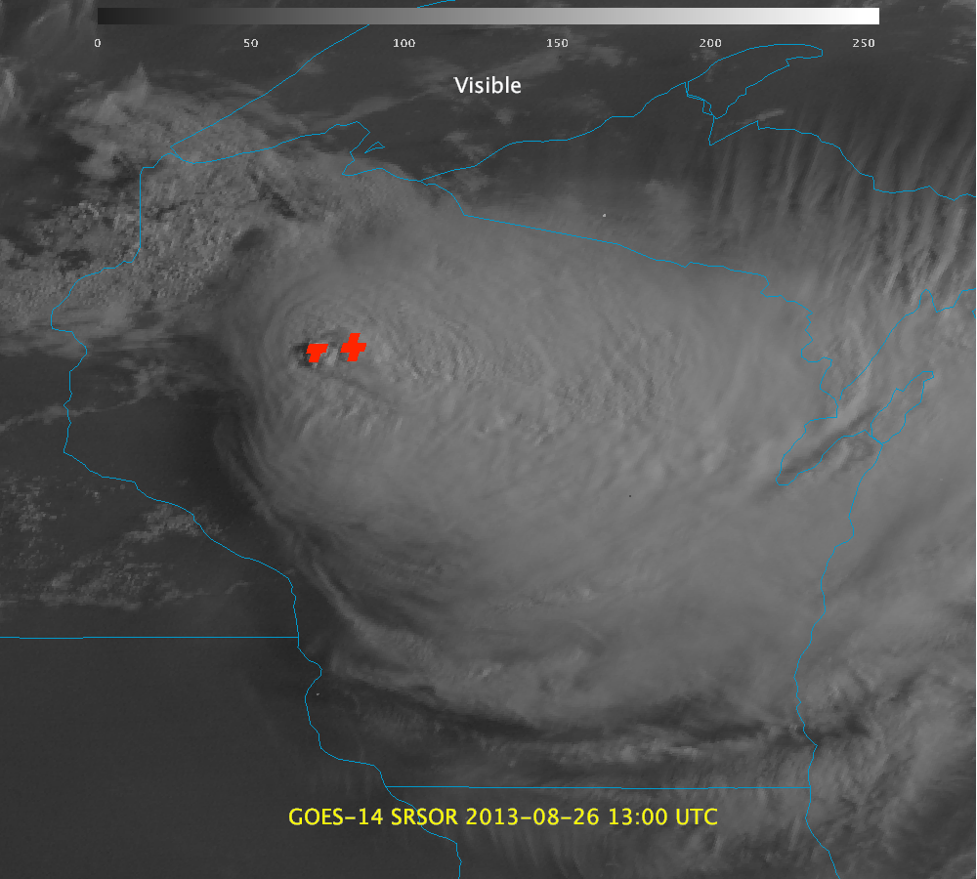
Figure 10. GOES-14 visible image and derived Over-shooting Tops (along with radar information?) from August 26, 2013 at 13:00 UTC.
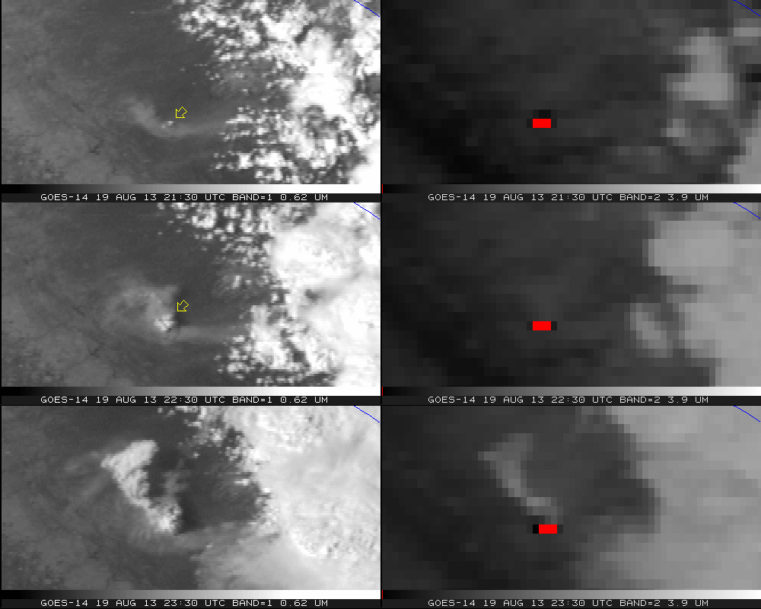
Figure 11. GOES-14 Visible (left panels) and shortwave infrared window (right panels) from the California Rim fire for August 19, 2013. Note that warm temperatures have been color-coded to be dark, with the hottest pixels red.
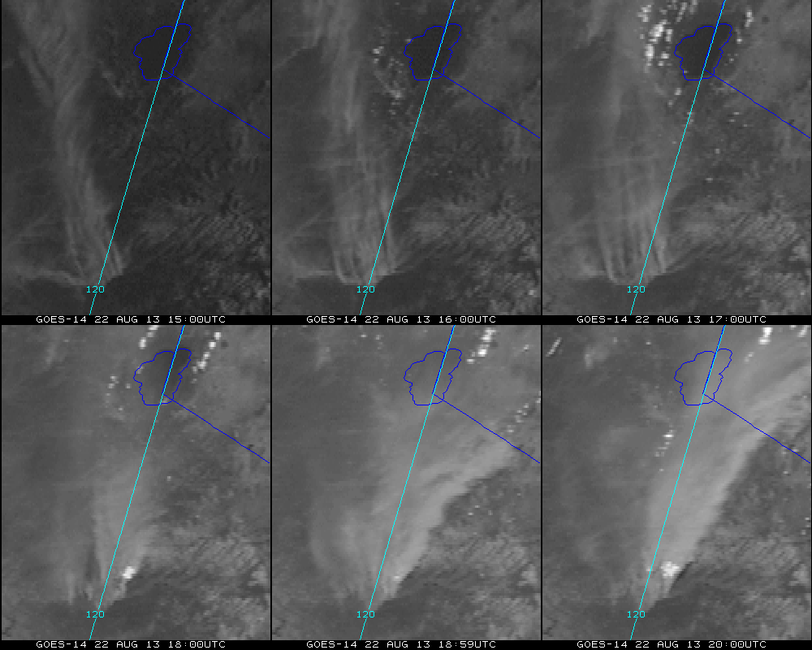
Figure 12. GOES-14 visible image enhanced to better visual the smoke from the California Rim fire on August 22, 2013.

Supplemental Material:

Visible imagery and DCLMA observations of the derecho on June 13, 2013:
http://cimss.ssec.wisc.edu/goes/srsor2013/Tornado_Lightning_hires.mp4

Visible imagery on June 13, 2013:
http://cimss.ssec.wisc.edu/goes/srsor2013/800x1000_GOES_B1_DERECHO_animated_2013164_180400_182_2013165_004900_182_X.mp4

Fog and low stratus on August 20, 2013:
http://cimss.ssec.wisc.edu/goes/srsor2013/800x1000_GOES_B1_FOG_PA_animated_2013232_111500_182_2013232_151500_182_X.mp4

GOES-14 visible band with University of Wisconsin-Cloud Top Cooling (UW-CTC) for the SRSOR timing (left panel) and the timing of routine GOES operations (right panel) on August 21, 2013: http://cimss.ssec.wisc.edu/goes/srsor2013/goes14_srsor_uwctc_aug212013.mp4

Combined visible and infrared 'sandwich' product from August 26, 2013:
TBD (to be done)
GOES-14 visible image and derived Over-shooting Tops from August 26, 2013:
TBD (to be done)

California Rim Fire on August 19, 2013:
http://cimss.ssec.wisc.edu/goes/srsor2013/GOES14_VIS_IR2_19AUG2013loop_redo.mp4

California Rim Fire on August 22, 2013:
http://cimss.ssec.wisc.edu/goes/srsor2013/800x1000_GOES_B1_RIM_FIRE_animated_2013234_150000_182_2013234_200000_182_X.mp4
California Rim Fire on August 25, 2013:
http://cimss.ssec.wisc.edu/goes/srsor2013/800x1000_GOES_B1_RIM_FIRE_animated_2013237_133000_182_2013237_185900_182_X.mp4

