Rapid Refresh Information of Significant Events: Preparing users for the next generation of geostationary operational satellites

Timothy J. Schmit,ª Steven J. Goodman,^{b} Mathew M. Gunshor,^{c} Justin Sieglaff,^{c} Andrew K. Heidinger,ª A. Scott Bachmeier,^{c} Scott S. Lindstrom,^{c} Amanda Terborg,^{c} Joleen Feltz,^{c} Kaba Bah,^{c}
Scott Rudlosky,^{f} Daniel T. Lindsey,^{d} Robert M. Rabin,^{e} and Christopher C. Schmidt ^{c}

ª NOAA Center for Satellite Applications and Research,
Advanced Satellite Products Branch (ASPB), 1225 West Dayton Street, Madison, Wisconsin, USA, (608) 263-0291
tim.j.schmit@noaa.gov
^{b} NOAA/NESDIS GOES-R Program Office,
NASA GSFC Code 417, Greenbelt, Maryland, USA
^{c} Cooperative Institute for Meteorological Satellite Studies (CIMSS), University of Wisconsin-Madison, Madison, Wisconsin, USA
^{d} NOAA Center for Satellite Applications and Research, Fort Collins, Colorado, USA
^{e} NOAA/NSSL, Norman, Oklahoma, USA
^{f} NOAA Center for Satellite Applications and Research,
College Park, MD, USA

9-April-2014
Abstract
The Geostationary Operational Environmental Satellite (GOES)-14 Imager was operated by the National Oceanic and Atmospheric Administration (NOAA) in an experimental rapid scan 1-minute mode during parts of the summers of 2012 and 2013. This scan mode, known as the Super Rapid Scan Operations for GOES-R (SRSOR), emulates the high temporal resolution sampling of the mesoscale region scanning of the Advanced Baseline Imager (ABI) on the next generation GOES-R series. This paper both introduces these unique datasets, along with highlighting future satellite imager capabilities. Many phenomena were observed from GOES-14, including fog, clouds, severe storms, fires and smoke (including the California Rim Fire), and several tropical cyclones. In 2012 over six days of SRSOR data of Hurricane Sandy were acquired. In 2013, the first two days of SRSOR in June observed the propagation and evolution of a mid-Atlantic Derecho event. The data from August 2013 were unique in that the GOES imager operated in nearly continuous 1-minute mode; prior to this time, the 1-minute data were interrupted every 3 hours for full disk scans. Used in a number of NOAA testbeds and operational centers, including NOAA’s Storm Prediction Center (SPC), the Aviation Weather Center (AWC), the Ocean Prediction Center (OPC), and the National Hurricane Center (NHC), these experimental data are helping better prepare users for the next generation imager which will be able to routinely acquire mesoscale (1,000 km x 1,000 km) images every 30 seconds (or two separate locations every minute). Several animations are included showcasing the rapid change of the many phenomena observed during SRSOR from the GOES-14 Imager.
Capsule
The GOES-14 Imager collected experimental rapid scan 1-minute data. These special scans emulated the high temporal resolution possible from the imager on the next generation GOES-R series.

Introduction
This paper introduces unique high time resolution datasets from a geostationary imager. The data are being used to highlight future geostationary imager capabilities, and are used as part of a Proving Ground project (Goodman et al., 2012; Martin et al., 2013). All of the special Geostationary Operational Environmental Satellite (GOES)-14 GVAR (GOES Variable) rapid scan data have been archived, either by CLASS (Comprehensive Large Array-data Stewardship System), the SSEC Data Center, or others. With many of the international geostationary satellite providers deploying advanced imagers beginning in 2015 (offering in general full disk coverage every 10 minutes and smaller mesoscale sectors every 2.5 minutes), these special GOES-14 data can be used to research the benefits of higher time resolution information. This paper provides an overview of the data, along with interesting examples of how they can be used.
There are two scan modes envisioned from the Advanced Baseline Imager (ABI) included on the next generation GOES-R series satellites (Schmit et al, 2005). The first is the ‘flex’ mode and consists of full disk scans every 15 minute, plus continental U.S. (CONUS) images every 5 minute, and two mesoscale (1000 km by 1000 km, at the satellite sub point) images every minute. The other mode, Continuous Full Disk (CFD), consists of sequential Full Disk imagery every 5 minutes. Strong convection with active overshooting tops can evolve rapidly; therefore, 5-minute scans could miss key periods of the cold signature as an over-shooting top (OST) ascends, peaks, and begins to collapse. This could cause aliasing in the brightness temperature rate of change estimations. For example, a 20 July 1986 microburst-producing storm in Northern Alabama during which a research dual polarization radar observed rapid glaciation in less than 2.5 minutes. In fact, this same storm recorded no total lightning to its peak lightning rate in 7 minutes (Goodman et al., 1988; Gatlin and Goodman, 2010).
Given that the ABI will scan the CONUS region every 5 minute with either mode, the question becomes whether 5 minute data are needed outside of CONUS on a routine basis over a large area, versus more frequent images of certain regions offered by the ‘flex’ mode. The 'flex' mode is one example of the 'targeted observations' concept, outlined during THORPEX (Shapiro and Thorpe, 2004). A 'targeted observation' means taking more observations in regions of interest. In this scheme, data collection regions could be assigned weight based many factors, including criticality to safety and commerce, the need for repeated rapid scans to reduce model uncertainty, to monitor expected convection tropical cyclone activity, or other significant, rapidly changing events such as convection.
SRSOR Overview
The GOES-14 Imager was operated by the National Oceanic and Atmospheric Administration (NOAA) in an experimental rapid scan 1-minute mode during parts of 2012 and 2013 while the satellite was in its normal annual north/south maneuver and performance testing. This scan mode, known as the Super Rapid Scan Operations for GOES-R (SRSOR), emulated the high temporal resolution sampling of the mesoscale images from the Advanced Baseline Imager (ABI) included on the next generation GOES-R series satellites (Schmit et al, 2005). This paper both introduces these unique datasets, along with highlighting future satellite imager capabilities. The GOES-R also will carry the first Geostationary Lightning Mapper (GLM), which will monitor total lightning activity (Goodman et al., 2013) and, among many other uses, complement the ABI information in regions of overlap. GOES-R is slated to launch in early 2016. Many phenomena were observed from GOES-14 during this experiment at unprecedented temporal resolution, including fog, clouds, severe storms, monsoon moisture, fires and smoke (including the California Rim Fire), and several tropical cyclones. These data are helping better prepare users for the next generation GOES-R imager which will be able to routinely take mesoscale (1,000 km x 1,000 km) images every 30 seconds over one location (or every minute over two separate locations).
Table 1 compares various GOES-East schedules. These include routine, RSO (Rapid Scan Operations), SRSO (Super Rapid Scan Operations), SRSOR (Super Rapid Scan Operations for GOES-R) and that expected from the ABI on the GOES-R series. Note that there are two versions of the SRSOR schedule, one with full disk imaging every 3 hours and one without. The SRSOR data from August 2013 ran the latter schedule. The area near the middle of the image over northwestern Illinois in Figure 1 demonstrates how much can change over only 34 minutes, underscoring the need for the geostationary vantage point to observe rapidly changing phenomena.
In 2012 the GOES-14 instrument scanned experimental images to collect data needed for the imager stray light correction, which allowed SRSOR imagery to be acquired during other times of the day (than near satellite midnight). The SRSOR campaign of 2012 included approximately 38 days of SRSOR data. In fact, over six days of SRSOR data of Hurricane Sandy were acquired in late October (Schmit et al., 2013; Folmer et al., 2014). Many operational uses for these data were noted: “Examples from the SRSOR data included better determining the cyclone center early in the daylight hours by the NHC, improved monitoring of cumulus cloud fields prior to convective initiation by the SPC, utilizing the imagery animations and derived Atmospheric Motion Vectors (AMV) by the OPC, identifying meso-high locations associated with hurricanes to better assess the rainfall potential by WPC, monitoring smoke plumes by the Satellite Analysis Branch, and overshooting tops (OT) detection by the forecast offices” (Schmit et al, 2013).
The SRSOR campaign of 2013 included approximately 14 days of SRSOR data. See Table 2 for schedule and daily image center point information; the GOES-14 sub-point was 105 W. Daily center point decisions were based on a number of factors, including SPC and HPC outlooks, regions with other observations to compare to, and whether or not the region had been recently scanned. On several days, the location was chosen in part to coincide with other observations from a NASA field experiment called SEAC4RS (Studies of Emissions and Atmospheric Composition, Clouds and Climate Coupling by Regional Surveys) and ground-based lightning mapping networks providing GLM total lightning proxy data. In June 2013, the first two days of SRSOR observed a mid-Atlantic derecho , defined by the American Meteorological Society (AMS) glossary of meteorology as “a widespread convectively induced straight-line windstorm….any family of downburst clusters produced by an extratropical mesoscale convective system,”. . This event occurred just days after the 11-day period when GOES-14 had operated as the GOES-East. GOES-13 had experienced a major anomaly, possibly due to a collision with a micro-meteoroid (Aviation Week, 2013). The data from August 2013 were unique in that the GOES imager operated in nearly continuous 1-minute mode. For the first time there were no 30 minute outages of the 1-minute data when full disk images had been scanned every 3 hours under the prior SRSOR schedule.
- The SRSOR experimental data were used in a number of NOAA testbeds and operational centers, including at NOAA’s Storm Prediction Center (SPC), the Aviation Weather Center (AWC), the Weather Prediction Center (WPC), the Ocean Prediction Center (OPC), and the National Hurricane Center (NHC). At the SPC MetWatch desk, the SRSOR data provided enhanced situational awareness of an “outflow boundary and nearby frontal zone which was not readily apparent in the scant surface data.” Forecasters reported the 1-minute imagery “helped to increase lead-time for convective development” and “more easily determine whether convection was elevated or rooted in the boundary layer.” They also stated that it “could be helpful in radar gap areas, and where there is less confidence in radar.” Several animations are included to showcase the rapid change of the many phenomena observed during SRSOR from the GOES-14 Imager.
- The recent SRSOR imagery continues the long legacy of rapid scan imagery from GOES, as stated by Davis (2007): “Rapid interval imaging has been an important component of the GOES research program since 1975. In 1979 during a project known as SESAME (Severe Environmental Storm and Mesoscale Experiment) two GOES satellites were synchronized to produce three minute interval rapid scan imagery to study storm development.” Previously, T. Fujita and others demonstrated the many uses of these data (Purdom, 1976).
Derecho Event of June 12 and 13, 2013
The GOES-14 satellite was placed into SRSOR mode to monitor the development of severe weather over a SPC High Risk region on 12 June 2013. In SRSOR mode, images were available at approximately 1-minute intervals (compared to the routine 15-minute image interval). The development of numerous large thunderstorms can be seen on GOES-14 SRSOR 0.63 µm visible channel images. These storms produced tornadoes, large hail, and damaging winds across parts of Minnesota, Iowa, Wisconsin, and Illinois according to NOAA SPC storm reports. One item of interest revealed by the 1-minute imagery was the appearance of “inflow feeder band” clouds (Weaver and Lindsey, 2004) that developed along the western edge of a large thunderstorm which was located over northeastern Iowa during the 2015 – 2058 UTC; the 1-minute temporal resolution allows for improved detection of such subtle mesoscale features, compared with conventional 15-minute imagery. Numerous overshooting tops could also be seen on some larger storms. The severe weather reports from NOAA’s SPC are over-plotted, showing the active weather associated with a derecho. The plotted (preliminary) reports are follow the SPC time range convention of 12 UTC on the preceding day to 12 UTC on the given day (Figure 2 and Figure 3 for June 12 and 13, respectively). Tornado reports are plotted in red, hail in green and winds in blue; note that these reports have been parallax corrected to be more consistent with the satellite view (Davenport and 2008). These figures also show the coverage each minute from the current GOES imager in SRSOR mode.
To simulate the future GLM, the Washington D.C. Lightning Mapping Array (DCLMA), one of a handful of regional multi-station (VHF) total lightning mapping networks and which provides detailed 3-D lightning observations, was used. Knowledge of rapidly changing lightning patterns in developing storms enhances the situational awareness of forecasters and helps inform decision makers regarding severe weather and lightning threats. These lightning channel VHF source data have been resampled to the GLM nadir pixel resolution of 8 km to produce a pseudo-GLM flash extent density grid updated every minute (Goodman et al, 2012). The flash extent density product is then combined with GOES-14 visible SRSOR information to illustrate a potential new blended product that could be provided to weather forecasters and broadcast meteorologists in the GOES-R era (Figure 4). Recent studies have shown that rapidly increasing lightning flash rates (colloquially known as “lightning jumps”) often precede severe winds, hail, and tornadoes (Schultz et al., 2009; 2011). Lightning jumps are evident ~20 minutes prior to each of the tornadoes shown in Fig. 4, and frequent lightning flashes persist throughout the duration of both tornadoes. The GOES-14 and DCLMA image is complemented by an animation in the online supplement for this article (available at http://dx.doi.org.10.1175/BAMSD-14-yyyyy.1) while a larger GOES-14 Visible satellite only view is at: http://dx.doi.org.10.1175/BAMSD-14-yyyyy.2.

Fog over Pennsylvania on August 20, 2013
While fog may not change rapidly, finer time resolution imagery may provide faster, more accurate detection, or a better understanding of fog formation and dissipation. More frequent images increase confidence in the products by better capturing any changes. Time delays can be critical when detecting fog that may affect surface transportation, such as fog in river valleys or at airports. A combination of the infrared bands (along with other data) can be used to detect fog and low stratus at night. From the 2013 SRSOR data, valley fog was clearly evident in the GOES imager visible band over Pennsylvania on August 20, 2013 (Figure 5).
- The improved spectral, temporal and spatial capabilities of the ABI will provide an improved product. For example, the number of bands improve from 5 to 16, the coverage rate improves by a factor of five and the spatial resolution improves by a factor of 4 (two in each direction) (Schmit et al, 2005). The GOES-14 image of low cloud and fog referenced in the text is complemented by an animation in the online supplement for this article (available at http://dx.doi.org.10.1175/BAMSD-14-yyyyy.3).
Severe Convection over the Midwest on August 21, 2013
A cold front moving through Wisconsin triggered severe convection (NOAA SPC storm reports of wind and hail) on August 21, 2013. GOES-14 SRSOR data provided a compelling look at the convective development at 1-minute refresh intervals. The Cloud Top Cooling (CTC) product developed for GOES/GOES-R at the University of Wisconsin (UW), known as UW-CTC, provides an estimate of the cooling rate of the cloud tops to give better situational awareness (Dworak et al., 2012; Sieglaff et al., 2013a, 2013b; Cintineo et al., 2013). Figure 6 shows the GOES-14 visible band on August 21, 2013 with the UW-CTC product over-plotted in red. Notice the rear inflow into the convection near Rice Lake, WI. The figure illustrates the importance of timing in detecting rapidly cooling (vertically growing) convection with both the SRSOR and routine GOES imager operations. The GOES-14 image of UW-CTC complemented by an animation is in the online supplement for this article (available at http://dx.doi.org.10.1175/BAMSD-14-yyyyyy.4). An animation of the GOES-14 visible images with SPC (parallax-corrected) storm reports is also available (http://dx.doi.org.10.1175/BAMSD-14-yyyyyy.5). This animation over northwestern Wisconsin is shown with imagery spaced approximately 1, 5 and 15 minute apart. Additionally, the ability to scan in intervals as small as 1-minute may be necessary to more accurately diagnose physical processes within deep convection. Cintineo et al. (2013) demonstrated using GOES-14 SRSOR data that infrared cloud-top brightness temperatures can cool substantially within minutes and even 5 minute scanning intervals can under-represent the actual vertical growth and associated cloud-top cooling. Of course 5 minute scanning only offers a time rate of change over a 10 minute period.

These data were a valuable resource as they also coincided with the 3rd annual Summer Experiment at the Aviation Weather Testbed (AWT) in Kansas City, MO, which took place August 12-23, 2013. The AWT had a two-fold purpose: (1) provide a pre-operational environment in which to test and evaluate new GOES-R proxy products, and (2) aid in familiarizing forecasters with the capabilities of the next generation GOES series. The goal with the SRSOR information was to familiarize forecasters with the temporal latency expected with the GOES-R ABI in its mesoscale mode and how it will benefit operations. Participation included 14 operational forecasters from the Aviation Weather Center (AWC), as well as 44 visitors. These visitors represented various organizations throughout the aviation community which included government personnel, commercial entities, and aviation research interests. For example, participants came from the Federal Aviation Administration (FAA), Lockheed Martin, United Parcel Service (UPS), the Air Force Weather Agency (AFWA), the GOES-R program, Earth Networks, various research entities within NOAA, and numerous universities. Operational forecasting desks with real-time, nowcasting responsibilities such as the Convective Significant Meteorological Information (SIGMET), CSIG, and National Aviation Meteorologist (NAM) desks, consistently used the 1-minute imagery as a situational awareness tool. These forecasters were able to identify details missed in the typical 15-minute latency of current GOES. An excellent example of this was noted in association with convective development around the area known as the Minneapolis Air Route Traffic Control Center (identified by the circle in Figure 7). Participants used the 1-minute imagery to monitor the convective development just to the northeast. In particular, the growth of the southwestern-most cell closest to Minneapolis was evident in the SRSOR information, especially the rapid expansion of the anvil as it began to impede the airspace above the center. This additional detail will provide air traffic managers and aviation forecasters a more accurate picture of the growth rate or dissipation of convection, and thus allow for more efficient and safer air traffic control. Forecasters were very pleased with the SRSOR imagery overall and eagerly anticipate it in operations on a permanent basis come the launch and operation of GOES-R.

For the same case Figure 8 shows an analysis performed using the Algorithm Working Group (AWG) Cloud Height Algorithm (ACHA) products (Heidinger and Pavolonis, 2009) generated from 1 minute GOES-14 SRSOR data. The upper-panels show a broad-view of the ACHA cloud-top temperature product at 20 UTC, 21 UTC and 22 UTC. The lower panel shows times series from both the satellite (dashed line) and radar (solid line) for the region defined by the black boxes in the top panels. The dashed line shows the maximum cloud-top height for clouds with opaque cloud types. The restriction to opaque cloud types removes the non-convective signal offered by cirrus clouds. The time series captures the vertical velocity of the growing convective cells early in development of this line and the tallest clouds increased by 3 km in the 30 minute period from 1930 UTC to 2000 UTC. Of course these velocities are not the individual storm cores, but what is observed within an IR pixel (Adler and. Fenn, 1979); the availability of 1 minute data provides a much more accurate ability to estimate these vertical velocities than 15 minute resolution data. After 22 UTC, the undulation in the maximum cloud height values likely represent gravity waves which are poorly sampled at the 15 minute resolution data. Also shown (solid line) are a time series of the radar data that were obtained from a national (CONUS) 3D radar mosaic grid with a 1-km horizontal resolution over 31 vertical levels. The number of points are plotted in the defined box with heights greater than 10 km. The National Mosiac and Multi-sensor QPE (NMQ) system (Zhang et al, 2011) takes base level data from all available radars (NEXRAD, Canadian, Terminal Doppler Weather Radar, etc.), performs quality control, and combines reflectivity observations onto a 3D cartesian grid. The plot shows the areal coverage of the 18dBZ reflectivity at heights of at least 10km AGL.
Severe Convection over Wisconsin August 26, 2013
The GOES-14 SRSOR information proved valuable to NOAA’s SPC as noted in a forecast discussion on August 26, 2013: “TOWERING CU ROOTED IN THE BOUNDARY LAYER IS INCREASING IN AREAL COVERAGE OVER THE PAST HR PER 1-MIN SUPER RAPID SCAN VISIBLE SATELLITE IMAGERY.”

One method of combining the views of the visible and longwave window imagery is known as the ‘sandwich’ product (M. Setvák, personal communication, Miller et al., 2012). This allows information from two spectral bands to be shown at the same time. The two layers of this blended product are the full resolution visible imagery and a color-enhanced longwave window band that is shown with a partial transparency (Figure 9). Note that only clouds colder than 280 K in the infrared window are color-coded. While detecting and observing rapid developing convection is important, so is the rapid dissipation that was evident on this day. The GOES-14 ‘sandwich product’ referenced in the text is complemented by an animation in the online supplement for this article (available at http://dx.doi.org.10.1175/BAMSD-14-yyyyy.6). SRSOR data showed both rapid dissipation, but also an undular bore (Martin and Johnson, 2008) over southern Wisconsin on the morning of 26 August. The presence of two OST at 13:00 UTC was evident (Figure 10); an OST is derived from the infrared window band (Bedka et al., 2010). However, parallel lines of low clouds marked the leading edge of the bore, later in the day (after 1600 UTC, northwest of Madison, WI). The GOES-14 animation in the online supplement for this article (available at http://dx.doi.org.10.1175/BAMSD-14-yyyyy.7) also shows the transformation of the atmosphere from convectively unstable, with transverse bands in the cirrus outflow suggestive of turbulence, to an atmosphere with mid-level cumuliform clouds (over northwest Wisconsin) in the wake of a departing mesoscale system. [Note that the images do contain some ‘salt and pepper’ noise artifacts, most likely during the local ingest of the data from the satellite.]

California Rim Fire on August 19 and 22, 2013
On August 19, 2013, the Rim Fire complex in Groveland, CA spawned a pyrocumulonimbus cloud (pyroCb; Fromm et al. 2010) as it burned through the Stanislaus National Forest. The GOES-14 SRSOR visible imagery showed a white plume (our soon-to-be pyroCb) erupting from the fire complex in the center of the image at approximately 2300 UTC (Figure 11). The fire complex was enveloped by convection from the east as the evening progressed, but the path of the initial pyroCb was seen throughout. As this plume drifted to the northwest, it developed into a pyroCb, casting a shadow over some lower-level clouds. The GOES-14 shortwave InfraRed (IR) imagery showed the pyroCb (lighter pixels) which emanated from the fire complex (red pixels). The GOES-14 imagery referenced in the text is complemented by an animation in the online supplement for this article (available at http://dx.doi.org.10.1175/BAMSD-14-yyyyy.8).
Quantitative derived products have the capability to derive multiple pieces of information from the radiances. The Wildfire Automated Biomass Burning Algorithm (WFABBA) not only reports locations of detected fires, but also derives information about fire characteristics. For example, it is postulated that a hot spot with greater temporal changes in fire radiative power (FRP) may be more erratic than a hot spot with a more uniform fire radiative power. It is shown for August 22, 2013 that the high time resolution GOES-14 SRSOR allows for sensing these rapid changes in FRP (Figure 12). This time series represents GOES-R ABI-like time resolutions for the mesoscale images. The horizontal line near the top of the image represents a saturated pixel value. A sequence of GOES-14 SRSOR 0.63 µm visible channel images showed that the initial northward motion of the smoke plume transitioned to a more northeasterly motion after approximately 1700 UTC (Figure 13). This change was due to a shift in the winds at the plume height as a semi-stationary cut-off low just west of the coast of California began to move northward during the day. This shift is best seen in the GOES-14 animation in the online supplement for this article (available at http://dx.doi.org.10.1175/BAMSD-14-yyyyy.9).

Summary
The GOES-14 Imager was operated in an experimental rapid scan 1-minute mode during parts of the summer in 2012 and 2013. These special scans, called Super Rapid Scan Operations for GOES-R (SRSOR), emulated the high temporal resolution sampling possible from the ABI on the next generation GOES-R series. Many phenomena were observed from GOES-14, including fog, clouds, convection, severe storms, fires and smoke (including the California Rim Fire), monsoon moisture and several tropical cyclones. These data are helping users better prepare for the next generation GOES-R imager which will be able to routinely scan mesoscale regions every 30 seconds (or two separate locations every minute). In addition, these experimental data were used in a number of NOAA testbeds, including those at NOAA’s Storm Prediction Center (SPC), the Aviation Weather Center (AWC), the Ocean Prediction Center and others. The applications included monitoring towering cumulus, rapidly growing convection, heavy precipitation, fires, smoke, over-shooting tops, cloud-top cooling, monitoring outflow boundaries and frontal zones, earlier detection of convection dissipation, increasing lead-time for convective development and a better understanding of convective processes. Forecasters stated that super rapid scan information could be helpful in radar gap areas. Many animations, or derived products, are available to showcase the rapid change of the multiple phenomena observed during SRSOR from the GOES-14 Imager. This article provides exciting examples of actual applications of GOES-14 1-minute refresh SRSOR datasets collected in the summers of 2012 and 2013 and hints at what will be capable with the ABI on the GOES-R series. In fact, researchers have shown how the GOES rapid scan information could be used to increase lead time before severe weather (Bedka et al., 2014). Of course the most complete information, results from combining information provided by geostationary, polar orbiting and other sources. One challenge for the GOES-R era will be to effectively use the rapid scan, multi-spectral imagery and derived products, along with other measurements, to best monitor the earth/atmosphere system in order to enhance the timeliness of forecasts and warnings for a wide range of environmental phenomena that impact human activities.
Acknowledgements
More information about the SRSOR in 2013 has been posted at: http://cimss.ssec.wisc.edu/goes/srsor2013/GOES-14_SRSOR.html. This includes the daily schedule, center point, coverage area and other information. The authors thank the many contributors to the generation of the GOES-14 SRSOR Imager data streams. The NOAA National Environmental Satellite, Data, and Information Service (NESDIS) Office of Satellite and Product Operations (OSPO) are especially thanked for the production of the GVAR data. Thanks to: Vanessa Griffin, Kevin Ludlum, GOES shift supervisors and operators, John Tsui, Tom Renkevens, Ralph Petersen, Steve Weiss, Jaime Daniels, Bill Bellon, Pete Pokrandt, Michael J. Folmer, Gregg Gallina, Jordan Gerth, William Straka, Chad Gravelle, Bill Line, Mark Ruminski, Bryan Baum, John L. Cintineo, Lee Cronce, Christopher S. Velden, Kristopher M. Bedka, Mike Hiley, Carrie Langston, Wayne Feltz, and Louis Nguyen. James P. Nelson III and Gary S. Wade are thanked for Figure 2 and Figure 3; while Patrick Meyers is thanked for Figure 4. Martin Setvák is thanked for his work with the ‘sandwich product’; for more information on this product: http://essl.org/cwg/?page_id=143. Special thanks to Jerry Robaidek and the SSEC Data Center staff who acquired the GOES-14 data in real-time, and subsequently archived them, at the SSEC Data Center. The Man computer Interactive Data Access System (McIDAS-X or V) was used to create most of the images. Special thanks to Leanne Avila for an internal review of this manuscript and the anonymous reviewers for their detailed comments. More information on the aviation summer experiment: http://testbed.aviationweather.gov/page/public?name=2013_Summer_Experiment. The views, opinions, and findings contained in this report are those of the authors and should not be construed as an official National Oceanic and Atmospheric Administration or U.S. Government position, policy, or decision. More information on many of these cases can be found in the CIMSS Satellite blog, under the GOES-14 category: http://cimss.ssec.wisc.edu/goes/blog/archives/category/goes-14.

References
Adler, R. F., D. D. Fenn, 1979: Thunderstorm Intensity as Determined from Satellite Data. J. Appl. Meteor., 18, 502–517. doi: http://dx.doi.org/10.1175/1520-0450(1979)018<0502:TIADFS>2.0.CO;2
Aviation Week, GOES Control Problem Could Be Due To Micrometeroid Collision, May 30, 2013, http://www.aviationweek.com/Article.aspx?id=/article-xml/asd_05_30_2013_p03-01-583298.xml
Bedka, K. M., J. Brunner, R. Dworak, W. Feltz, J. Otkin, and T. Greenwald, 2010: Objective satellite-based overshooting top detection using infrared window channel brightness temperature gradients. J. Appl. Meteor. And Climatol., 49, 181-202. http://dx.doi.org/10.1175/2009JAMC2286.1
Bedka K., C. Wang, R. Rogers, L. D. Carey, W. Feltz, J. Kanak, 2014: Monitoring the Co-Evolution Between Total Lightning, WSR-88D, and GOES-14 Super Rapid Scan Observations Within Deep Convective Clouds. Submitted to Wea. Forecasting.
Cintineo, J. L.; Pavolonis, M. J.; Sieglaff, J. M. and Heidinger, A. K., 2013: Evolution of severe and nonsevere convection inferred from GOES-derived cloud properties. Journal of Applied Meteorology and Climatology, Volume 52, Issue 9, 2009–2023.
Davenport, J.C, R.J. Kuligowski, 2008: An improved GOES parallax correction scheme for rainfall estimation. 22nd Conference on Hydrology, Amer. Meteor. Soc., paper 9.4.
Davis G, 2007: History of the NOAA satellite program. J. Appl. Remote Sens. 0001;1(1):012504-012504-18.
Dworak, R.; Bedka, K., Brunner, J. and Feltz, W., 2012: Comparison between GOES-12 overshooting-top detections, WSR-88D radar reflectivity, and severe storm reports. Wea. Forecasting, 27, Issue 3, 684–699. http://dx.doi.org/10.1175/WAF-D-11-00070.1
Folmer M. J., and co-authors, 2014: Use of Satellite Tools to Monitor and Predict “Hurricane Sandy 2012” – Current and Emerging Products, submitted to the National Weather Association Digest.
Fromm, M., D.T. Lindsey, R. Servranckx, G. Yue, T. Trickl, R. Sica, P. Doucet, S. Godin-Beekmann, 2010: The Untold Story of Pyrocumulonimbus. Bull. Amer. Meteor. Soc., 91:9, 1193–1209. doi: 10.1175/2010BAMS3004.1
Gatlin, P. N., and Goodman, S. J., 2010: A Total Lightning Trending Algorithm to Identify Severe Thunderstorms. Journal Of Atmospheric & Oceanic Technology, 27(1), 3-22. doi:10.1175/2009JTECHA1286.1
Goodman, S. J., D. E. Buechler, P. D. Wright, and W. D. Rust, 1988: Lightning and precipitation history of a microburst producing storm, Geophys. Res. Lett., 15, 1185–1188.
Goodman, S. J., and Co-authors, 2012: The GOES-R Proving Ground: Accelerating User Readiness for the Next-Generation Geostationary Environmental Satellite System. Bull. Amer. Meteor. Soc., 93, 1029–1040. doi: http://dx.doi.org/10.1175/BAMS-D-11-00175.1
Goodman, S. J., R. J. Blakeslee, W. J. Koshak, D. Mach, J. Bailey, D. Buechler, L. Carey, C. Schultz, M. Bateman, E. McCaul Jr., G. Stano, 2013: The GOES-R Geostationary Lightning Mapper (GLM), Atmospheric Research, Volumes 125–126, Pages 34-49, ISSN 0169-8095, http://dx.doi.org/10.1016/j.atmosres.2013.01.006.
Heidinger, A. K. and Pavolonis, M. J., 2009: Gazing at cirrus clouds for 25 years through a split window, part 1: Methodology. Journal of Applied Meteorology and Climatology, Volume 48, Issue 6, pp.1100-1116.
Martin, E. R., R. H. Johnson, 2008: An Observational and Modeling Study of an Atmospheric Internal Bore during NAME 2004. Mon. Wea. Rev., 136, 4150–4167. doi: http://dx.doi.org/10.1175/2008MWR2486.1
Martin, R. F. and Coauthors, 2013: The emergence of weather-related test beds linking research and forecasting operations. Bull. Amer. Meteor. Soc., 94, 1187–1211. doi: http://dx.doi.org/10.1175/BAMS-D-12-00080.1

Miller, S. D., C. C. Schmidt, T. J. Schmit, and D. W. Hillger (2012). A case for natural colour imagery from geostationary satellites, and an approximation for the GOES-R ABI. International Journal of Remote Sensing, 33,3999-4028.doi:10.1080/01431161.2011.637529
Purdom, J. F. W., 1976: Some uses of high-resolution GOES imagery in the mesoscale forecasting of convection and its behavior. Mon. Wea. Rev., 104, 1474–1483. http://dx.doi.org/10.1175/1520-0493(1976)104<1474:SUOHRG>2.0.CO;2
Schmit, T. J., M. M. Gunshor, W. P. Menzel, J. Li, S. Bachmeier, and J. J. Gurka, 2005: “Introducing the Next-generation Advanced Baseline Imager (ABI) on GOES-R”, Bull. Amer. Meteor. Soc., 8, August, pp. 1079-1096. doi: http://dx.doi.org/10.1175/BAMS-86-8-1079
Schmit, T. J., and co-authors, 2013: GOES-14 Super Rapid Scan Operations to Prepare for GOES-R, In production at J. Applied Remote Sensing.
Schultz, C. J., W. A. Petersen, and L. D. Carey, 2009: Preliminary Development and Evaluation of Lightning Jump Algorithms for the Real-Time Detection of Severe Weather. J. Appl. Meteor. Climatol., 48, 2543–2563. doi: http://dx.doi.org/10.1175/2009JAMC2237.1
Schultz, C. J., W. A. Petersen, L. D. Carey, 2011: Lightning and Severe Weather: A Comparison between Total and Cloud-to-Ground Lightning Trends. Wea. Forecasting, 26, 744–755. http://dx.doi.org/10.1175/WAF-D-10-05026.1
Shapiro, M., and A. Thorpe, 2004: THORPEX international science plan. WMO/TD-1246, WWRP/THORPEX 2, 55 pp
Sieglaff, J. M.; Cronce, L. M. and Feltz, W. F., 2013a: Improving satellite-based convective cloud growth monitoring with visible optical depth retrievals. Journal of Applied Meteorology and Climatology, http://dx.doi.org/10.1175/JAMC-D-13-0139.1
Sieglaff, J. M.; Hartung, D. C.; Feltz, W. F.; Cronce, L. M. and L., Valliappa, 2013b: A satellite-based convective cloud object tracking and multipurpose data fusion tool with application to developing convection. J. Atmos. Oceanic Technol., Volume 30, 510–525. http://dx.doi.org/10.1175/JTECH-D-12-00114.1
Weaver, J.F., and D.T. Lindsey, 2004: Some frequently overlooked visual severe thunderstorm characteristics observed on GOES imagery – a topic for future research. Mon. Wea. Rev., 132, 1529-1533. http://dx.doi.org/10.1175/1520-0493(2004)132<1529:SFOSTC>2.0.CO;2
Zhang, J. , K. Howard, C. Langston, S. Vasiloff, B. Kaney, A. Arthur, S. Van Cooten, K. Kelleher, D. Kitzmiller, F. Ding, D. J. Seo, E. Wells, C. Dempsey, 2011: National Mosaic and Multi-sensor QPE (NMQ) System: Description, Results, and Future Plans. Bull. Amer. Meteor. Soc., 92, 1321–1338. http://dx.doi.org/10.1175/2011BAMS-D-11-00047.1

Tables
Table 1. Comparison of GOES-East Imager schedules, including routine, RSO, SRSO, SRSOR and GOES-R ABI. The approximate number of images over three hours is also listed. FD is a Full Disk, NHE is Northern Hemisphere Extended, NH is Northern Hemisphere, CONUS is Continental U.S., SHEMI is a Southern Hemisphere, SA is South America scans and MESO is a mesoscale sized image.
Table 2. Starting day (with ordinal day number), schedules, start times, and location with SRSOR from GOES-14 during 2013.

 | Routine | RSO | SRSO | SRSOR | SRSOR  (No FD) | GOES-R ABI
# of images  (in 3 hours) | 16 | 26 | 56 | 129 | 157 | ~400
# of images covering part of CONUS  (in 3 hours) | 11 | 21 | 56 | 129 | 157 | ~400
Finest refresh time (min) | 15 | 5 | 1 | 1 | 1 | 0.5
2nd slowest refresh rate (min) | 15 | 10 | 10 | 4 | 4 | 5
Slowest refresh rate (min) | 30 | 30 | 30 | 30 | 15 | 15
Sectors Scanned (listed by size) | FD, NHE,CONUS, SHEMI | FD, NH, CONUS, SA | FD, NH, CONUS, MESO | FD, MESO | FD, MESO | FD, CONUS, MESO
Table 1. Comparison of GOES-East Imager schedules, including routine, RSO, SRSO, SRSOR and GOES-R ABI. The approximate number of images over three hours is also listed. FD is a Full Disk, NHE is Northern Hemisphere Extended, NH is Northern Hemisphere, CONUS is Continental U.S., SHEMI is Southern Hemisphere, SA is South America scans and MESO is a mesoscale sized image.

Starting Date | Schedule | Starting Time | Center Point | Comments
June 12 [163] | SRSOR | 16:14:30 UTC 11:44:30 UTC | 37N 85W | Moderate Risk over IL, IN, OH
June 13 [164] | SRSOR | 11:44:30 UTC 12:14:30 UTC | 36N 84W | Moderate Risk over MD, DE etc.
August 13 [225] | SRSOR (no FD) | 11:14:30 UTC 11:14:00 UTC | 39N 115W | Pacific NW fires, etc.
August 14 [226] | SRSOR (no FD) | 11:14:30 UTC 11:14:00 UTC | 37N 85W | South East US. E/W maneuver ~1220-1230 UTC
August 15 [227] | SRSOR (no FD) | 11:14:30 UTC 11:14:00 UTC | 32N 85W | Global Hawk (GH) ferry flight + Gulf of Mexico Convection
August 19 [231] | SRSOR (No FD) | 11:14:30 UTC 11:14:00 UTC | 39N 115W | West Coast, NW Fires, etc.
August 20 [232] | SRSOR (No FD) | 11:14:30 UTC 11:14:00 UTC | 37N 84W | South East US, GH take-off, AWC support, etc.
August 21 [233] | SRSOR (No FD) | 11:14:30 UTC 11:14:00 UTC | 39N 93W | Slight Risk over MN
August 22 [234] | SRSOR (No FD) | 11:14:30 UTC 11:14:00 UTC | 39N 115W | Western US, fires, etc.
August 23 [235] | SRSOR (No FD) | 11:14:30 UTC 11:14:00 UTC | 35N 91W | SEAC4RS field experiment
August 24 [236] | SRSOR (No FD) | 11:14:30 UTC 11:14:00 UTC | 39N 98W | Northern Plains, slight risk
August 25 [237] | SRSOR (No FD) | 11:14:30 UTC 11:14:00 UTC | 37N 113W | Monsoon convection over South West US
August 26 [238] | SRSOR (No FD) | 11:14:30 UTC 11:14:00 UTC | 40N 96W | Convection over Upper Midwest
August 27 [239] | SRSOR (No FD) | 11:14:30 UTC 11:14:00 UTC | 39N 115W | West Coast: Monsoon, SEAC4RS flights, etc.
August 28 [240] | Schedule tests | 11:14:30 UTC 14:14:00 UTC | 39N 115W | Optimized Super Rapid Scan
August 28 [240] | Schedule tests | 14:14:30 UTC 17:00:00 UTC | N/A | Optimized Rapid Scan
Table 2. Starting day (with ordinal day number), schedules, start times, and location with SRSOR from GOES-14 during 2013.

List of Figure Captions
Figure 1. GOES-14 visible image on June 12, 2013 showing rapid convective development forming over approximately 30 minutes in northwest Illinois. Note the three convective storms within the circle that developed during this short time frame.
Figure 2. A demonstration of the GOES-14 SRSOR coverage (June 12, 2013) in one minute mode, with the days severe weather reports plotted (the colors indicate the type where tornadoes reports are plotted in red, hail in green and winds in blue). The satellite image is of the 10.7 μm longwave window (GOES Imager band 4).
Figure 3. A demonstration of the GOES-14 SRSOR coverage (June 13, 2013) in one minute mode, with the days severe weather reports plotted (the colors indicate the type where tornadoes reports are plotted in red, hail in green and winds in blue). The satellite image is of the 10.7 μm longwave window (GOES Imager band 4).
Figure 4. Visible GOES-14 SRSOR imagery blended with DCLMA lightning observations to illustrate a potential new GOES-R product. Red lines indicate the paths of two F-0 tornadoes, and the red circles illustrate their estimated locations at 1941 UTC on 13 June 2013 (animation available at http://dx.doi.org.10.1175/BAMSD-14-yyyyy.1).
Figure 5. Enhanced GOES-14 Visible image of fog and low stratus on August 20, 2013 at 1300 UTC (animation available at http://dx.doi.org.10.1175/BAMSD-14-yyyyy.3).
Figure 6. The SRSOR imagery shows GOES-14 visible band on August 21, 2013 with University of Wisconsin-Cloud Top Cooling (UW-CTC) for the SRSOR timing (left panel) and the timing of routine GOES operations (right panel). The SRSOR shows the convective cloud-top cooling over far northern Wisconsin well before that from routine operations (animation available at http://dx.doi.org.10.1175/BAMSD-14-yyyyy.4).
Figure 7. One minute visible imagery and Aircraft Situation Display to Industry (ASDI) flight routes over the Minneapolis Air Traffic Control Center on August 21, 2013 at 2100 UTC. The colors denote the height of the aircraft, with warm colors being lower. The white circle denotes the region of interest associated with the flights into or out of Minneapolis.
Figure 8. Time Series of the Cloud Height on August 21, 2013. Time Series of ACHA results between 18 and 24 UTC on August 21, 2013. Top three images show ACHA cloud-top temperature at 20, 21 and 22 UTC. The dashed line is the maximum satellite cloud-top height for opaque cloud types over the box drawn in the top three images. The time series from the radar (solid line) also shows rapid changes.
Figure 9. Combined visible and infrared 'sandwich' product from August 26, 2013 at 13:01 UTC (animation available at http://dx.doi.org.10.1175/BAMSD-14-yyyyy.5).
Figure 10. GOES-14 visible image and derived Over-shooting Tops from August 26, 2013 at 13:00 UTC (animation available at http://dx.doi.org.10.1175/BAMSD-14-yyyyy.6).
Figure 11. GOES-14 Visible (left panels) and shortwave infrared window (right panels) from the California Rim fire for August 19, 2013. Note that warm temperatures have been color-coded to be dark, with the hottest pixels red (animation available at http://dx.doi.org.10.1175/BAMSD-14-yyyyy.7).
Figure 12. Time series of Fire Radiative Power (FRP) from WFABBA of GOES-14 SRSOR and GOES-15 data from 13 to 20 UTC on August 22, 2013. The dots represent the times, while the lines represent running averages. The cyan line is from the higher time resolution GOES-14 SRSOR data, while the blue line is derived from GOES-15 views.
Figure 13. GOES-14 visible image enhanced to better visualize the smoke from the California Rim fire on August 22, 2013 (animation available at http://dx.doi.org.10.1175/BAMSD-14-yyyyy.8).

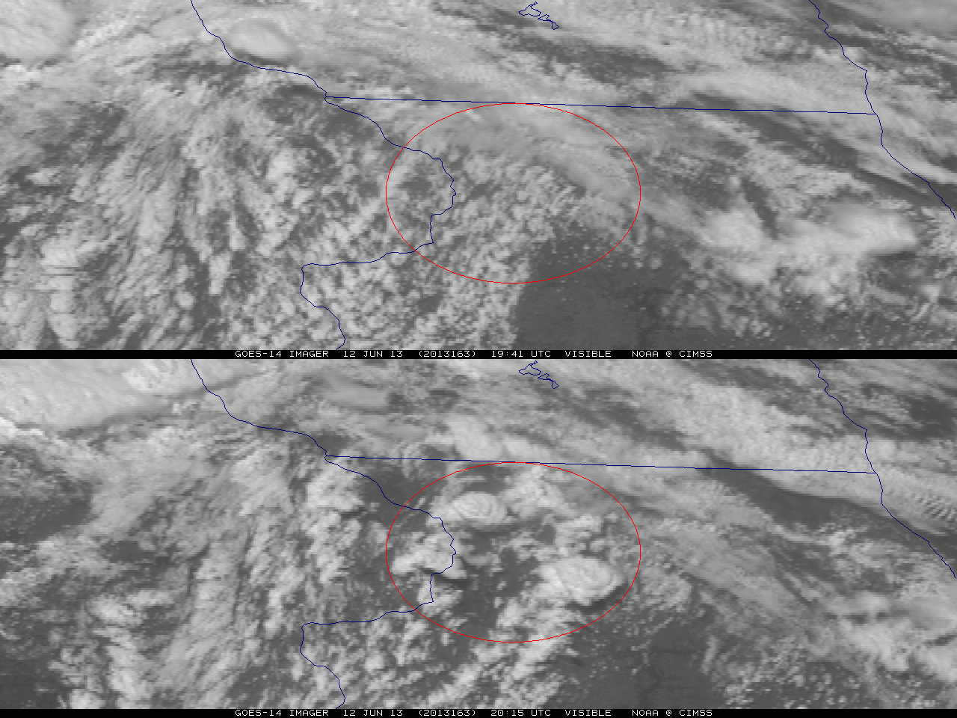
Figure 1. GOES-14 visible image on June 12, 2013 showing rapid convective development forming over approximately 30 minutes in northwest Illinois. Note the three convective storms within the circle that developed during this short time frame.

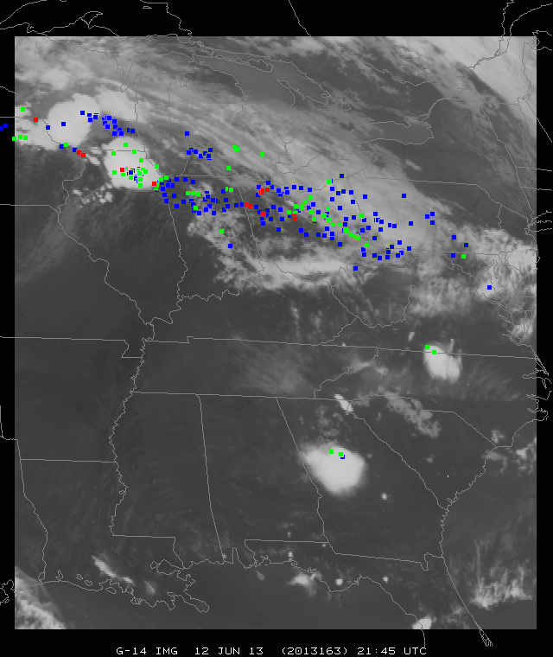
Figure 2. A demonstration of the GOES-14 SRSOR coverage (June 12, 2013) in one minute mode, with the day’s severe weather reports plotted (the colors indicate the type, where tornado reports are plotted in red, hail in green and winds in blue). The satellite image is of the 10.7 μm longwave window (GOES Imager band 4).
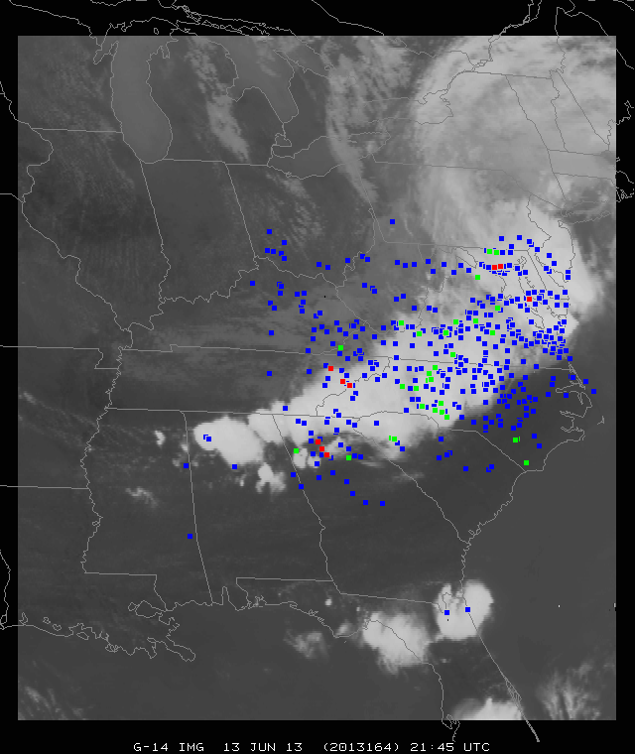
Figure 3. A demonstration of the GOES-14 SRSOR coverage (June 13, 2013) in one minute mode, with the day’s severe weather reports plotted (the colors indicate the type, where tornado reports are plotted in red, hail in green and winds in blue). The satellite image is of the 10.7 μm longwave window (GOES Imager band 4).

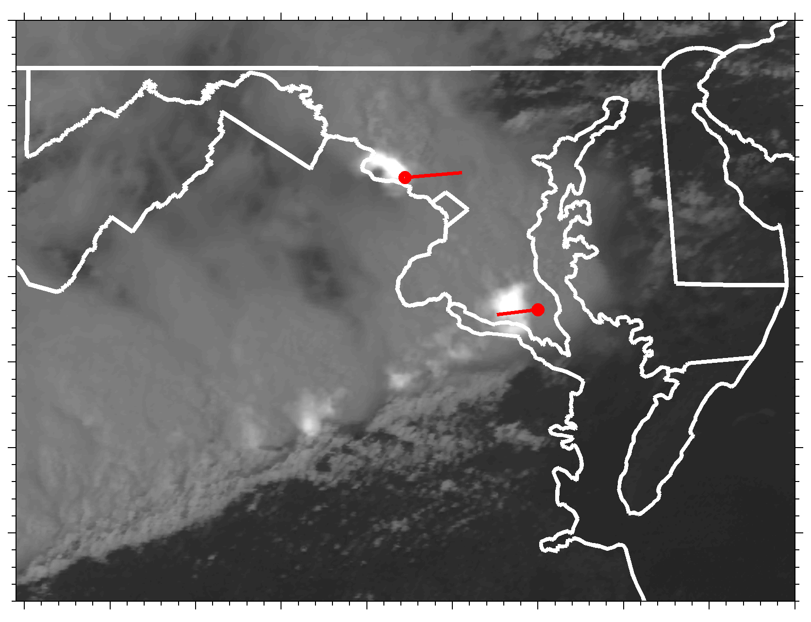
Figure 4. Visible GOES-14 SRSOR imagery blended with DCLMA lightning observations to illustrate a potential new GOES-R product. Red lines indicate the paths of two F-0 tornadoes, and the red circles illustrate their estimated locations at 1941 UTC on 13 June 2013 (animation available at http://dx.doi.org.10.1175/BAMSD-14-yyyyy.1).
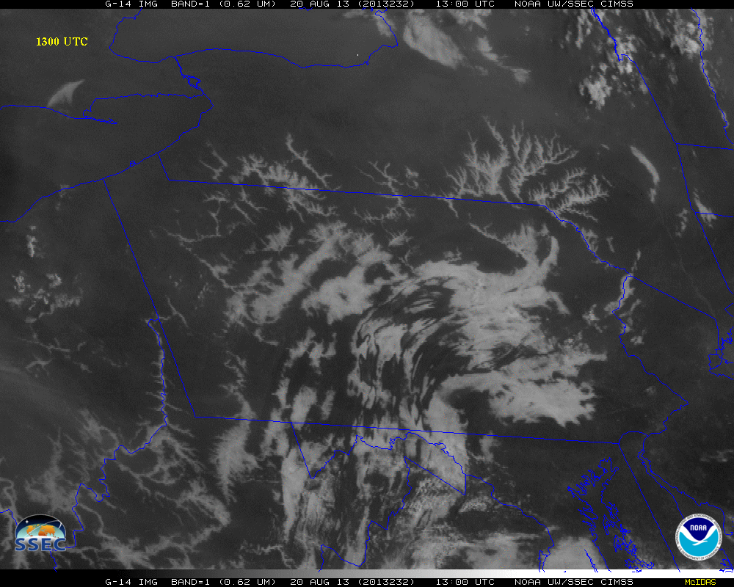
Figure 5. Enhanced GOES-14 Visible image of fog and low stratus on August 20, 2013 at 1300 UTC (animation available at http://dx.doi.org.10.1175/BAMSD-14-yyyyy.3).

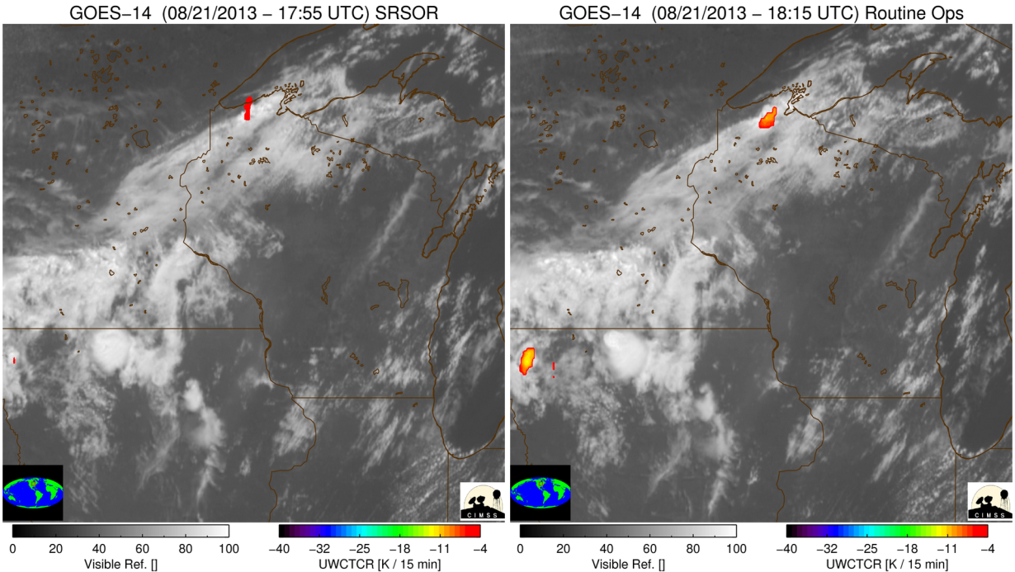
Figure 6. The SRSOR imagery shows GOES-14 visible band on August 21, 2013 with University of Wisconsin-Cloud Top Cooling (UW-CTC) for the SRSOR timing (left panel) and the timing of routine GOES operations (right panel). The SRSOR shows the convective cloud-top cooling over far northern Wisconsin well before that from routine operations (animation available at http://dx.doi.org.10.1175/BAMSD-14-yyyyy.4).

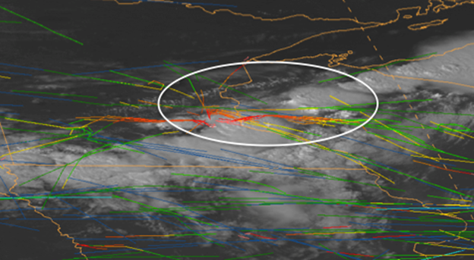
Figure 7. One minute visible imagery and Aircraft Situation Display to Industry (ASDI) flight routes over the Minneapolis Air Traffic Control Center on August 21, 2013 at 2100 UTC. The colors denote the height of the aircraft, with warm colors being lower. The white circle denotes the region of interest associated with the flights into or out of Minneapolis.

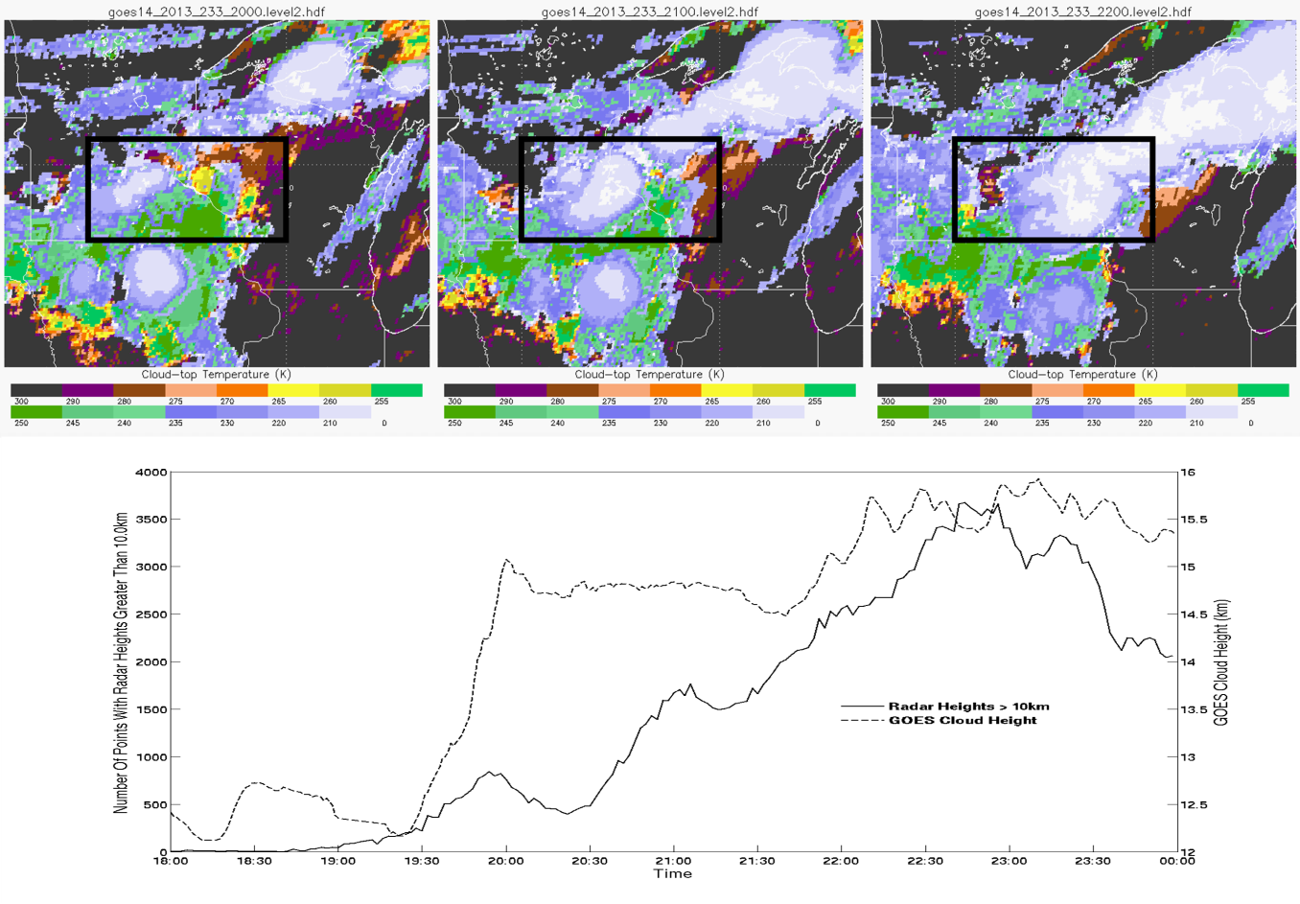
Figure 8. Time Series of the Cloud Height on August 21, 2013. Time Series of ACHA results between 18 and 24 UTC on August 21, 2013. Top three images show ACHA cloud-top temperature at 20, 21 and 22 UTC. The dashed line is the maximum satellite cloud-top height for opaque cloud types over the box drawn in the top three images. The time series from the radar (solid line) also shows rapid changes.
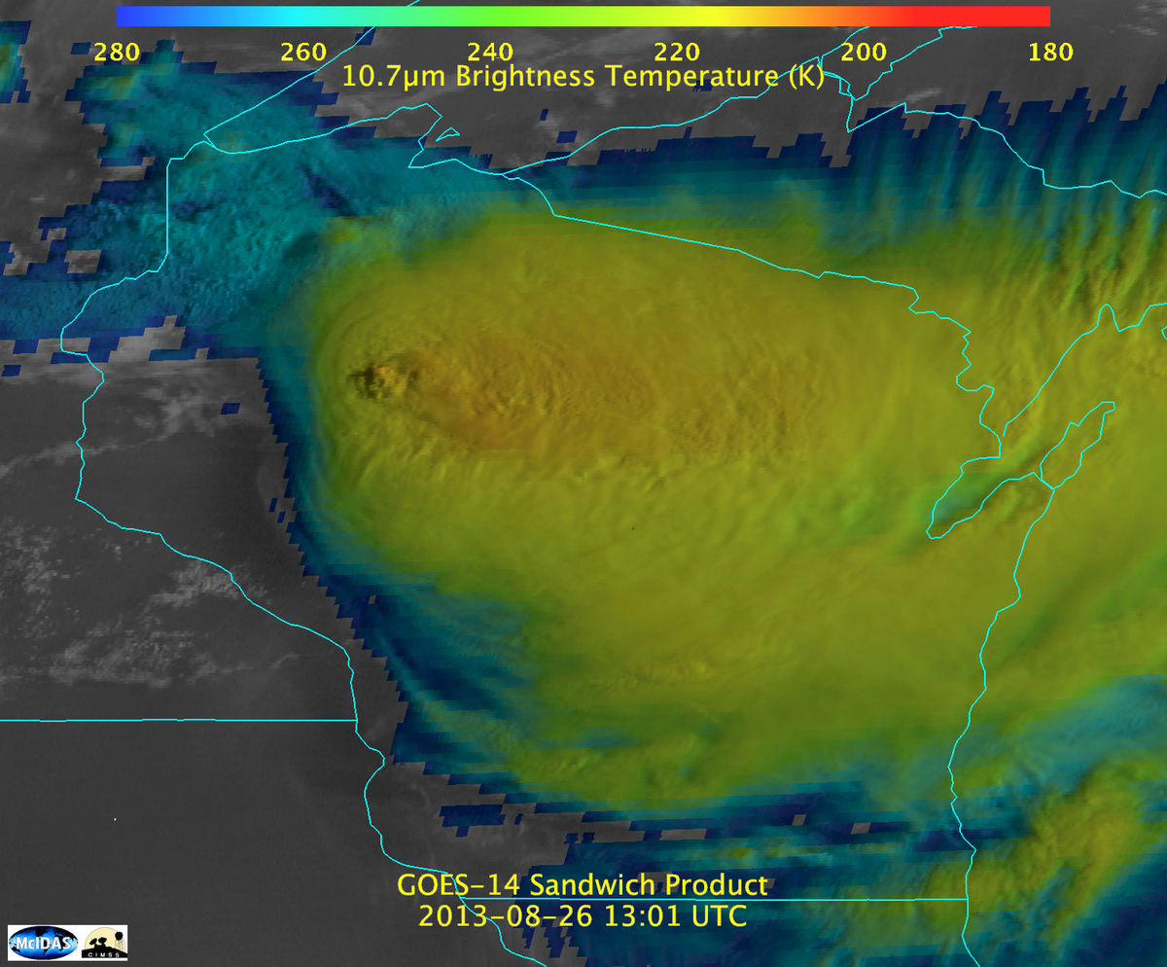
Figure 9. Combined visible and infrared 'sandwich' product from August 26, 2013 at 13 UTC (animation available at http://dx.doi.org.10.1175/BAMSD-14-yyyyy.5). This product shows both the visible imagery as well as the infrared window band.
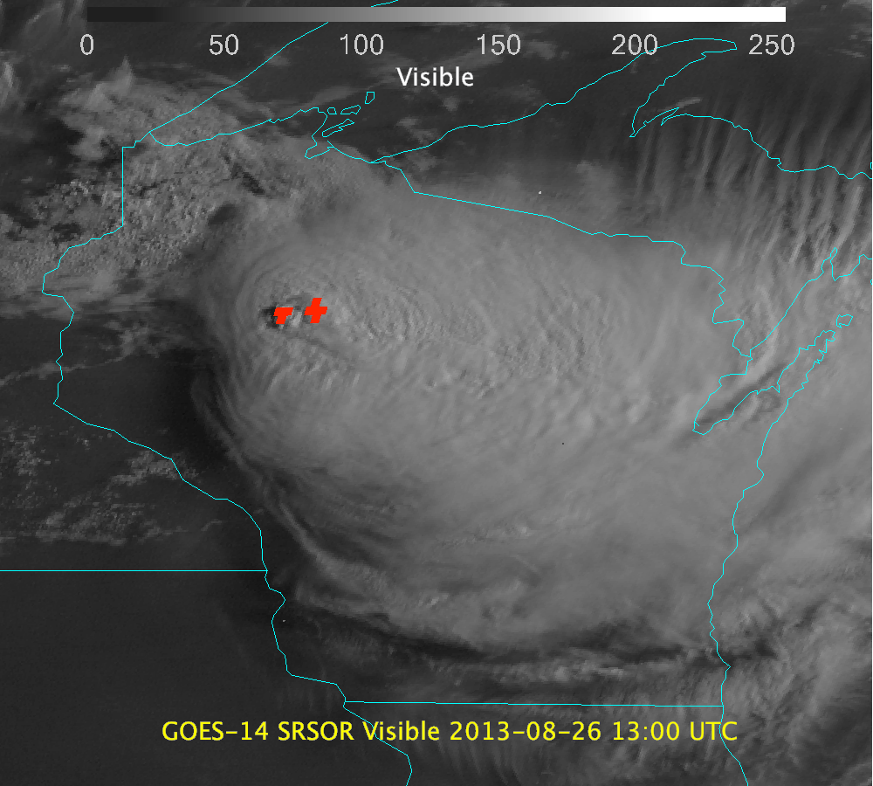
Figure 10. GOES-14 visible image and derived Over-shooting Tops (in red) from August 26, 2013 at 13 UTC (animation available at http://dx.doi.org.10.1175/BAMSD-14-yyyyy.6). The OST are derived from IR window information.
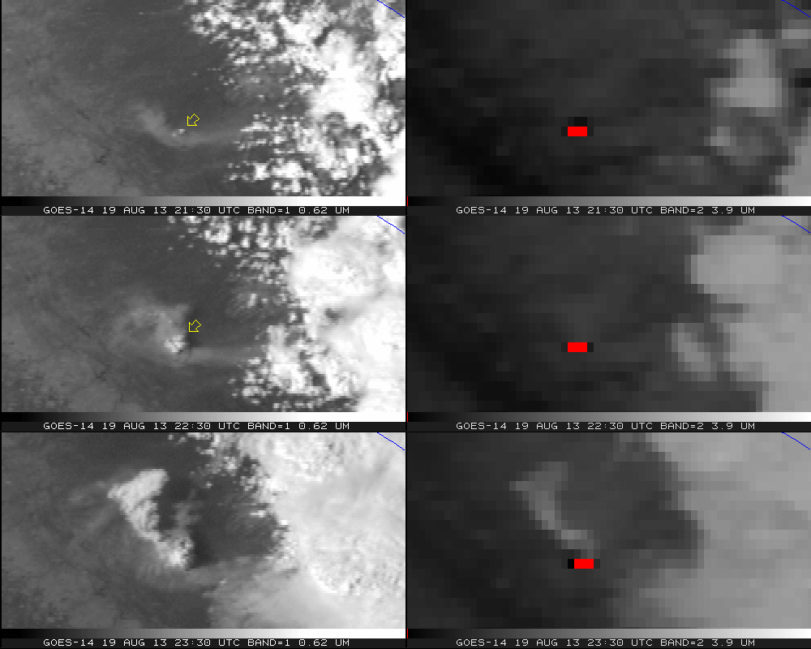
Figure 11. GOES-14 Visible (left panels) and shortwave infrared window (right panels) from the California Rim fire for August 19, 2013. Note that warm temperatures have been color-coded to be dark, with the hottest pixels red (animation available at http://dx.doi.org.10.1175/BAMSD-14-yyyyy.7).

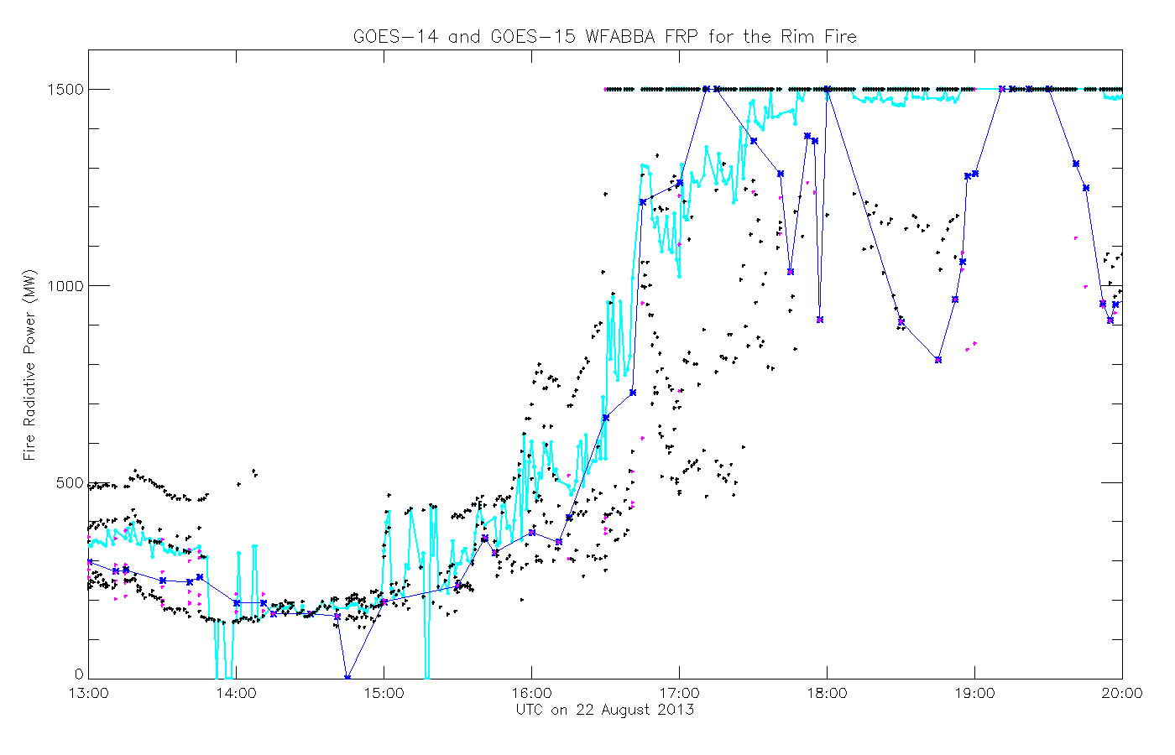
Figure 12. Time series of Fire Radiative Power (FRP) from WFABBA of GOES-14 SRSOR and GOES-15 data from 13 to 20 UTC on August 22, 2013. The dots represent the times, while the lines represent running averages. The cyan line is from the higher time resolution GOES-14 SRSOR data, while the blue line is derived from GOES-15 views.
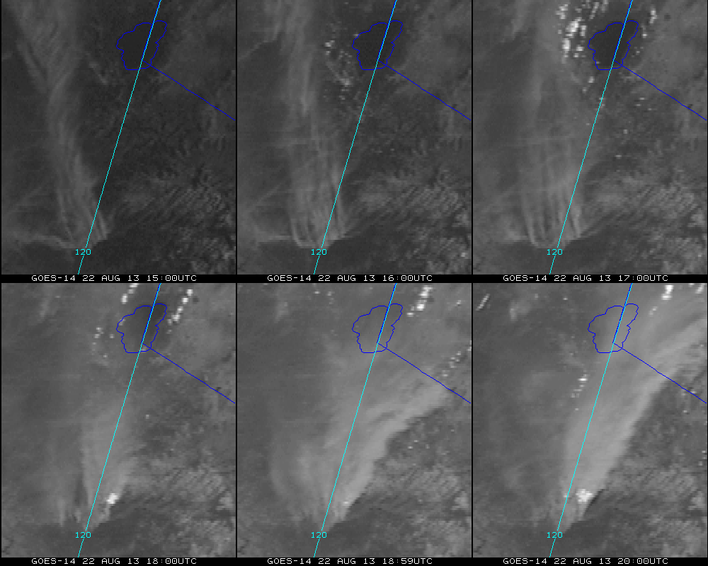
Figure 13. GOES-14 visible image enhanced to better visualize the smoke from the California Rim fire on August 22, 2013 (animation available at http://dx.doi.org.10.1175/BAMSD-14-yyyyy.8). The fire is near the lower part of the image, while the smoke moves, in general, to over Lake Tahoe, reducing its visibility.

Supplemental Material:
1.
Visible imagery and DCLMA observations of the derecho on June 13, 2013:
http://cimss.ssec.wisc.edu/goes/srsor2013/Tornado_Lightning_hires.mp4
2.
GOES-14 Visible imagery on June 13, 2013:
http://cimss.ssec.wisc.edu/goes/srsor2013/800x1000_GOES_B1_DERECHO_animated_2013164_180400_182_2013165_004900_182_X.mp4
3.
Fog and low stratus on August 20, 2013:
http://cimss.ssec.wisc.edu/goes/srsor2013/800x1000_GOES_B1_FOG_PA_animated_2013232_111500_182_2013232_151500_182_FOG_DAN.mp4
4.
GOES-14 visible band with University of Wisconsin-Cloud Top Cooling (UW-CTC) for the SRSOR timing (left panel) and the timing of routine GOES operations (right panel) on August 21, 2013: http://cimss.ssec.wisc.edu/goes/srsor2013/goes14_srsor_uwctc_aug212013.mp4
5.
GOES-14 visible band on August 21, 2013 with over-plotted serve weather reports, using the SPC color convection (hail reports in green) that have been parallax corrected, assuming a height of 12 km. This region over northwestern Wisconsin is shown at approximately 1, 5 and 15 minute imagery:

http://cimss.ssec.wisc.edu/goes/srsor2013/600x1800_triplets_21Aug2013_org.mp4
6.
Combined visible and infrared 'sandwich' product from August 26, 2013:
http://cimss.ssec.wisc.edu/goes/srsor2013/GOES14_sandwich_larger.mp4
7.
GOES-14 visible image and derived Over-shooting Tops from August 26, 2013:
http://cimss.ssec.wisc.edu/goes/srsor2013/agoes14_other_WI_26th_20130826_enh.mp4
8.
California Rim Fire on August 19, 2013:
http://cimss.ssec.wisc.edu/goes/srsor2013/GOES14_VIS_IR2_19AUG2013loop_redo.mp4
9.
California Rim Fire on August 22, 2013:
http://cimss.ssec.wisc.edu/goes/srsor2013/800x1000_GOES_B1_RIM_FIRE_animated_2013234_150000_182_2013234_200000_182_X.mp4

Side-bar

A list of Baseline Products from the ABI which will be made available by the GOES-R series. Baseline Products are those that are funded for operational implementation as part of the ground segment base contract. Note that not all products will be produced from the Mesoscale scans. More information can be found at: http://www.goes-r.gov/

Aerosol Detection (Including Smoke and Dust)
Aerosol Optical Depth (AOD)
Clear Sky Masks
Cloud and Moisture Imagery
Cloud Optical Depth
Cloud Particle Size Distribution
Cloud Top Height
Cloud Top Phase
Cloud Top Pressure
Cloud Top Temperature
Derived Motion Winds
Derived Stability Indices
Downward Shortwave Radiation: Surface
Fire/Hot Spot Characterization
Hurricane Intensity Estimation
Land Surface Temperature (Skin)
Legacy Vertical Moisture Profile
Legacy Vertical Temperature Profile
Radiances
Rainfall Rate / QPE
Reflected Shortwave Radiation: TOA
Sea Surface Temperature (Skin)
Snow Cover
Total Precipitable Water
Volcanic Ash: Detection and Height

