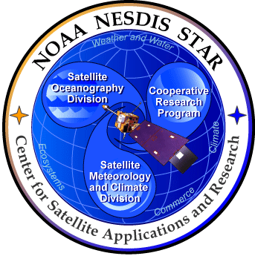

NOAA NESDIS
CENTER for SATELLITE APPLICATIONS and RESEARCH

GOES-R Advanced Baseline Imager (ABI) Routine Validation Tool Description Document For
Cloud and Moisture Imagery Product (CMIP)

Tim Schmit, NOAA/NESDIS/STAR
Mat Gunshor, CIMSS
Kaba Bah, CIMSS

Draft Version 1.0
July 18, 2012
TABLE OF CONTENTS
LIST OF FIGURES 3
LIST OF TABLES 4
LIST OF ACRONYMS 5
1 INTRODUCTION 6
1.1 Information Volume relative to current GOES 6
1.2 Purpose of the Imagery team 6
1.3 Purpose of this document 7
1.4 Who should use this document 7
2 PRODUCT OVERVIEW 8
2.1 Products Generated 8
2.2 Instrument Characteristics 8
2.3 Product Requirements 10
2.4 GOES-R Simulated AIB Datasets 11
3 VALIDATION OVERVIEW 12
3.1 Algorithm Overview and Description 12
3.2 Validation Approach 13
4 CORRELATIVE DATA SOURCES 14
4.1 Monitor Image quality: inspection and animation of imagery 14
5 Analysis Tools 19
5.1 Images for routine visualization 19
5.2 Routine Image Animation 22
5.3 Image correlations 23
5.4 Image combination 24
6 SOFTWARE REQUIREMENTS 26
6.1 Software Library Support 26
7 REFERENCES 27
Appendix 1. Select Links 29
Appendix 2. Sample script 30

LIST OF FIGURES

Figure 1. High-level flowchart for generating CMIP 12
Figure 2. Image comparisons example, using the ‘fader’ option. 14
Figure 3. Comparing current GOES to GOES-R Both images shown in ABI projection using McIDAS-V. September 29, 2011 at 06 UTC. 15
Figure 4. Comparisons between current GOES and GOES-R. The images on the left shows current GOES images from the 3.9 µm and the 13.3µm. The images on the right shows simulated ABI. 16
Figure 5. ECMWF example of calculation versus observation for the GOES-15 Imager. 17
Figure 6. Real time data quality analysis via comparison to other satellites. GOES-15 Imager water vapor band compared to co-located MTSAT values. Note large brightness temperature differences beginning near 21UTC on March 12, 2012. Plus, the SPS unit used for the generation of GVAR is noted (obtained from the GVAR signal). 18
Figure 7. GOES-R Simulated ABI for the full disk at 137°W. 19
Figure 8. CONUS simulated GOES-R ABI bands 1 through 16 at 75°W at for 2100 UTC on 4 June 2005, showing reflectance for the visible bands and Brightness temperatures for the IR bands. 20
Figure 9. Mesoscale simulated GOES-R ABI bands 1 through 16 at 75°W for 1730 UTC on 19 July 2006, showing reflectance for the visible bands and Brightness temperatures for the IR bands. 21
Figure 10. Routine Image Animation. 22
Figure 11. Image statistical analysis. 22
Figure 12. image visual analysis. 23
Figure 13. “True Color” with “synthetic” green band from ABI simulated data (from CIMSS); image from Don Hillger, RAMMB. 24

LIST OF TABLES

Table 1. GOES-R ABI instrument characteristics. 8
Table 2. GOES-R ABI Product List. 9

LIST OF ACRONYMS

ABI – Advanced Baseline Imager
AIT – Algorithm Integration Team
ARW – Advanced WRF
ATBD – Algorithm Theoretical Basis Document
AWG – Algorithm Working Group
AWIPS – Advanced Weather Interactive Processing System
BT – Brightness Temperature
BV – Brightness Value
CF – Climate and Forecasts
CFD – Continuous Full Disk
CIMSS – Cooperative Institute for Meteorological Satellite Studies
CMIP – Cloud and Moisture Imagery Product
CONUS – Continental United States
CRTM – Community Radiative Transfer Model
DC – Digital Count
FD – Full Disk
FGF – Fixed Grid Format
GFS – Global Forecast System
GPO – GOES-R Program Office
GRB – GOES ReBroadcast
GS – Ground Segment
GVAR – GOES Variable
HDF – Hierarchical Data Format
IDL – Interactive Data Language
IDV – Integrated Data Viewer
IR – InfraRed
ITT – ITT Industries
I&VT – Imagery and Visualization Team
IV&V – Independent Verification and Validation
KPP – Key Performance Parameter
McIDAS – Man computer Interactive Data Access System
NCSA – National Center for Supercomputing Applications
NetCDF – Network Common Data Format
PCI – [data visualization tool]
QC – Quality Control
SOI – Successive Order of Integration
SR – Scaled Radiance
TBD – To Be Determined
TOA – Top Of Atmosphere
TRR – Test Readiness Review
UTC – Universal Time Coordinated
UW – University of Wisconsin
WRF – Weather Research and Forecasting

1 INTRODUCTION

The Advanced Baseline Imager (ABI) on GOES-R will monitor the Western hemisphere in various time intervals and at 0.5, 1, and 2 km spatial resolutions in visible, near-IR, and IR wavelengths. The ABI has two main scan modes, of which the most likely mode will allow a full disk image every 15 minutes, along with a Continental U.S. (CONUS) image every 5 minutes, and a mesoscale image as often as every 30 seconds (or two locations every one minute). Cloud and Moisture Imagery Product (CMIP) is the ABI tier 1A and Key Performance Parameter (KPP) product for GOES-R. The end products include 16 ABI single-band images for 3 coverage areas plus the multi-band spectral products for each coverage area in NetCDF and McIDAS formats, which will be used as input data by various other algorithms.
Cloud and Moisture Imagery algorithms produce digital maps of clouds, moisture, and atmospheric windows, through which land and water are observed, from radiances for the visible, near-IR, and IR bands. Information will also be provided on the conversion from radiance to reflectance factor (ABI bands 1-6) and radiance to Brightness Temperatures (BT) (ABI bands 7-16). Cloud and Moisture Imagery provides input to other algorithms producing other environmental products.

GOES-R ABI CMIP algorithms have been tested on ABI simulated data covering the CONUS and nearly Full Disk sectors. The generated image files have been compared with the validation data generated by the research code, and the images are effectively identical.

1.1 Information Volume relative to current GOES

Compared to current GOES, the ABI has improved spectral, spatial, and temporal image resolution by factors of 3, 4, and 5 respectively. In addition, there will be improved radiometric and image navigation and registration performance. This allows for not only improved and new uses directly with the imagery, but it also allows for improved and new products to be derived from the ABI data.

The ABI will improve every product from the current GOES Imager and will introduce a host of new products, such as cloud-top phase/particle size information and improved snow/ice detection, total column ozone, aerosol and smoke detection for air quality monitoring and forecasts. Other new products include vegetation monitoring and upper-level sulfur dioxide detection. The ABI will begin a new era in U.S. environmental remote sensing with more spectral bands, faster imaging, and higher spatial resolution than the current GOES imager.

1.2 Purpose of the Imagery team

The purpose of the imagery team is generally two-fold:
(I) Demonstrate how to convert from GRB scaled radiances (e.g., GRB counts) to other physical units, such as radiance, brightness temperatures and brightness values.
(2) Build files that can be used for processing most of the ABI products, such as clouds, soundings, etc.

1.3 Purpose of this document

This document provides a description for the routine validation tools for the CMIP with simulated ABI images of the Advanced Baseline Imager onboard the Geostationary Operational Environmental Satellite (GOES-R) series of NOAA geostationary meteorological/environmental satellites. The topics covered in this document include routine validation tools that are currently being developed or would be of great use for routine validation if developed, requirements for CMIP algorithms and software system, description of CMIP key algorithms, test data sets and outputs.

1.4 Who should use this document

The intended users of this document include: algorithm reviewers, who would understand the theoretical basis of CMIP; product users, who would use the product in an operational task; scientific programmers, who would develop new routine validation algorithms; and system administrators, who would maintain the software.

This document consists of the following main sections:
- Product Overview: provides relevant details of the ABI and a brief description of the products generated by the algorithm.

- Product Requirement Description: provides the detailed requirements for the CMIP key algorithms and software system.

- Algorithm Description: provides the details for CMIP processing outline, input/output parameters and key routine validation algorithms.

- Test Data Sets, and Output: provides a description of the test data sets used to characterize the performance of the algorithms and quality of the data products. It also describes the results of using test data sets.

2 PRODUCT OVERVIEW
This section describes the CMIP and the requirements it places on the system.

2.1 Products Generated

The CMIP will be produced using all 16 bands in three coverage areas: FD, CONUS, and mesoscale. Bands 1-6 are the visible bands (1 and 2) and near-IR (3-6), while bands 7-16 are IR bands.

The CMIP is responsible for ABI cloud and moisture imagery, and will produce 54 total end products, including:
- 16 ABI single-band products ([spectral] radiance in bands 1-16) for 3 coverage areas
- Multi-band spectral products (16 bands at 2 km resolution) for 3 coverage areas in NetCDF4 format
- Multi-band spectral products (16 bands at 2 km resolution) for 3 coverage areas in McIDAS format
The three coverage areas are for full disk, CONUS and mesoscale images. By community convention the term “radiance” is used throughout this document and actually refers to a spectral radiance; e.g., technically radiance is only at a single frequency, while spectral radiance is radiance per unit frequency (either wavelength or wave number). It should also be noted that the radiance is actually an average value, weighted by the sensor response for that given band.

2.2 Instrument Characteristics

The ABI on GOES-R has 16 spectral bands. The selection of each covers a variety of environmental applications. ABI Infrared (IR) bands have been chosen to coincide either with spectral absorption features (including those of water vapor bands or CO₂ bands) or with regions having little absorption (atmospheric windows) that permit observations of the surface. Visible and near-IR bands have been chosen in order to sense lower tropospheric cloud cover (including fog) and the Earth’s surface (NOAA/NESDIS 2007).
Table 1 summarizes the instrument (nominal) central wavelength, spatial resolution (at the sub-point), and bit-depth characteristics of the ABI data in the data stream transmitted to users—the GOES Re Broadcast (GRB). The instrument has two basic modes of operation:
- Every 15 minutes, ABI will scan the full disk (FD) once, plus the continental United States (CONUS) three times (every 5 minutes). A selectable 1000 km × 1000 km mesoscale area will be scanned every 30 seconds. This has been referred to as mode 3 (or ‘flex’ mode).
- The ABI can be programmed to scan the FD iteratively. The FD image can be acquired in approximately 5 minutes (Schmit et al. 2005). This mode has been referred to as mode 4 or the Continuous Full Disk (CFD).
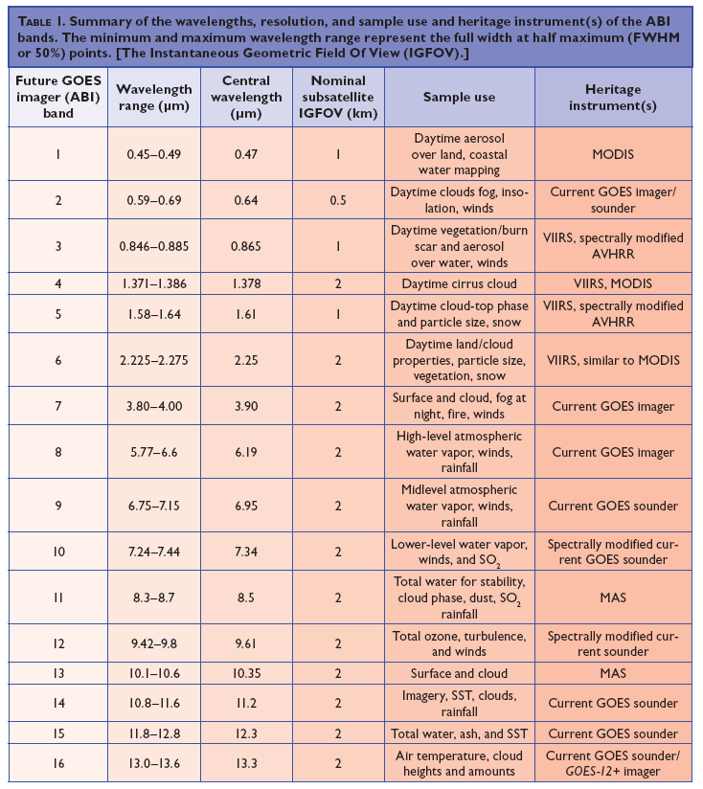
Table 1. GOES-R ABI instrument characteristics.

2.3 Product Requirements
Name | Release Number | Product Baseline or Product Option (1 or 2) | Output Format for each Coverage | Number of End-Products | RBU Product | Product Level | Product Geographic Coverage (Product Orthogonality/Coverage for Space Weather) | Product Vertical Resolution (Product Horizontal / Angular Resolution for Space Weather) | Product Horizontal Resolution (Product Pointing/ Mapping Accuracy for Space Weather) | Product Mapping Accuracy (Product Pointing Knowledge / Mapping Uncertainty for Space Weather) | Product Measurement Range | Product Measurement Accuracy | Product Refresh Rate/ Coverage Time (B) (ABI Mode 3) | Refresh Rate / Coverage Time (B) Mode 4 | VAGL (B) Mode 3 | VAGL (B) Mode 4 | Product Measurement Precision | Product Type | Product Sub-type
Cloud & Moisture Imagery | 1 | B | NetCDF  McIDAS | 54 | Yes | 2+ | CONUS, Full Disk, Mesoscale | Not Applicable | 2 km, with finer daytime obser-vations | 1.0 km | Not Applicable | Not Applicable | CONUS: 5 min Full Disk: 15 min Mesoscale: 30 sec | CONUS: 5 min  Full Disk: 5 min | CONUS: 50 sec  Full Disk: 50 sec  Mesoscale: 23 sec | CONUS: 50 sec  Full Disk: 50 sec | Not applicable | Atmosphere | Clouds
From F&PS Appendix A. Table 1.
The primary output of this algorithm is the information to generate enhanced cloud and moisture images of all the ABI bands. That said, these files could also be used to generate the rest of the ABI products. For example, products can access either radiance, reflectance factor or BT. The supported formats will be in NetCDF (version 4) format and McIDAS format. Output should be able to be converted from NetCDF or McIDAS format to other formats.

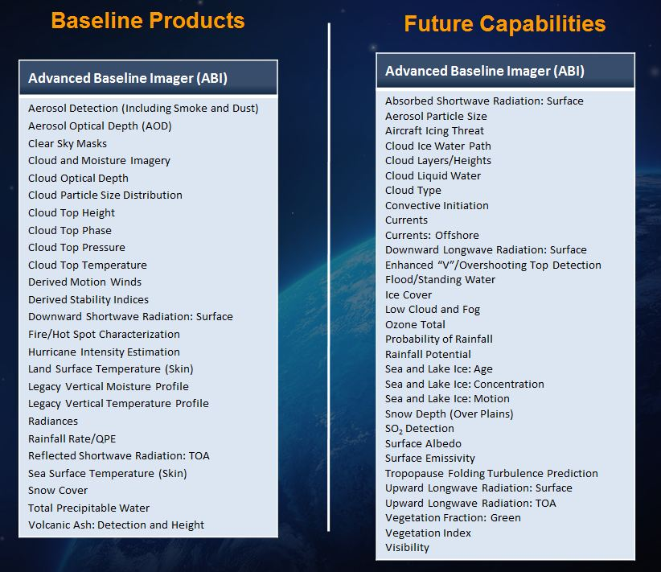
Table 2. GOES-R ABI Product List.

2.4 GOES-R Simulated AIB Datasets

Simulated GOES-R ABI data has been used in the pre-launch phase to develop, test, and validate the ABI CMIP products. The data is derived from use of a radiative transfer model, where the atmospheric and earth surface representations are provided by a high resolution numerical weather prediction forecast model. The GOES-R Algorithm Working Group Proxy Data Team is responsible for the generation of the proxy and simulated instrument data sets. Within the proxy group, the simulated images used by the imagery team were generated by the Cooperative Institute for Meteorological Satellites Studies (CIMSS).

Much work has been done to generate high-quality simulated ABI images based on output from the high resolution Weather Research and Forecasting (WRF) numerical model. The forward radiative transfer models used to transform from model (environmental parameter) space to measurement (radiances and BTs) space cover from the visible, to the IR spectral regions (Otkin and Greenwald 2008). High quality forward model simulations have been made of each of the ABI 16 bands.

The GOES-R AWG Proxy Data team has created several ABI simulations. This section details the work on a CONUS simulation which mimics one of the proposed scan segments on the future ABI (Otkin et. al 2007). Two flexible scanning scenarios are currently under review for the ABI. The first mode allows the ABI to scan the full disk (FD) every 15 minutes, 3 CONUS scenes, and scan a 1000 km x 1000 km selectable area every 30 seconds, although it is envisioned that 2 areas will be scanned, giving a 1-minute cadence for each. A second mode would program the ABI to scan the FD every 5 minutes (Schmit et al. 2005).

The synthetic GOES-R ABI imagery begins as a high resolution WRF model simulation. The CONUS simulation was performed at the National Center for Supercomputing Applications (NCSA) at the University of Illinois at Urbana-Champaign by the GOES-R AWG proxy data team at CIMSS. Simulated atmospheric fields were generated using version 2.2 of the WRF model (Advance Research WRM (ARW) core). The simulation was initialized at 2355 UTC on 04 June 2005 with 1° Global Forecast System (GFS) data and then run for 30 hours using a triple-nested domain configuration. The outermost domain covers the entire GOES-R viewing area with a 6-km horizontal resolution while the inner domains cover the CONUS and mesoscale regions with 2 km and 0.667 km horizontal resolution, respectively.

WRF model output, including the surface skin temperature, atmospheric temperature, water vapor mixing ratio, and the mixing ratio and effective particle diameters for each hydrometeor species, were ingested into the Successive Order of Interaction (SOI) forward radiative transfer model in order to generate simulated top of atmosphere (TOA) radiances. Gas optical depths were calculated for each ABI infrared band using the Community Radiative Transfer Model (CRTM). Ice cloud absorption and scattering properties were obtained from Baum et al. (2005), whereas the liquid cloud properties were based on Lorenz-Mie calculations.

Near-realtime generation of simulated bands for all the ABI channels is planned. These datasets can be used for a variety of purposes, including validation testing.

3 VALIDATION OVERVIEW
This section describes the CMIP software system processing outline, input/output parameters, and key algorithms at their current level of maturity.

3.1 Algorithm Overview and Description
The CMIP algorithms consist of acquiring the radiometrically calibrated and mapped radiances and converting to BV. The BV are used as indices either to customized color tables or to the red/green/blue color components of a composite image, resulting in enhanced imagery intending to highlight environmental features of interest. The GOES-R ABI CMIP radiometric algorithms are based on GOES 8-13 algorithms (Weinreb et al. 1997; Schmit et al. 1991). Algorithms for mapping TOA reflectance factor and BT to BV are based on examples from the literature (Acharya and Ray 2005; Russ 2002), commercial remote sensing data visualization tools (e.g., ENVI and PCI), and open source tools (e.g. McIDAS-X/V and IDV). Some display systems may be capable of displaying more than 8 bits (or 256 levels). The bit-depth of the end-products (BV) for CMIP is 12 bits for all the bands, with the exception of band 7, which is 14 bits. Hence, the enhancements need to be applied on the user display side and not converted to only 8 bits, for example. This is because the conversion to an 8-bit BV also includes a ‘compression’ such as a square-root function in the solar bands and a bi-linear stretch for the IR bands.
The CMIP will convert from the radiances to a number of geophysical parameters, such as brightness temperature or reflectance factor. This is needed in that a number of subsequent products use these units.
CMIP algorithms are responsible, in part, for:
- Converting the scaled [spectral] radiance from the input data stream (eg, GRB) to a spectral radiance (bands 1-16).
- Re-sampling bands 1, 3, and 5 from 1 km to 2 km for multi-band product. Re-sampling band 2 from 0.5 km to 2 km for multi-band product.
- Converting the spectral radiance to equivalent BT (bands 7-16).
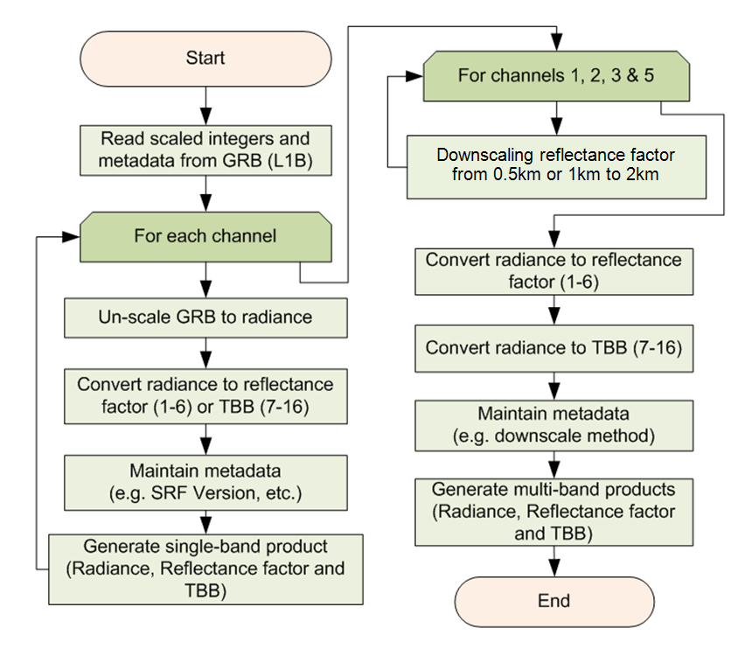
Figure 1. High-level flowchart for generating CMIP

Field | Name | Description | Dimension
1 | Reflectance Factor | Bands 1-6 [nominally 0-1] | grid (ysizeh, xsizeh)  grid (ysize1, xsize1)  grid (ysize2, xsize2)
2 | Brightness Temperature | Bands 7-16 [K] | grid (ysize2, xsize2)
3 | Nominal Image Start Day/Time | Julian Date/Time (UTC) | array (zsize)
4 | Image Day/Times | Nominal swath start day/times | array (2,22) FD  array (2,6) CONUS  array (2,2) MESO
5 | Fixed Grid Coordinates | Definition of earth in GRS80 | array (lsize)
6 | Sub-point (projected) | Nominal subpoint location | array (2)
7 | Sub-point (actual) | Actual subpoint location | array (2)
8 | Band Center wavenumbers | Band Center wavenumbers | array (21)
9 | Radiance to reflectance factor conversion coefficients | Slopes and Intercepts, Esuns | array (3)
10 | Radiance to Brightness Temperature coefficients | Slopes and Intercepts, Planck Coefficients | array (6)
11 | Quality Flags | Quality Flags by band (quality and saturation) | grid (ysizeh, xsizeh)  grid (ysize1, xsize1)  grid (ysize2, xsize2)
12 | Sat. id | Satellite ID | array (1)
13 | Earth-Sun Distance, , π | Earth-Sun Distance, pi | array (2)
14 | Image Center point | Latitude/Longitude | array (2)
15 | Line array | Absolute fixed grid Y-coordinate, North to South | array (ysizeh)  array (ysize1)  array (ysize2)
16 | Element array | Absolute fixed grid X-coordinate, West to East | array (xsizeh)  array (xsize1)  array (xsize2)
17 | Bits per pixel |  | array (1)
18 | Spare
19 | Satellite name | GOES-16, -17, etc.
20 | Instrument | ABI
21 | Altitude | km | array (1)
22 | Scan type | FD, CONUS, Mesoscale, Other
23 | Product Version | Version # | array (1)
24 | Data compression | type
25 | Location of production
26 | Citations to Documents
27 | Contact Information
28 | SRF version |  | array (1)
29 | Processing day/time |  | array (2)
30 | Product Name | Cloud and Moisture Imagery
31 | Radiance Units | W/(m²-sr-µm) for bands 1-6  mW/(m²•sr•cm⁻¹) for bands 7-16
32 | Brightness Temperature Units | K
33 | Reflectance factor Units | N/A
34 | GRB version number |  | array (1)
35 | Central wavelength | area under the curve weighted value (µm) | array (1)
36 | Band resolution | km | array (1)
37 | Nominal Earth-Sun distance |  | array (1)
38 | Reflectance factor stats | Min, Max, Mean and Stddev + units | array (5)
39 | Brightness Temperature stats | Min, Max, Mean and Stddev + units | array (5)
40 | # good cal points | From level1b | array (1)
41 | # good nav points | From level1b | array (1)
42 | Total # of points | From level1b | array (1)
Table of Input parameters.

3.2 Validation Approach

Validation of the Imagery products is slightly different than for the other ABI products. Imagery products do not all have external data sources to compare to and some validation methods will involve comparing current data to previous data (time series analysis). That said, “The business of imagery is imagery”. So it’s envisioned that images will be made off all the ABI bands and posted.

During the pre-launch phase of the GOES-R program, the product validation activities are aimed at characterizing the performance and uncertainties of the CMIP products resulting from parameterizations and algorithmic implementation artifacts. During this phase, the validation strategies can be tested on current GOES (and other geostationary satellites if possible, with more bands) in addition to the ABI simulated data described in Section 4.1. Some of the validation error thresholds can be established using similar bands on current instruments. Post-launch validation will apply lessons learned to inter-comparisons of actual CMIP products generated from real ABI measurements and other observations. Validation methodologies and tools developed and tested during the pre-launch phase will be automated and applied.

4 CORRELATIVE DATA SOURCES

Testing algorithm and Comparing SEVIRI and the ABI
• Several bands of the ABI were added, in part, due to SEVIRI experience.
• SEVIRI data are key and being used by many AWG application teams (clouds, aviation, hydrology, trace gas, soundings, cryosphere, land, winds, etc).
• SEVIRI data offers routine 15-min full disk images, similar to the ABI in ‘flex’ mode.
• In the ‘overlap’ region, ABI data can be compared to SEVIRI data.

4.1 Monitor Image quality: inspection and animation of imagery
By generating animations of ABI, we can animate and inspect those loops or compare to other bands. Ideally, images could be toggled, faded, paneled or differenced. The loops can also be compared to current GOES images. Such comparisons can be used to verify image quality and make sure that the output images do meet the expected quality.
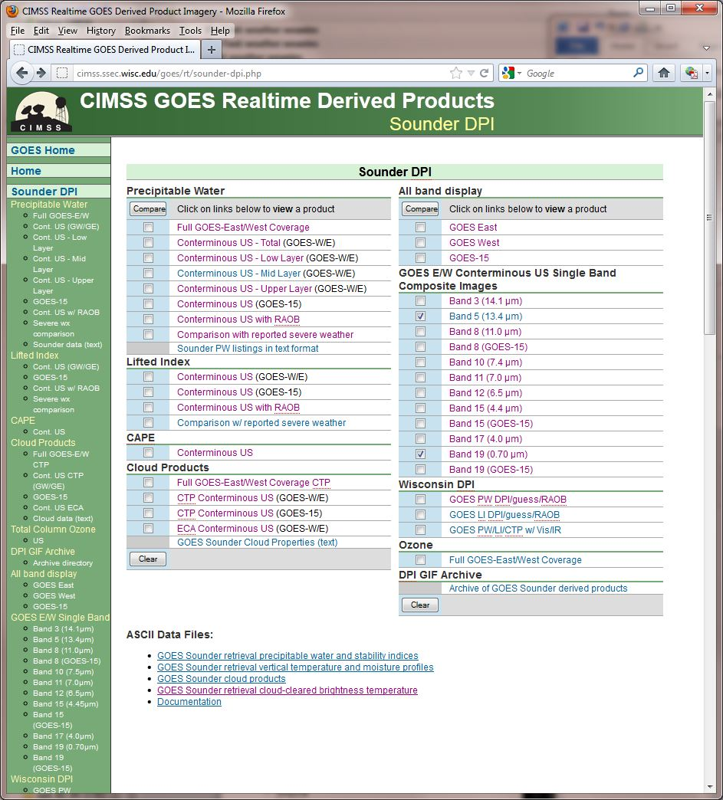

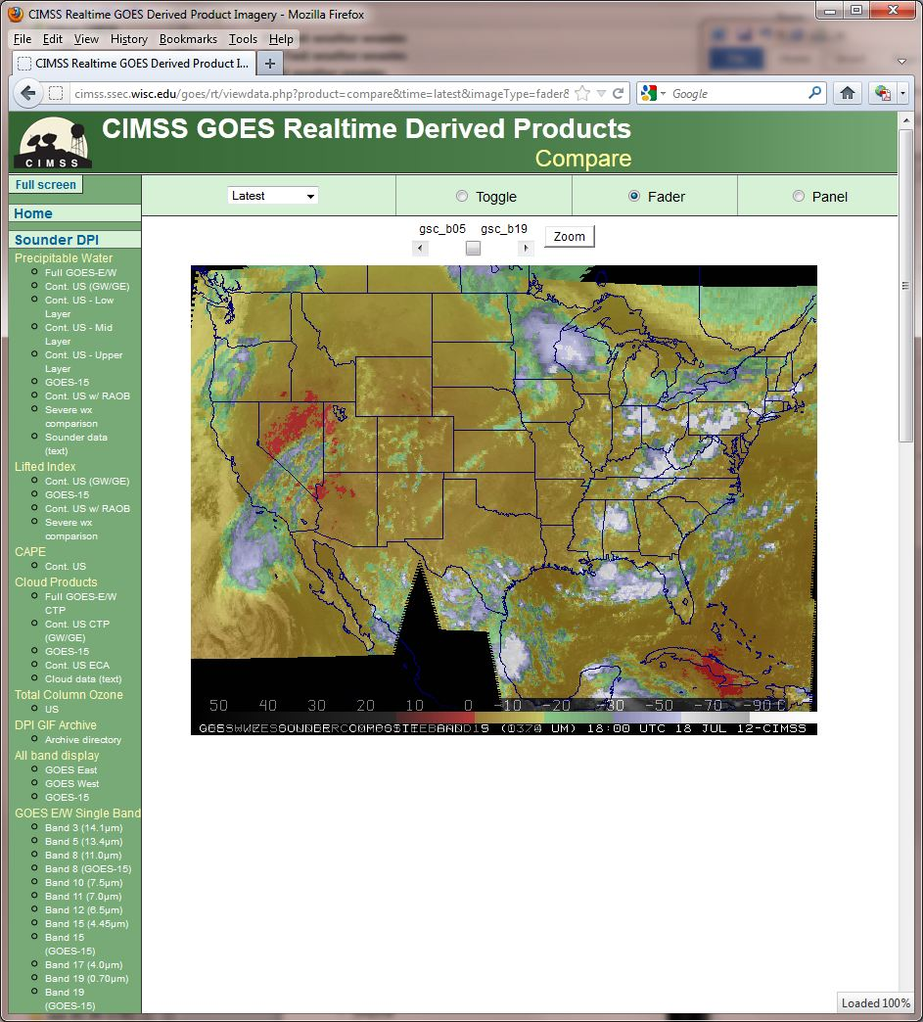
Figure 2. Image comparisons example, using the ‘fader’ option.

http://cimss.ssec.wisc.edu/goes/rt/sounder-dpi.php

http://cimss.ssec.wisc.edu/goes/rt/viewdata.php?product=compare&time=latest&imageType=fader&productList=gsc_b03|gsc_b05

The above examples are from the following URL: http://cimss.ssec.wisc.edu/goes/rt/sounder-dpi.php. The pages also allow one to choose a given day/time.

WRF runs at the Arctic Region Supercomputing Center 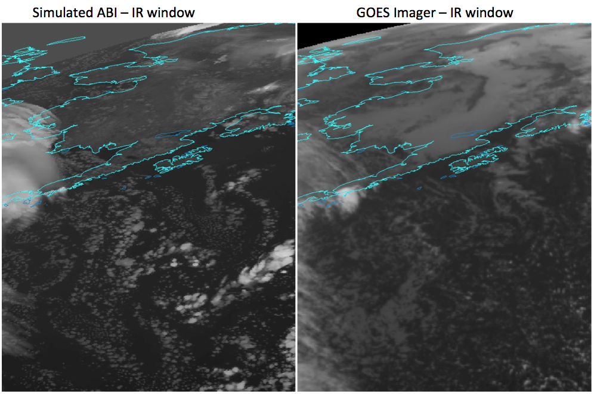
Figure 3. Comparing current GOES to GOES-R Both images shown in ABI projection using McIDAS-V. September 29, 2011 at 06 UTC.

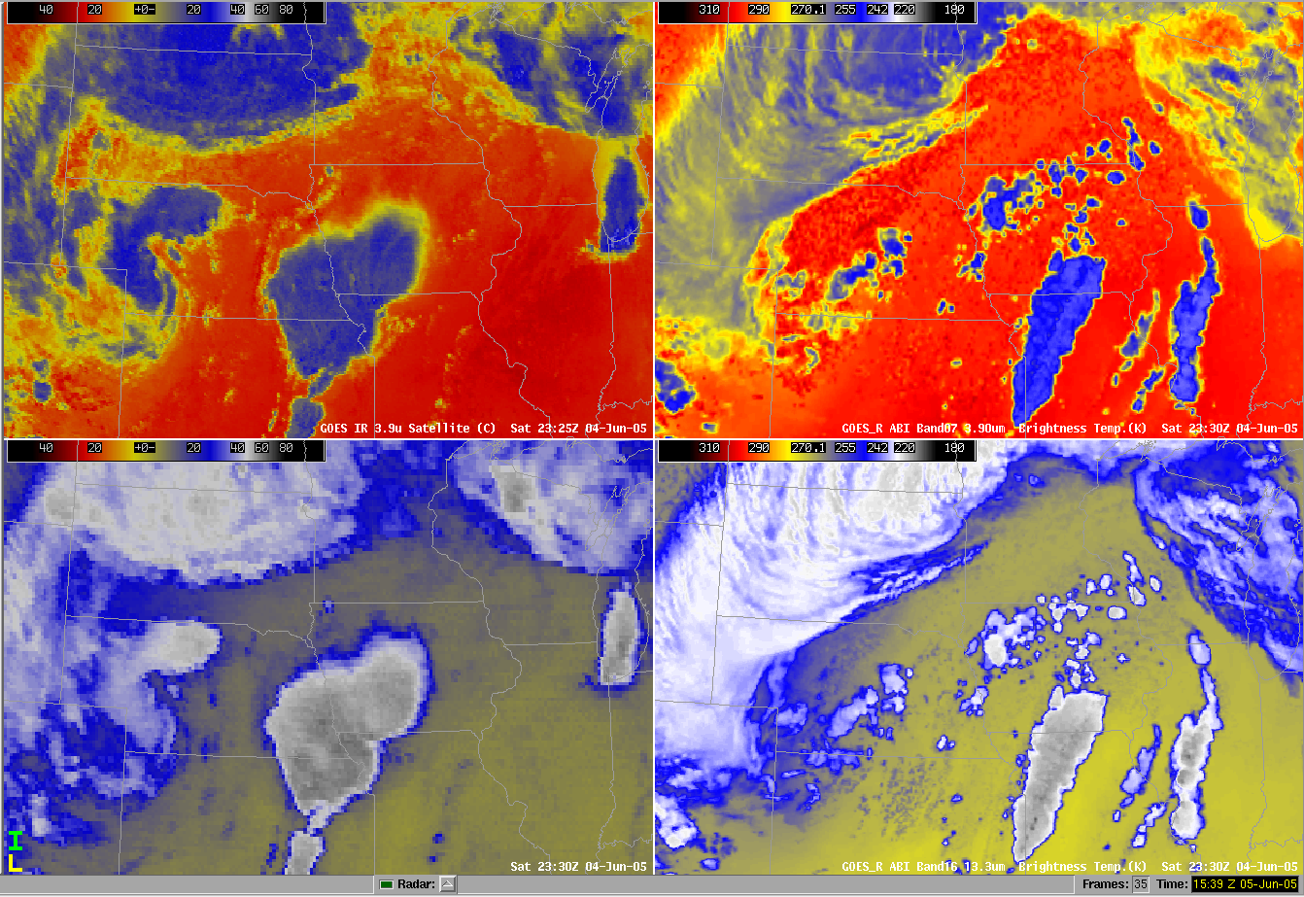
Figure 4. Comparisons between current GOES and GOES-R. The images on the left shows current GOES images from the 3.9 µm and the 13.3µm. The images on the right shows simulated ABI.

Geo-located GOES-15 and MTSAT Mean Water Vapor Brightness temperatures, below, show good agreement until 2045 UTC on March 12, when the SPS change that accessed incorrect values in a different database was implemented. the SPS unit used for the generation of GVAR is noted

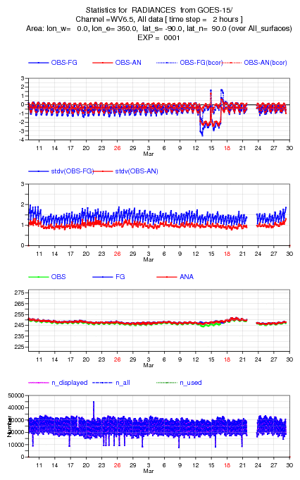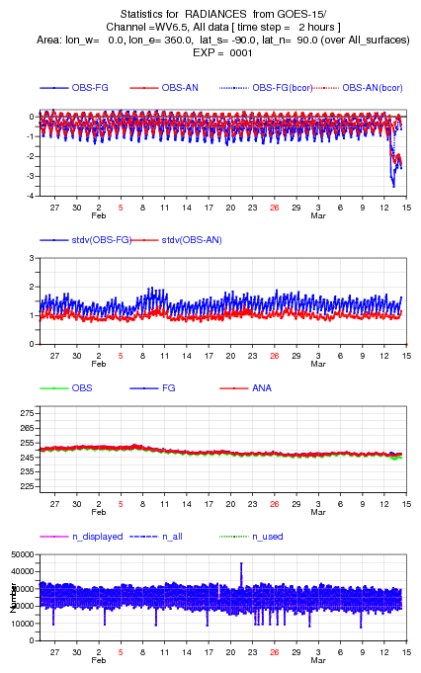
GOES-15 Imager Calibration Anomaly

Large observation minus calculation
Figure 5. ECMWF example of calculation versus observation for the GOES-15 Imager.

These type comparisons may best fit under the calibration monitoring task.

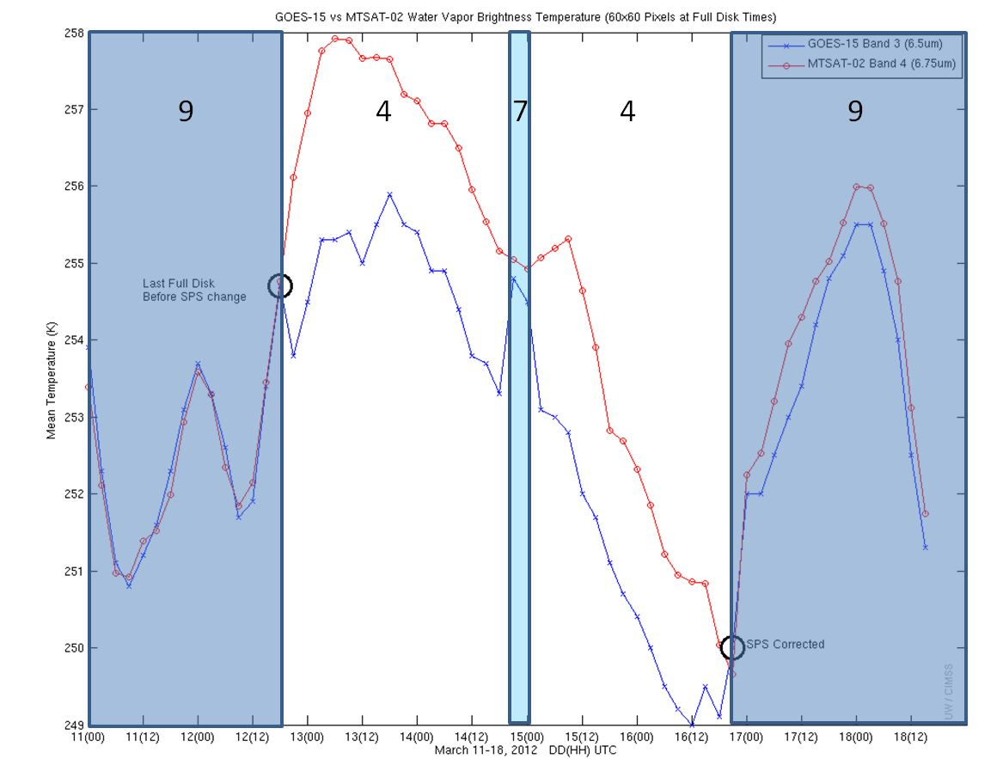
Figure 6. Real time data quality analysis via comparison to other satellites. GOES-15 Imager water vapor band compared to co-located MTSAT values. Note large brightness temperature differences beginning near 21UTC on March 12, 2012. Plus, the SPS unit used for the generation of GVAR is noted (obtained from the GVAR signal).

When done routinely, this can help us detect calibration as well as navigation issues if any exist. It is likely that Japan will be operating an ABI-like instrument over the Pacific and an ABI placed as “GOES-West” will be able to compare in nearly all bands.

5 Analysis Tools

5.1 Images for routine visualization

The idea is that thumbnails could be ‘clickable’ to show a larger image. All the images shown below have been remapped to the GOES-R ABI Fixed Grid Format (FGF). The FGF comprises a set of fixed view angles at regular intervals, and their respective intersections with the GRS80 Earth geoid, from an ideal or nominal point in space in the equatorial plane. The transform algorithms are being tested in the McIDAS-V geolocation framework, and necessary CF-compliant metadata have been added to NetCDF files . Using the FGF will reduce the file size (by not needing to carry a latitude/longitude value for each pixel) and should also improve the performance of any remapping functions.
Simulated ABI scaled integer data for these dataset were computed using output from a high-resolution Weather Research and Forecasting model with Chemistry (WRF-CHEM, version 3.0.1) simulation coupled with the NOAA/NESDIS CRTM forward radiative transfer model.
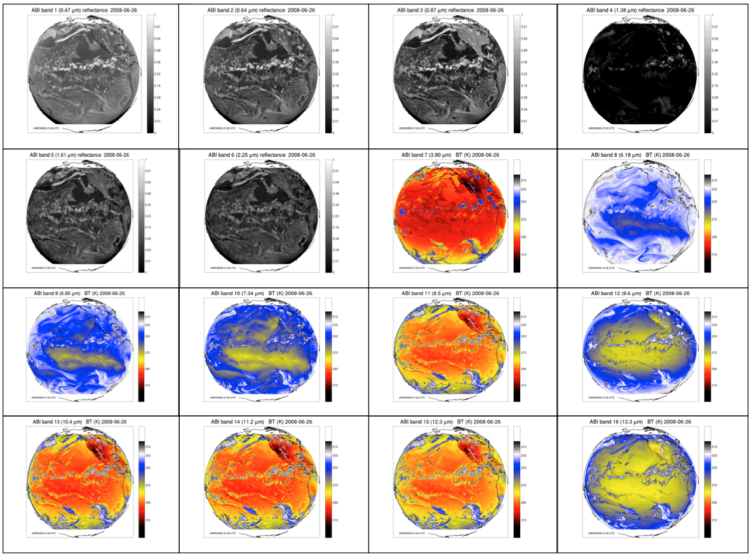
Figure 7. GOES-R Simulated ABI for the full disk at 137°W.

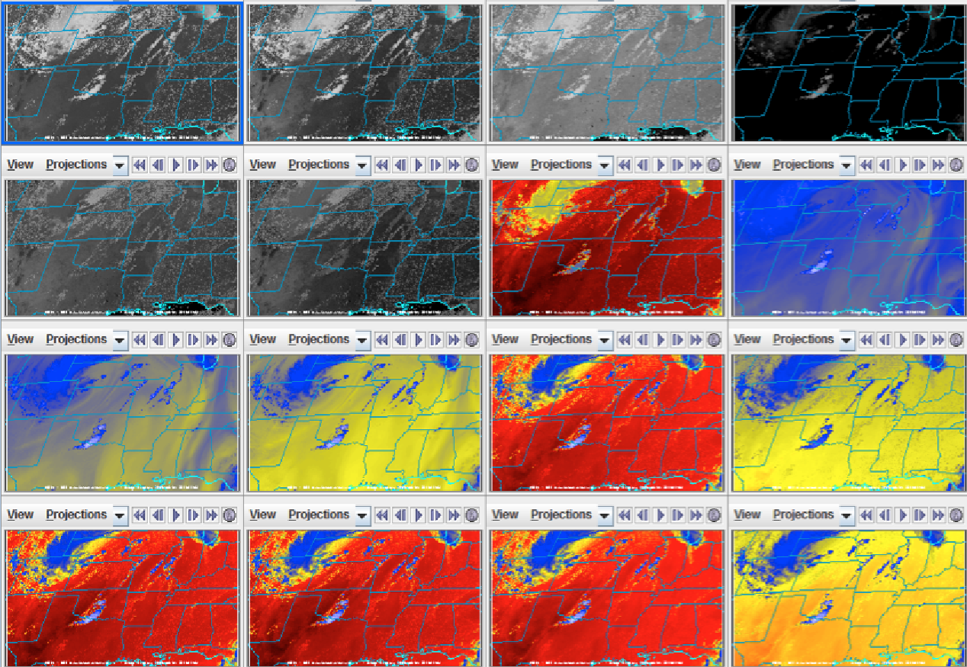
Figure 8. CONUS simulated GOES-R ABI bands 1 through 16 at 75°W at for 2100 UTC on 4 June 2005, showing reflectance for the visible bands and Brightness temperatures for the IR bands.

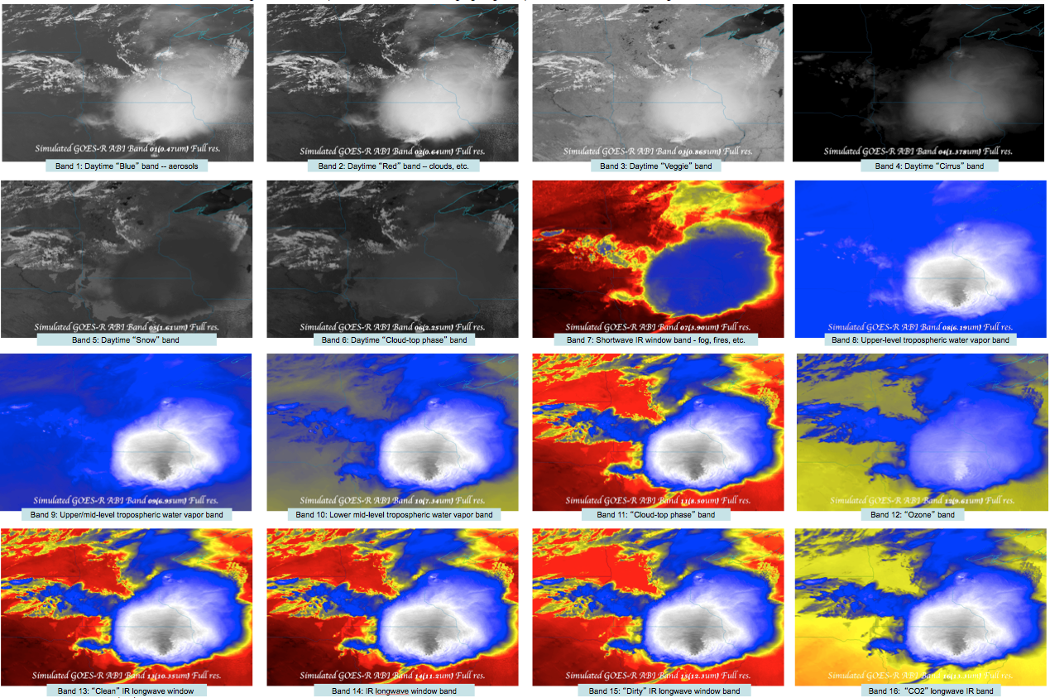
Figure 9. Mesoscale simulated GOES-R ABI bands 1 through 16 at 75°W for 1730 UTC on 19 July 2006, showing reflectance for the visible bands and Brightness temperatures for the IR bands.

5.2 Routine Image Animation

Visualization and analysis software package such as McIDAS-V or programming
languages like IDL, MATLAB etc. may be used to routinely generate animated
movies. The images below were generated using the jython scripting capabilities
in McIDAS-V. These new scripting capabilities in McIDAS-V are currently being
improved to allow for remotely running on a server.
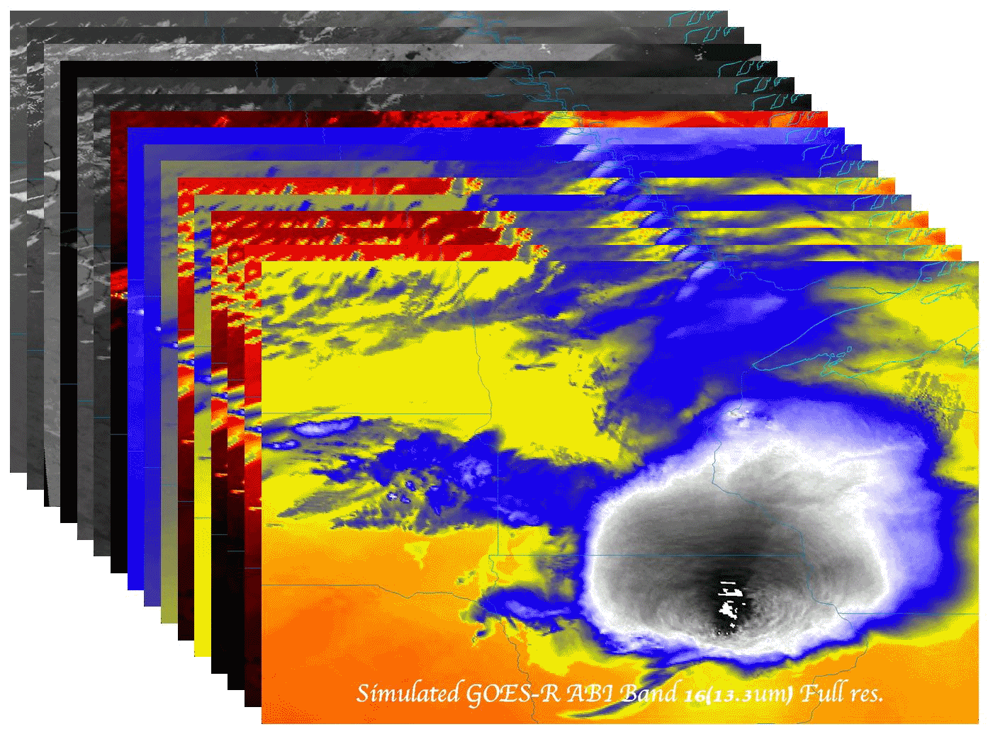
Figure 10. Routine Image Animation.

5.3 Image correlations

Computing statistics such as those shown below is one way of routinely validating
datasets. Most software’s such as McIDAS-V have the built in capability to compute such statistics (Mean, Median, variance, Correlation etc). That said, this task may fall under system monitoring.

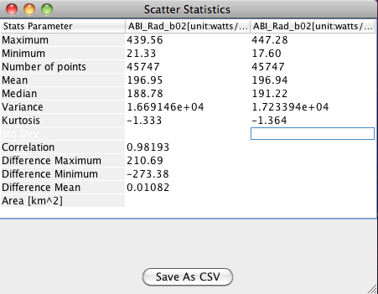
Figure 11. Image statistical analysis.

Figures 11 compares two different times for GOES-R ABI band 2 (0.64um). In this case, there is strong correlation between the two files (0.98193), with very minimal differences in the mean (0.01082) and very minimal variances within
each individual file (1.669146e+04, 1.723394e+04). Such statistics supports the argument that the differences between the two files are within the expected range for band2 (0.46um) at 10:00 UTC.

The three key improvements in GOES-R ABI as compared to the current imager are improvements in resolution (Spectral, Spatial, Temporal). A good way to verify improved resolution is to generate high quality images at full resolution and zoom into these animated images to look at finer details.

Figure 12. image visual analysis.

5.4 Image combination

By using the red band and the blue band that already exist in GOES-R ABI and generating a synthetic green band, one can create “true color” images that shows vegetation, clouds and Ocean when the right color enhancement is applied to it. This is one method to validate a number of ABI bands at once.

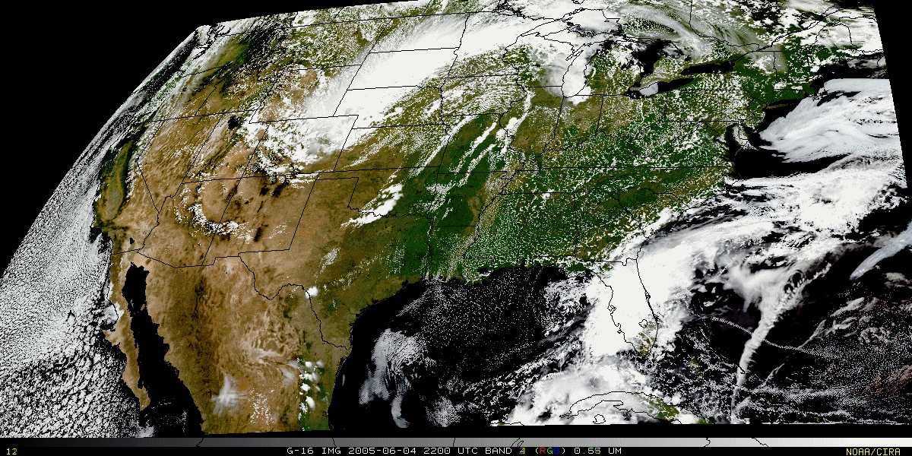
Figure 13. “True Color” with “synthetic” green band from ABI simulated data (from CIMSS); image from Don Hillger, RAMMB.

6 SOFTWARE REQUIREMENTS

6.1 Software Library Support

Several libraries are needed, including McIDAS-V, Jython scripts and php (for the web).

7 REFERENCES

Acharya, T., and A. K. Ray> 2005: Image processing: principles and applications: Wiley-Interscience.
Baum, Bryan A., Ping Yang, Andrew J. Heymsfield, Steven Platnick, Michael D. King, Y-X. Hu, Sarah T. Bedka, 2005: Bulk Scattering Properties for the Remote Sensing of Ice Clouds. Part II: Narrowband Models. J. Appl. Meteor., 44, 1896–1911. doi: 10.1175/JAM2309.1
Cao, C., and A. Heidinger. 2002: Proceedings of SPIE (http://www.star.nesdis.noaa.gov/smcd/spb/calibration/icvs/documents/Cao_2002SPIE.pdf).
Clarke, J., 2010: GOES-R ABI LEVEL 1B SOLAR CHANNEL DATA DISTRIBUTION STUDY: Analysis of alternatives for utilization of Radiance and Reflectance Factor Instrument Data.
Michael D.; Hu, Y.-X., and Bedka, S. T., 2005: Bulk scattering properties for the remote sensing of ice clouds, part II: Narrowband models. Journal of Applied Meteorology, Volume 44, Issue 12, pp.1896-1911.
Gurka, J. J., and G. J. Dittberner. 2001: The next generation GOES instruments: Status and potential impact. Paper read at Fifth Symp. on Integrated Observing Systems, Albuquerque, NM.
Hillger, D. W., and T. Schmit. 2004: Quantization noise for GOES-R ABI bands. Paper read at Proceedings of the 13th Conference on Satellite Meteorology and Oceanography, Sep., Norfolk, VA.
NOAA/NASA, 2010: GOES-R Ground Segment (GS) Functional and Performance Specification (F&PS): GOES-R/Code 417.
NOAA/NESDIS, 2007: GOES-R Series Mission Requirements Document (MRD, version 3.1): GOES-R Program/Code 417.
Otkin, J. A., D. J. Posselt, E. R. Olson, H.-L. Huang, J. E. Davies, J. Li, and C. S. Velden, 2007: Mesoscale numerical weather prediction models used in support of infrared hyperspectral measurements simulation and product algorithm development. J. Atmospheric and Oceanic Tech., 24, 585-601.
Otkin, J. A., and T. J. Greenwald, 2008: Comparison of WRF model-simulated and MODIS-derived cloud data. Mon. Wea. Rev. 136:1957-1970.
Padula, F. and C. Cao, 2011: CWG (Calibration Working Group) Analysis: ABI Max/Min Radiance Characterization and Validation.
Russ, J. C., 2002: The Image Processing Handbook, Fourth Edition CRC Press.
Schmit, T. J., M. M. Gunshor, W. P. Menzel, J. Li, S. Bachmeier, and J. J. Gurka, 2005: Introducing the next-generation Advanced Baseline Imager (ABI) on GOES-R. Bull. Amer. Meteor. Soc. 8:1079-1096.
Schmit, T. J., M. P. Weinreb, and W. P. Menzel, 1991: GVAR IR scale factor coefficients: NOAA.
Weinreb, M. P., M. Jamison, N. Fulton, Y. Chen, J. X. Johnson, J. Bremer, C. Smith, and J. Baucom, 1997. Operational calibration of Geostationary Operational Environmental Satellite-8 and -9 imagers and sounders. Appl. Opt. 36:6895-6904.
Weinreb, M. P., J. X. Johnson, J. H. Lienesch, and D. S. Crosby, 1989: Destriping GOES images by matching empirical distribution functions. Rem. Sens. Environ 29 (185-195).

Appendix 1. Select Links

GOES-R:
http://www.goes-r.gov
http://www.goes-r.gov/education/index.html
http://www.meted.ucar.edu/index.htm
http://cimss.ssec.wisc.edu/goes_r/proving-ground.html

GOES:
http://goespoes.gsfc.nasa.gov/goes/index.html
http://goes.gsfc.nasa.gov/text/goes.databookn.html
http://rapidfire.sci.gsfc.nasa.gov/
http://goes.gsfc.nasa.gov/
http://rammb.cira.colostate.edu/projects/goes-n/
http://rammb.cira.colostate.edu/projects/goes-o/
http://rammb.cira.colostate.edu/projects/goes-p/

UW/SSEC/CIMSS/ASPB:
http://cimss.ssec.wisc.edu/goes/rt/sounder-dpi.php
http://cimss.ssec.wisc.edu/goes_r/awg/proxy/nwp/
http://cimss.ssec.wisc.edu/goes/abi/
http://cimss.ssec.wisc.edu/goes/abi/wf
http://cimss.ssec.wisc.edu/goes/blog/
http://www.ssec.wisc.edu/data/geo/
http://www.ssec.wisc.edu/~jordang/awips-modis/index.html
http://cimss.ssec.wisc.edu/dbs/SatelliteNotes/Notes.html

Appendix 2. Sample script

Sample McIDAS-V scripting for generating back ground images:

import time
setOffScreen(1)

# command line options have been removed. Use this script as a template and use sed, awk or whatever works to insert necessary
# parameters.

datadir=""
indir="/Users/kbah/glance/input/calnex/val/"
outdir="/Users/kbah/mcidasv/output/script/calnex/"
aband=["01(0.47um)","02(0.64um)","03(0.86um)","04(1.37um)","05(1.61um)","06(2.25um)","07(3.9oum)","08(6.19m)","09(6.95um)","10(7.34um)","11(8.5um)","12(9.62um)","13(10.35um)","14(11.2um)","15(12.3um)","16(13.3um)"]
ares=["2", "2", "2","2", "2", "2", "2","2","2","2","2","2","2","2", "2", "2"]
times=["0000utc","0100utc","0200utc","0300utc","0400utc","0500utc","0600utc","0700utc","0800utc","0900utc","1000utc","0000utc","1100utc","1200utc","1300utc","1400utc","1500utc","1600utc","1700utc","1800utc","1900utc","2000utc","2100utc","2200utc","2300ut"]
adate=["0501", "0502", "0503", "0504", "0505", "0506", "0507", "0508", "0509", "0510", "0511", "0512", "0513", "0514", "0515", "0516", "0517", "0518","0519", "0520", "0521", "0522", "0523", "0524","0525", "0526", "0527", "0528", "0529", "0530"]
alabel="SIMULATED GOES-R ABI (CalNex) "
b_var=["ABI_Refl_fact_b", "ABI_TBB_b"]

sourceType = 'netcdf.grid'
displayType = 'planviewcolor'
dataMin=None
dataMax=None
cTable="goesr"
projection="CALNEX"
scaleFactor=1.0
width = 800
height = 800
#d=0
for d in range (17, 29):
for i in range(0,1):
for j in range(0, 24):
bb=str(i+1)
ee="_"
visir="ir"
bb=str(i+1).zfill(2)
if i < 6:
ee="_esun_"
visir="vis"
cTable="Square Root Visible Enhancement"
#cTable="Inverse Gray Scale"
pre_name="GRB_VAL"+ee+"band"+bb+"_calnex_chem_rem_2km_sim_abi_fixed_grid_"+visir+"_CRTM_V2.04_2010_"+adate[d]+"_"+times[j]+".nc"
inputFileName1 = indir+pre_name
selectedField1 = b_var[1]+ str(i+1).zfill(2)
outFileName=outdir+ "band"+aband[i]+"_"+ adate[d]+"_"+ times[j]+ ".jpg"

if i < 6:
selectedField1=b_var[0]+str(i+1).zfill(2)

idv.getStateManager().setViewSize(java.awt.Dimension(width,height)) #change the width and height of the display

#### GET THE DATA FOR USE IN McIDAS-V ONLY RUN CODE IF NO ERRORS ARE ENCOUNTERED###
with managedDataSource(inputFileName1, dataType=sourceType) as dd1:
dataSource1 = idv.getDataManager().findDataSource(dd1.getName())
dataChoice1 = dataSource1.findDataChoice(selectedField1)
flatField1 = dataSource1.getData(selectedField1)

#### GET LABELS ####

#### Use Grid Utilities to get color bar label ([0] is selecting the first element in the java array returned from GridUtill.getParamUnits(Choice1))
print type(dd1), type(dataChoice1), selectedField1
colorBarLabel1= GridUtil.getParamUnits(flatField1)[0]
dataDescription1 = dataChoice1.getDescription()

# Display the data and get the displayControl (dc)
dc=createDisplay('planviewcolor',dataChoice1)
time.sleep(5)

# get the view managers for setting lat/lon lines, projections and color tables
myDisplay = firstDisplay()

#set the projection
if type(projection).__name__ != 'NoneType':
myDisplay.setProjectionByName(projection)

#zoom if desired
myDisplay.setScaleFactor(scaleFactor)

#---changing the color table---#
ctm=idv.getColorTableManager()
ct=ctm.getColorTable(cTable)
dc.setColorTable(ct)

# Turn off the layer label
dc.setShowInDisplayList(0)

#### SAVE THE IMAGE ####
writeImage(outFileName,\
"matte background=white top=60;matte background=black bottom=40;\
colorbar width=300 height=10 anchor=UM place=UM,0,20 showlines=true tickmarks=2 showunit=true;\
overlay text="+dataDescription1+"_"+adate[d]+"_"+times[j]+" place=LM,0,-20 anchor=LM color=yellow fontsize=20 fontface=Arial")
#;\
#overlay text="+str(colorBarLabel1)+" anchor=UM place=UM,0,40 color=black fontsize=12 fontface=Arial")
time.sleep(10)

